Steps:

1. Click the deployed boilerplate which will open the nodered in bluemix.

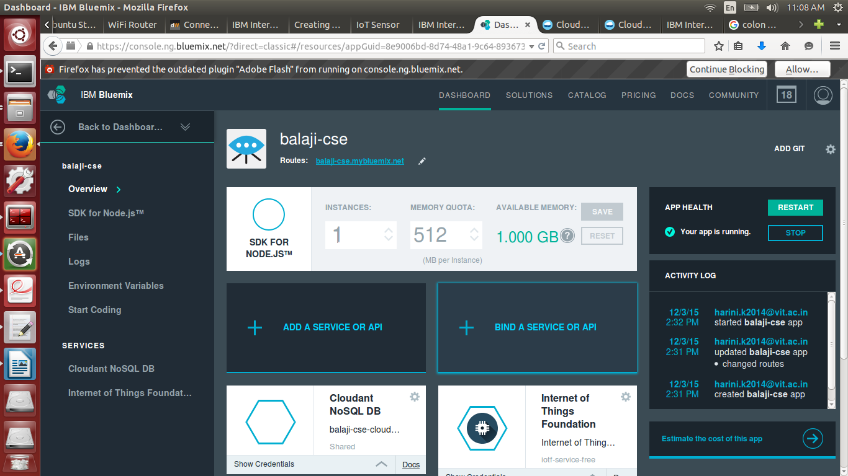

2. Click the Go to your Node-Red flow editor.

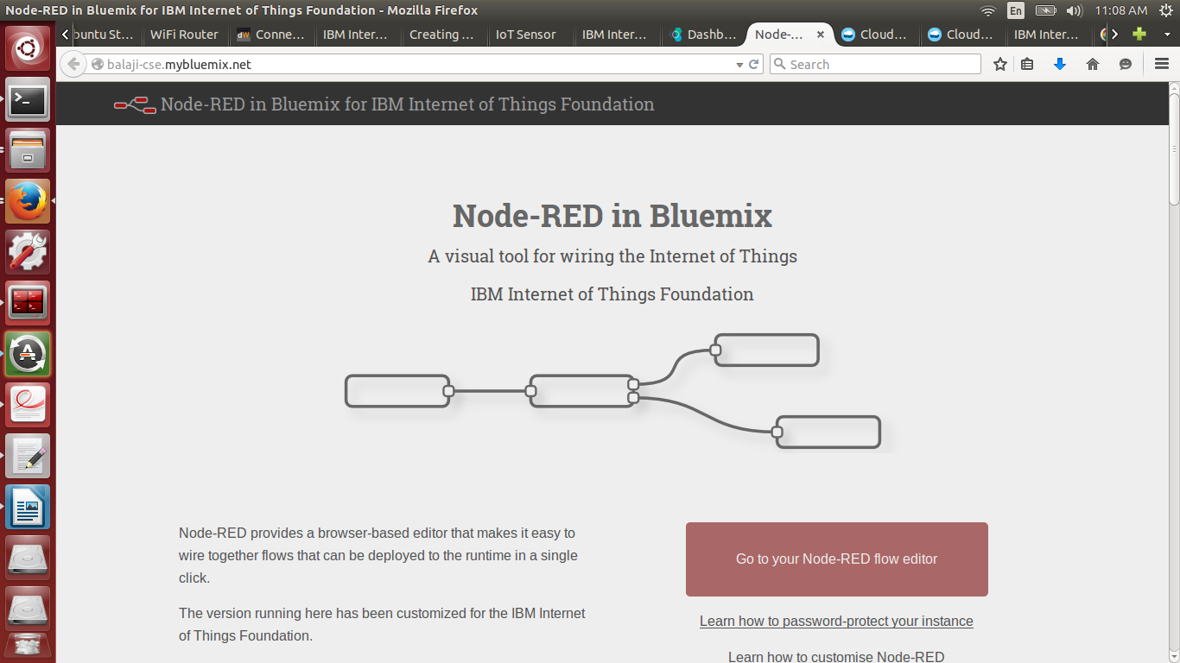

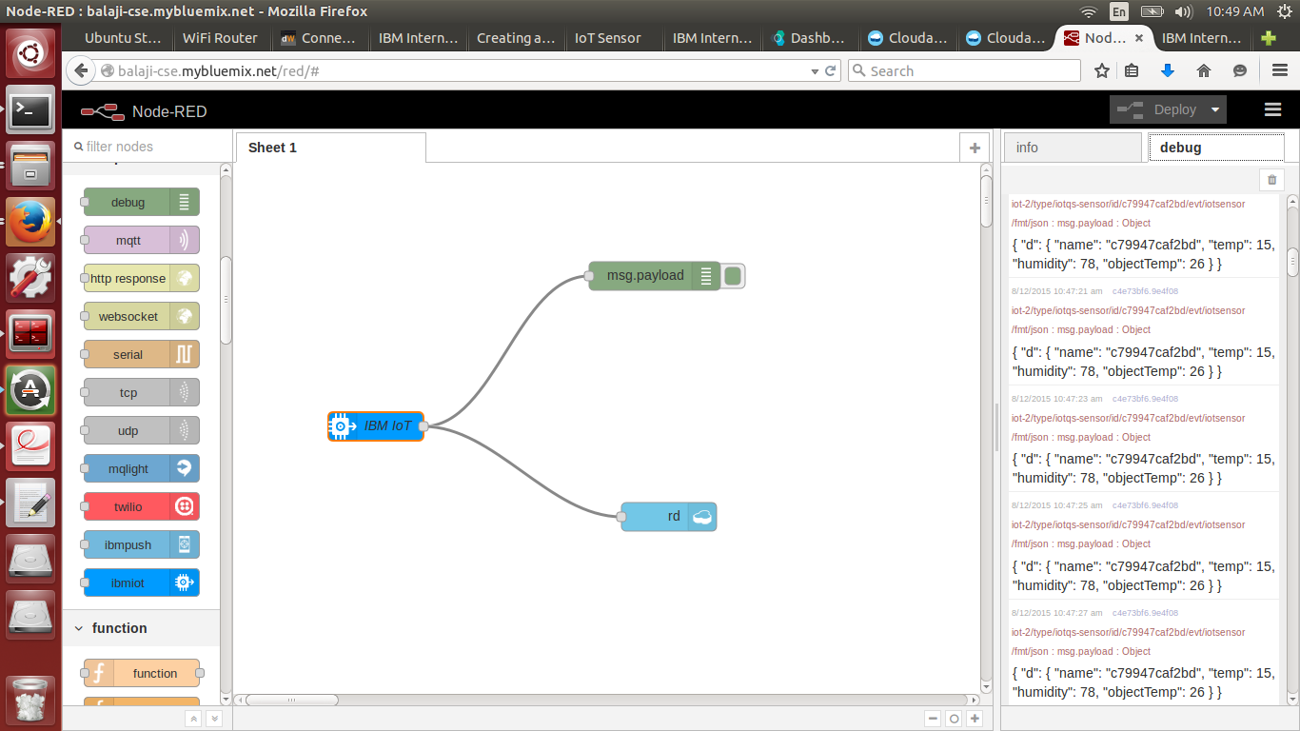3. Click on the IBM IoT

4. Double click that and give the following – give your device MAC adrress without any space or colon inbetween.

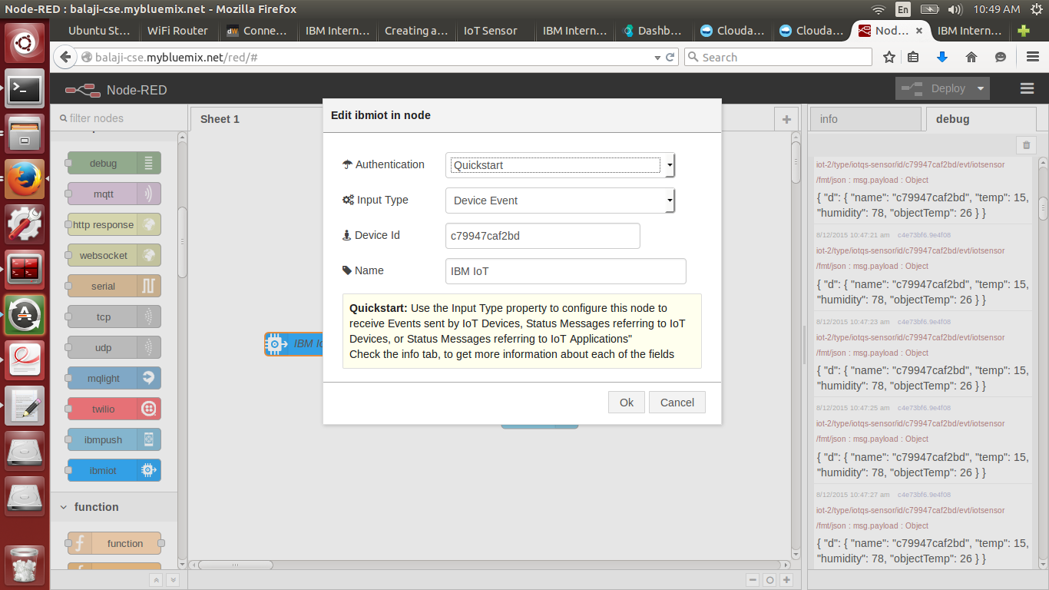

5. Drag and drop any storage according to your convenient, I used cloudant here.

Give the database name and insert operation and click ok.

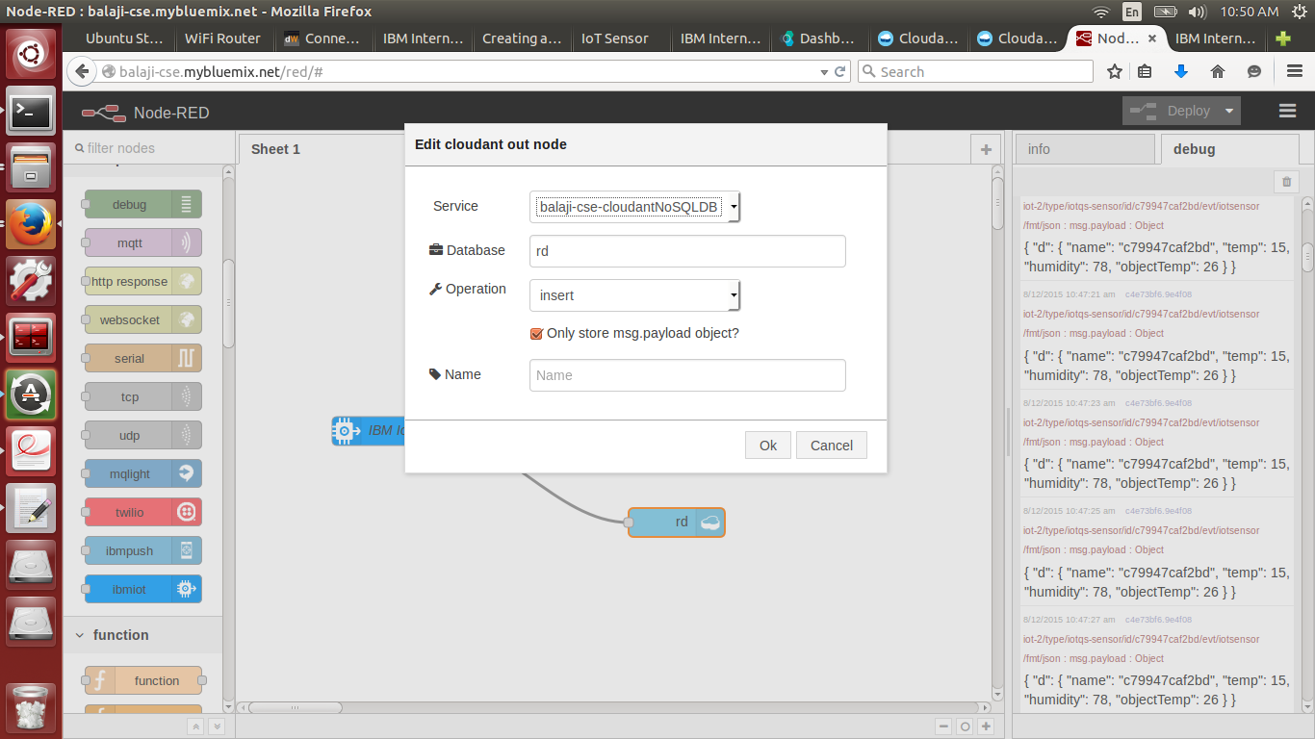

6. Debug node for the output operation(no change required here).

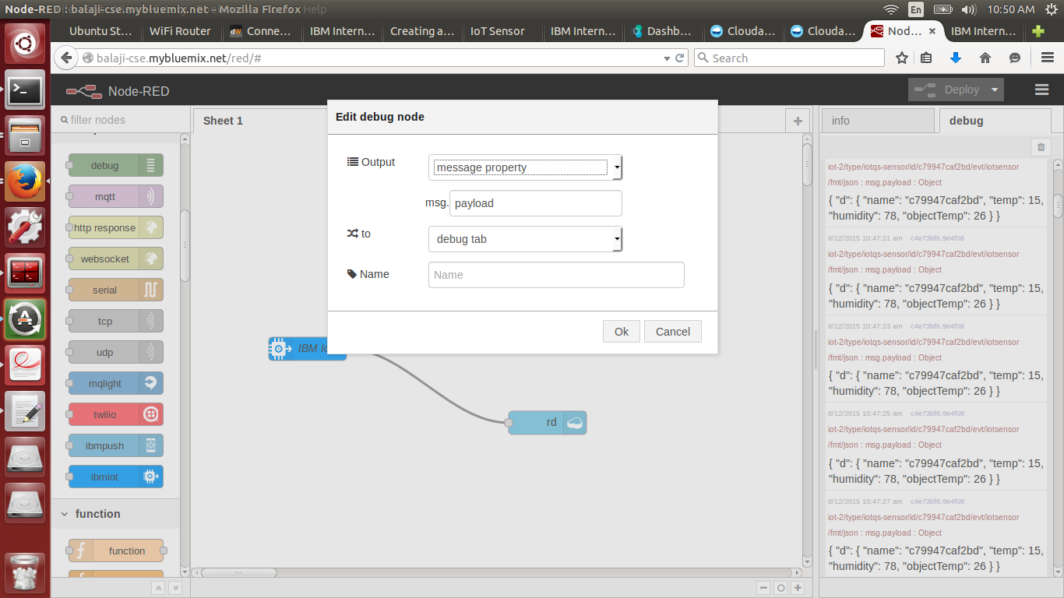

7. Then click the deploy which is in the right corner of this page, the output will be displayed in the debug column. Before doing this step check whether your iot device is running properly or not.

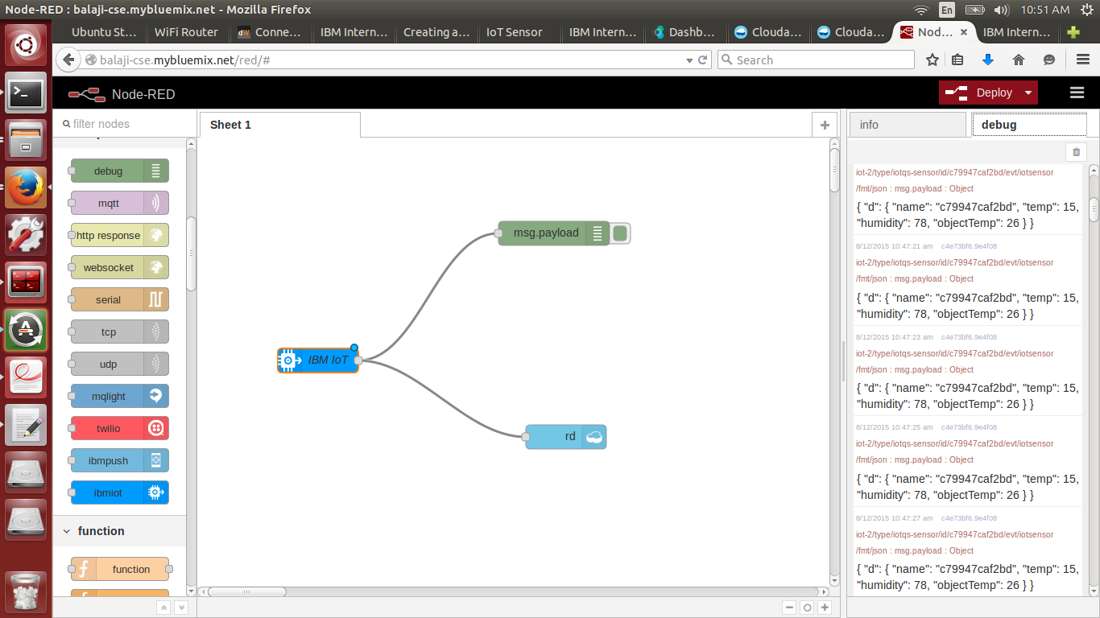

8. Go to cloudant and check whether the data is uploaded or not.

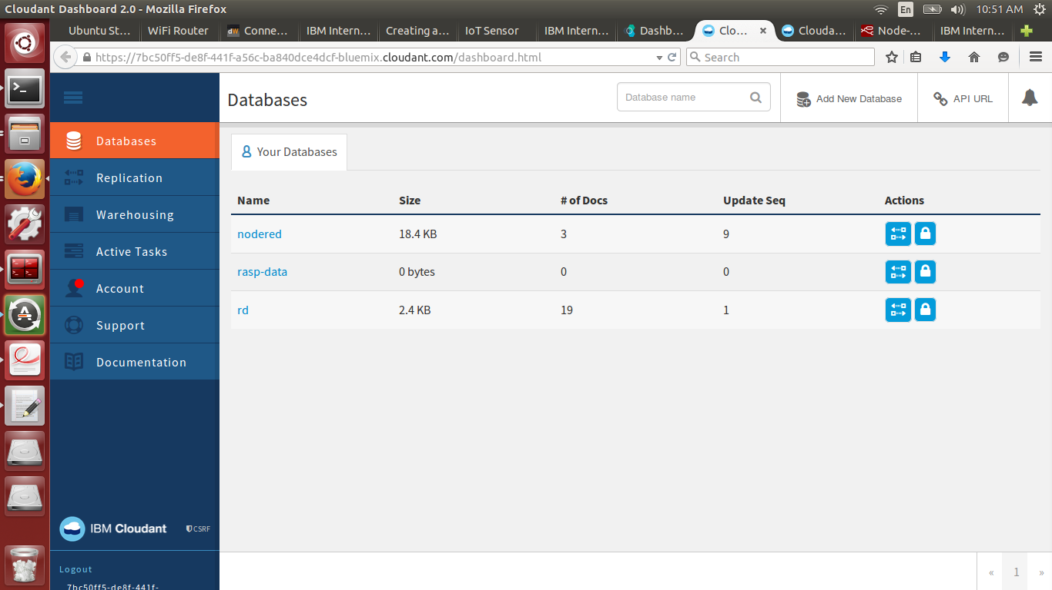

9. Check the data by clicking the data name.

