**Lab 1 :**

**Device data Quick view**

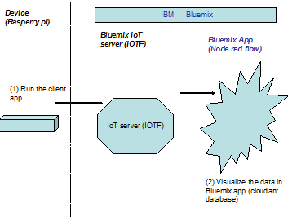

**Steps A**

1. Login to Bluemix
   1. Bluemix.net

Note: Register with Bluemix to get a 30days free bluemix trial using <https://ibm.biz/hackblue>

1. Deploy the Internet of Things Boiler plate (Catalog tab)

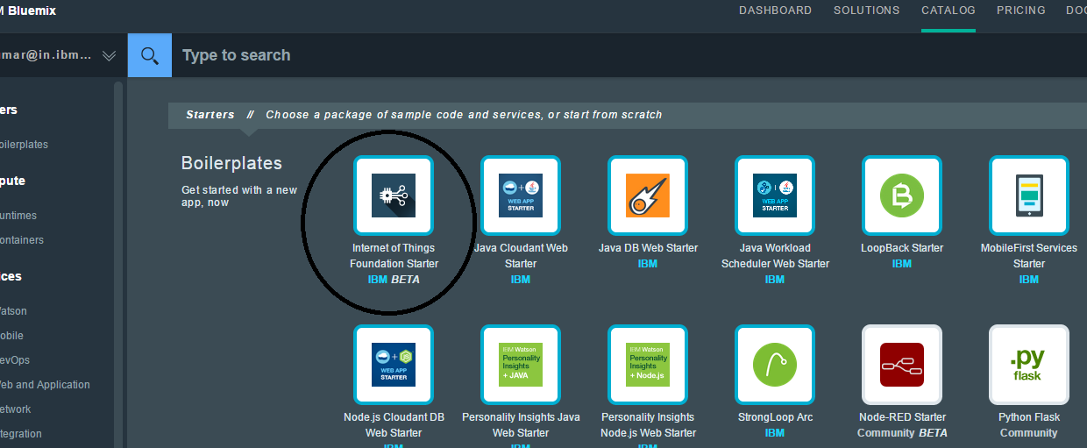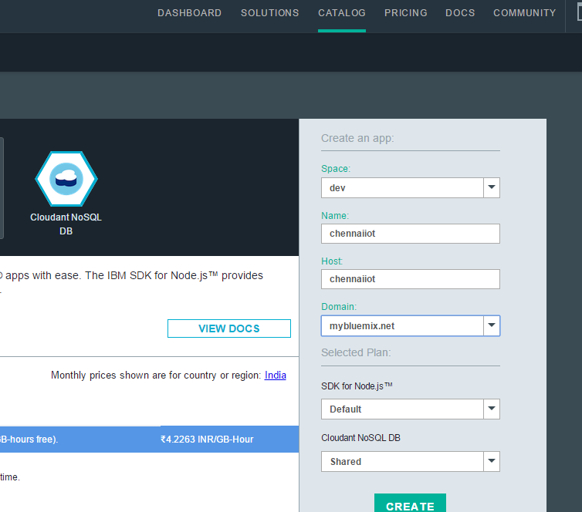

(i) Name -> It should be an unique name.In this case, chennaiiot

(ii) Space -> Create any space name

(iii) Leave the rest to default value

(iv) Click on CREATE

(v) Application getting staged. At this stage, Node Red editor and Cloudant database is provisioned.

(vi) Proceed to App overview (scroll down to see the button )

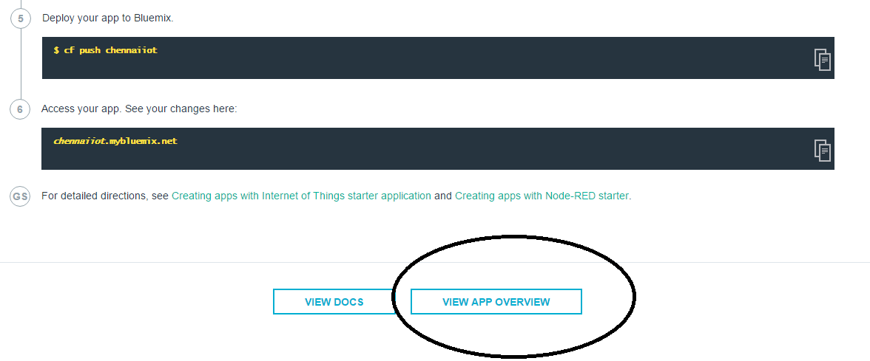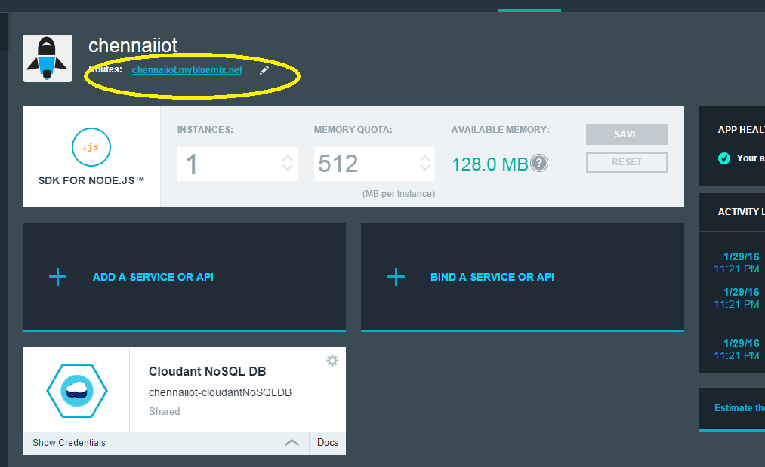

1. click on the route to open the nodered editor (as shown above)

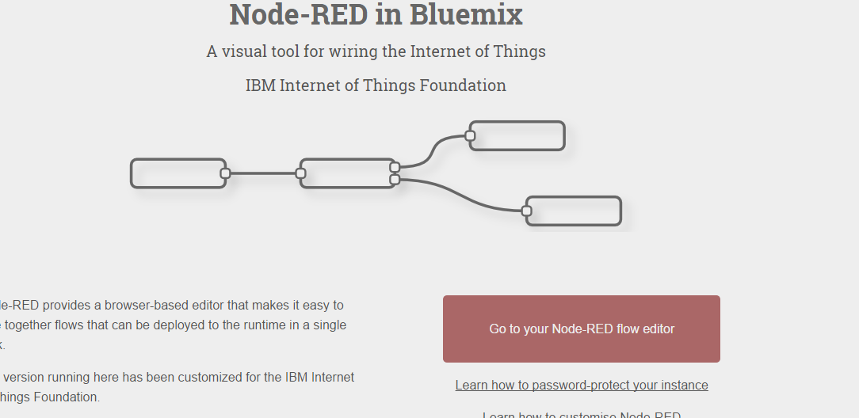

(i) click on ‘Go to your Node-RED flow editor

1. Click the link which will open the nodered in bluemix. (as shown below)

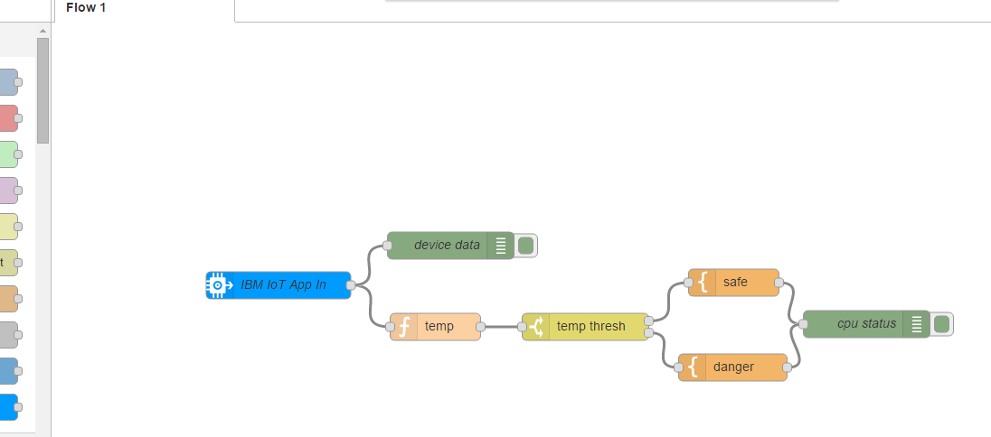

Note: What you see here are all different nodes which are wired to move the data from device to the Bluemix

1. click on “IBM IoT App In” node
2. Provide the MAC address of the raspberry pi (to be shared by the event admin)
3. Let the Authentication be “Quickstart” and Inpu type be “Device Event”

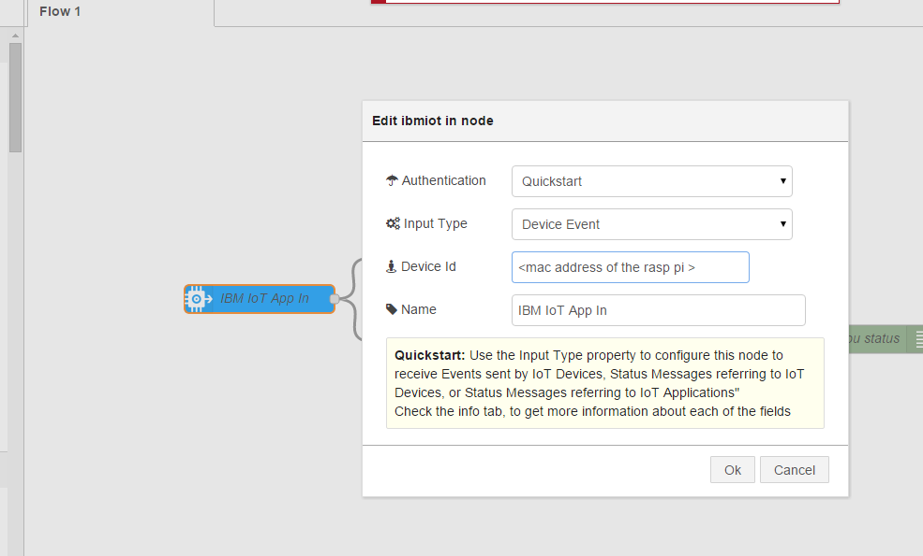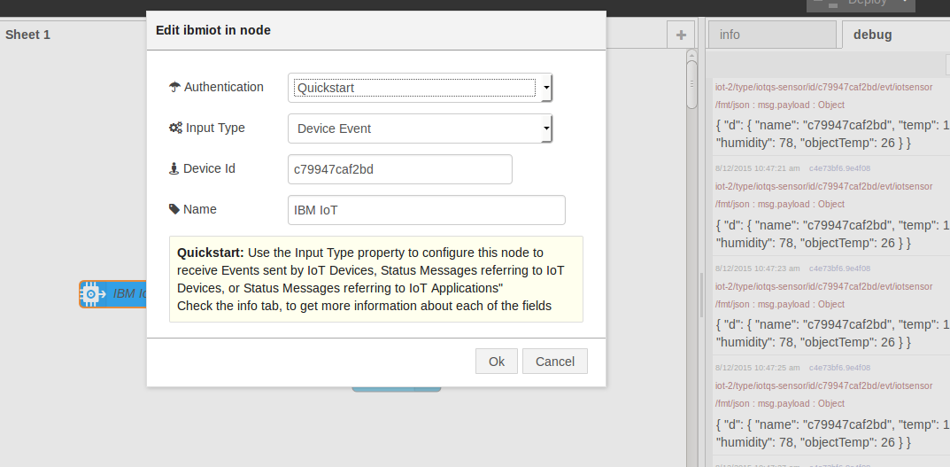

**Step B**

1. Login into the raspberry pi using PUTTY (IP address of the device will be given by the event admin)
2. Run the client program which will start publishing the data to the Bluemix IOTF server
   1. Program is available as python code under the folder **/iot**
   2. **Ibmiot.js**
   3. **Run it as “node ibmiot.js”**
   4. Wait for a while to see that it connects with the device and start publishing the (built in) sensor data , as shown below

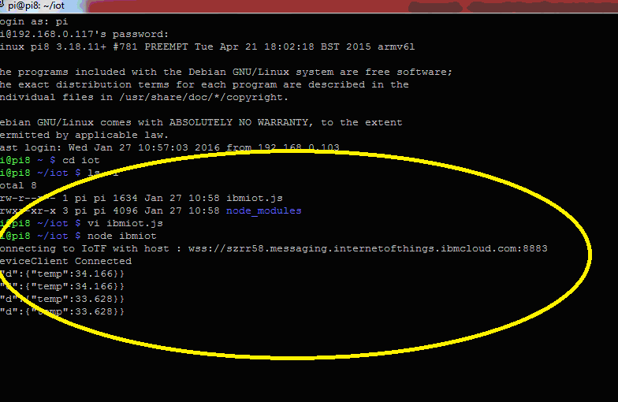

**STEP 3**

Moving the data from device to the Bluemix cloud

1. Go back to the recently deployed IoT Bluemix Boilerplate application , as shown in STEP A

(In our case, it will be chennaiiot .mybluemix.net)

1. Deploy the node red application , as shown below:

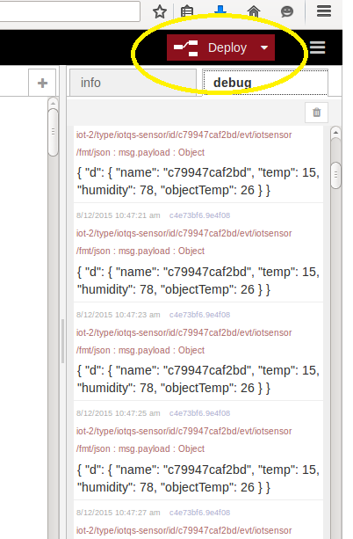

Note: The data from the raspberry pi displayed in the Bluemix nodered console, as shown above

**STEP 4**

Moving the data to cloudant database

1. Go to the node red editor, add cloudant node as shown below

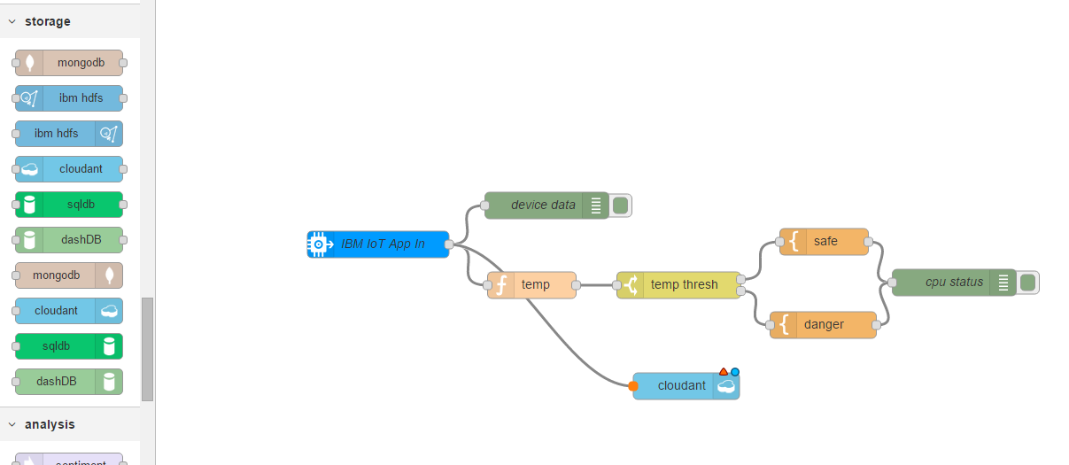

Click on the cloudnat node and provide the database name.In our case “rd”

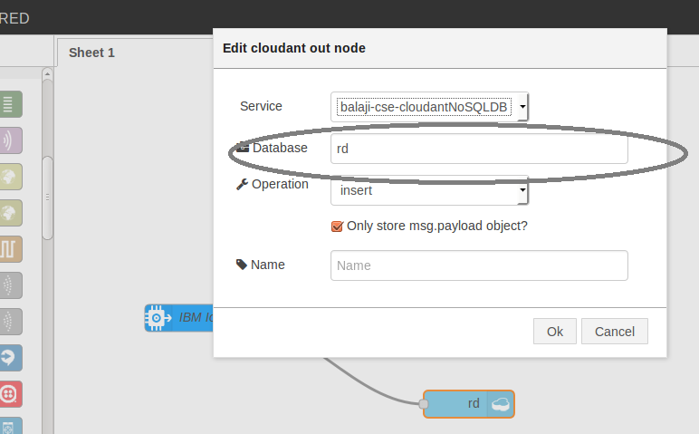

View the data in cloudant console by going back to Bluemix application console

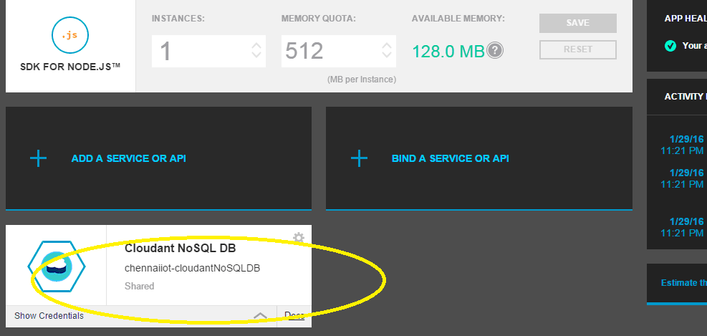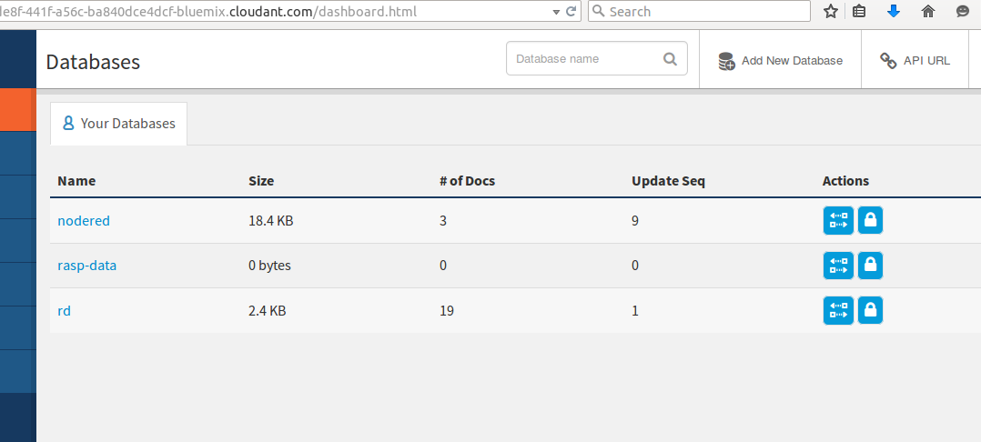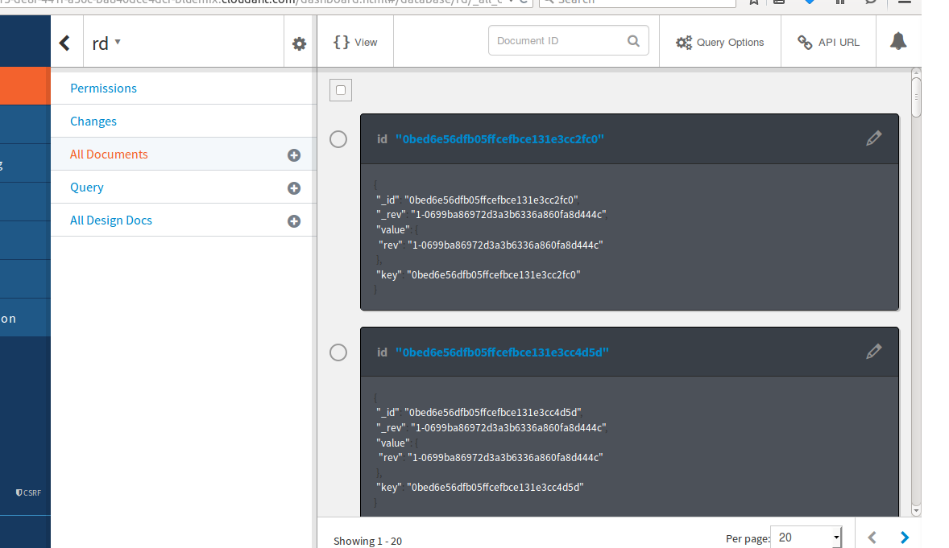

That’s it…now the data flows down to cloudant database

**Explore:**

1. **Tweet once the temperature goes above say 35 deg**
2. **Similarly try sending the data to other databases**

Proceed to Lab 2 ..register the device and send command back to the device…

8