**Lab 2; Register the device with Bluemix IoT server (IOTF) and send the command back to the device**

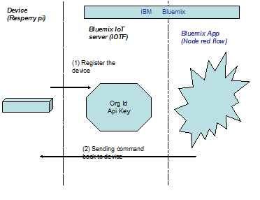

STEPS:

1. In catalog choose the “Internet of Things Foundation” service

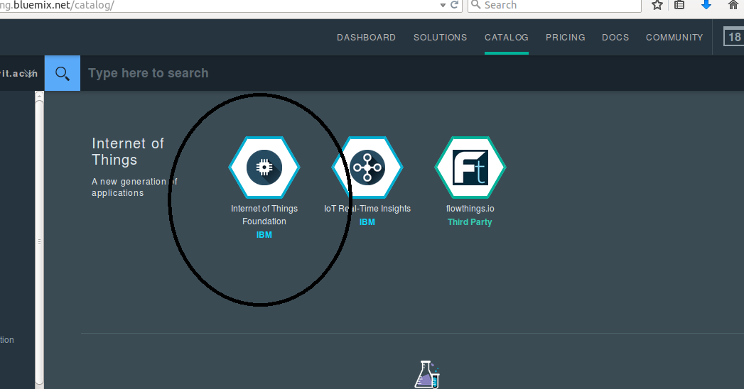

1. Bind it to the application created in Lab1, in our case, Chennaiiot

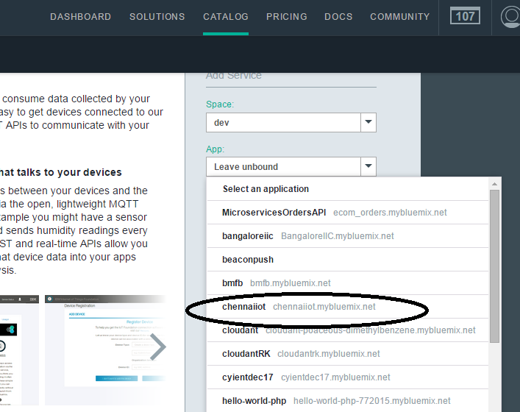

Note: At this stage, the application gets restaged

1. Launch the Internet of things dashboard

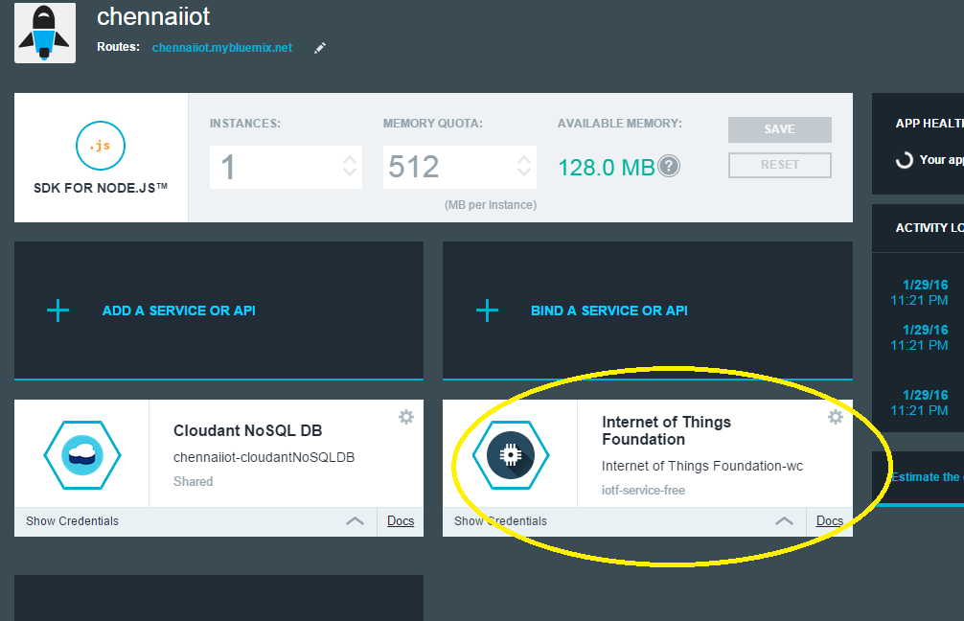

4 . Launch dashboard

.

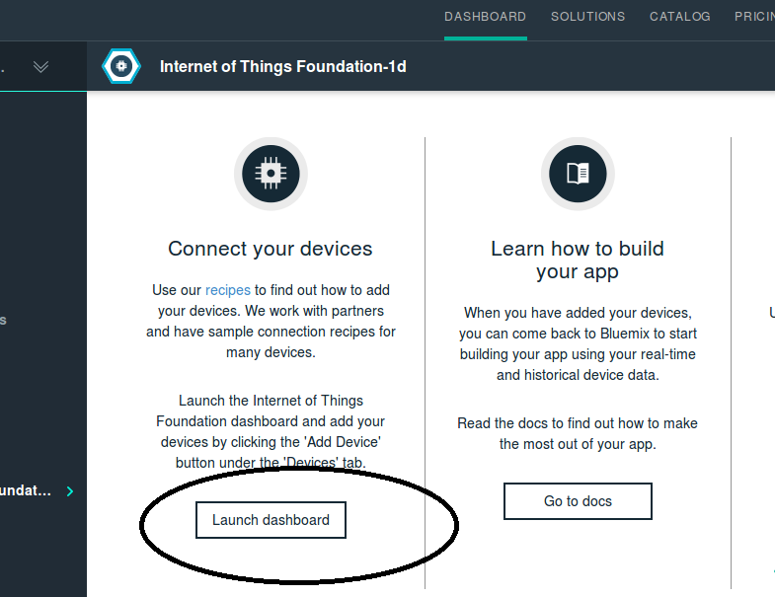

5. Then Click on Add a device.

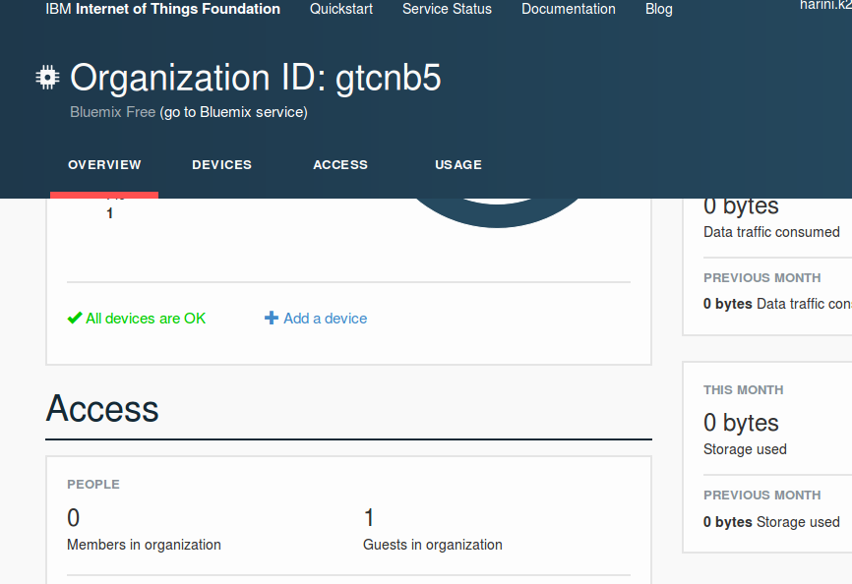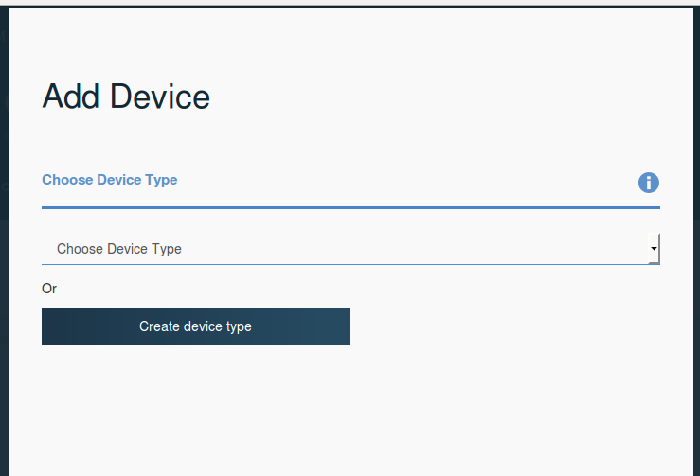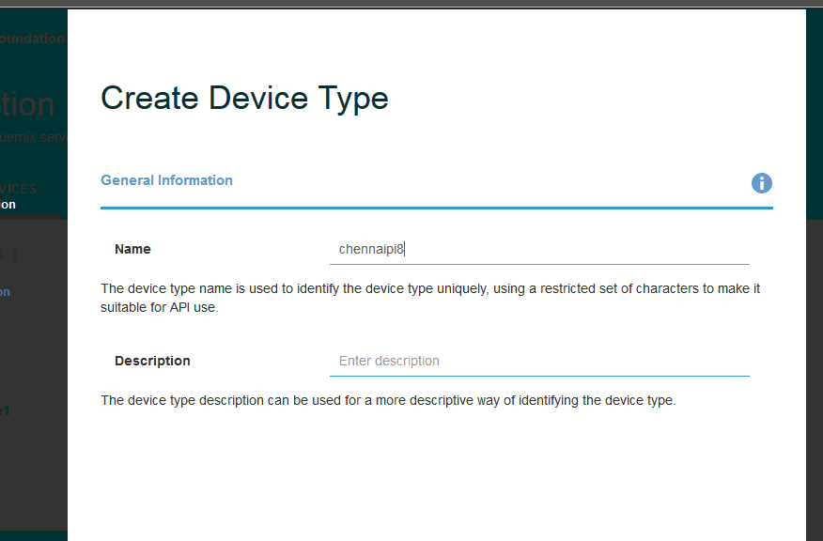

Note: Name the device, in this case , chennaipi8. You can give any other name

6. Provide the Device Id as MAC address of the raspberry pi which you will be connecting (to be provided by the event admin )

7. Bluemix IoT Server , IOTF , returns access credentials as shown

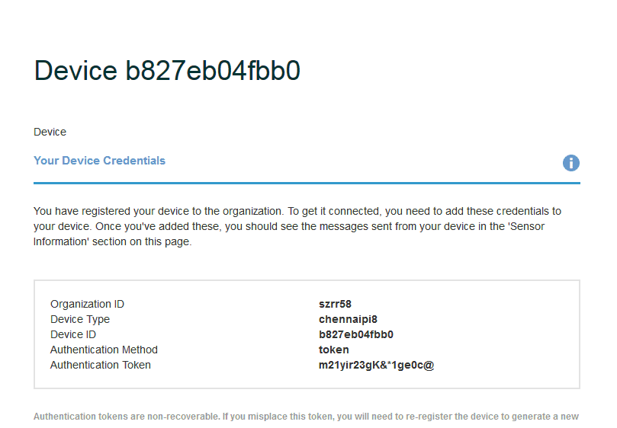

Note: It is important to note down these credetials in a notepad

In our case, it is as below:

Organization ID - szrr58

Device Type - chennaipi8

Device ID - b827eb04fbb0

Authentication Method -token

Authentication Token -@(SW?o4+yNG6Y)1zx&

**STEP B**

Provide these credentials to the client application running in the raspberry pi device

1. Open the file ibmiot.js and provide the credentials what you have got

* 1. Program is available as python code under the folder **/iot**
  2. **Ibmiot.js**

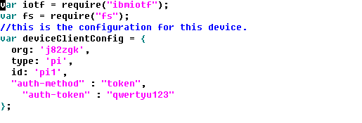

2. Save this file and run the client program

**Run it as “node ibmiot.js”**

Wait for a while to see that it connects with the device and start publishing the (built in) sensor data , as shown below

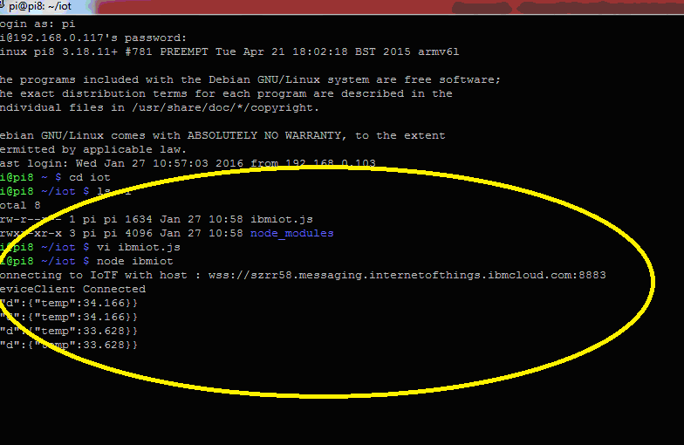

**STEP C**

Go back to the Bluemix node red flow editor and send the command back to the device.

In our case, we send the command to ‘createfile” and update the file with a string content

1. Go back to bluemix console and run the boilerplate app created as in lab 1. In our case <http://chennaiiot.mybluemix.net/>

2.open the node red editor

4. Add 2 new nodes to inject commands back to the device

Node 1 : Inject node from **input**

**Node 2 : ibm iot out node**

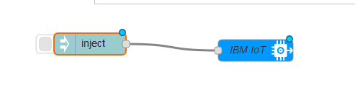

5. provide details in the IBM IOT outnode as shown in the image below

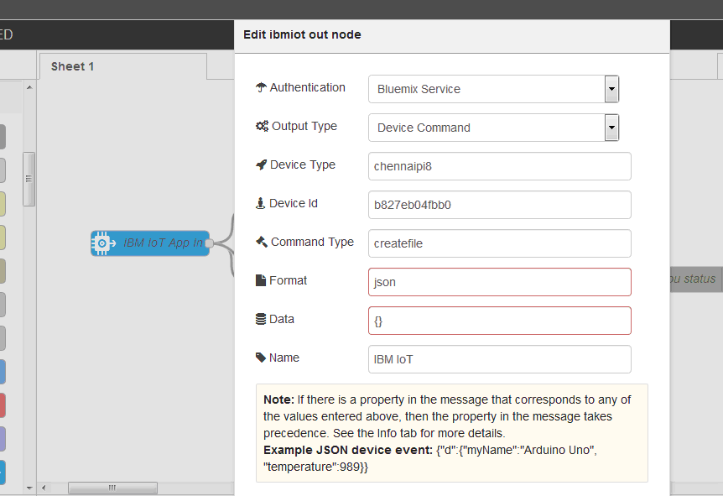

6. In the Inject node, send the command to create file

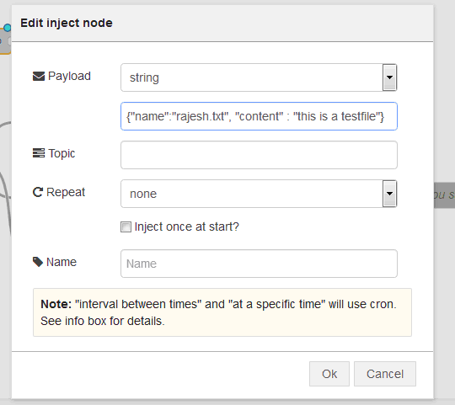

That’s it….now deploy the node and see the file is been created under the fole /iot…

