Ethan Cravener
exc261
EECS 376

PS8 Writeup

Commands:
roslaunch mobot_urdf mobot_in_pen.launch
rosrun mobot_pub_des_state mobot_pub_des_state
rosrun mobot_pub_des_state open_loop_controller
rosrun mobot_pub_des_state pub_des_state_path_client //modified path to navigate to goal

I was able to get the open_loop_controller to navigate the robot to the goal, however I had my max speed and acceleration set to very small values as seen below.
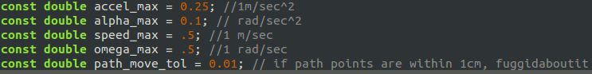
When the values were changed to their initial values the robot was not successful in navigating to the goal location.
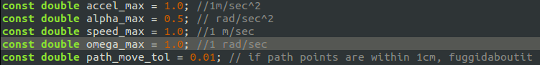
Commands:
roslaunch mobot_urdf mobot_in_pen.launch
rosrun mobot_pub_des_state mobot_pub_des_state
rosrun lin_steering lin_steering_wrt_odom
rosrun mobot_pub_des_state pub_des_state_path_client //modified path to navigate to goal

When using the lin_steering algorithm the robot navigated to its goal, but overshot the final location. It also swerved far off the path before correcting, which could have led to a crash if the starting location was not a large room.

Lowering K_PHI, the angular gain, resulted in less precise control and the robot was unable to navigate to its goal.

Increasing K_PHI, and K_DISP by a large amount resulted in the robot doing circles before crashing.

I was unable to find a combination of gains that worked better with the current max speed and acceleration values. Many other combinations crashed. The following gain values worked comparably to the initial values.
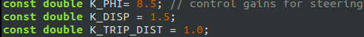

The video of the robot is attached as final_movement.mp4

