

**Report of Field visit**

**Name of Event**: Field visit to L.B.Patil Center for Invention, Innovation & Incubation,

S.M.Joshi College, Hadapsar, Malvadi Hadapsar, Pune - 411028

**Date of Event**: 30.01.2021 (2.00pm to 4.30pm)

**Brief Description**:

In this fast growing and dynamic global scenario, use of latest technology and innovations are utmost essential for the success and growth of the businesses. Today, more than ever, the industry requires competent candidates who are ready to take up the needs and challenges of the hour as an entrepreneur or as a ready competent resource who can help to grow the business/industry.

The “L.B.Patil Center for Invention, Innovation & Incubation (CIII)” established by Rayat Shikshan Sanstha in collaboration with Science & Technology Park, Department of Science & Technology, Government of India and Tata Technologies Ltd, leading global engineering service provider will provide an ecosystem for enhancing skills among employable persons and to identify, promote and support startup companies and budding entrepreneurs to successfully setup new enterprises.

I, Prof. Mandar Kakade along with my team Prof. Ranjeet Bidwe, Prof. Bhushan Zope and students Nikhil Jain, Herambh Joshi (BE Computer), Yash Jaggi (Computer 2020 batch), Dhaval Gundecha (SE IT) visited LBP-CIII to learn how business incubator is running and how it is beneficial for students those are interested to start their own startups. In this visit, we interacted with Mr. Indrasen Dhumal (Prativ Technology & Engineering India) and Mr. Kamal Sehagal (eVoV LLP) and discussed the details regarding how to scan environment for startups, what are various difficulties for startup and how to overcome those difficulties etc.

Mr. Indrasen Dhumal (member, Prativ Technology & Engineering India) works on fully integrated ERP system where the entire hospital management & processes can work seamlessly through one integrated system, Peace of mind for Doctors with inbuilt software correction, upgrades & dedicated 24X7 online software services support. Systematic financial reporting, business revenue & intelligent reports. Time based automated system reporting. Module-wise functionality including future AI* integrations & Reliability.

Mr.Kamal Sehagal (CO- Founder and CEO, eVoV LLP) works on IoTization – Device, Gateway, Connectivity, Security using IoT Platform – Data storage, Device management, Data Science workbench Integration of IoT Applications with rest of IT landscape.

**List of Incubatees at LBP-CIII –**

* Ashnni Motors Pvt. Ltd
* Picodel
* Prativ Technology & Engineering India
* Apka Doctor
* Panther Nails
* Think sharp Foundation
* Impel
* eVoV LLP
* Impel Infotech Pvt. Ltd
* EDUMitra
* Khetiwalo Organics & Agro Technologies Pvt. Ltd
* Avocado Labs
* Conceum Technology

**Photograph with Caption –**

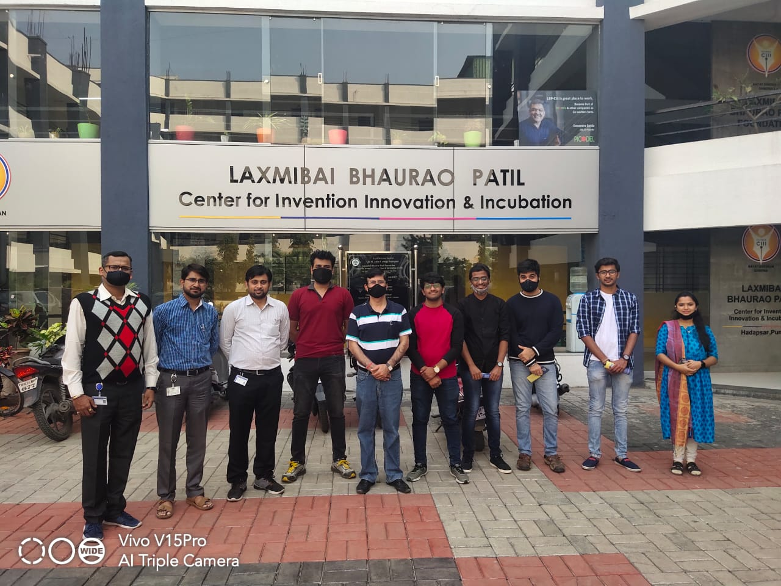

**Group Photograph with Mr. Kamal Sehagal**

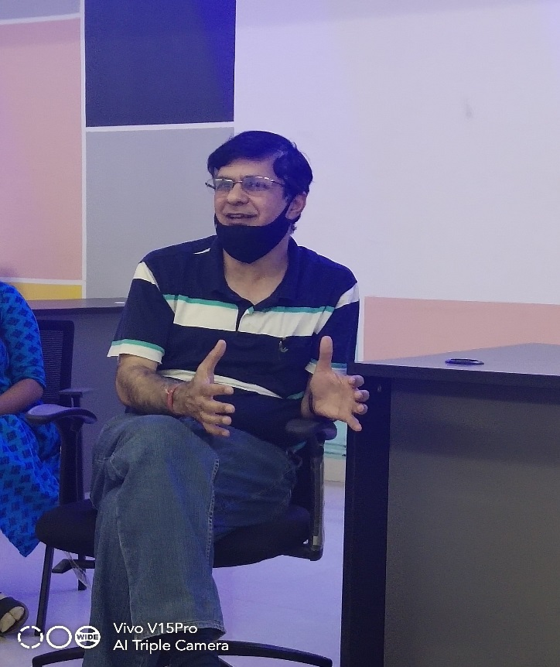 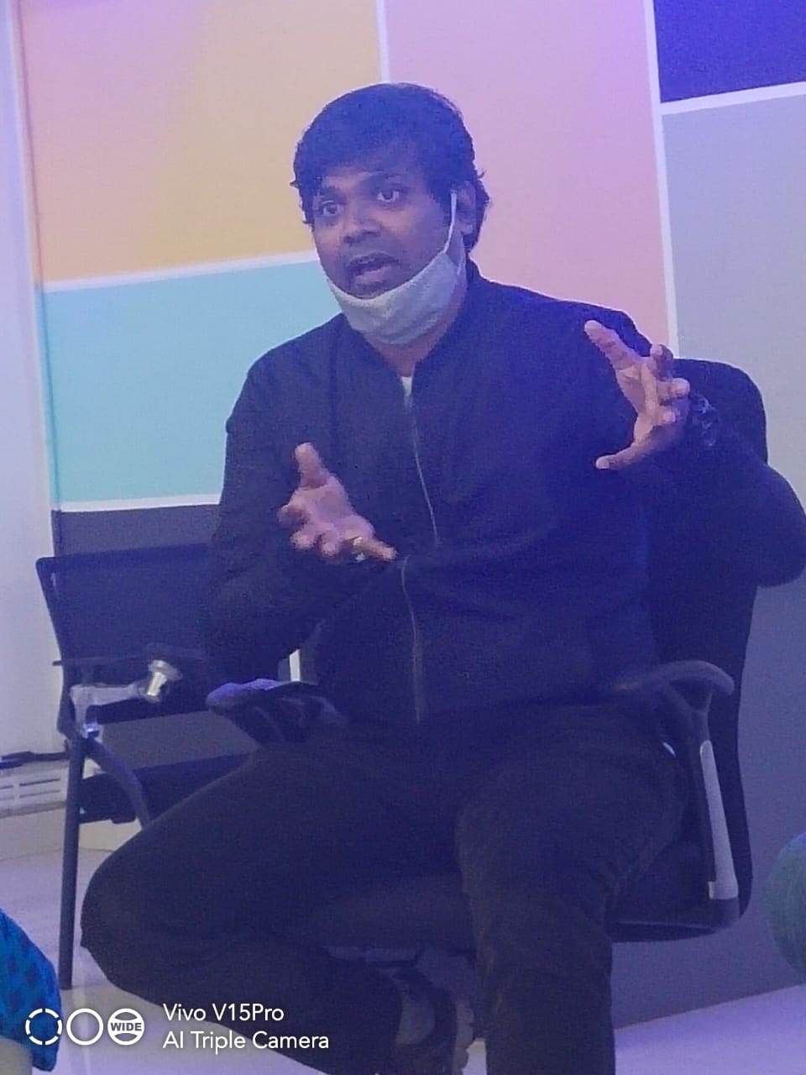

**Mr. Kamal Sehagal Mr. Indrasen Dhumal**

**(CO- Founder and CEO, eVoV LLP) (member, Prativ Technology & Engineering India)**

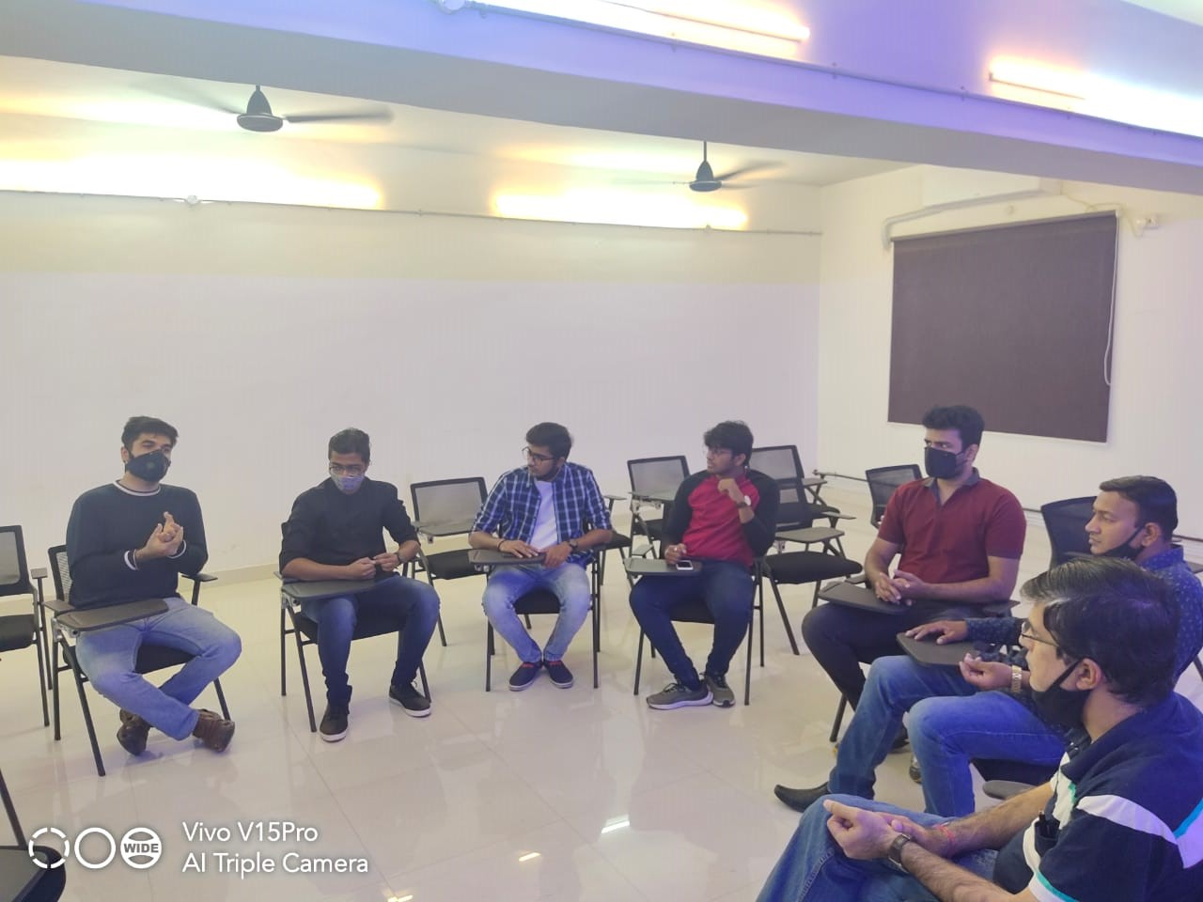

**Discussion with Startups/Entrepreneurs**

**Instruments available with LBP-CIII**

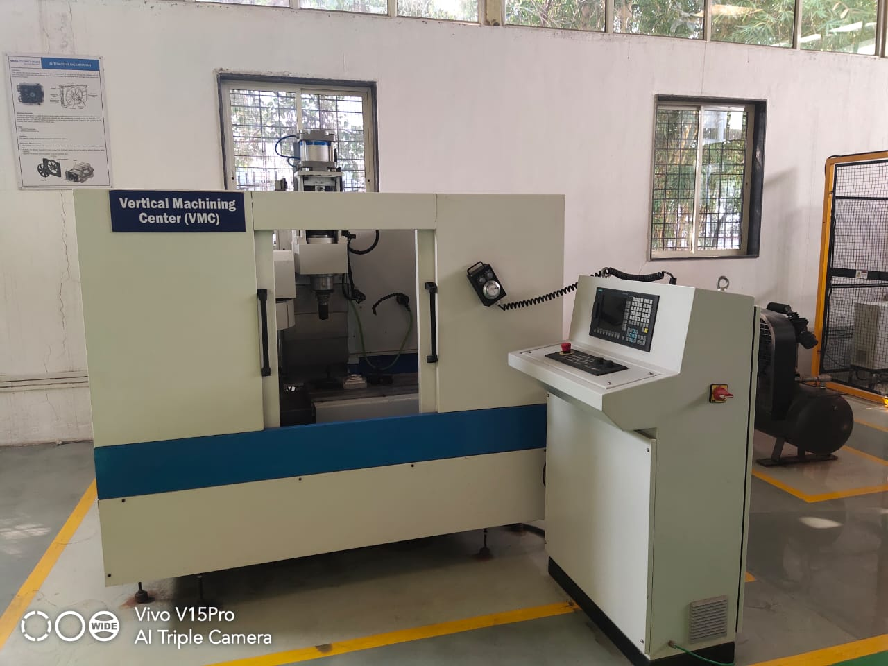 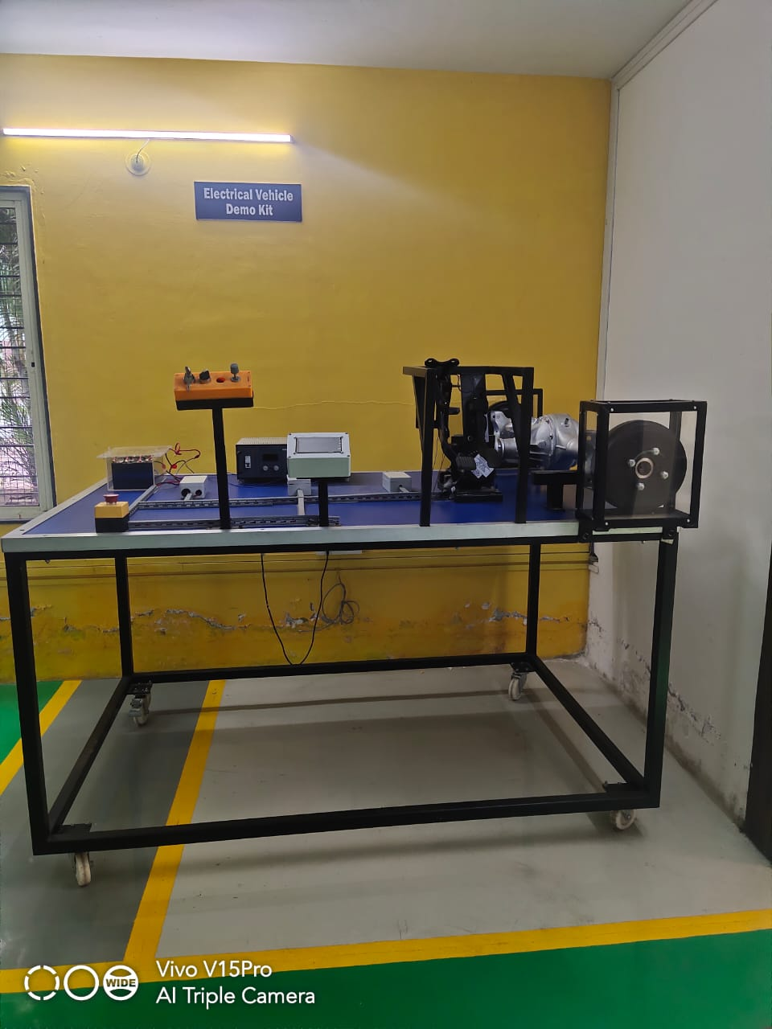

**Vertical Machining Center (VMC) Machine Electric Vehicle Demo Kit**

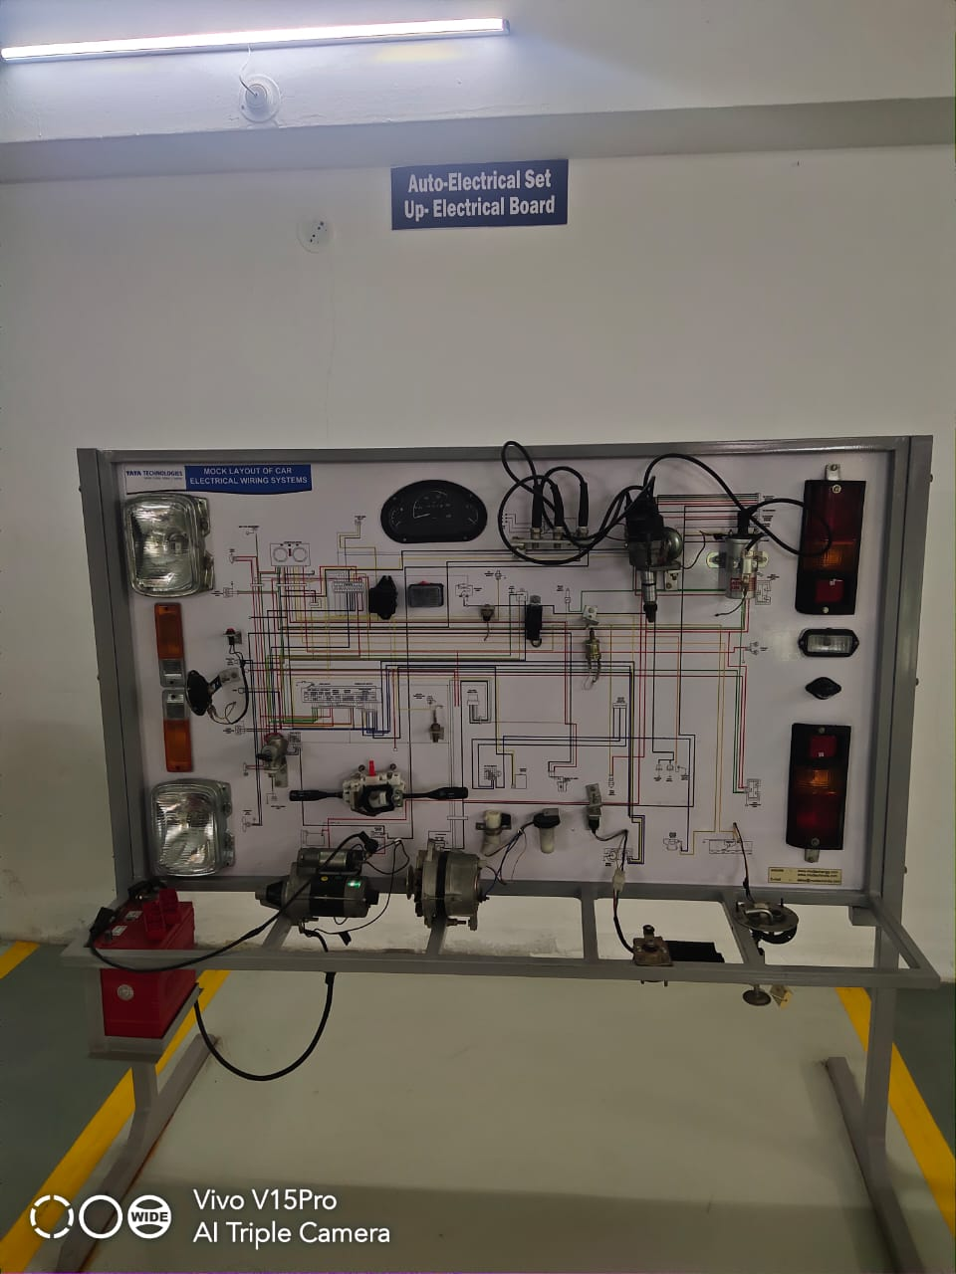 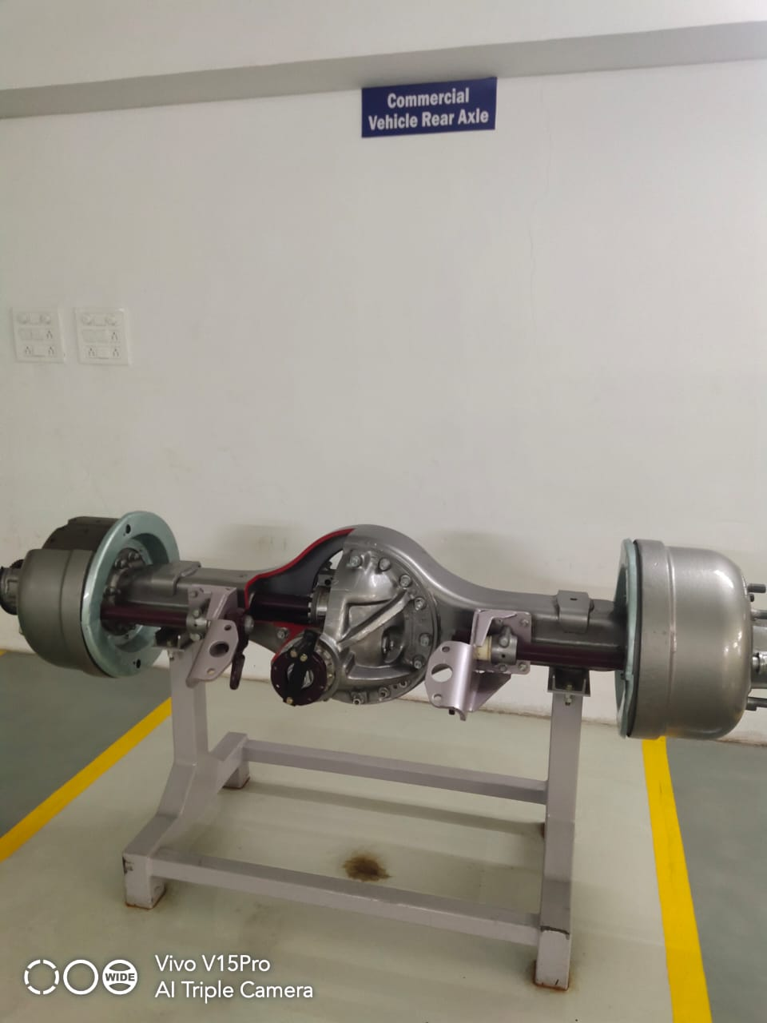

**Auto Electrical Set Commercial Vehicle Rear Axle**

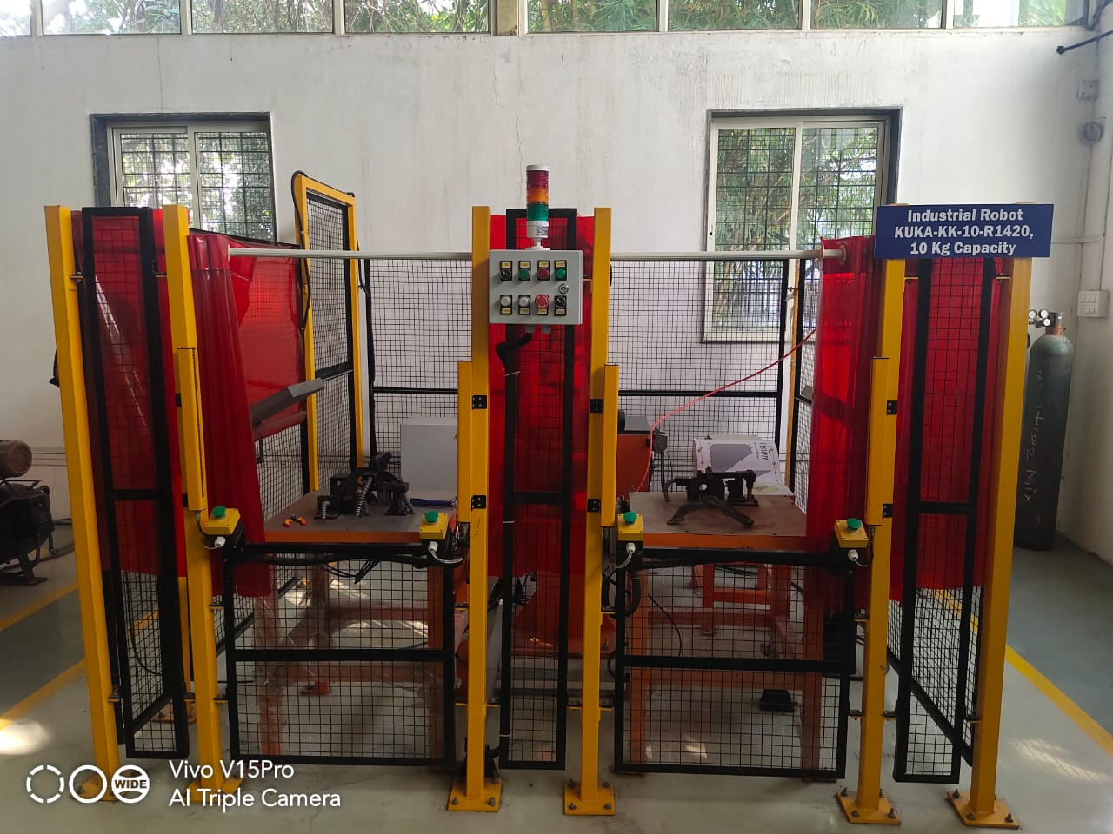 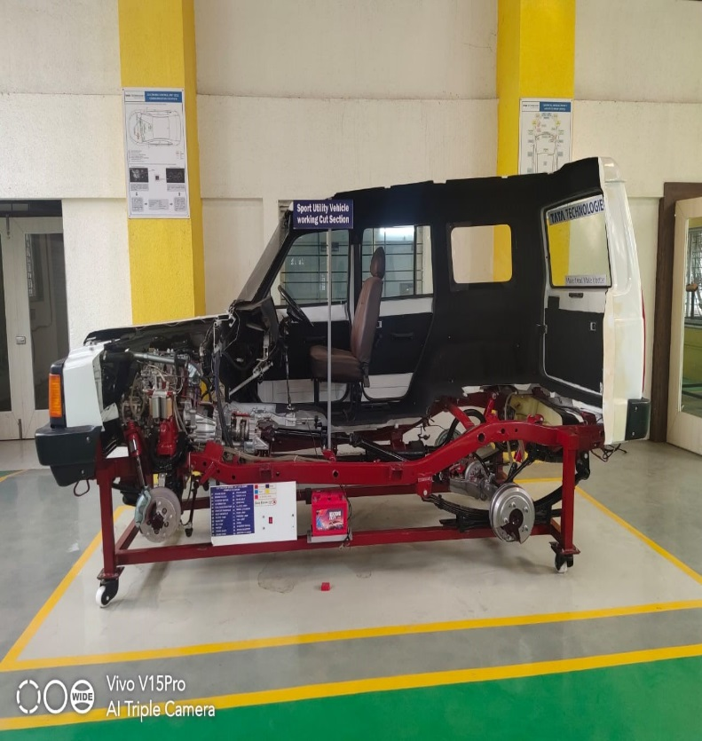

**KUKA Industrial Robot SUMO vehicle cut section**

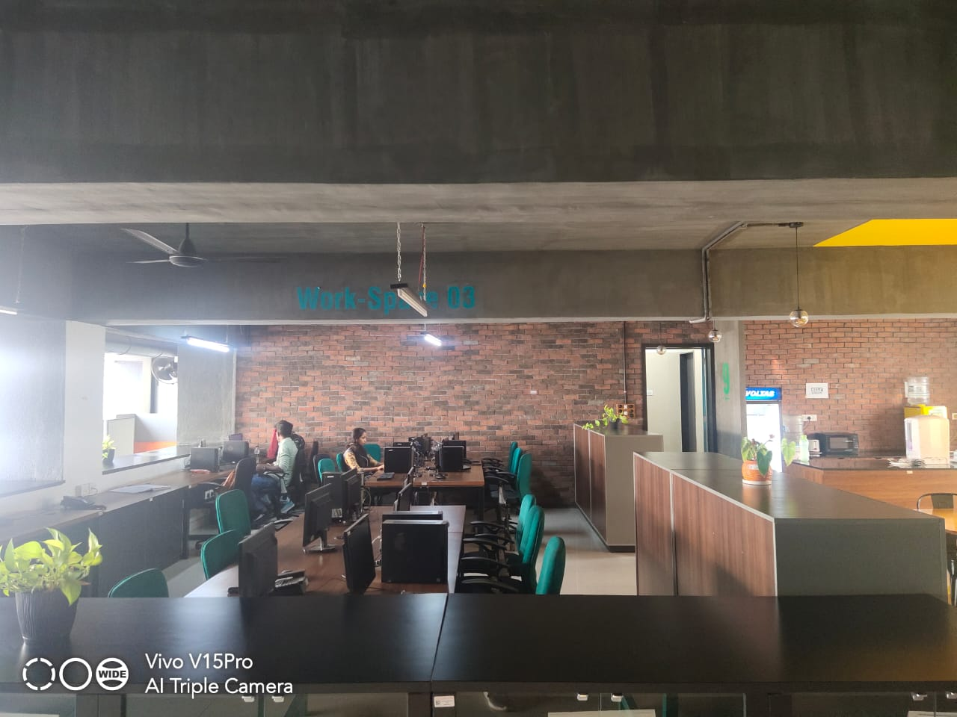 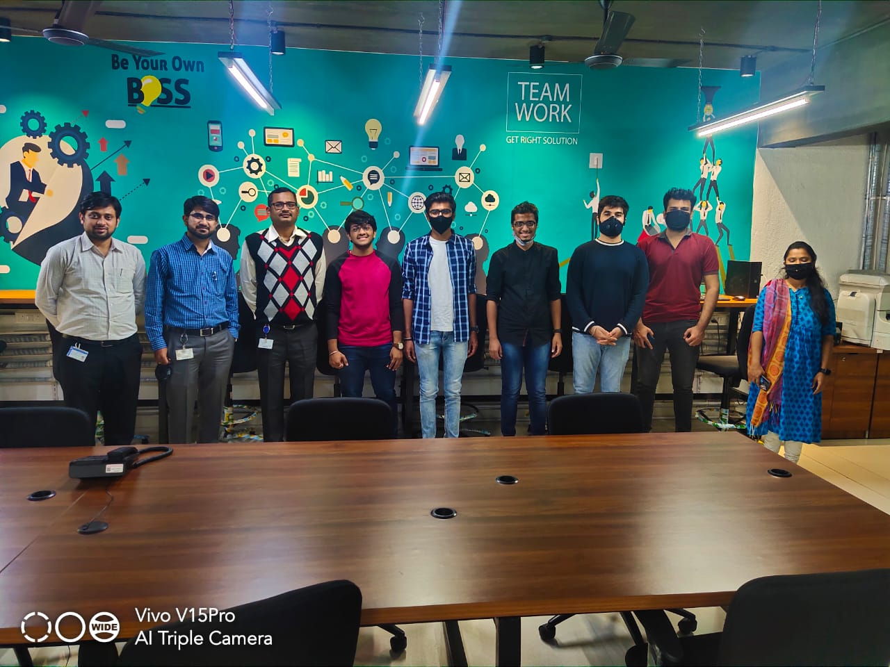

**Work Space area available with LBP CIII**

**Prof. Mandar Kakade Dr. Gaurav Bansod**

**Member & Visit Coordinator President**

**Institution’s Innovation Council, SCTR’s PICT, Pune**