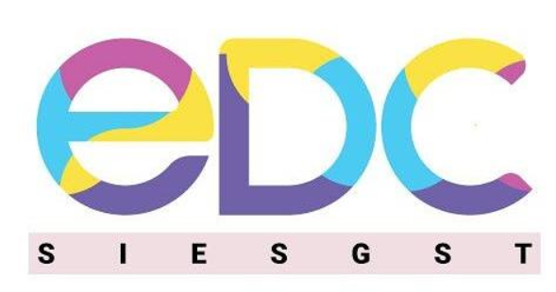

**Entrepreneurship Development Cell (EDC)**

**SIESGST - Student Chapter – Activities Summary 2022-23**

1. **Faculty Coordinator:**

Dr. Kaustubh Chavan – Assistant Professor

1. **Student Chapter – Executive Committee Members:**

**Chairperson:** Shrinidhi Iyengar (BE IT)

**EDC Representative & Incubation Head:** Kunal Soni (BE CE)

**Publicity & Events & Operations Head:** Sakshi Sakhre (BE ECS)

**MDO & Technical Head:** Sakshi Sakhre (BE ECS)

**Vice Chairperson:** Anamika Nevase (TE ECS)

**Secretary:** Sanmitha Shetty (TE ECS)

**Treasure:** Ved Gawade (TE ECS)

**Incubation Co-Ordinator:** Janarthanan Balakrishnan (TE CE)

**PR & Marketing Co-Ordinator:** Sarvesh Bhayje (TE ECS)

**Design Co-Ordinator:** Hitesh Patil (TE CE)

**Design Co-Ordinator:** Pranali Unavane (TE ECS)

**Publicity & Social Media Co-Ordinator:** Sakshi Sakhre (TE ECS)

**Active Committee members**:

Yash Bhujbal – ECS

Rishi Krishnan – CE

Rishi Jha – CE

Isha Desai – ECS

Kushal Hawaldar – ECS

Ayush Patil – ECS

Shivpriya Kadam – EXTC

Arya Pawar – ECS

Rudrani Kanole – ECS

Suhani Hosur – ECS

Pranavi Tangudu – ECS

Ketaki Vaturkar – CE

1. **Summary of Activities:**

| **Sr. No.** | **Title of Seminar / Workshop / Talk arranged** | **Resource Person – Name, Designation & Organization** | **Date Conducted and Duration** | **Target Audience** |
| --- | --- | --- | --- | --- |
| **1.** | Buzz Up Episode - 3 | Mr. Devansh Lakhani, Founder of Lakhani Financial Services, Angel Investor. | 17th September 2022  (One Day) | More than 60 viewers from all years and branches who are interested in Startup-up business. |
| **2.** | How to be Outstanding. (Career, Investment, Finance) | Mr.Swapnil Shinde, Insurance Advisor at DITTO | 22nd  September 2022  (One Day) | 80 students across all years and branches. |
| **3.** | All About LinkedIn | Shweta Ojha,  LinkedIn Coach & Personal Branding Strategist. | 12th December  2022  (One Day) | Mostly FE & SE and the students who needed their LinkedIn profile |
| **4.** | TML Events:  IPL Auction, Brand It | SIESGST -TML 2022– EDC | 10th and 11th February 2022  (Two Days) | 130+ students across all years and branches participated. |
| **5.** | Buzz Up Episode - 4 | Anoushka Jolly,  Founder of Kavach | 6th March  (One Day) | More than 70 viewers across all branches and years. |
| **6.** | BIZENCE | 1. Dr. Brijesh Karia,  Chief Operating Officer at Singhania Education  2. Ms. Riddhi Sharma,  CEO & Founder at Thought In A Dot  3. Mr. Devang Raja,  Founder at Venture Wolf  4. Mr. Nand K Purohit,  Digital Business Transformation Practitioner  5. Ms. Kavitha Nadar,  Business Operations Manager at Capgemini | 24th, 25th, 26th March 2022  (Three Days) | Around 25 teams (per team 3 to 4 participants) from all over India participated. |

~ * ~ * ~

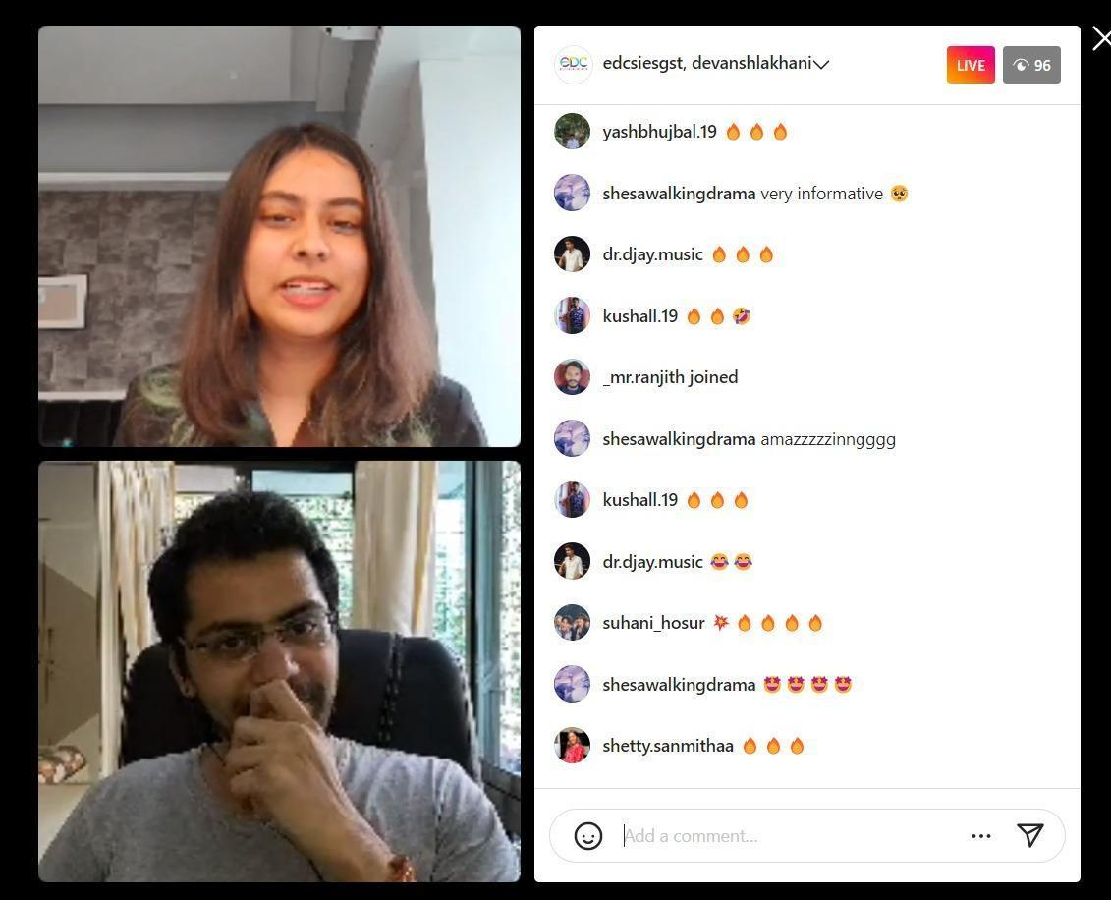

**BUZZ UP – EP 3**

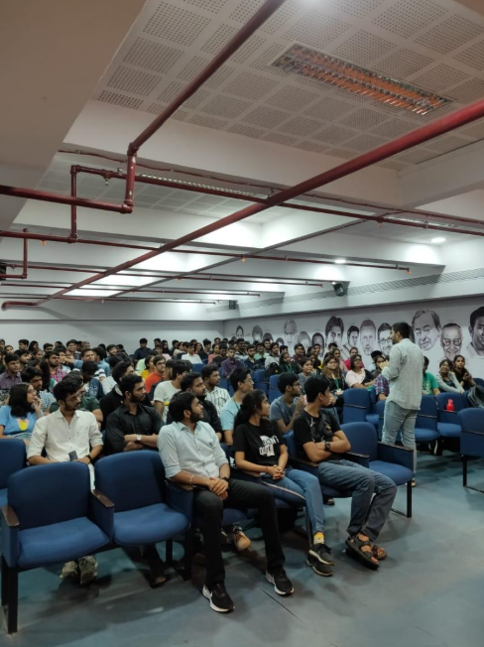

**How to be outstanding**

**All About LinkedIn**

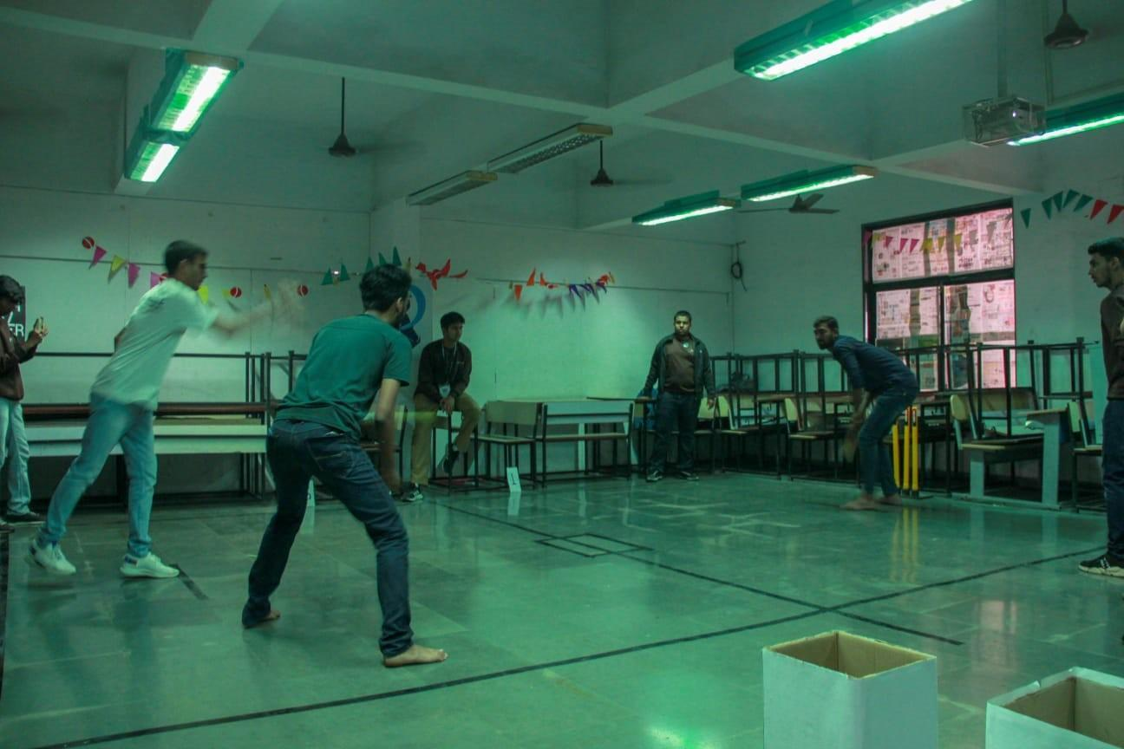

**TML Events (IPL Auction)**

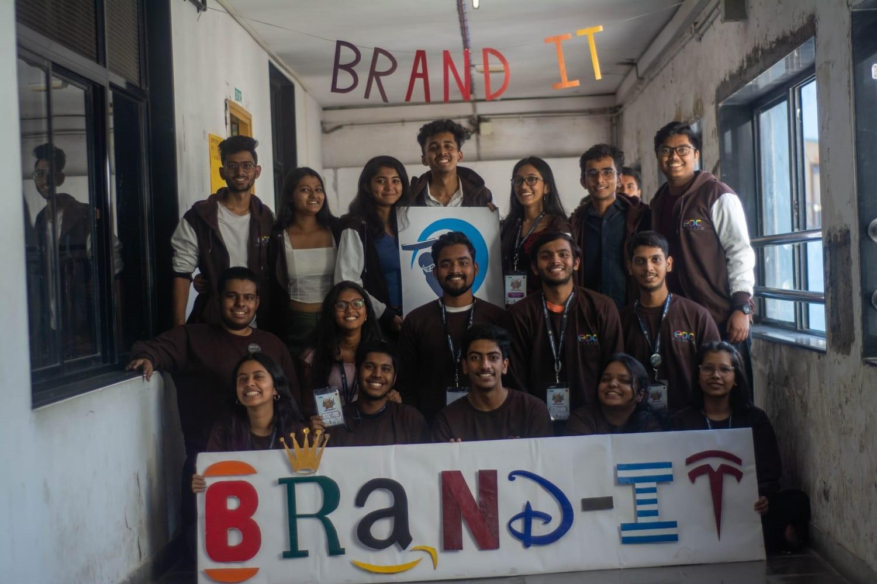

**TML Events (Brand-IT)**

**BUZZ UP Ep- 4**

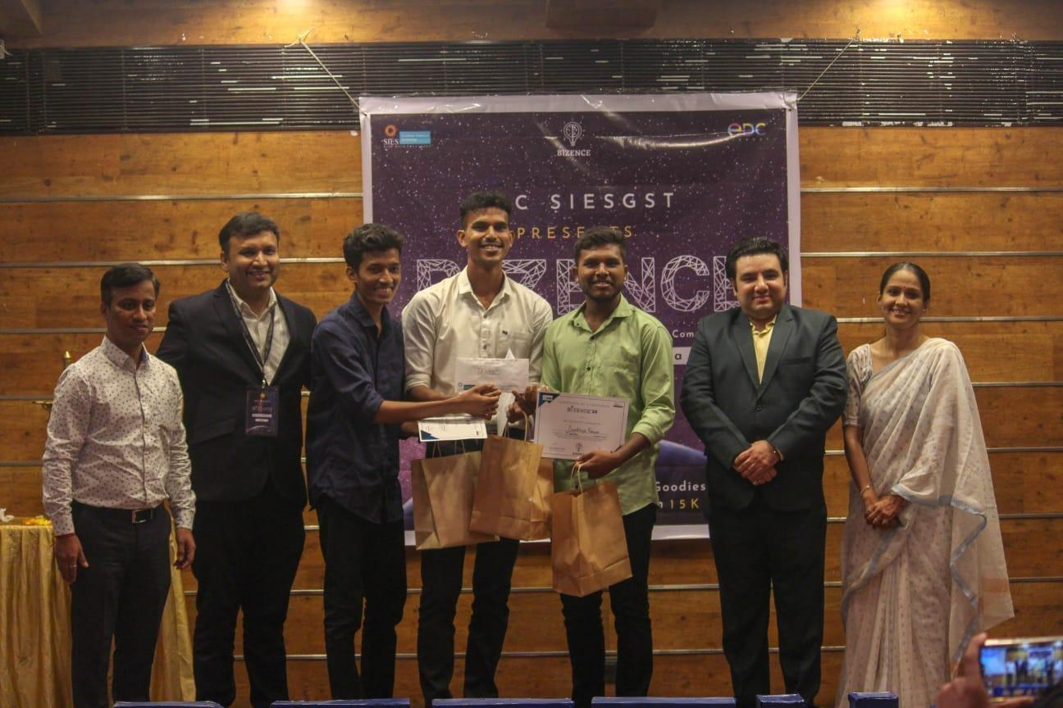

**BIZENCE**