Grant Egyed

Two Factors Authentication

1. <https://github.com/EDGIES/CIT130/tree/master/TwoFactorsAuthentication>
2. Description: Creates a Username and password. When logging in it will prompt you a code that’s random generated and will give you a short period of time to authenticate.
3. 2018 Fall, CIT-130, CCAC West-Hills Campus

6. 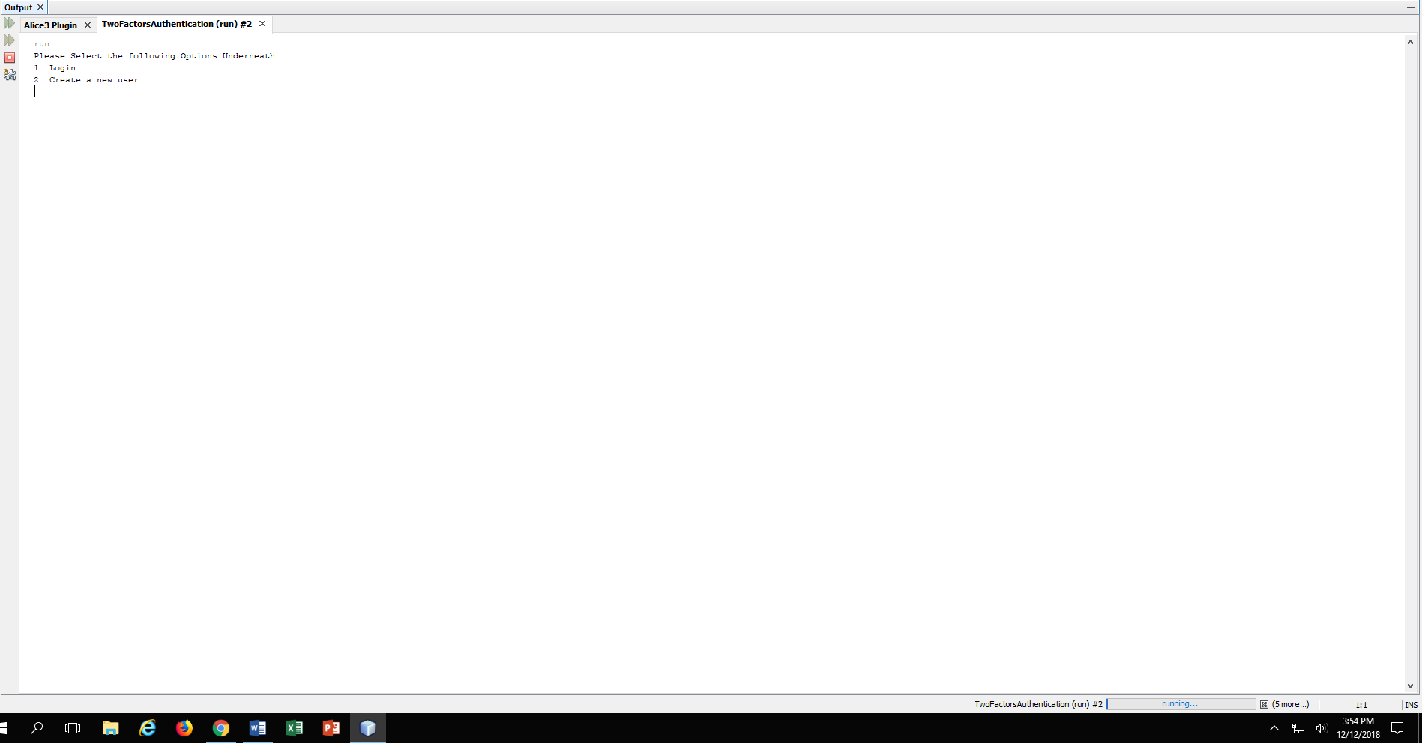

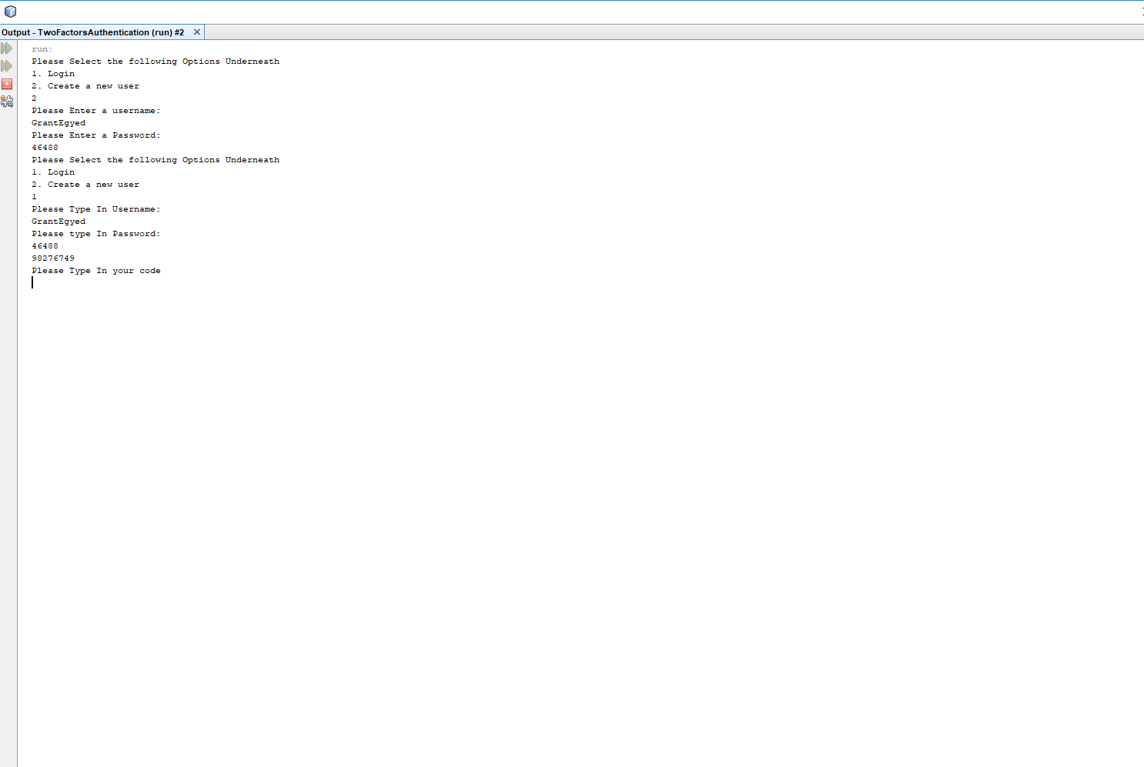

7.

<https://www.amazon.com/Java-Complete-Reference-Tenth/dp/1259589331/ref=sr_1_5?ie=UTF8&qid=1544648549&sr=8-5&keywords=java>

8. Creating a Two output screens. One for the login and one for the random Number generated code for the factor authentication.