**XXXX SBO Service**



1、推送销售订单服务

2、推送销售出库服务

3、推送销售退货服务

4、推送采购收货服务

5、推送采购退货服务

6、推送库存转储服务

**参数&约定**



接口风格：restful api



 网络传输协议：http

请求数据格式：***json*** + ***AES*加密**+ ***Hex*编码**



 编码规则：UTF-8

 小数点保留2位

日期格式： ***yyyy-MM-dd*** ，如2019年7月28号，表示为：***2019-07-28***



 时间格式： ***HHmmSS***，如13时28分30秒，表示为：***132830***

加密方式：***AES*加密**，128位，key：***Byte190-890Dance***



 返回格式：返回数据不进行加密，接收方接收到后可直接使用

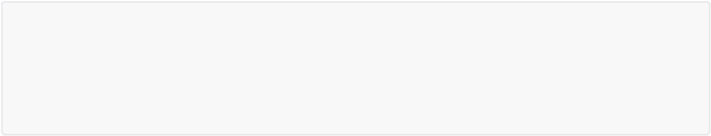

{

"code":"",

"message":"",

"data":""

}

|  |  |  |
| --- | --- | --- |
| **属性** | **说明** | **是否可空** |
|  |  |  |
| code | 状态值，0标识成功，其他标识失败 | 否 |
|  |  |  |
| message | 返回消息 | 否 |
|  |  |  |
| data | 操作结果的封装 | 是 |
|  |  |  |

**接口列表**



**1、推送销售订单服务**

请求地址：***<http://localhost:8082/applicationname/edi/sap/v1/salesorder>***



 请求协议：***post***

 请求参数格式：

**加密前**：（参考）



{

"docdate": "",

"docduedate": "",

"cardcode": "",

"cardname": "",

"discprcnt": "",

"discsum": "",

"discsumfc": "",

"doccur": "",

"doctotal": "",

"doctotalfc": "",

"slpcode": "",

"taxdate": "",

"ownercode": "",

"canceled":"",

"platform_no": "",

"platform_orderno": "",

"so_type": "",

"salesorder_orderline":[

{

"itemcode":"",

"dscription":"",

"quantity":"",

"shipdate":"",

"price":"",

"currency":"",

"rate":"",

"discprcnt":"",

"whscode":"",

"project":"",

"codebars":"",

"vatgroup":"",

"priceafvat":"",

"freetxt":"",

"cogsocrcod":"",

"ocrcode2":"",

"ocrcode3":"",

"ocrcode4":"",

"ocrcode5":"",

"u_delivery":"",

"shipto":""

}

]

}

如需要向SBO推送以上退货信息，需先将上述json格式的退货单信息***AES*加密**后进行***HEX*编码**，才能正确推送至SBO系统。

**加密后**：

3433434343dfeereEREFSDFW43ljsdfo2345dIUEKJSJESDFGSDFDSFSFEW23452452424342342 34343242342342345jljsdleLJLERJLWEJWELREKWLJRO4

 返回报文格式：



{

"code":"0",

"message":"OK",

"data":""

}

**2、推送销售出库服务**

请求地址：***<http://localhost:8082/applicationname/edi/sap/v1/salesdelivery>***



 请求协议：***post***

 请求参数格式：

**加密前**：（参考）



{

"canceled":"",

"docdate":"",

"docduedate":"",

"cardcode":"",

"cardname":"",

"taxdate":"",

"comments":"",

"platform_no":"",

"platform_orderno":"",

"sotype":"",

"salesdelivery_orderline":[

{

"itemcode":"",

"dscription":"",

"quantity":"",

"price":"",

"currency":"",

"rate":"",

"discprcnt":"",

"whscode":"",

"project":"",

"codebars":"",

"freetxt":"",

"vatgroup":"",

"priceafvat":"",

"cogsocrcod":"",

"ocrcode2":"",

"ocrcode3":"",

"ocrcode4":"",

"ocrcode5":"",

"baseentry":"",

"baseline":"",

"basetype":"",

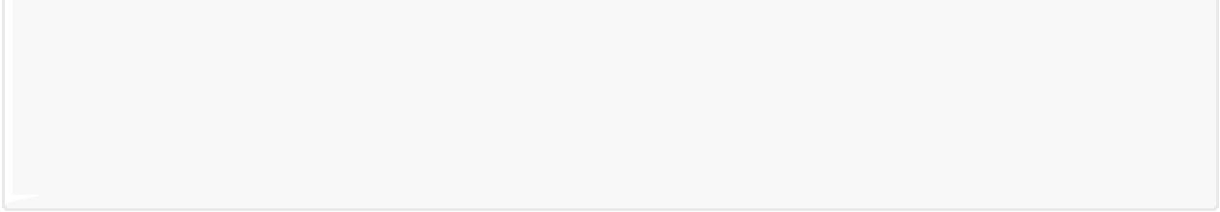"delivery":"",

"shipto":""

}

]

}

如需要向SBO推送以上退货信息，需先将上述json格式的退货单信息***AES*加密**后进行***HEX*编码**，才能正确推送至SBO系统。

**加密后**：



3433434343dfeereEREFSDFW43ljsdfo2345dIUEKJSJESDFGSDFDSFSFEW23452452424342342 34343242342342345jljsdleLJLERJLWEJWELREKWLJRO4

 返回报文格式：



{

"code":"0",

"message":"OK",

"data":""

}

**3、推送销售退货服务**

请求地址：***<http://localhost:8082/purchasereturn/edi/sap/v1/salesreturn>***



 请求协议：***post***

 请求参数格式：

**加密前**：（参考）



{

"canceled":"",

"docdate":"",

"docduedate":"",

"cardcode":"",

"cardname":"",

"discprcnt":"",

"discsum":"",

"discsumfc":"",

"doccur":"",

"doctotal":"",

"doctotalfc":"",

"slpcode":"",

"taxdate":"",

"ownercode":"",

"comments":"",

"platform_no":"",

"platform_orderno":"",

"sotype":"",

"salesreturn_orderline":[

{

"itemcode":"",

"dscription":"",

"quantity":"",

"shipdate":"",

"price":"",

"currency":"",

"rate":"",

"discprcnt":"",

"whscode":"",

"project":"",

"codebars":"",

"vatgroup":"",

"priceafvat":"",

"freetxt":"",

"baseentry":"",

"baseline":"",

"basetype":"",

"cogsocrcod":"",

"ocrcode2":"",

"ocrcode3":"",

"ocrcode4":"",

"ocrcode5":""

}

]

}

如需要向SBO推送以上退货信息，需先将上述json格式的退货单信息***AES*加密**后进行***HEX*编码**，才能正确推送至SBO系统。

**加密后**：



3433434343dfeereEREFSDFW43ljsdfo2345dIUEKJSJESDFGSDFDSFSFEW23452452424342342 34343242342342345jljsdleLJLERJLWEJWELREKWLJRO4

 返回报文格式：



{

"code":"0",

"message":"OK",

"data":""

}

**4、推送采购收货服务**

请求地址：***<http://localhost:8082/transferrequest/edi/sap/v1/puchasereceipts>***



 请求协议：***post***

 请求参数格式：

**加密前**：（参考）



{

"canceled":"",

"docdate":"",

"docduedate":"",

"cardcode":"",

"cardname":"",

"discprcnt":"",

"discsum":"",

"discsumfc":"",

"doccur":"",

"doctotal":"",

"doctotalfc":"",

"slpcode":"",

"taxdate":"",

"ownercode":"",

"comments":"",

"platform_no":"",

"platform_orderno":"",

"purchasereceipts_orderline":[

{

"itemcode":"",

"dscription":"",

"quantity":"",

"shipdate":"",

"price":"",

"currency":"",

"rate":"",

"discprcnt":"",

"whscode":"",

"vatgroup":"",

"priceafvat":"",

"freetxt":"",

"baseentry":"",

"baseline":"",

"basetype":"",

"podeladdr":""

}

]

}

如需要向SBO推送以上库存转储信息，需先将上述json格式的退货单信息***AES*加密**后进行***HEX*编码**，才能正确推送至SBO系统。

**加密后**：



3433434343dfeereEREFSDFW43ljsdfo2345dIUEKJSJESDFGSDFDSFSFEW23452452424342342 34343242342342345jljsdleLJLERJLWEJWELREKWLJRO4

 返回报文格式：



{

"code":"0",

"message":"OK",

"data":""

}

**5、推送采购退货服务**

请求地址：***<http://localhost:8082/transferrequest/edi/sap/v1/purchasereturn>***



 请求协议：***post***

 请求参数格式：

**加密前**：（参考）



{

"canceled": "",

"docdate": "",

"docduedate": "",

"cardcode": "",

"cardname": "",

"discprcnt": "",

"discsum": "",

"discsumfc": "",

"doccur": "",

"doctotal": "",

"doctotalfc": "",

"slpcode": "",

"taxdate": "",

"ownercode": "",

"comments": "",

"platform_no": "",

"platform_orderno": "",

"purchasereturn_orderline": [

{

"itemcode": "",

"dscription": "",

"quantity": "",

"shipdate": "",

"price": "",

"currency": "",

"rate": "",

"discprcnt": "",

"whscode": "",

"vatgroup": "",

"priceafvat": "",

"freetxt": "",

"baseentry": "",

"baseline": "",

"basetype": "",

"poretaddr": ""

}

]

}

如需要向SBO推送以上库存转储信息，需先将上述json格式的退货单信息***AES*加密**后进行***HEX*编码**，才能正确推送至SBO系统。

**加密后**：



3433434343dfeereEREFSDFW43ljsdfo2345dIUEKJSJESDFGSDFDSFSFEW23452452424342342 34343242342342345jljsdleLJLERJLWEJWELREKWLJRO4

 返回报文格式：

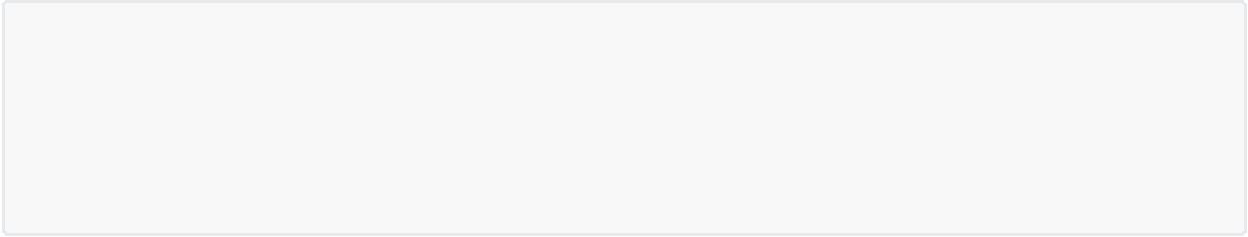{

"code":"0",

"message":"OK",

"data":""

}

**6、推送库存转储服务**

请求地址：***<http://localhost:8082/transferrequest/edi/sap/v1/inventorytransfer>***



 请求协议：***post***

 请求参数格式：

**加密前**：（参考）



{

"canceled": "",

"docdate": "",

"docduedate": "",

"taxdate": "",

"filler": "",

"towhscode": "",

"comments": "",

"platform_no": "",

"platform_orderno": "",

"inventorytransfer_orderline": [

{

"itemcode": "",

"dscription": "",

"quantity": "",

"fromwhscod": "",

"whscode": "",

"baseentry": "",

"baseline": "",

"basetype": "",

"importlog": ""

}

]

}

如需要向SBO推送以上库存转储信息，需先将上述json格式的退货单信息***AES*加密**后进行***HEX*编码**，才能正确推送至SBO系统。

**加密后**：



3433434343dfeereEREFSDFW43ljsdfo2345dIUEKJSJESDFGSDFDSFSFEW23452452424342342 34343242342342345jljsdleLJLERJLWEJWELREKWLJRO4

 返回报文格式：

{

"code":"0",

"message":"OK",

"data":""

}