**Agentic HR Chatbot using Google ADK:**

An intelligent, agent-based HR chatbot that answers employee questions using internal HR documents (Word, Excel, PDFs, databases, and more). This system uses **Google ADK (Agent Development Kit)** for modular agent logic and **Streamlit** for a lightweight UI.

**Project Overview:**

This chatbot assists employees in retrieving HR-related information such as:

* Leave policies
* Reimbursement rules
* Holiday calendars
* HR forms
* Org structure
* Employee records

The system utilizes an **agentic architecture** with **tool-based modularity**, **semantic search via vector embeddings**, and **LLM-driven decision making**.

**Functional Flow:**

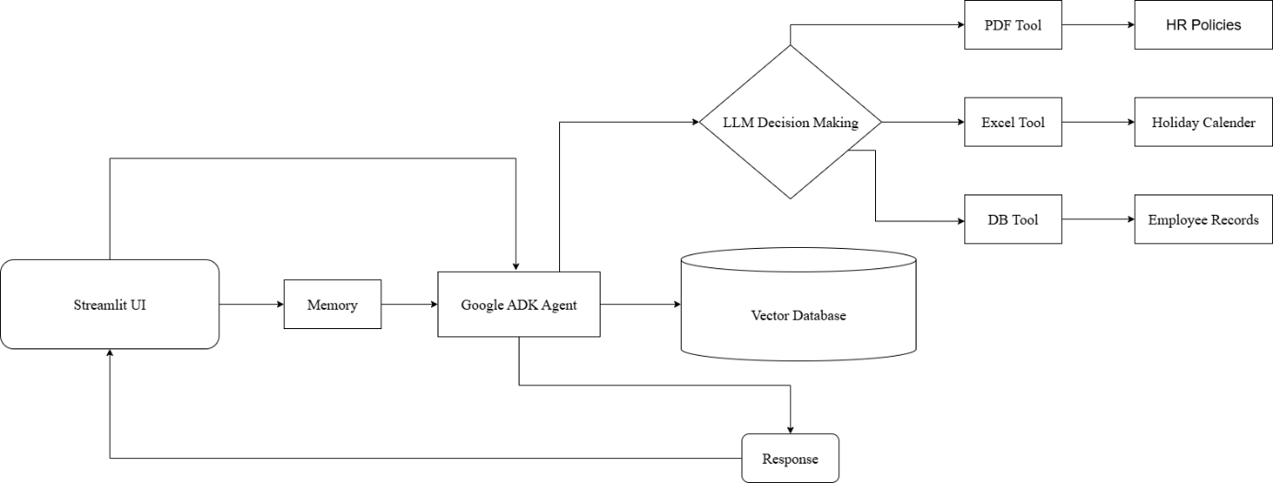

1. **User Interaction**:
   * Employee interacts with chatbot via Streamlit UI.
   * Example: “How do I apply for leave?”, “Where is the org chart?”
2. **Google ADK Agent**:
   * Determines appropriate tool/agent to handle the query.
   * Retrieves relevant content from vector database.
3. **LLM Decision Making**:
   * Analyzes query context.
   * Chooses tool (PDF, Excel, DB, etc.) and invokes it.
4. **Response Generation**:
   * Uses Gemini/GPT model to form natural-language response.
   * Response is shown on Streamlit UI.

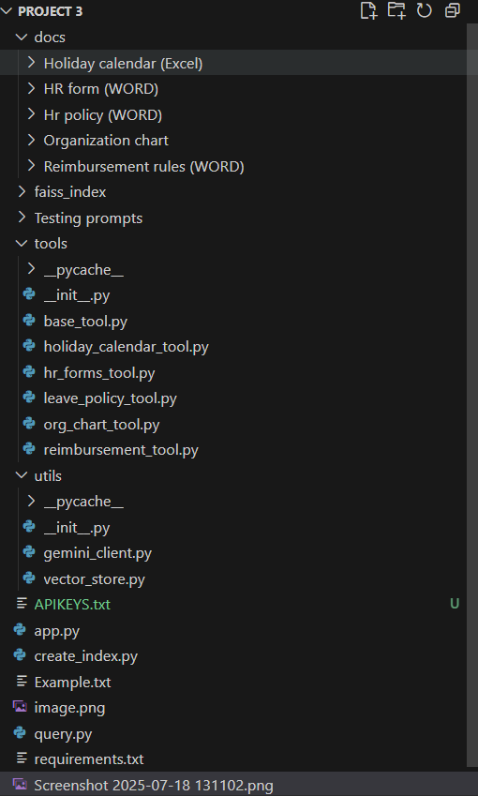**Project Structure:**

**Technologies Used:**

|  |  |
| --- | --- |
| **Tech** | **Role** |
| Google ADK | Agent-based architecture & planning |
| Streamlit | User interface |
| LangChain | Document loading, chunking, embeddings |
| Gemini API (Google Generative AI) | LLM-based response generation |
| FAISS | Vector-based semantic document retrieval |
| Pandas | Excel/CSV parsing |
| Python | Core logic & glue |

**Key Components:**

**create_index.py**

* Loads Word & Excel documents.
* Splits them into chunks using RecursiveCharacterTextSplitter.
* Generates embeddings via GoogleGenerativeAIEmbeddings.
* Stores the embeddings in a FAISS index.

**query.py**

* CLI-based interactive query tool.
* Loads FAISS index.
* Performs semantic search and displays results.

**tools/ folder**

Contains specialized HR tools such as:

* LeavePolicyTool: Handles leave rules & applications.
* HolidayCalendarTool: Fetches holidays and dates.
* ReimbursementTool: Retrieves reimbursement rules.
* OrgChartTool: Resolves reporting and team structure.
* HRFormsTool: Provides forms and procedures.

**Each tool:**

* Has its own keyword set.
* Matches the query type.
* Retrieves documents & generates contextual LLM-based answers.

**LLM Decision-Making (Gemini)**

**LLM helps with:**

* Matching ambiguous queries.
* Selecting appropriate HR tool.
* Formulating human-like answers.
* Backing responses with relevant document context.

**Supported Query Types:**

The chatbot handles these categories of HR queries:

1. **Leave Policy**
   * "How many sick leaves do I get per year?"
   * "What's the process for applying for annual leave?"
2. **Holiday Calendar**
   * "When is the next company holiday?"
   * "Show me the holiday calendar for Q3"
3. **Reimbursement**
   * "What expenses are reimbursable for business travel?"
   * "How do I submit a reimbursement claim?"
4. **Organization Chart**
   * "Who is the head of the IT department?"
   * "Show me the reporting structure for my team"
5. **HR Forms**
   * "Where can I find the expense report form?"
   * "How do I apply for parental leave?"

**Learning Resources:**

|  |  |
| --- | --- |
| **Resource** | **Link** |
| Google ADK Docs | <https://google.github.io/adk-docs> |
| Streamlit Docs | [https://docs.streamlit.io](https://docs.streamlit.io/) |
| Gemini API | [https://makersuite.google.com](https://makersuite.google.com/) |
| YouTube – Build Agents | [Watch here](https://www.youtube.com/watch?v=P4VFL9nIaIA) |