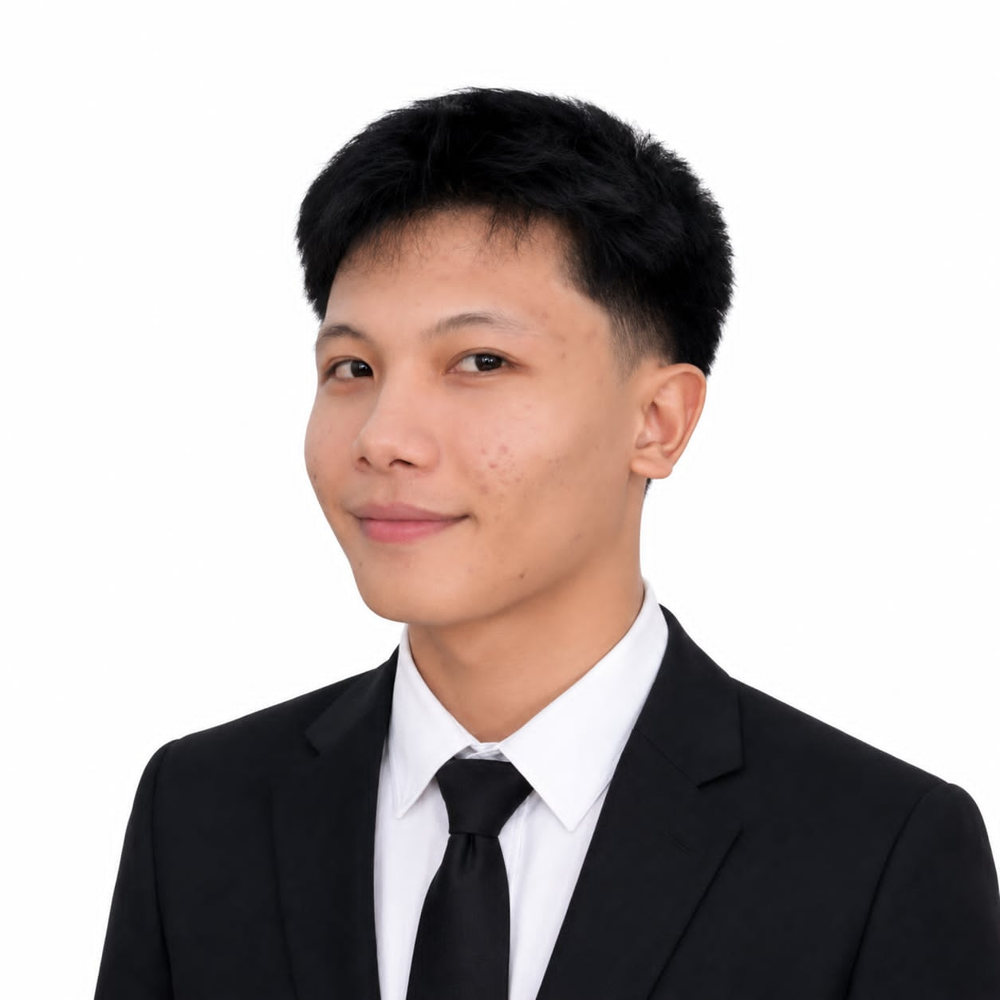 | EDJAE URSAL  Aspiring Software Engineer  📞 09351853538  ✉ edjaeursal90@gmail.com  💻 EDJAE  🌐 Edjae Ursal Personal Info  📍 Philippines
PROFESSIONAL SUMMARY
Motivated BS Computer Science student with hands-on experience in Flutter, ASP.NET, Java, C#, SQL, and software development. Built multiple academic projects including healthcare, web, and mobile applications. Passionate about creating scalable, user-focused solutions and eager to begin a career as a Software Engineer.
TECHNICAL SKILLS
Programming: Java, C#, Dart, HTML, CSS, JavaScript, SQL
Frameworks: Flutter, ASP.NET
Databases: MySQL, SQL Server
Tools: Git, GitHub, VS Code, Visual Studio, Android Studio
OS: Windows, Linux
EDUCATION
Bachelor of Science in Computer Science
[Tangub City Global College]
Expected Graduation: 2028
PROJECTS
Hospital Appointment Reminder Application (Flutter/Firebase)
• Appointment booking, reminders, medical records.
TCGC Confession Platform (Flutter)
• Anonymous confession platform with authentication.
Online Food Ordering System (ASP.NET/C#/SQL Server)
• Product management, ordering and database integration.
SOFT SKILLS
Communication • Teamwork • Leadership • Problem Solving • Adaptability • Time Management • Critical Thinking

AWARDS & ACHIEVEMENTS
Add awards, Dean's List, competitions or hackathons here.
LANGUAGES
English (Professional)
Filipino (Native)
Cebuano (Native)

