Infection in heterogeneous population with interventions

C. Bartels

18 April 2020

## simulations

# setup  
require(dplyr)

## Loading required package: dplyr

##   
## Attaching package: 'dplyr'

## The following objects are masked from 'package:stats':  
##   
## filter, lag

## The following objects are masked from 'package:base':  
##   
## intersect, setdiff, setequal, union

require(tidyr)

## Loading required package: tidyr

require(ggplot2)

## Loading required package: ggplot2

require(gganimate)

## Loading required package: gganimate

set.seed(123)  
  
theme_set(theme_classic())  
  
# size of population  
nPop <- 10^5  
  
  
# end of simulation  
tend <- 365  
  
# infective period, assumed to start one day after infection with duration  
idur <- 7  
  
# number of repeated simulations  
nsim <- 50  
  
# homgenous population  
 # rate of new infections per day   
 r0a = 0.4  
 # between subject variability of r0  
 sd0a = 0.0  
  
# heterogenous population  
 # rate of new infections per day  
 r0b = 0.2  
 # between subject variability of r0  
 sd0b = 1.0  
  
  
  
# simulate spread of infection  
mySim <- function(pat1, int1 = NULL, rVac = 0.0) {  
   
 # number of patients that get vaccinated  
 nVac <- max(1.0, min(nrow(pat1), rVac*nrow(pat1)))  
   
 pat1 <-  
 pat1 %>%  
 mutate(  
 is = 0, # day of infection (0 ... not infected)  
 ip = 1:n(), # subject identifier  
 is = ifelse(ip <= nVac, 99999, is), # vacinated subjects  
 is = ifelse(ip %in% ceiling(runif(10,nVac,n())), 1, is), # 10 random subjects get infected  
 cru = cumsum(r0) / sum(r0) # to select subjets that get infected with probability proportional to r0  
 )  
  
 # simulate day by day  
 for(iw in 2:tend) { # iw <- 2  
   
 # intervention  
 if(is.null(int1)) {  
 if1 <- 1  
 } else {  
 if1 <- int1 %>% filter(t == iw) %>% select(rf) %>% unlist()  
 }  
   
 # select patients that are infective  
 pat2 <- pat1 %>% filter(is != 0 & is > iw-idur & is <= iw)  
   
 # rate of transmission  
 rt <- sum(pat2$r0) * if1  
   
 # number of subjects infected  
 ni <- rpois(1, rt)  
   
 if(ni > 0) {  
 # randomly select the patients who get transmitted  
 pt1 <- runif(ni, min = 0.0, max = 1.0)  
 ip1 <- findInterval(pt1, pat1$cru) + 1  
   
 # select patients who receive infection  
 pat1$sel <- FALSE  
 pat1[ip1, "sel"] <- TRUE  
   
 # infect patients who are not immune  
 pat1 <-   
 pat1 %>%  
 mutate(is = ifelse(is == 0 & sel, iw, is))  
 }  
   
 }  
  
 return(pat1)  
}  
  
# repeated simulations and summarize as median and percentile  
mySim2 <- function(r0, sd0, int1 = NULL)   
{  
   
 # subjects  
 pat1 <- tibble(  
 r0l = rnorm(nPop, log(r0), sd0), # log of patient specific rate  
 r0 = exp(r0l) / exp(sd0^2/2) # patient specific rate (rescaled to have mean r0)  
 )  
  
 sims <- list()  
 for(isim in 1:nsim) {  
   
 sim1 <- mySim(pat1, int1)  
  
 pp1 <-  
 ggplot(sim1, aes(x=r0, fill=(is!=0))) +   
 geom_density(alpha=0.4, position="stack") +   
 scale_x_log10()  
   
 s2 <- sim1 %>% group_by(is) %>% summarise(ni = n())  
   
 ts1 <-   
 tibble(t = 1:tend, isim=isim) %>%   
 left_join(s2, by = c("t" = "is")) %>%   
 mutate(  
 ni = ifelse(is.na(ni), 0, ni),  
 nt = cumsum(ni))   
   
 sims[[isim]] <- ts1  
   
 }  
   
 sim2 <-   
 bind_rows(sims) %>%  
 group_by(t) %>%  
 summarise(  
 ni25 = quantile(ni, probs = 0.25),  
 nim = median(ni),  
 ni75 = quantile(ni, probs = 0.75),  
 nt25 = quantile(nt, probs = 0.25),  
 ntm = median(nt),  
 nt75 = quantile(nt, probs = 0.75)  
 )  
  
}  
  
  
# Illustrate heterogenous patient population  
pat1 <- tibble(  
 r0l = rnorm(nPop, log(r0b), sd0b), # log of patient specific rate  
 r0 = exp(r0l) / exp(sd0b^2/2) # patient specific rate (rescaled to have mean r0)  
)  
  
p0 <-  
 ggplot(pat1, aes(x=r0)) +   
 geom_density() +  
 scale_x_log10() +  
 xlab("Infection rate (1/Day)")  
  
print(p0)

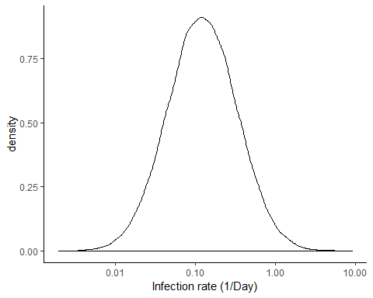

# make animated graph of disease progression  
mygraph1 <- function(sim1) {  
 sim1 <-  
 sim1 %>%  
 mutate(bin = cut_interval(log(r0), n = 40)) %>%  
 group_by(bin) %>%  
 mutate(  
 dbin = median(r0),  
 order = as.double(bin)) %>%  
 ungroup()  
   
 an1 <-  
 sim1 %>%  
 expand(ip, iweek) %>%  
 rename(lweek = iweek) %>%  
 full_join(sim1, by="ip") %>%  
 ungroup()  
   
 an2 <-  
 an1 %>%  
 group_by(dbin, bin, order, lweek) %>%  
 summarise(  
 n = sum(is>0 & iweek<=lweek),  
 ntot = n(),  
 ninf = sum(is>0),  
 reff = mean(r0 * (is == 0 | iweek>lweek)) * (idur - 1)) %>%  
 ungroup() %>%  
 arrange(lweek, dbin)  
   
 mylabs1 <-   
 sim1 %>%   
 select(order, dbin) %>%   
 unique() %>%  
 mutate(lab = ifelse((order+2) %% 5 == 0, paste(signif(dbin,2)), ""))  
   
 # Animation  
 p <-  
 an2 %>%   
 ggplot(aes(x = order)) +  
 geom_bar(aes(y=ntot), stat = "identity", fill = "grey20", alpha=0.2) +  
 geom_bar(aes(y=ninf), stat = "identity", fill = "red", alpha=0.2) +  
 geom_bar(aes(y=n), stat = "identity", fill = "#ff9933") +  
 labs(title=paste0('Week {closest_state}\nR(1 year) = ', round(R360, 2)),   
 x="Infection rate (1/Day)",  
 y="Number of subjects") +  
 theme(plot.title = element_text(hjust = 0.5, size = 18)) +  
 scale_x_continuous(breaks=mylabs1$order, labels=mylabs1$lab) +  
 transition_states(lweek, transition_length = 1, state_length = 5) +  
 view_follow(fixed_y=TRUE, fixed_x = TRUE) +  
 ease_aes('cubic-in-out')  
  
 return(p)  
}

## No intervention, no Heterogeneity

sim2 <- mySim2(r0a, sd0a)  
   
p1 <-  
 ggplot(sim2, aes(x = t, y = ntm / nPop * 100)) +  
 geom_ribbon(aes(ymin = nt25 / nPop * 100, ymax = nt75 / nPop * 100), alpha = 0.3) +  
 geom_line() +  
 xlab("Day") +  
 ylab("% infected")  
  
print(p1 + coord_cartesian(ylim = c(0, 100)))

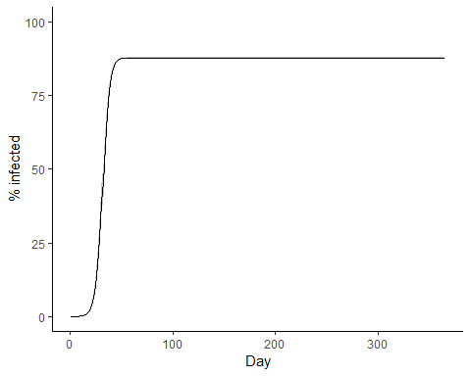

print(p1 + scale_y_log10() + coord_cartesian(ylim = c(1, 100)))

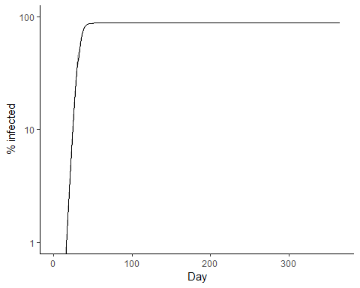

print(p1 + scale_y_log10() + coord_cartesian(xlim = c(10,30)))

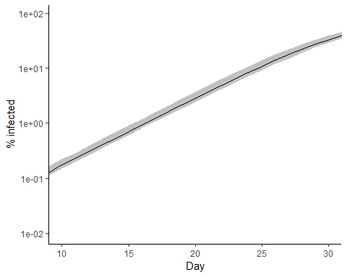

p2 <-  
 ggplot(sim2, aes(x = t, y = nim / nPop * 100)) +  
 geom_ribbon(aes(ymin = ni25 / nPop * 100, ymax = ni75 / nPop * 100), alpha = 0.3) +  
 geom_line() +  
 xlab("Day") +  
 ylab("% infectious")  
  
print(p2)

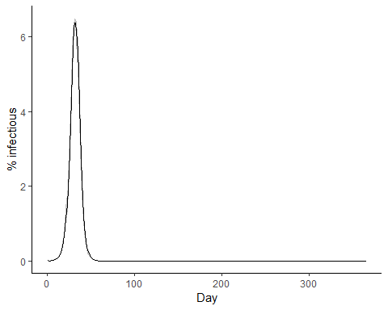

ts2 <- sim2 %>% mutate(Scenario = "Base")

## No intervention, with Heterogeneity

sim2 <- mySim2(r0b, sd0b)  
   
  
p1 <-  
 ggplot(sim2, aes(x = t, y = ntm / nPop * 100)) +  
 geom_ribbon(aes(ymin = nt25 / nPop * 100, ymax = nt75 / nPop * 100), alpha = 0.3) +  
 geom_line() +  
 xlab("Day") +  
 ylab("% infected")  
  
print(p1 + coord_cartesian(ylim = c(0, 100)))

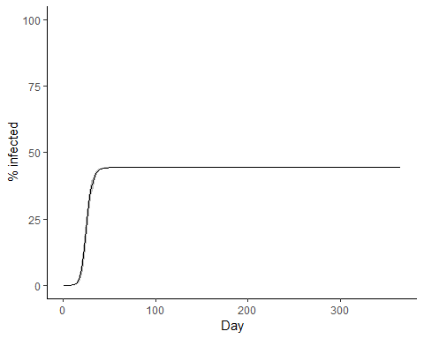

p2 <-  
 ggplot(sim2, aes(x = t, y = nim / nPop * 100)) +  
 geom_ribbon(aes(ymin = ni25 / nPop * 100, ymax = ni75 / nPop * 100), alpha = 0.3) +  
 geom_line() +  
 xlab("Day") +  
 ylab("% infectious")  
  
print(p2)

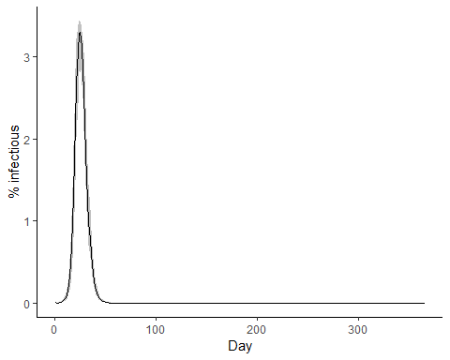

ts2 <- bind_rows(  
 ts2,  
 sim2 %>% mutate(Scenario = "Heterogeneity")  
)   
  
p1 <-  
 ggplot(ts2 %>% filter(Scenario %in% c("Base", "Heterogeneity")), aes(x = t, y = ntm / nPop * 100)) +  
 geom_line(aes(linetype = Scenario)) +  
 geom_ribbon(data = ts2 %>% filter(Scenario == "Base"),  
 aes(ymin = nt25 / nPop * 100, ymax = nt75 / nPop * 100), alpha = 0.3) +  
 xlab("Day") +  
 ylab("% infected")  
  
print(p1 + coord_cartesian(ylim = c(0, 100)))

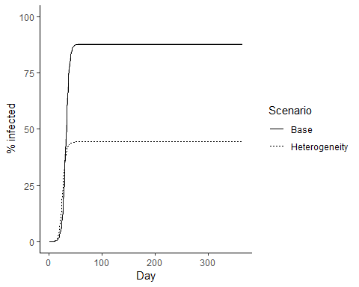

print(p1 + coord_cartesian(xlim = c(4, 30)) + scale_y_log10())

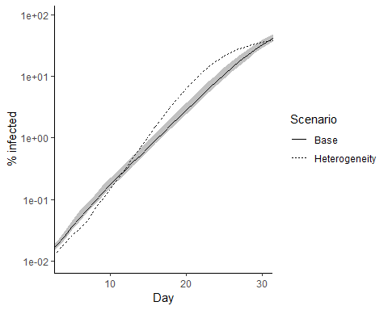

## Intervention from day 20 to 50, no Heterogeneity

# intervention  
int1 <-   
 tibble(t = 1:tend) %>%  
 mutate(rf = ifelse(t>20 & t<50, 0.3, 1.0)) # period of social distancing  
  
  
sim2 <- mySim2(r0a, sd0a, int1)  
   
  
p1 <-  
 ggplot(sim2, aes(x = t, y = ntm / nPop * 100)) +  
 geom_ribbon(aes(ymin = nt25 / nPop * 100, ymax = nt75 / nPop * 100), alpha = 0.3) +  
 geom_line() +  
 xlab("Day") +  
 ylab("% infected")  
  
print(p1 + coord_cartesian(ylim = c(0, 100)))

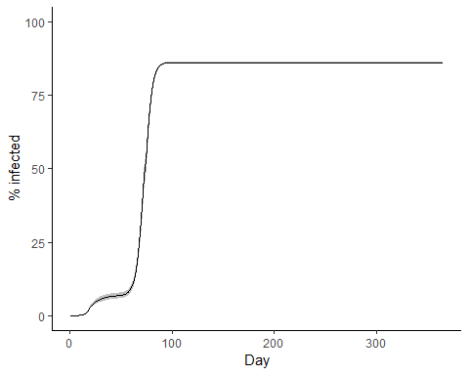

p2 <-  
 ggplot(sim2, aes(x = t, y = nim / nPop * 100)) +  
 geom_ribbon(aes(ymin = ni25 / nPop * 100, ymax = ni75 / nPop * 100), alpha = 0.3) +  
 geom_line() +  
 xlab("Day") +  
 ylab("% infectious")  
  
print(p2)

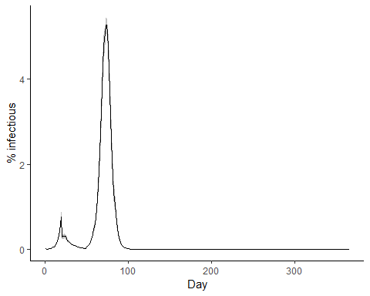

ts2 <- bind_rows(  
 ts2,  
 sim2 %>% mutate(Scenario = "Intervention")  
)   
  
p1 <-  
 ggplot(ts2 %>% filter(Scenario %in% c("Base", "Intervention")), aes(x = t, y = ntm / nPop * 100)) +  
 geom_line(aes(linetype = Scenario)) +  
 geom_ribbon(data = ts2 %>% filter(Scenario == "Base"),  
 aes(ymin = nt25 / nPop * 100, ymax = nt75 / nPop * 100), alpha = 0.3) +  
 xlab("Day") +  
 ylab("% infected")  
  
print(p1 + coord_cartesian(ylim = c(0, 100)))

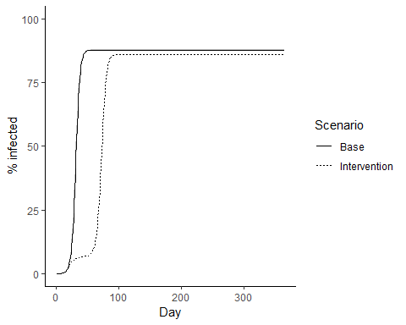

## Intervention from day 20 to 50, with Heterogeneity

sim2 <- mySim2(r0b, sd0b, int1)  
   
  
p1 <-  
 ggplot(sim2, aes(x = t, y = ntm / nPop * 100)) +  
 geom_ribbon(aes(ymin = nt25 / nPop * 100, ymax = nt75 / nPop * 100), alpha = 0.3) +  
 geom_line() +  
 xlab("Day") +  
 ylab("% infected")  
  
print(p1 + coord_cartesian(ylim = c(0, 100)))

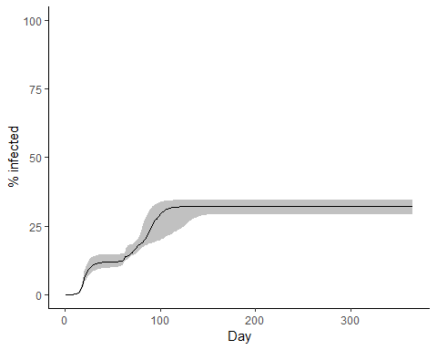

p2 <-  
 ggplot(sim2, aes(x = t, y = nim / nPop * 100)) +  
 geom_ribbon(aes(ymin = ni25 / nPop * 100, ymax = ni75 / nPop * 100), alpha = 0.3) +  
 geom_line() +  
 xlab("Day") +  
 ylab("% infectious")  
  
print(p2)

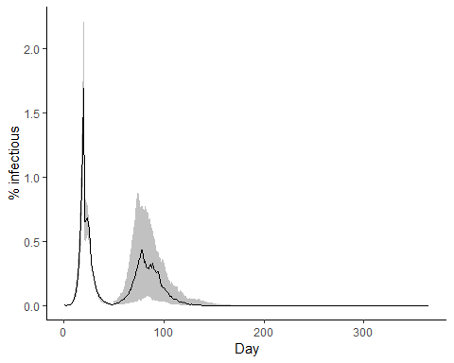

ts2 <- bind_rows(  
 ts2,  
 sim2 %>% mutate(Scenario = "Both")  
)   
  
p1 <-  
 ggplot(ts2 %>% filter(Scenario %in% c("Heterogeneity", "Both")), aes(x = t, y = ntm / nPop * 100)) +  
 geom_line(aes(linetype = Scenario)) +  
 geom_ribbon(data = ts2 %>% filter(Scenario == "Both"),  
 aes(ymin = nt25 / nPop * 100, ymax = nt75 / nPop * 100), alpha = 0.3) +  
 xlab("Day") +  
 ylab("% infected")  
  
print(p1 + coord_cartesian(ylim = c(0, 100)))

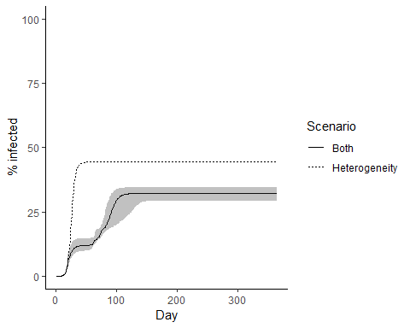

## Intervention from day 20 to 50 with follow up to day 80, with Heterogeneity

# intervention  
int2 <-   
 tibble(t = 1:tend) %>%  
 mutate(rf = case_when(  
 t <= 20 ~ 1,  
 t < 50 ~ 0.3,  
 t < 80 ~ 0.6,  
 TRUE ~ 1  
 )) # period of social distancing  
  
sim2 <- mySim2(r0b, sd0b, int2)  
   
p1 <-  
 ggplot(sim2, aes(x = t, y = ntm / nPop * 100)) +  
 geom_ribbon(aes(ymin = nt25 / nPop * 100, ymax = nt75 / nPop * 100), alpha = 0.3) +  
 geom_line() +  
 xlab("Day") +  
 ylab("% infected")  
  
print(p1 + coord_cartesian(ylim = c(0, 100)))

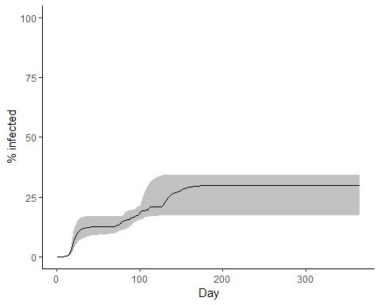

p2 <-  
 ggplot(sim2, aes(x = t, y = nim / nPop * 100)) +  
 geom_ribbon(aes(ymin = ni25 / nPop * 100, ymax = ni75 / nPop * 100), alpha = 0.3) +  
 geom_line() +  
 xlab("Day") +  
 ylab("% infectious")  
  
print(p2)

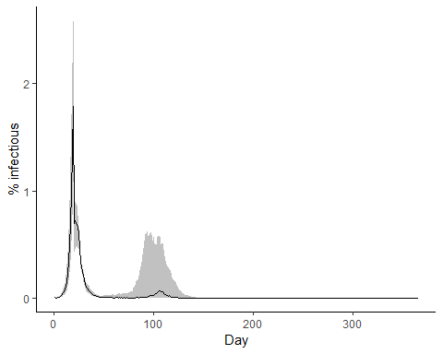

ts2 <- bind_rows(  
 ts2,  
 sim2 %>% mutate(Scenario = "Follow up to day 80")  
)   
  
p1 <-  
 ggplot(ts2 %>% filter(Scenario %in% c("Follow up to day 80", "Both")), aes(x = t, y = ntm / nPop * 100)) +  
 geom_line(aes(linetype = Scenario)) +  
 geom_ribbon(data = ts2 %>% filter(Scenario == "Both"),  
 aes(ymin = nt25 / nPop * 100, ymax = nt75 / nPop * 100), alpha = 0.3) +  
 xlab("Day") +  
 ylab("% infected")  
  
print(p1 + coord_cartesian(ylim = c(0, 100)))

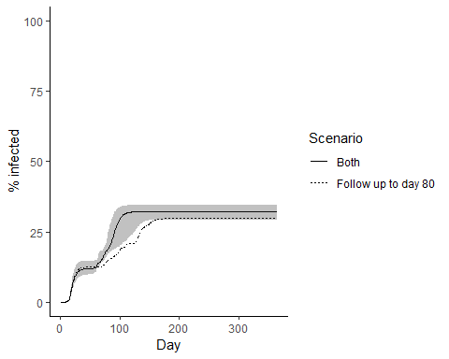

## Intervention from day 20 to 50 with follow up to day 180, with Heterogeneity

# intervention  
int3 <-   
 tibble(t = 1:tend) %>%  
 mutate(rf = case_when(  
 t <= 20 ~ 1,  
 t < 50 ~ 0.3,  
 t < 180 ~ 0.6,  
 TRUE ~ 1  
 )) # period of social distancing  
  
sim2 <- mySim2(r0b, sd0b, int3)  
   
p1 <-  
 ggplot(sim2, aes(x = t, y = ntm / nPop * 100)) +  
 geom_ribbon(aes(ymin = nt25 / nPop * 100, ymax = nt75 / nPop * 100), alpha = 0.3) +  
 geom_line() +  
 xlab("Day") +  
 ylab("% infected")  
  
print(p1 + coord_cartesian(ylim = c(0, 100)))

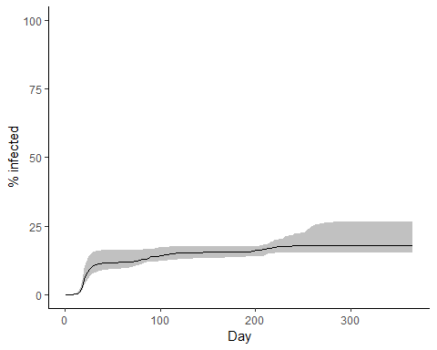

p2 <-  
 ggplot(sim2, aes(x = t, y = nim / nPop * 100)) +  
 geom_ribbon(aes(ymin = ni25 / nPop * 100, ymax = ni75 / nPop * 100), alpha = 0.3) +  
 geom_line() +  
 xlab("Day") +  
 ylab("% infectious")  
  
print(p2)

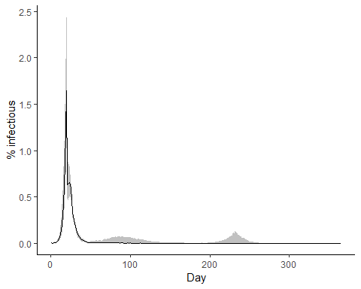

ts2 <- bind_rows(  
 ts2,  
 sim2 %>% mutate(Scenario = "Follow up to day 180")  
)   
  
   
p1 <-  
 ggplot(ts2 %>% filter(Scenario %in% c("Follow up to day 180", "Both")), aes(x = t, y = ntm / nPop * 100)) +  
 geom_line(aes(linetype = Scenario)) +  
 geom_ribbon(data = ts2 %>% filter(Scenario == "Follow up to day 180"),  
 aes(ymin = nt25 / nPop * 100, ymax = nt75 / nPop * 100), alpha = 0.3) +  
 xlab("Day") +  
 ylab("% infected")  
  
print(p1 + coord_cartesian(ylim = c(0, 100)))

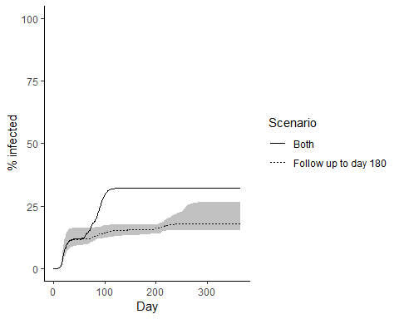

## Intervention from day 20 to 50 with pronounced follow up to day 180, with Heterogeneity

# intervention  
int4 <-   
 tibble(t = 1:tend) %>%  
 mutate(rf = case_when(  
 t <= 20 ~ 1,  
 t < 50 ~ 0.3,  
 t < 180 ~ 0.5,  
 TRUE ~ 1  
 )) # period of social distancing  
  
sim2 <- mySim2(r0b, sd0b, int4)  
   
p1 <-  
 ggplot(sim2, aes(x = t, y = ntm / nPop * 100)) +  
 geom_ribbon(aes(ymin = nt25 / nPop * 100, ymax = nt75 / nPop * 100), alpha = 0.3) +  
 geom_line() +  
 xlab("Day") +  
 ylab("% infected")  
  
print(p1 + coord_cartesian(ylim = c(0, 100)))

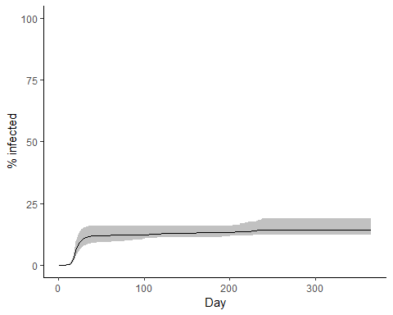

p2 <-  
 ggplot(sim2, aes(x = t, y = nim / nPop * 100)) +  
 geom_ribbon(aes(ymin = ni25 / nPop * 100, ymax = ni75 / nPop * 100), alpha = 0.3) +  
 geom_line() +  
 xlab("Day") +  
 ylab("% infectious")  
  
print(p2)

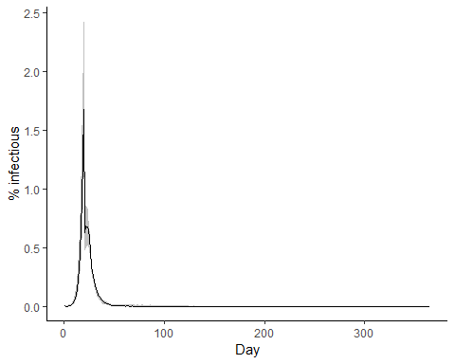

ts2 <- bind_rows(  
 ts2,  
 sim2 %>% mutate(Scenario = "Pronounced follow up to day 180")  
)

## Intervention from day 20 to day 180, with Heterogeneity

# intervention  
int5 <-   
 tibble(t = 1:tend) %>%  
 mutate(rf = case_when(  
 t <= 20 ~ 1,  
 t < 50 ~ 0.3,  
 t < 180 ~ 0.3,  
 TRUE ~ 1  
 )) # period of social distancing  
  
sim2 <- mySim2(r0b, sd0b, int5)  
   
p1 <-  
 ggplot(sim2, aes(x = t, y = ntm / nPop * 100)) +  
 geom_ribbon(aes(ymin = nt25 / nPop * 100, ymax = nt75 / nPop * 100), alpha = 0.3) +  
 geom_line() +  
 xlab("Day") +  
 ylab("% infected")  
  
print(p1 + coord_cartesian(ylim = c(0, 100)))

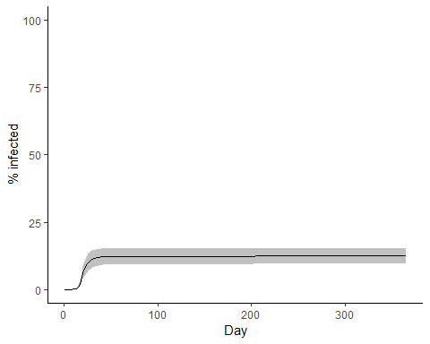

p2 <-  
 ggplot(sim2, aes(x = t, y = nim / nPop * 100)) +  
 geom_ribbon(aes(ymin = ni25 / nPop * 100, ymax = ni75 / nPop * 100), alpha = 0.3) +  
 geom_line() +  
 xlab("Day") +  
 ylab("% infectious")  
  
print(p2)

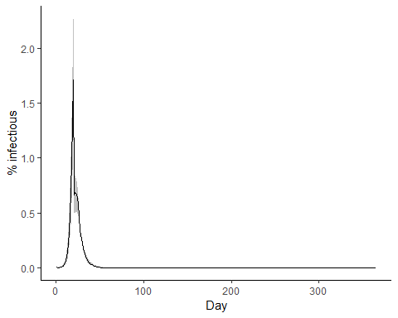

ts2 <- bind_rows(  
 ts2,  
 sim2 %>% mutate(Scenario = "Intervention to day 180")  
)   
  
   
p1 <-  
 ggplot(ts2, aes(x = t, y = ntm / nPop * 100)) +  
 geom_line(aes(colour = Scenario)) +  
 geom_ribbon(data = ts2 %>% filter(Scenario == "Follow up to day 180"),  
 aes(ymin = nt25 / nPop * 100, ymax = nt75 / nPop * 100), alpha = 0.3) +  
 xlab("Day") +  
 ylab("% infected")  
  
print(p1 + coord_cartesian(ylim = c(0, 100)))

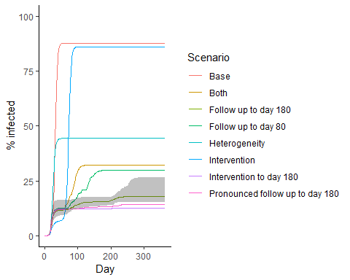

print(p1 + scale_y_log10() + coord_cartesian(ylim = c(1, 100)))

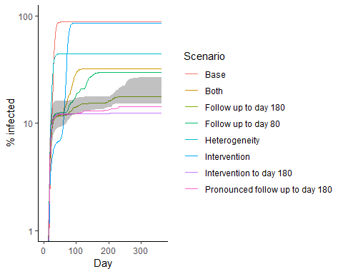

print(p1 + scale_y_log10() + coord_cartesian(xlim = c(4,30)))

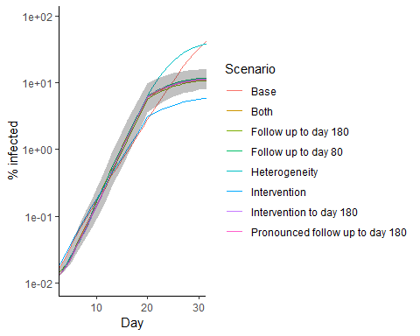

p1 <-  
 ggplot(ts2, aes(x = t, y = nim / nPop * 100, colour = Scenario)) +  
 geom_line(aes(colour = Scenario)) +  
 geom_ribbon(data = ts2 %>% filter(Scenario == "Follow up to day 180"),  
 aes(ymin = ni25 / nPop * 100, ymax = ni75 / nPop * 100), alpha = 0.3) +  
 xlab("Day") +  
 ylab("% infectious")  
  
print(p1 )

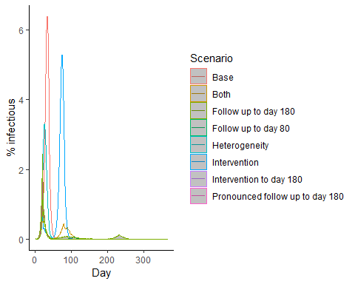

# plots of density

# subjects  
set.seed(123)  
pat0 <- tibble(  
 r0l = rnorm(nPop, log(r0a), 0.001), # log of patient specific rate  
 r0 = exp(r0l) / exp(0.001^2/2) # patient specific rate (rescaled to have mean r0)  
)  
  
set.seed(123)  
sim1 <- mySim(pat0)  
  
R360 = sim1 %>% summarise(mr = mean(r0 * (is == 0)) * (idur - 1)) %>% unlist()  
  
  
sim1 <-  
 sim1 %>%  
 mutate(  
 iweek = pmin((is + 6) %/% 7, 52))  
  
pp1 <-  
 ggplot(sim1, aes(x=r0)) +   
 # geom_freqpoly(fill = NA, size=2) +  
 geom_histogram(aes(fill = (is>0)), bins=40, alpha=0.2) +  
 geom_freqpoly(aes(colour=factor(iweek)), position="stack", bins=40) +   
 scale_x_log10() +  
 xlab("Infection rate (1/Day)") +  
 scale_fill_discrete(labels = c("No", "Yes")) +  
 guides(colour = "none", fill = guide_legend("Infected")) +  
 ggtitle(paste0("Homogeneous\nR(1 year) = ", round(R360, 2)))  
  
  
print(pp1)

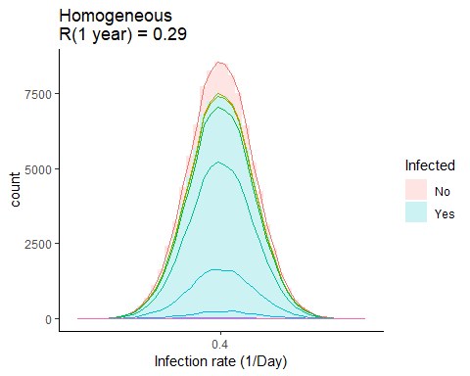

p <- mygraph1(sim1)  
animate(p, nframes=50, fps=4)



anim_save("animHom.gif", p)  
  
  
# including vaccination  
set.seed(123)  
sim1 <- mySim(pat0, rVac = 1-1/r0a/(idur - 1))  
  
R360 = sim1 %>% summarise(mr = mean(r0 * (is == 0)) * (idur - 1)) %>% unlist()  
  
  
sim1 <-  
 sim1 %>%  
 mutate(  
 iweek = pmin((is + 6) %/% 7, 52))  
  
pp1 <-  
 ggplot(sim1, aes(x=r0)) +   
 # geom_freqpoly(fill = NA, size=2) +  
 geom_histogram(aes(fill = (is>0)), bins=40, alpha=0.2) +  
 geom_freqpoly(aes(colour=factor(iweek)), position="stack", bins=40) +   
 scale_x_log10() +  
 xlab("Infection rate (1/Day)") +  
 scale_fill_discrete(labels = c("No", "Yes")) +  
 guides(colour = "none", fill = guide_legend("Infected")) +  
 ggtitle(paste0("Vaccination\nR(1 year) = ", round(R360, 2)))  
  
  
print(pp1)

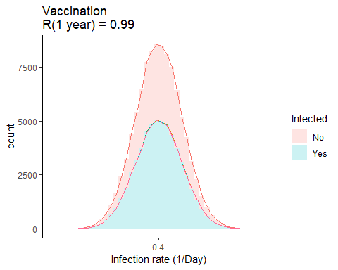

p <- mygraph1(sim1)  
animate(p, nframes=50, fps=4)



anim_save("animHomVac.gif", p)  
  
  
# intervention  
set.seed(123)  
sim1 <- mySim(pat0, int4)  
  
R360 = sim1 %>% summarise(mr = mean(r0 * (is == 0)) * (idur - 1)) %>% unlist()  
  
  
sim1 <-  
 sim1 %>%  
 mutate(  
 iweek = pmin((is + 6) %/% 7, 52))  
  
pp1 <-  
 ggplot(sim1, aes(x=r0)) +   
 # geom_freqpoly(fill = NA, size=2) +  
 geom_histogram(aes(fill = (is>0)), bins=40, alpha=0.2) +  
 geom_freqpoly(aes(colour=factor(iweek)), position="stack", bins=40) +   
 scale_x_log10() +  
 xlab("Infection rate (1/Day)") +  
 scale_fill_discrete(labels = c("No", "Yes")) +  
 guides(colour = "none", fill = guide_legend("Infected")) +  
 ggtitle(paste0("Homogeneous with follow up to day 180\nR(1 year) = ", round(R360, 2)))  
  
  
print(pp1)

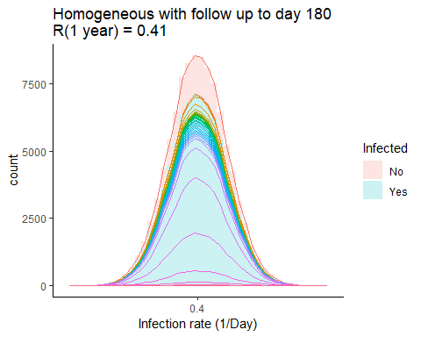

p <- mygraph1(sim1)  
animate(p, nframes=50, fps=4)



anim_save("animHomI4.gif", p)  
  
  
# subjects  
set.seed(123)  
pat1 <- tibble(  
 r0l = rnorm(nPop, log(r0b), sd0b), # log of patient specific rate  
 r0 = exp(r0l) / exp(sd0b^2/2) # patient specific rate (rescaled to have mean r0)  
)  
  
set.seed(123)  
sim1 <- mySim(pat1)  
  
R360 = sim1 %>% summarise(mr = mean(r0 * (is == 0)) * (idur - 1)) %>% unlist()  
  
sim1 <-  
 sim1 %>%  
 mutate(  
 iweek = pmin((is + 6) %/% 7, 52))  
  
pp1 <-  
 ggplot(sim1, aes(x=r0)) +   
 # geom_freqpoly(fill = NA, size=2) +  
 geom_histogram(aes(fill = (is>0)), bins=40, alpha=0.2) +  
 geom_freqpoly(aes(colour=factor(iweek)), position="stack", bins=40) +   
 scale_x_log10() +  
 xlab("Infection rate (1/Day)") +  
 scale_fill_discrete(labels = c("No", "Yes")) +  
 guides(colour = "none", fill = guide_legend("Infected")) +  
 ggtitle(paste0("Heterogeneous\nR(1 year) = ", round(R360, 2)))  
  
  
print(pp1)

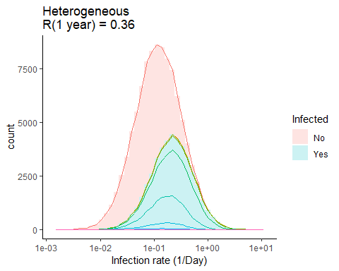

p <- mygraph1(sim1)  
animate(p, nframes=50, fps=4)



anim_save("animHetBase.gif", p)  
  
  
set.seed(123)  
sim1 <- mySim(pat1, int4)  
  
R360 = sim1 %>% summarise(mr = mean(r0 * (is == 0)) * (idur - 1)) %>% unlist()  
  
sim1 <-  
 sim1 %>%  
 mutate(  
 iweek = pmin((is + 6) %/% 7, 52))  
  
pp1 <-  
 ggplot(sim1, aes(x=r0)) +   
 # geom_freqpoly(fill = NA, size=2) +  
 geom_histogram(aes(fill = (is>0)), bins=40, alpha=0.2) +  
 geom_freqpoly(aes(colour=factor(iweek)), position="stack", bins=40) +   
 scale_x_log10() +  
 xlab("Infection rate (1/Day)") +  
 scale_fill_discrete(labels = c("No", "Yes")) +  
 guides(colour = "none", fill = guide_legend("Infected")) +  
 ggtitle(paste0("Heterogeneous with follow up to day 180\nR(1 year) = ", round(R360, 2)))  
  
  
print(pp1)

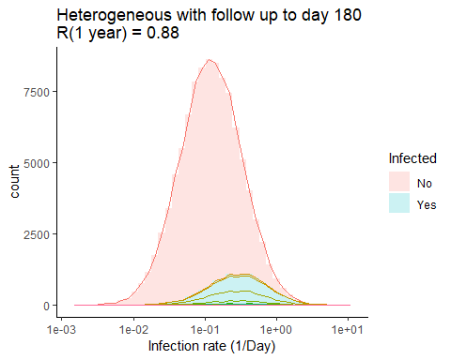

p <- mygraph1(sim1)  
animate(p, nframes=50, fps=4)



anim_save("animHetI4.gif", p)