[RYERSON UNIVERSITY](http://www.ryerson.ca/index.html)

Department of Electrical and Computer Engineering

Faculty of Engineering and Architectural Science

|  |
| --- |
|  |
| Title of the Project |
|  |
| EDP Project Report |

Authors: [Name1, Name2, Name3]

Faculty Lab Coordinator: [Name]

[Pick the date]

Introduction

This is a tentative template for the ELE/COE-800 Engineering Design Project report.

The main body of the report is limited to ***40 pages***, including text, analysis equations/ algorithms diagrams, schematics, tables and references list. Additional material (e.g. source code, datasheets, etc.), not subjected to grading, can be inserted in the Appendix.

Acknowledgements

Certification of Authorship

Table of Contents

Introduction 2

Acknowledgements 3

Certification of Authorship 4

Table of Contents 5

Abstract 6

Objectives 7

Theory and Design 8

Heading 2 8

Figures and Tables 8

Documentation Including Schematics and Parts Lists 10

Measurement and Testing Procedure 11

Performance Measurement 12

Analysis of Performance 13

Time spent on the design of each project component 14

Conclusion 15

Appendices 16

References 17

# Abstract

The abstract must accurately précis the entire report contents in half a page or less.

# Objectives

# Theory and Design

This chapter must include theory that you exploited in the project and practical design implementation results.

The following is an example of equation:

 (1)

An alternative equation style is shown below:

$$f\left(x\right)=a_{0}+\sum_{n=1}^{∞}{\left(a_{n}\cos{\frac{nπx}{L}}+b_{n}\sin{\frac{nπx}{L}}\right)}$$

## Heading 2

Remember to update the Table of Contents (TOC) by right clicking the **TOC** page and selecting “Update Field”.

### Figures and Tables

There are several header levels. All of the header formats are not numbered. You may do the numbering yourself as needed.

When referring a reference, please use square bracket, for example, the reference [1].

A sample of the **figure** is shown below. The caption is placed below it.

The caption of a **table** should be placed above the table (see below).

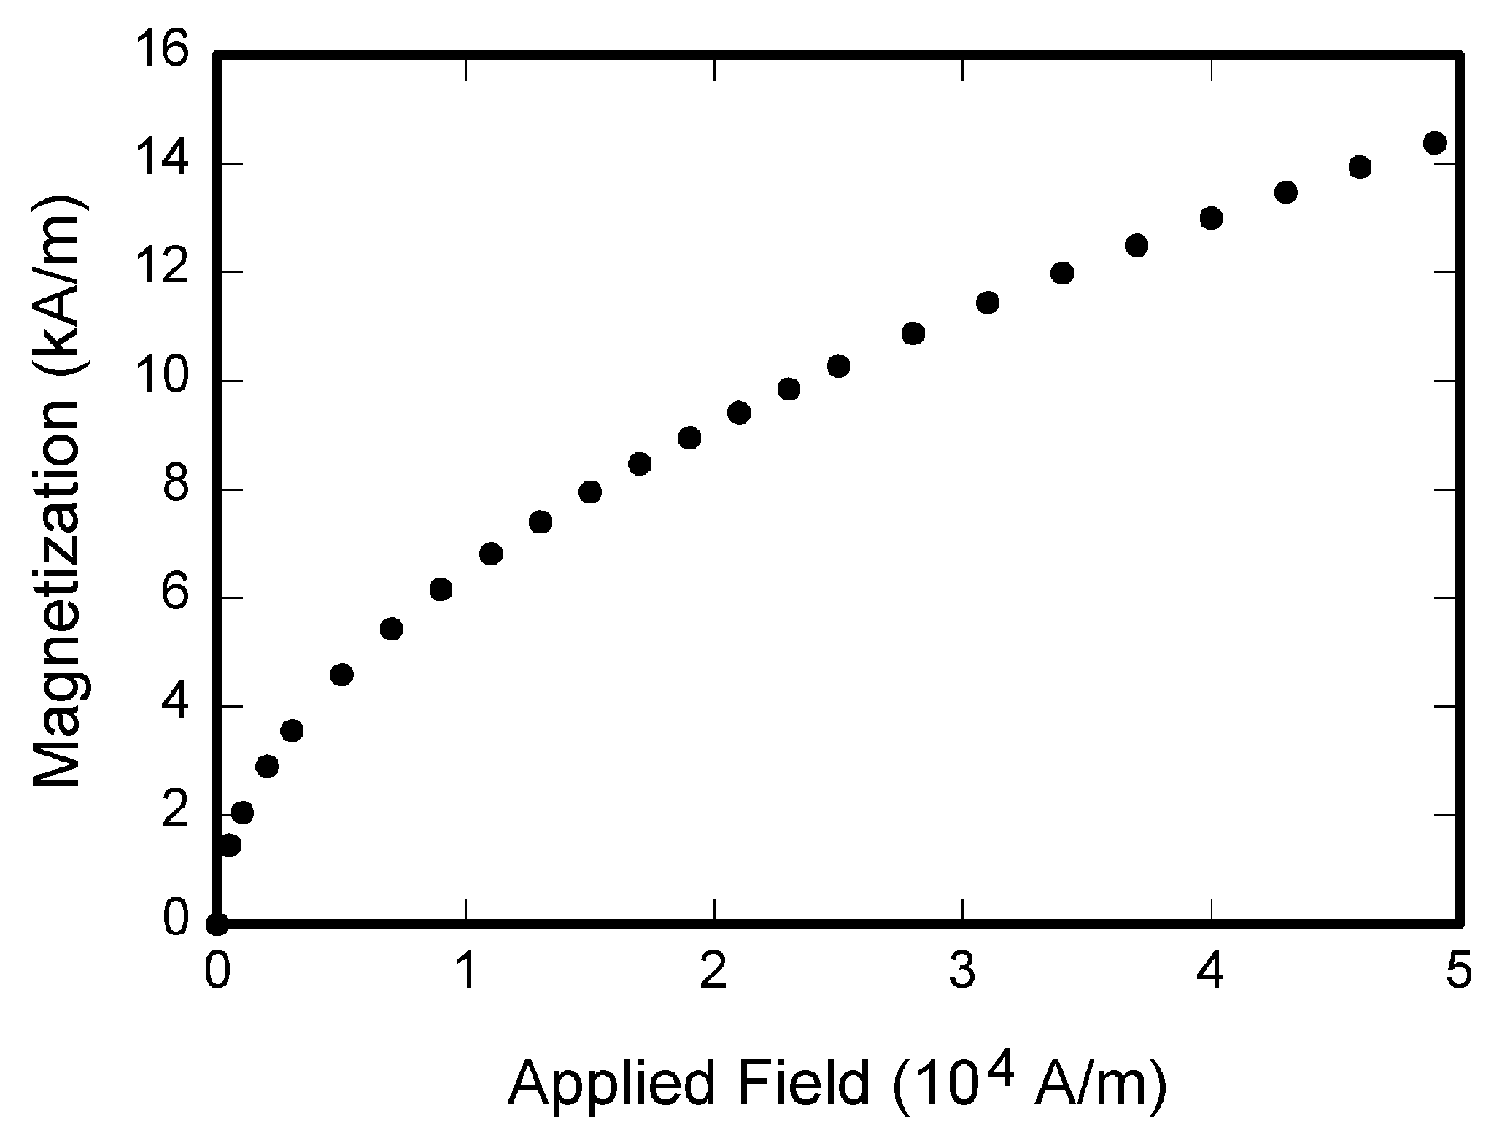

Fig. 1. Magnetization as a function of applied field. Note that “Fig.” is abbreviated. There is a period after the figure number, followed by two spaces. It is good practice to explain the significance of the figure in the caption.

TABLE I

Units for Magnetic Properties

|  |  |  |
| --- | --- | --- |
| Symbol | Quantity | Conversion from Gaussian and  CGS EMU to SI a |
| Φ | magnetic flux | 1 Mx → 10−8 Wb = 10−8 V·s |
| *B* | magnetic flux density,  magnetic induction | 1 G → 10−4 T = 10−4 Wb/m2 |
| *H* | magnetic field strength | 1 Oe → 103/(4π) A/m |
| *m* | magnetic moment | 1 erg/G = 1 emu  → 10−3 A·m2 = 10−3 J/T |
| *M* | magnetization | 1 erg/(G·cm3) = 1 emu/cm3  → 103 A/m |
| 4π*M* | magnetization | 1 G → 103/(4π) A/m |
| σ | specific magnetization | 1 erg/(G·g) = 1 emu/g → 1 A·m2/kg |
| *j* | magnetic dipole  moment | 1 erg/G = 1 emu  → 4π × 10−10 Wb·m |
| *J* | magnetic polarization | 1 erg/(G·cm3) = 1 emu/cm3  → 4π × 10−4 T |
| χ*,* κ | susceptibility | 1 → 4π |
| χρ | mass susceptibility | 1 cm3/g → 4π × 10−3 m3/kg |
| μ | permeability | 1 → 4π × 10−7 H/m  = 4π × 10−7 Wb/(A·m) |
| μr | relative permeability | μ → μr |
| *w, W* | energy density | 1 erg/cm3 → 10−1 J/m3 |
| *N, D* | demagnetizing factor | 1 → 1/(4π) |

Vertical lines are optional in tables. Statements that serve as captions for the entire table do not need footnote letters.

aGaussian units are the same as cg emu for magnetostatics; Mx = maxwell, G = gauss, Oe = oersted; Wb = weber, V = volt, s = second, T = tesla, m = meter, A = ampere, J = joule, kg = kilogram, H = henry.

# Documentation Including Schematics and Parts Lists

This chapter must also reflect the prices of all parts used in the project.

# Measurement and Testing Procedure

It is essential that a project be properly designed. A designer must satisfy the examiner, the FLC, that the program or circuit will perform its tasks to specification under all or at least the usual, variations in the operating or manufacturing environment. Such issues as component tolerance, voltage variations, maximum and minimum computer cycle times and data throughputs are examples of variables. In other words, the examiner must be convinced that the project is battle-proof and its operation at the demonstration is not an unusual event.

Another guide used to assess whether the design is competent is to consider the mass production of this prototype. Could one anticipate a reasonable yield and customer satisfaction?

The working prototype performance must be measured to quantify the extent to which it meets the design specifications. The procedure used to measure performance is to be described in sufficient detail that the reader can repeat it. The measured results must be documented in conjunction with appropriate schematics or flow charts.

The results should be analyzed to ensure that they fit the anticipated performance and if not an explanation is called for.

# Performance Measurement

# Analysis of Performance

# Time spent on the design of each project component

# Conclusion

The conclusion should address the project's objectives; to what extent were they met?

# Appendices

# References

1. (For a journal paper) A. Author, B. Arthur, “The title of a reference paper,” *Journal of Excitement*, vol. 1, no. 1, pp. 123-234, Jul. 1999.
2. R. Lucky, “Automatic equalization for digital communication,” *Bell Syst. Tech. J.*, vol. 44, no. 4, pp. 547–588, Apr. 1965.
3. (For a book) H. Poor, *An Introduction to Signal Detection and Estimation*. New York: Springer-Verlag, 1985, ch. 4.
4. (For a conference paper) G. Juette, L. Zeffanella, “Radio noise currents,” *IEEE Summer power Meeting*, Dallas, TX, June 22–27, 1990.
5. (Thesis style) J. Williams, “Narrow-band analyzer,” Ph.D. dissertation, Dept. Elect. Eng., Harvard Univ., Cambridge, MA, 1993.
6. (Patent style) J. P. Wilkinson, “Nonlinear resonant circuit devices,” U.S. Patent 3 624 12, July 16, 1990.
7. (Standard style) *Letter Symbols for Quantities*, ANSI Standard Y10.5-1968.
8. (Report style) E. Reber, R. Michell, C. Carter, “Oxygen absorption in the Earth’s atmosphere,” Aerospace Corp., Los Angeles, CA, Tech. Rep. TR-0200, Nov. 1988.
9. (Handbook style) *Transmission Systems for Communications*, 3rd ed., Western Electric Co., Winston-Salem, NC, 1985, pp. 44–60.
10. (Basic Book/Monograph Online Sources) J. Author. (year, month, day). Title (edition) [Type of medium]. Volume(issue). Available: <http://www.(URL>)
11. J. Jones. (1991, May 10). Networks (2nd ed.) [Online]. Available: <http://www.atm.com>