

Team

# “Sladkoyezhki”

**Contents**

▶ Team members

▶ Project idea

▶ Technologies used

▶ Steps of Realization

▶ Work Plan

**Team members**

Ivaila Keserdzhieva Developer

Ekaterina Zalinskaya Scrum trainer

Ivelin Metodiev Developer

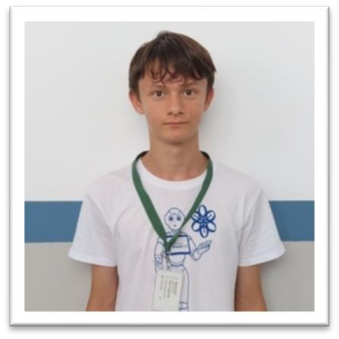Elizaveta Furnika Designer

## Project idea

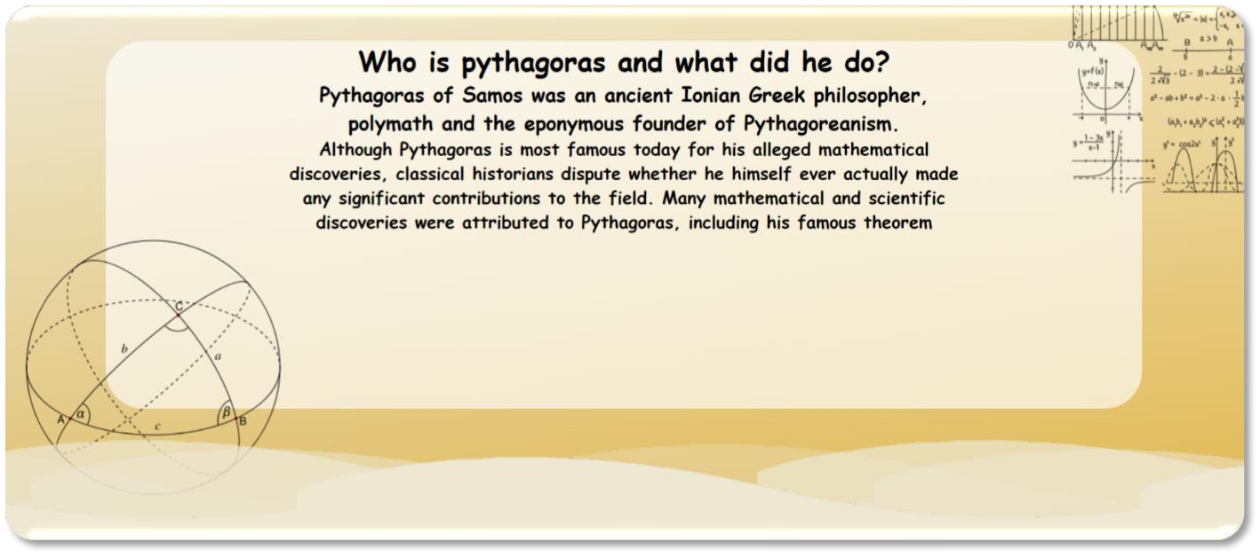▶ It is a site where you can find some information about famous mathematicians and their discoveries. You can learn more about them, their formulas and how they influenced the world of mathematics.

# Technologies used



## Steps of Realization

1. Planning — Our team divided the roles and discussed which part are we going to do.
2. Process — We had team meetings almost every day to discuss the entire process.
3. Completing — Considering to deadlines, we split the amount of work for each day and had enough time to finish it.

## Work Plan

### Create a site

1. Add Sign Up page

### Add pages with the main information

1. Create design

### Create documentation