ISTE-230 Introduction to Database & Data Modeling

## Homework # 4 – Normalization

DUE:

**Name: _____**Edward Riley**____________**

**Submit this document edited to include your answers, for the six tasks, to the HW#4 Dropbox by the stated deadline.**

**Task #1 (12 points)**

MUSIC(Title, Artist, NumGrpMembers, Year, Producer, ProducerURL, Category, CategorySales, Media, MediaPrice )

Business Rules:

1. Each “album” (CD) is uniquely identified by its title. Note that, for the rest of the business rules, the “Title” attribute of MUSIC refers to the name of the “album”.
2. An artist may either be a single person or a band made up of multiple members (the count being recorded in NumGrpMembers, which can be 1).
3. Each album has one release year.
4. Each album is produced by one music production company (producer).
5. Each producer has one company URL.
6. A specific album has only one artist.
7. Each album is classified into one music category (Rock, Country, etc.)
8. Each category is associated with one category sales value, which is the year-to-date sales for that given category.
9. For convenience, the music company sells all of its music at the same price based on the media type. For example, all cassettes are $9.99, all CDs are $16.99, etc.

List ALL **functional** dependencies for the MUSIC relation above, according only to the business rules listed. Use the format A 🡪 B. Then, for each functional dependency denote with a ‘Y’ or ‘N’ if the respective functional dependency causes 2NF or 3NF violation in the MUSIC relation.

|  |  |  |
| --- | --- | --- |
| **Functional Dependencies** | **2NF violation?** | **3NF violation?** |
| **Album = Title** | **?** | **?** |
| **Artist 🡪 NumGrpMembers** | **N** | **Y** |
| **Title 🡪 Year** | **Y** | **N** |
| **Title 🡪 Producer** | **Y** | **N** |
| **Producer 🡪 Company URL** | **N** | **Y** |
| **Title 🡪 Artist** | **Y** | **N** |
| **Category 🡪 CategorySales** | **N** | **Y** |
| **Media 🡪 MediaPrice** | **Y** | **N** |

**Task #2 (9 points)**

For the relation below, determine the *highest* normal form the relation is in, the reason, and if necessary normalize the relation, and all resulting relations, through BCNF. Use proper relational notation and include reference statements for any foreign keys.

Q1( a, b, c, d )

Functional Dependencies:

a, b 🡪 c, d

c 🡪 d

**YOUR ANSWER:**

Q1(a, b, *c*, ~~d~~)

Q2(c, d)

Q1(c) MUST EXIST IN Q2(c)

Q1 (2NF) has the highest normal form because there is no partial and it is a transitive dependency.

**Task #3 (12 points)**

For the relation below, determine the *highest* normal form the relation is in, the reason, and if necessary normalize the relation, and all resulting relations, through BCNF. Use proper relational notation and include reference statements for any foreign keys.

Q2(a, b, c, d)

Functional dependencies:

a, b 🡪 c, d

a 🡪 c

b 🡪 d

**YOUR ANSWER:**

Q2(*a*, *b*, ~~c~~, ~~d~~)

Q3(a, c)

Q2(a) MUST EXIST IN Q3(a)

Q4(b, d)

Q2(b) MUST EXIST IN Q4(b)

Q2 has the highest normal form because it has partial dependency.

**Task #4 (17 points)**

Given the E-R diagram, the resulting relation, and the functional dependencies below, normalize the ITEM relation and resulting relations through BCNF. Be sure to use proper relational notation and reference statements for foreign keys.

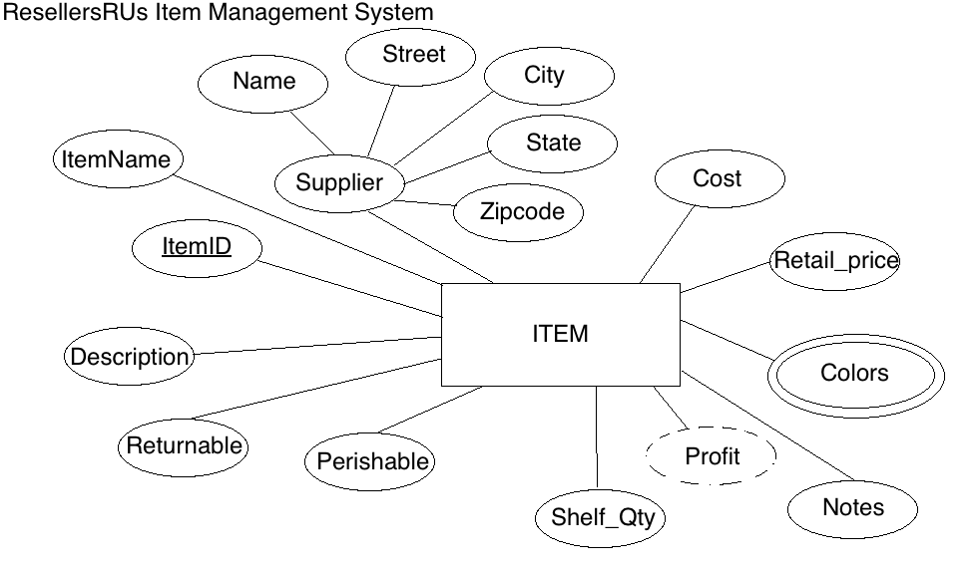

Resulting Relation:

ITEM(ItemID, ItemName, Name, Street, City, State, Zipcode, Cost, Retail_price, Color1, Color2, Notes, Shelf_Qty, Perishable, Returnable, Description)

Functional Dependencies:

ItemID 🡺 ItemName, Name, Street, City, State, Zipcode, Cost, Retail_price, Color1, Color2, Notes, Shelf_Qty, Perishable, Returnable, Description

Name 🡺 Street, City, State, Zipcode

**YOUR ANSWER (Final set of relations normalized to BCNF):**

ITEM( itemid, ItemName, *name*, ~~street, city, state, zip~~, cost, retail_price, color1, color2, notes, shelf_qty, perishable, returnable, description)

SUPPLIER(name, street, city, state, zip)

ITEM(name) MUST EXIST IN SUPPLIER(name)

**Task #5 (23 points)**

Given the relation and functional dependencies below, normalize the SALE relation and resulting relations through BCNF. Be sure to use proper relational notation and reference statements for foreign keys.

SALE(Invoice#, Item#, CustID, CustName, CustAddress, ItemName, ItemPrice, ItemQtyPurch, Salesperson#, SalespersonName, Subtotal, Tax, TotalDue)

Functional Dependencies:

Invoice#, Item# 🡪 CustID, CustName, CustAddress, ItemName, ItemPrice, ItemQtyPurch, Salesperson#, SalespersonName, Subtotal, Tax, TotalDue

Item# 🡪 ItemName, ItemPrice

Invoice# 🡪 CustID, CustName, CustAddress, Salesperson#, SalespersonName, Subtotal, Tax, TotalDue

CustID 🡪 CustName, CustAddress

Salesperson# 🡪 SalespersonName

**YOUR ANSWER (Final set of relations normalized to BCNF):**

SALE(*Invoice#*, *Item#*, *~~CustID~~*, ~~CustName, CustAddress~~, ~~ItemName, ItemPrice~~, ItemQtyPurch, ~~Salesperson#, SalespersonName, Subtotal, Tax, TotalDue~~)

SALE(Item#) MUST EXIST IN ITEM_NUMBER(Item#)

ITEM_NUMBER( *Item#*, ItemName, ItemPrice )

SALE(Invoice#) MUST EXIST IN INVOICE_NUMBER(Invoice#)

INVOICE_NUMBER( Invoice#, *CustID*, *Salesperson#*, subtotal, Tax, TotalDue )

INVOICE_NUMBER(CustID) MUST EXIST IN CUSTOMER(CustID)

CUSTOMER( CustID, CustName, CustAddress )

INVOICE_NUMBER(Salesperson#) MUST EXIST IN SALESPERSON(Salesperson#)

SALESPERSON( Salesperson#, SalespersonName)

**Task #6 (27 points)**

Given the relation and functional dependencies below, normalize the relation and resulting relations through BCNF. Be sure to use proper relational notation and reference statements for foreign keys.

A(1, 2, 3, 4, 5, 6, 7, 8, 9, 10)

Functional Dependencies:

1, 2, 3, 4->5, 6, 7, 8, 9, 10

1->5, 6

5->1,6

2,3->7,8

7->8

4->9,10

9->10

10->9

**YOUR ANSWER (Final set of relations normalized to BCNF):**

A(1, 2, 3, 4, ~~5~~, ~~6~~, ~~7~~, ~~8~~, ~~9~~, ~~10~~)

A(1) MUST EXIST IN B(1)

B( 1, *5*)

B(5) MUST EXIST IN C(5)

C( 5, 6 )

A(2) MUST EXIST IN D(2)

A(3) MUST EXIST IN D(3)

D( 2, 3, *7* )

D(7) MUST EXIST IN E(7)

E( 7, 8 )

A(4) MUST EXIST IN F(4)

F( 4, *9* )

F(9) MUST EXIST IN G(9)

G( 9, 10 )