ISTE-230 Introduction to Database & Data Modeling

## Homework # 5 – HAS-A and IS-A Relationships

**Name: _Edward Riley___**

**Submit this document, edited to include your answers, to the HW#5 Dropbox by the stated deadline.**

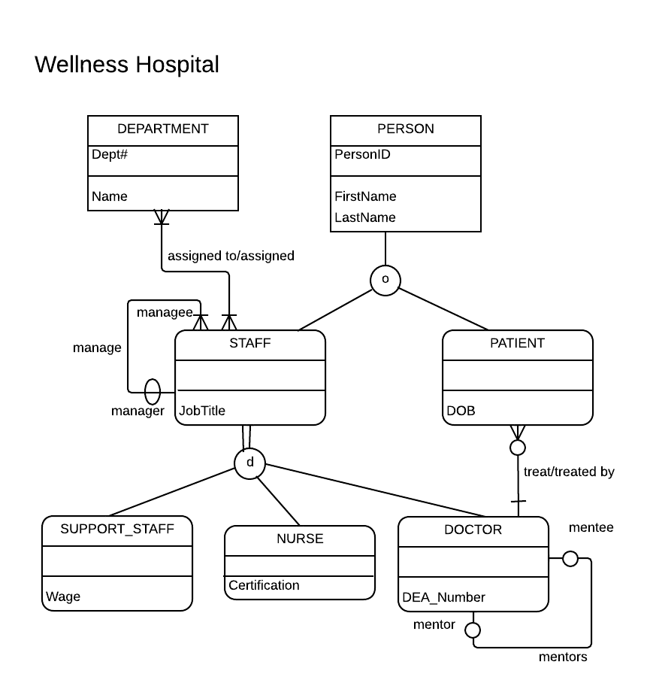

Using the E-R diagram for Wellness Hospital, that appears on the previous page, please provide your answer to the following questions.

1. (5 points) List the relationship verb phrase for each 'HAS-A' relationship that appears in the diagram.

**YOUR ANSWER:** Assigned to/assigned, treat/treated by, and mentors, manage

1. (5 points) List the relationship verb phrase for each binary relationship that appears in the diagram.

**YOUR ANSWER:** Assigned to/assigned and treat/treated by

1. (5 points) List the relationship verb phrase for each recursive relationship that appears in the diagram.

**YOUR ANSWER:** Mentors, Manage

1. (5 points) List the name of each supertype entity that appears in the diagram.

**YOUR ANSWER:** PERSON, STAFF

1. (6 points) List the name of each subtype entity that appears in the diagram.

**YOUR ANSWER:** STAFF, PATIENT, SUPPORT_STAFF, NURSE, and DOCTOR

1. (5 points) Provide an example of an entity instance of PERSON.

**YOUR ANSWER:** PersonID = 0; FirstName = ‘Edward’; LastName = ‘Riley’;

1. (5 points) List the relationship verb phrase for every 1:1 relationship that appears in the diagram.

**YOUR ANSWER:** Mentors

1. (5 points) List the relationship verb phrase for every 1:N (N:1) relationship that appears in the diagram.

**YOUR ANSWER:** Manage, Treat/Treated by

1. (5 points) List the relationship verb phrase for every M:N relationship that appears in the diagram.

**YOUR ANSWER:** Assigned

1. (5 points) List the name of each strong entity that appears in the diagram.

**YOUR ANSWER:** PERSON, DEPARTMENT

1. (6 points) List the name of each weak entity that appears in the diagram.

**YOUR ANSWER:** DOCTOR, STAFF, SUPPORT_STAFF, NURSE, PATIENT

1. (4 points) Must a STAFF:managee be managed by a manager? Explain how you determined your answer from the E-R diagram provided.

**YOUR ANSWER:** No. Because Manager has no oval – this means that manager is within managee.

1. (4 points) Can there be an instance of DOCTOR that is not an instance of STAFF? Explain your answer.

**YOUR ANSWER:** No. STAFF has total specialization and DOCTOR is under STAFF.DOCTORis a weak subtype.

1. (4 points) Can a DOCTOR treat more than one PATIENT? Explain how you determined your answer from the E-R diagram provided.

**YOUR ANSWER:** Yes. There is crow feet on the PATIENT which means it has maximum cardinality.

1. (4 points) Must every instance of PERSON belong to a subtype? Fully explain how you determined your answer from the E-R diagram provided.

**YOUR ANSWER:** No. PERSON has partial specialization to STAFF and PATIENT. STAFF and PATIENT are also under PERSON. PERSON is a supertype unlike STAFF and PATIENT.

1. (4 points) Could an instance of PERSON be both a STAFF and a PATIENT? Fully explain how you determined your answer from the E-R diagram provided.

**YOUR ANSWER:** No. It has overlap rule and partial specialization. This superype can’t belong to a subtype.

1. (4 points) Must every instance of STAFF belong to a subtype? Fully explain how you determined your answer from the E-R diagram provided.

**YOUR ANSWER:** Yes. It has total specialization, which must be belongs to a subtype.

1. (4 points) Could an instance of STAFF be both a SUPPORT_STAFF and a DOCTOR? Fully explain how you determined your answer from the E-R diagram provided.

**YOUR ANSWER:** No. Disjointed rule and STAFF has to be belong to any of subtypes.

1. (5 points) If a discriminator were to be added to PERSON, fully explain what that would entail and why?

**YOUR ANSWER:** PERSON is as an overlap rule because it has discriminator. It will select STAFF or PATIENT either with Boolean values – it’s one or the other.

1. (5 points) If a discriminator were to be added to STAFF, fully explain what that would entail and why?

**YOUR ANSWER:** STAFF is as a disjointed rule because it has discriminator. It will select SUPPORT_STAFF, NURSE, or DOCTOR either with an imaginary Boolean values. Imaginary boolean values being S for STAFF, N for NURSE, and D for DOCTOR.

1. (5 points) Fully state the business rules for the **assigned to/assigned** relationship without using technical terms.

**YOUR ANSWER:** DEPARTMENT is assigned at least one STAFF but can assigned to many STAFF. On the other hand, STAFF is assigned at least one DEPARTMENT but can assigned to many DEPARTMENT.