ISTE-230 Introduction to Database & Data Modeling

## Homework # 6 – Transposing

DUE:

**Name: ____Edward Riley_____________________**

**Submit this document edited to include your answers, for the two parts, to the HW#6 Dropbox by the stated deadline.**

(It may be helpful to right-click on the  icon and select Hide Spelling Errors and Hide Grammatical Errors.)

**Part #1 – 50 points**

1. (45 points) Transpose the E-R diagram above into relations, implementing all relationships. Denote primary keys and foreign keys appropriately. Use proper relation notation. You need to provide reference statements.

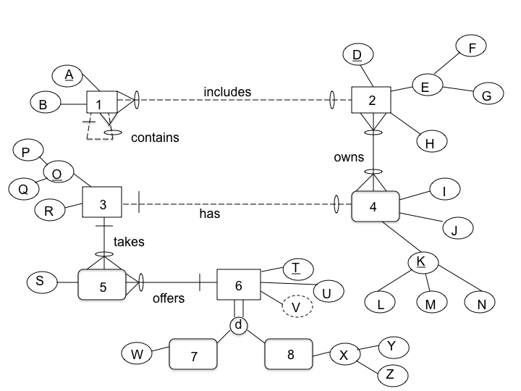

**YOUR TRANSPOSED RELATIONS:**

1(A, B)

2(D, E, F, G, H, *L, M, N*)

2(L) MUST EXST IN 4(L)

2(M) MUST EXST IN 4(M)

2(N) MUST EXST IN 4(N)

3(O, R, Q, P)

4(I, J, L, M¸ N, *D*)

4(D) MUST EXIST IN 2(D)S

5(S, *O, T*)

5(T) MUST EXIST IN 6(T)

6(T, U)

7(*T,* W)

7(T) MUST EXIST IN 6(T)

8(*T*, Y, Z)

8(T) MUST EXIST IN 6(T)

2. (2 points) Using the E-R diagram above, please explain why entity 7 is weak and what the specific term for that type of entity is.

**REASON:** Entity 7 is weak because it relies on a **strong** Entity 6 due to the partial specialization that breaks down to either one of them.

**TERM:** Subtype Entity

3. (2 points) Using the E-R diagram above, please explain why entity 5 is weak and what the specific term for that type of entity is.

**REASON:** There is a “0” on entity 5 offering as it is not needed to be taken by Entity 3 therefore is not required.

**TERM:** Subtype Entity

4. ( 1 point) Using the E-R diagram above, please explain what relationship makes entity 4 weak and what about that relationship causes it to be weak.

**EXPLANATION:** The relationship that makes entity 4 weak can be due to the intersectionality between entity Entity 3 and Entity 2 as visible by their crow feet.

**Part 2 – RIT Savings and Loan (50 points)**

1. (50 points) Transpose the E-R diagram above into relations, implementing all relationships. Denote primary keys and foreign keys appropriately. Use proper relation notation. You need to provide reference statements.

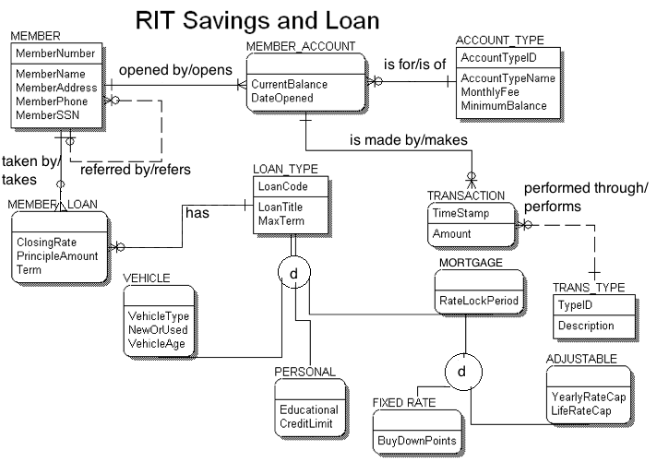

**YOUR TRANSPOSED RELATIONS:**

MEMBER(MemberNumber, MemberName, MemberAddress, MemberPhone, MemberSSN)

MEMBER_ACCOUNT(CurrentBalance, DateOpened, *MemberNumber, AccountTypeID*)

MEMBER_ACCOUNT(MemberNumber) must exist in MEMBER(MemberNumber)

MEMBER_ACCOUNT(AccountTypeID) must exist in ACCOUNT_TYPE(AccountTypeID)

ACCOUNT_TYPE(AccountTypeID, AccountTypeName, MonthlyFee, MinimumBalance)

MEMBER_LOAN(ClosingRate, PrinicpleAmount, Term, *MemberNumber*)

MEMBER_LOAN(MemberNumber) must exist in MEMBER(MemberNumber)

LOAN_TYPE(LoanCode, LoanTitle, MaxTerm, *MemberNumber*)

LOAN_TYPE(MemberNumber) must exist in MEMBER_LOAN(MemberNumber)

TRANSACTION(TimeStamp, Amount, *MemberNumber*)

TRANSACTION(MemberNumber) must exist in MEMBER_ACCOUNT(MemberNumber)

MORTGAGE(RateLockPeriod, *LoanCode*)

MORTGAGE(LoanCode) must exist in LOAN_TYPE(LoanCode)

TRANS_TYPE(TypeID, Description)

VEHICLE(VehicleType, NewOrUsed, VehicleAge, *LoanCode*)

VEHICLE(LoanCode) must exist in LOAN_TYPE(LoanCode)

PERSONAL(Educational, CredLimit, *LoanCode*)

PERSONAL(LoanCode) must exist in LOAN_TYPE(LoanCode)

FIXED_RATE(BuyDownPoints, *LoanCode*)

FIXED_RATE(LoanCode) must exist in MORTGAGE(LoanCode)

ADJUSTABLE(YearlyRateCap, LifeRateCap, *LoanCode*)

ADJUSTABLE(LoanCode) must exist in MORTGAGE(LoanCode)