ISTE-230 Introduction to Database & Data Modeling

## Homework #7 – Implementing a Relational Schema using SQL

DUE:

**Name: ____Edward Riley___________________**

**Submit your script to the HW#7 Dropbox by the deadline.**

(It may be helpful to right-click on the  icon and select Hide Spelling Errors and Hide Grammatical Errors.)

An E-R diagram and transposed relations for ACME Online have been developed and given to you for analysis. Create a script, called ‘*yourlastname*_HW7.sql’ that will include all statements that will create a database called ‘*yourlastname_*ACMEOnline’ and the tables that will implement the relational schema meeting provided specifications. Make sure that your statements are in a sequence that will execute without errors.

Be sure to include appropriate constraints (primary key, foreign key, etc). Constraints should be table level, except for NOT NULL, and be named appropriately (table_pk for primary key; table_attr(s)_fk for foreign key). For foreign key attributes, you will need to determine the data type and whether or not a NOT NULL constraint is needed.

Once the structure is in place, you will need to add the data specified to the tables. Use transactions to ensure that statements that need to be executed as a “unit” are handled in that fashion.

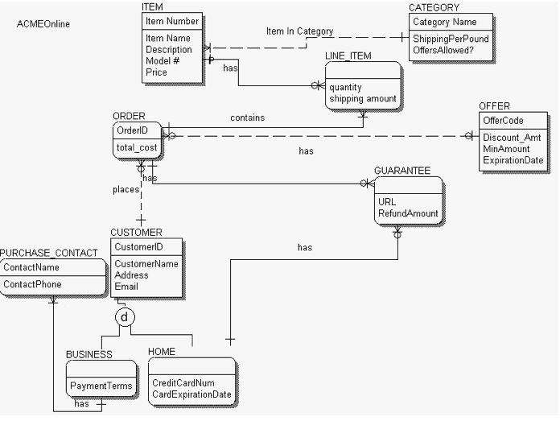

# ACMEOnline relations:

CATEGORY(Category Name, ShippingPerPound, OffersAllowed)

* Category_Name should allow up to 35 characters to be stored.
* ShippingPerPound should be able to store digits in the format ##.##.
* OffersAllowed should allow only ‘y’ and ‘n’ to be entered.

ITEM(Item Number, Item Name, Description, Model, Price, *Category Name*)

ITEM(Category Name) mei CATEGORY(Category Name)

* Item_Number an integIteer that will store only positive values and automatically increment by 1 when a record is inserted.
* Item_Name should store up to 35 characters. A value is required.
* Description should store up to 255 characters.
* Model should store up to 50 characters. A value is required.
* Price should be able to store digits in the format ######.##. A value is required.
* If the value for Category_Name is changed in CATEGORY, the change should be reflected here as well.

LINE_ITEM(*Item Number, OrderID*, quantity, shipping amount)

LINE_ITEM(Item Number) mei ITEM(Item Number)

LINE_ITEM(OrderID) mei ORDERED(OrderID)

* Quantity should be capable of storing a whole number up to 255 only.
* Shipping_amount should be able to store digits in the format ####.##.
* If an OrderID in ORDERED is changed, then the change should be reflected here as well.
* If an ORDERED is deleted, then any LINE_ITEM(s) associated with that order should also be deleted.
* If the Item_Number of an ITEM is changed, then the change should be reflected here as well.

OFFER(OfferCode, Discount_Amt, MinAmount, ExpirationDate)

* OfferCode should allow up to 15 characters to be stored.
* Discount must should up to 35 characters to be stored. A value is required.
* MinAmount should be able to store digits in the format ##.##. A value is required.
* ExpirationDate should store a date value. A value is required.

ORDERED(OrderID, total_cost, *CustomerID,* *OfferCode*)

ORDERED(CustomerID) mei CUSTOMER(CustomerID)

ORDERED(OfferCode) mei OFFER(OfferCode)

* ORDER is a reserved word in MySQL, so the table will need to be called ‘ORDERED’ instead.
* OrderID an integer that will store positive values and automatically increment by 1 when a record is added.
* Total should allow digits in the format of ########.## to be stored.
* If the CustomerID of a CUSTOMER is changed, that change should be reflected here as well.
* If the OfferCode of an OFFER is changed, that change should be reflected here as well.

CUSTOMER(CustomerID, CustomerName, Address, Email)

* CustomerID an integer that will store only positive values and automatically increment by 1 when a record is added.
* CustomerName should allow up to 50 characters to be stored. A value is required.
* Address should allow up to 150 characters to be stored. A value is required.
* Email should allow up to 80 characters to be stored.
* A discriminator should be added to determine participation in any subtype(s).

BUSINESS(*CustomerID*, PaymentTerms)

BUSINESS(CustomerID) mei CUSTOMER(CustomerID)

* PaymentTerms should allow up to 50 characters to be stored. A value is required.
* When the CustomerID of a CUSTOMER is changed, the change should be reflected here as well.

HOME(*CustomerID*, CreditCardNum, CardExpirationDate)

HOME(CustomerID) mei CUSTOMER(CustomerID)

* CreditCardNum will store exactly 16 characters. A value is required.
* CardExpiration will store exactly 6 characters. A value is required.
* When the CustomerID of a CUSTOMER is changed, the change should be reflected here as well.

PURCHASE_CONTACT(ContactName, *CustomerID*, ContactPhone)

PURCHASE_CONTACT(CustomerID) mei BUSINESS(CustomerID)

* ContactName should allow up to 50 characters to be stored.
* ContactPhone should store exactly 12 characters. A value is required.
* When the CustomerID of a BUSINESS customer is changed, the change should be reflected here as well.

GUARANTEE(*OrderID, CustomerID*, URL, RefundAmount)

GUARANTEE(OrderID) mei ORDERED(OrderID)

GUARANTEE(CustomerID) mei HOME(CustomerID)

* URL should be able to store up to 50 characters.
* RefundAmount should be able to store digits in the format ##########.##.
* When an OrderID is changed or deleted, it should be reflected in GUARANTEE
* When a CustomerID is changed, the change should be reflected here as well

**ACMEOnline Data:**

Please populate CATEGORY table with the following data:

+---------------+------------------+---------------+

| Category_Name | ShippingPerPound | OffersAllowed |

+---------------+------------------+---------------+

| Books | 0.99 | y |

| Home | 1.99 | y |

| Jewelry | 0.99 | n |

| Toys | 0.99 | y |

+---------------+------------------+---------------+

4 rows in set (0.00 sec)

Please add the following data to the ITEM table:

+--------------------------------+-----------------------------------------------+------------------+---------+---------------+

| Item_Name | Description | Model | Price | Category_Name |

+--------------------------------+-----------------------------------------------+------------------+---------+---------------+

| Cabbage Patch Doll | Baby boy doll | Boy | 39.95 | Toys |

| The Last Lecture | Written by Randy Pausch | Hardcover | 9.95 | Books |

| Keurig Beverage Maker | Keurig Platinum Edition Beverage Maker in Red | Platinum Edition | 299.95 | Home |

| 1ct diamond ring in white gold | diamond is certified vvs, D, round | 64gt32 | 4000.00 | Jewelry |

+--------------------------------+------------------------------------------------------------------+---------+---------------+

Please add the following data to the OFFER table:

+------------+----------+-----------+----------------+

| OfferCode | Discount | MinAmount | ExpirationDate |

+------------+----------+-----------+----------------+

| 345743213 | 20% off | 20.00 | 2013-12-31 |

| 4567890123 | 30% off | 30.00 | 2013-12-31 |

+------------+----------+-----------+----------------+

4 rows in set (0.00 sec)

Please add the following data for Janine Jeffers. You must make sure that all of the statements needed to accomplish what is described below are considered a single "unit", which will ensure that either all of the statements execute or none of them execute.

CustomerName: Janine Jeffers

Customer Address: 152 Lomb Memorial Dr., Rochester, NY 14623

Email: [jxj1234@rit.edu](mailto:jxj1234@rit.edu)

Credit Card Number: 1234567890123456

Card Expiration: 012014

Update Janine’s customer record to denote that she is a ‘home’ customer

Order Total: 4919.75

Offer Code: 4567890123

Line Item: OrderID=1; Item Number = 4; Quantity=1; Shipping_amount= .99

Line Item: OrderID=1; Item Number = 2; Quantity=2; Shipping_amount= 3.99

Line Item: OrderID=1; Item Number = 3; Quantity=3

Please add the following data for Joey John Barber Shop. You must make sure that all of the statements needed to accomplish what is described below are considered a single "unit", which will ensure that either all of the statements execute or none of them execute.

CustomerName: Joey John Barber Shop

Customer Address: 15 John St., Rochester, NY 14623

Email: [jj1978@hotmail.com](mailto:jj1978@hotmail.com)

Payment Terms: 30/90 days

Update Joey John Barber Shop’s customer record to denote that it is a ‘business’ customer

Order Total: 299.95

Offer Code: 345743213

Line Item: OrderID=2; Item Number = 3; Quantity=1

Contact Name: Joey James

Contact Phone: 585-475-1234