**ISTE-230 Introduction to Database & Data Modeling**

**Homework #9 – SELECT statements and FUNCTIONS**

DUE:

**Name:** Edward Riley

**Submit your script to the HW#9 Dropbox by the deadline.**

Needed to complete: MySQL version 5

Download the createBOOK.sql script execute it to create the database shown in the ER diagram below.

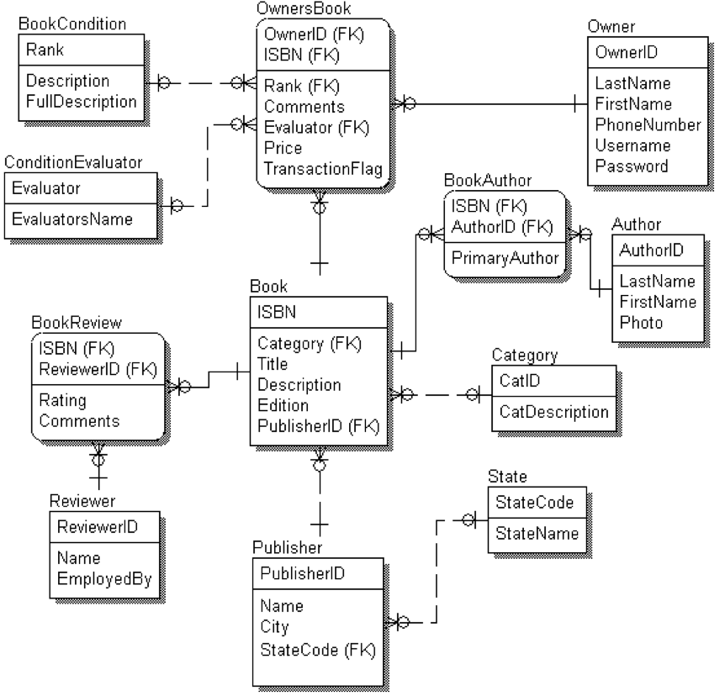

Captured in English, the entities of this Universe of Discourse, and the relationships among them, can be described like this:

|  |  |
| --- | --- |
| **Book** | .. (1) identified by an **ISBN**, (2) written by one primary **BookAuthor** and zero or more secondary **BookAuthors**, (3) categorized by subject matter **Category**, (4) published by **Publisher**, and (5) reviewed in a given **BookReview** |
| **BookAuthor** | .. individuals that are either the primary or secondary author(s) of a specific **Book** occurrence |
| **Author** | .. individuals that are primary or secondary authors |
| **BookReview** | .. the rating assigned to a specific **Book** occurrence by a given **Reviewer** |
| **Reviewer** | .. individuals that review **Book**s and assign a rating to it |
| **OwnersBook** | .. **Book**s *owned* by **Owners** that are deemed to be in a certain **Condition** as rated by a **ConditionEvaluator** |
| **Owners** | .. individuals that *own* **OwnersBook**s |
| **Condition** | .. the set of **Condition “**rankings” (1..5, corresponding to “bad”, “poor”, “average”, “good” and “excellent”) that can be assigned to an **OwnersBook** |
| **ConditionEvaluator** | .. individuals that evaluate the condition of a book and assign a **Condition** to it |
| **Category** | … the set of **BOOK** subject matter classifications |
| **Publisher** | .. publishes **BOOK**s in a given U.S. **State** |
| **State** | .. state codes and full state names |

Query the database

For each of the tasks that follow you will write a SQL statement that will answer the question given the specifications provided. The results you should achieve are shown after each task (unless a sort order is specified, if your records appear in a different order but the content is the same, that is fine). The SQL statement for each task, along with a preceding comment denoting the task number, should be placed in a script that follows the format ‘*yourlastname_*HW9.sql’.

* (17 points) Count the number of publishers that are in each city, statecode combination. Your output should match the display given below (including column headings):

+-------------------+-------+

| Location | Count |

+-------------------+-------+

| San Francisco, CA | 1 |

| Rochester, MN | 1 |

| Hartford, CT | 1 |

| Boston, MA | 1 |

| Rochester, NY | 2 |

| Chicago, IL | 3 |

| New York, NY | 4 |

+-------------------+-------+

7 rows in set (0.00 sec)

* (31 points) For EVERY book in the book table, show the title, the count of the number of ratings, the minimum rating, the maximum rating, and the average rating rounded to the nearest penny. Your results should be sorted by the count of the number of ratings in descending order, followed by the average ratings in descending order. Your output should match the display given below (including column headings):

+--------------------------------------------------+---------------+------+------+---------+

| title | Total Ratings | Low | High | Average |

+--------------------------------------------------+---------------+------+------+---------+

| Yes! Networking is for Bills Fans | 3 | 5 | 8 | 6.33 |

| The Shortest Book in the World | 2 | 10 | 10 | 10.00 |

| My Love's Last Lingering Lost | 2 | 8 | 9 | 8.50 |

| From Brockport to IT | 2 | 7 | 10 | 8.50 |

| How to Keep your Cellular Bill Down | 2 | 7 | 8 | 7.50 |

| Women are From Venus ORACLE is from Beyond Pluto | 1 | 10 | 10 | 10.00 |

| My Love's Last Longing | 1 | 10 | 10 | 10.00 |

| My Lost Love's Long Last Lingering | 1 | 9 | 9 | 9.00 |

| JAVA: It's more than Just a Programming Language | 1 | 9 | 9 | 9.00 |

| How to add Class to your Programming | 1 | 9 | 9 | 9.00 |

| I Lasted my Love's Last Lingering Longing | 1 | 7 | 7 | 7.00 |

| My Love's at Long Last Lost his Lingering | 1 | 7 | 7 | 7.00 |

| How to Keep your Cable Bill Down | 1 | 7 | 7 | 7.00 |

| From Deep in the Heart of Texas to IT | 1 | 6 | 6 | 6.00 |

| From the Shores of Lake Erie to IT | 1 | 4 | 4 | 4.00 |

| ER, SOM, NF, DK/NF, SQL, JDBC, ODBC, and RELVAR | 1 | 4 | 4 | 4.00 |

| Tired of wired? Infrared instead! | 0 | NULL | NULL | NULL |

| Master Wireless Through The Classic Comics | 0 | NULL | NULL | NULL |

| Master HTML Through The Classic Comics | 0 | NULL | NULL | NULL |

| Master C++ Through The Classic Comics | 0 | NULL | NULL | NULL |

| Calculus for Phys Ed Majors | 0 | NULL | NULL | NULL |

| The Science of Literature Searching | 0 | NULL | NULL | NULL |

| A language without Pointers? Priceless. | 0 | NULL | NULL | NULL |

+--------------------------------------------------+---------------+------+------+---------+

23 rows in set (0.00 sec)

* (23 points) Show the publisher name and count of books published for those publishers that have published more than two books. Records should be sorted by the count of books published in descending order, followed by publisher name in ascending order. Your output should match the display given below (including column headings):

+----------------------------------+------------+

| Publisher Name | Book Count |

+----------------------------------+------------+

| ReadEmandWeep Romance Publishing | 5 |

| CovertoCover Publishing | 4 |

| EZRead Masterpiece Comics | 3 |

+----------------------------------+------------+

3 rows in set (0.00 sec)

* (18 points) Write a query that will select all of the book titles that have “bill” in their name and will display the title of the book, the length of the title, and the part of the title that follows “bill”. Your output should match the display given below (including column headings). (HINT: Use SUBSTR and INSTR.)

+-------------------------------------+--------+------------+

| title | Length | After Bill |

+-------------------------------------+--------+------------+

| Yes! Networking is for Bills Fans | 33 | s Fans |

| How to Keep your Cellular Bill Down | 35 | Down |

| How to Keep your Cable Bill Down | 32 | Down |

+-------------------------------------+--------+------------+

3 rows in set (0.00 sec)

* (11 points) Show a listing of used book titles that are available (used books are found in ownersbook). A title should only appear once in the listing. Your output should match the display given below (including column headings):

+-------------------------------------------------+

| title |

+-------------------------------------------------+

| The Shortest Book in the World |

| From the Shores of Lake Erie to IT |

| My Love's at Long Last Lost his Lingering |

| My Love's Last Lingering Lost |

| How to Keep your Cellular Bill Down |

| Yes! Networking is for Bills Fans |

| My Love's Last Longing |

| From Deep in the Heart of Texas to IT |

| How to Keep your Cable Bill Down |

| I Lasted my Love's Last Lingering Longing |

| My Lost Love's Long Last Lingering |

| ER, SOM, NF, DK/NF, SQL, JDBC, ODBC, and RELVAR |

| The Science of Literature Searching |

+-------------------------------------------------+

13 rows in set (0.00 sec)