**ISTE-230 Introduction to Database & Data Modeling**

**Practice Exercise # 5 – Normalization through 2NF**

**Name:** Edward Riley

For each problem below, given the original relation and functional dependencies, normalize the original and all resulting relations to 2NF.  Be sure to use proper relational notation: RELATION(pkattr, attribute, *fkattr*).  Include reference statements for foreign keys.

**Problem #1**

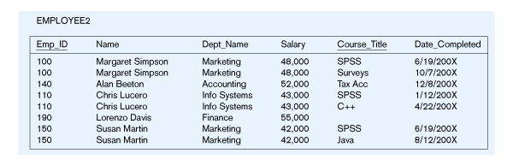

EMPLOYEE2(Emp_ID, Name, Dept_Name, Salary, Course_Title, Date_Completed)

Functional Dependencies:

Emp_ID, Course_Title ➔ Name, Dept_Name, Salary, Date_Completed

EmpID ➔ Name, Dept_Name, Salary

**YOUR ANSWER (Final set of relations normalized to 2NF):**

**EMPLOYEE-COURSE(Emp_ID, ~~Name, Dept_Name, Salary~~, Course_Title, Date_Completed)**

**EMPLOYEE-COURSE(Emp_ID) mei EMPLOYEE(Emp_ID)**

**EMPLOYEE(Emp_ID, Name, Dept_Name, Salary)**

**Problem #2**

ENGINEER-SERVICE(empID, firstname, lastname, email, serviceID, servicename)

Functional Dependencies:

empID, serviceID ➔ firstname, lastname, email, servicename

empID ➔ firstname, lastname, email

email ➔ empID, firstname, lastname

serviceID ➔ servicename

**YOUR ANSWER (Final set of relations normalized to 2NF):**

**ENGINEER-SERVICE(empID, ~~firstname, lastname, email,~~ serviceID, ~~servicename~~)**

**ENGINEER-SERVICE(empID) mei ENGINEER(empID)**

**ENGINEER-SERVICE(serviceID) mei SERVICE(serviceID)**

**ENGINEER(empID, firstname, lastname, email)**

**SERVICE(serviceID, servicename)**

**Problem #3**

Movie

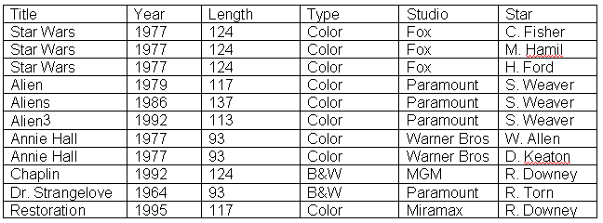

MOVIE(Title, Year, Length, Type, Studio, Star)

Functional Dependencies:

Title, Star ➔ Year, Length, Type Studio

Title ➔ Year, Length, Type, Studio

**YOUR ANSWER (Final set of relations normalized to 2NF):**

**MOVIE-LIST(*Title*, ~~Year, Length, Type, Studio,~~ *Star*)**

**MOVIE-LIST(Title) mei MOVIE(Title)**

**MOVIE(*Title*, Year, Length, Type, Studio)**

**Problem #4**

APPOINTMENT(clientID, providerID, apptDate, startime, endtime, firstname, lastname, notes, street, city, state, zipcode, phone, fname, lname,cellnum, serviceID, servicename, price, duration, description, email)

Functional Dependencies:

clientID, providerID, apptDate, serviceID, starttime ➔  endtime, firstname, lastname, notes, street, city, state, zipcode, phone, fname, lname, cellnum, servicename, price, duration, description, email

clientID ➔ firstname, lastname, street, city, state, zipcode, phone, email

email ➔ clientID, firstname, lastname, street, city, state, zipcode, phone

providerID, serviceID ➔ price

providerID ➔ fname, lname, cellnum,

serviceID ➔ servicename, duration, description

**YOUR ANSWER (Final set of relations normalized to 2NF):**

APPOINTMENT(*clientID, providerID,* apptDate*,* starttime*,* endtime, ~~firstname, lastname~~, notes, ~~street, city, state, zipcode, phone, fname, lname,cellnum~~, *serviceID,* ~~servicename, price, duration, description, email~~)

APPOINTMENT(clientID) mei CLIENT(clientID)

APPOINTMENT(providerID, serviceID) mei PROVIDER(providerID, serviceID)

CLIENT(clientID, firstname, lastname, street, city, state, zipcode, phone, email)

PROVIDER(*providerID, serviceID*, price, ~~firstname, lastname, cellnum, servicename, duration, description~~)

PROVIDER(providerID) mei PROVIDER(providerID)

PROVIDER(serviceID) mei SERVICE(ServiceID)

PROVIDER(providerID, firstname, lastname, cellnum)

SERVICE(serviceID, servicename, duration, description)