ISTE-230 Introduction to Database & Data Modeling

Homework # 2 – Interpret, Transpose, and Implement a Single Entity E-R Diagram in MySQL
DUE:
Name: ___________Edward Riley___________

Part 1
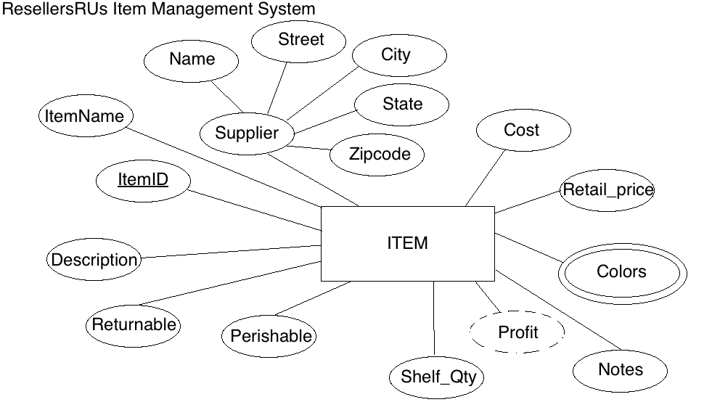
For the table below, please classify each attribute specified based on the E-R diagram above. Please place the best answer for each column that best describes the attribute.
Attribute | Composite or Simple | Single-valued or Multi-valued | Stored or Derived | Identifier ? (Yes or no)
Profit | Simple | Single-valued | Derived | No
Street | Simple | Single-valued | Stored | No
ItemID | Simple | Single-valued | Stored | Yes
Supplier | Composite | Single-valued | Stored | No
Colors | Single | Multi-valued | Stored | No
Part 2
Using relational structure notation, please transpose the E-R diagram below.
Your Answer:
ITEM(Name, Street, City, State, Zipcode, ItemID, ItemName, Description, Returnable, Perishable, Shelf_Qty, Notes, Colors, Retail_price, Cost)
Part 3
Create a script that includes the statements that will create a database called ‘HW2’ that includes a table for ITEM, based the relation above in Part 2 and the specifications in the table below . Use ONLY the data types discussed so far (CHAR, VARCHAR, INT, and DATE).
Attribute(s) | Data type description
Attributes not listed below | Variable-length string up to 25 characters
State | Fixed-length string of 2 characters
Zipcode | Stored in the format ‘#####-####’ or ‘#####’
Cost; Retail_price | Variable-length string up to 10 characters
Notes; Description | Variable-length string up to 255 characters
Returnable; Perishable | Will store one character
Shelf_Qty | A whole number between 0 and 50000

Your Answer:
-- AUTHOR: EDWARD RILEY
-- PROJECT: HW2
-- DATE: 2018/09/11
-- PURPOSE: Be able to retrieve information on a single ITEM database.

-- Drop the database if it already exists
DROP DATABASE hw02;

CREATE DATABASE hw02;

USE pe02;

CREATE TABLE item
(
state CHAR(2),
Zipcode CHAR(10),
cost VARCHAR(10),
Retail_price VARCHAR(10),
Notes VARCHAR(255),
Description VARCHAR(255),
Returnable CHAR(1),
Perishable CHAR(1),
Shelf_Qty VARCHAR(50000),
Name VARCHAR(25),
Street VARCHAR(25),
City VARCHAR(25),
ItemID VARCHAR(25),
ItemName VARCHAR(25),
Colors VARCHAR(25),

CONSTRAINT item_pk PRIMARY KEY(ItemID)

);

Submit to the Homework #2 dropbox, this document edited to include your answers and also the script file created for Part 3.

