Ignore the awful picture but we want to keep the tag line: Springboard Creating a better you...

See: www.rawhorizons.co.uk for ideas of the feel we want

The ‘team page’ has a picture that M likes, and he is suggesting something similar i.e. a landscape with people in it.

You already have the pic of Michael; you need one of me and there is a picture of Michael’s house I can send if you need that.

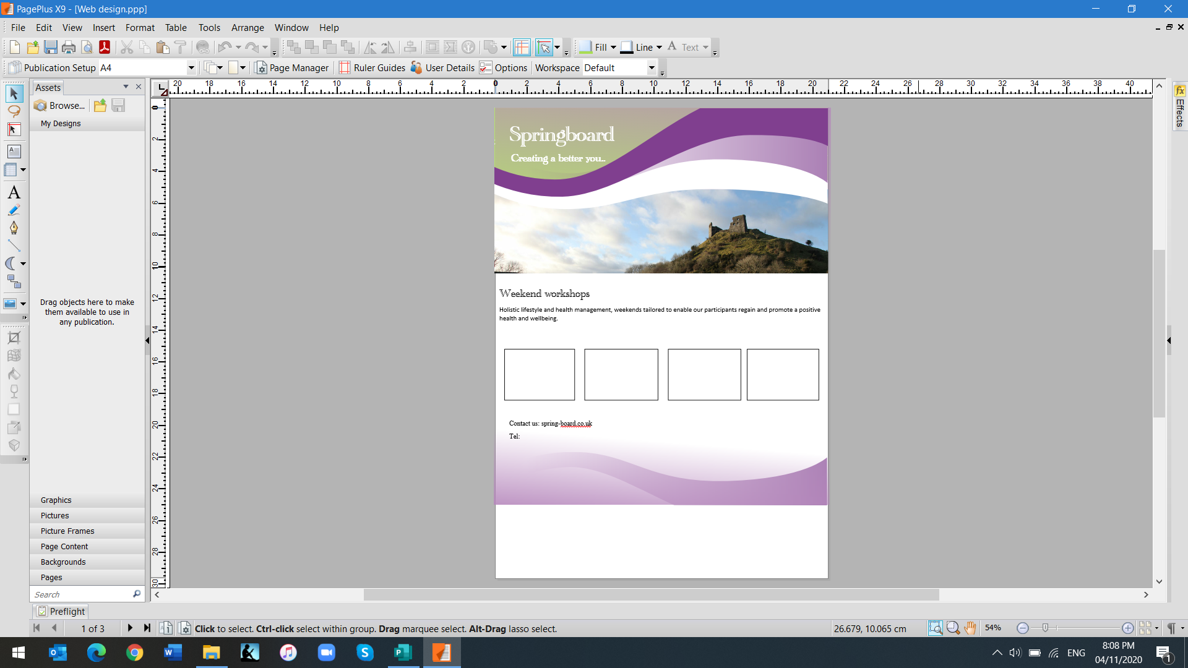**Content:**

Did you wake up this morning full of energy and enthusiasm for the day ahead? Do you have a clear direction in life, know where you are going and how you are going to get there?

No?... Maybe Springboard can help!

Springboard offers a starting point for those wanting to improve their lives physically, mentally and spiritually. Run by two health practitioners with many years’ experience, and expertise in a variety of therapies, we aim to give participants at our weekend workshops a gentle and supportive introduction to the simple ways in which they can begin to turn their lives around.

Our passion is to help people achieve their health goals. We limit our weekends to a small number of participants to make sure that everyone gets the personal attention they need. Each weekend is tailored to provide information, interaction, strategies, and techniques to take away and use.

Our location in the beautiful Welsh countryside, together with delicious healthy home cooked food, ensures that this will be a tranquil and relaxing experience that will allow everyone to unwind and get the maximum benefit from the time spent with us.

M doesn’t want man above woman so would like the bits about us side by side if possible with my bit on the left

Michael

Leaving a career in education and management behind him and as a result of experiencing difficult times and significant life trauma, Michael rediscovered his life purpose and developed a passion and desire to help and serve others. He now has a successful wellbeing business supporting individuals to achieve the best version of themselves as a Life Coach, personal trainer, sports massage therapist and yoga teacher.

Christine

Forced to leave her teaching career through disability, Christine went on to heal herself using the same therapies that she now teaches and shares with others. She incorporates healing, meditation and visualisation, Emotional Freedom Technique, and Natural Nutrition, all of which work with the energy of the human body to restore health and wellbeing.

**Weekend Workshops**

We have a range of Health and Wellbeing workshops planned for 2021. However due to the current situation with Covid-19 we are unable to provide details or specific dates at the present time.

Please contact us for further information or to be added to our waiting list. We will email you in due course, as soon as we are able to release dates and programme details.

Contact details

Michael: 07595 041953

Christine: 07852 500677

Email: spring-board@mail.com