**BTR beam stopping benchmarks**

E.D. Dlougach :: RRCKI [Dec 18 - Apr 18]

The interaction between the energetic neutral beam and plasma can be divided in two stages: the beam ionization with the creation of energetic ions, and the fast ions thermalization (also called as ‘slowing down’). The beam ionization is the process when the fast neutral particles are converted into fast ions due to the interaction with the plasma and this happens mainly due to three atomic reactions (similar for H, D or T particles): charge exchange (CX), ionization by ions (II), and ionization by electrons (EI).

Tangential injection of the neutral beam (i.e. parallel to the plasma magnetic axis) provides the beam passage of the highest density plasmas, creating a sufficient thickness of the target for beam capture by plasma core. The injection can be also carried out not along, but perpendicular to the plasma axis, which is technologically easier, but the beam is captured less efficiently in this case. The resulting ions are trapped by the magnetic field created in tokamak. In a transverse injection scheme the energy of ions across the magnetic field is high, and they are more likely to be captured and lost on banana orbits than in parallel injection. Due to the limitations associated with the location of toroidal coils, the design of the channel for tangential injection requires a more precise adjustment of all components of the beamline. The main advantage of tangential schemes is that they provide a higher length (total thickness) of beam ionization - almost 100% - for heating and maintaining the plasma current. During the energy transfer from the beam to plasma, some part of the neutral particles can pass throughout the plasma without ionization (shine-through), and this part creates a thermal load on the opposite (‘first’ or ‘far’ in other publications) wall of the plasma chamber - shine-through losses and power. Another source of fast ions losses is their neutralization, or charge exchange with neutral particles shortly after their generation. The resulting neutrals leave the plasma or become ionized again along their way to the wall, i.e. at a larger radius from plasma axis. This also leads to direct losses and broadening of the beam power profile (the beam ‘imprint’) in plasma.

**Preface and backgrounds**

The NB heating and current drive in plasma is higly efficient only when the beam is effectively captured by plasma core. The values of the neutral beam atoms energy and the plasma bulk density are typically chosen so that the when the atoms mean free path is sufficient to reach and heat the plasma core, and must not be too high compared with the beam total track in plasma. Our current estimations of beam stopping show, that for tangentially injected beam, the effective beam capture is obtained (> 90%) when the mean free path of atoms is less than one trird of the total beam lenth in plasma. It is also important to ensure that the resulting fast ions free path is less than the minor radius of plasma [1], otherwise the first-orbit losses can be high.

We can expect that the beam ‘penetration depth’ (e-times decay) is directly proportional to the beam energy and inversely proportional to the plasma density: *λi ≈ k*Eb/ne* (where k – coefficient, dependant on the beam atom mass. In the presence of impurities, the effective charge of plasma grows up, the penetration depth decreases, and the ionization and charge-exchange rates increase, and the probability for the beam atoms ionization in plasma periphery (SOL) rises as well.

The relevant range of plasma densities can be roughly estimated - for a given beam energy and the beam-plasma relative geometry. The approach for **σs** evaluation can be found in next paragraph.

For example, for DEMO-FNS [2] tokamak, which is very similar to ITER we have:

Beam : **Eb = 500 keV**, deuterium (A = 2)

Plasma : R = 3.2m, a = 1m.

According to the NBI geometry, the total beam path (torus chord length) in plasma is **Lb ≈ 5.5m.**

The ionization is mainly guided by plasma ions, the reaction average cross-section with account of multi-step enhancement is **σs ≈ 10-20 m2**.

We can next draw a Table 1 - with the values Ne, (Ne σs), λ =1/ (Neσs), Lb/ λ, Fs = exp(-Lb/ λ), Fc =1 – Fs. By plasma density Ne we mean the average along the beam path (chord-average).

Table 1 **DEMO-FNS** NB losses against plasma density

Plasma density (Ne), atoms mean free path (λ ), beam lost (shine-through) part (Fs) and captured in plasma (Fc)

|  |  |  |  |  |  |
| --- | --- | --- | --- | --- | --- |
| Ne, 1019 m-3 | (Neσs), m-1 | λ =1/(Neσs), m | Lb/ λ | Fs = exp(-Lb/ λ) | Fc =1 - Fs |
| 1.0 | 0.1 | 10.0 | 0.55 | 0.58 | 0.42 |
| 2.0 | 0.2 | 5.0 | 1.1 | 0.33 | 0.67 |
| 4.0 | 0.4 | 2.5 | 2.2 | 0.11 | 0.89 |
| 6.0 | 0.6 | 1.7 | 3.2 | 0.04 | 0.96 |
| 8.0 | 0.8 | 1.25 | 4.4 | 0.01 | 0.99 |
| 10.0 | 1.0 | **1.0** | 5.5 | 0.004 | 0.996 |

The same procedure can be applied for ITER NB in plasma.

Beam : Eb = **1000 keV**, deuterium (A = 2)

Plasma : R = 6.2m, a = 2m.

According to the NBI geometry, the total beam path (torus chord length) in plasma is **Lb ≈ 13m.**

The ionization is mainly guided by plasma ions, the reaction average cross-section with account of multi-step enhancement is **σs ≈ 0.5 * 10-20 m2**.

We can next draw a Table 2. By plasma density Ne we mean the average along the beam path (chord-average).

Table 2 **ITER** NB losses against plasma density

Plasma density (Ne), atoms mean free path (λ ), beam lost (shine-through) part (Fs) and captured in plasma (Fc)

|  |  |  |  |  |  |
| --- | --- | --- | --- | --- | --- |
| Ne, 1019 m-3 | (Neσs), m-1 | λ =1/(Neσs), m | Lb/ λ | Fs = exp(-Lb/ λ) | Fc =1 - Fs |
| 1.0 | 0.05 | 20.0 | 0.65 | 0.52 | 0.48 |
| 2.0 | 0.1 | 10.0 | 1.3 | 0.27 | 0.73 |
| 4.0 | 0.2 | 5.0 | 2.6 | 0.07 | 0.93 |
| 6.0 | 0.3 | 3.3 | 3.9 | 0.02 | 0.98 |
| 8.0 | 0.4 | 2.5 | 5.2 | 0.006 | 0.994 |
| 10.0 | 0.5 | **2.0** | 6.5 | 0.002 | 0.998 |

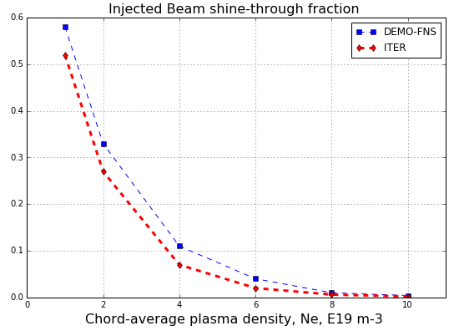It can be seen from the Tables 1and 2, that for efficient beam capture (Fc > 90%) the minimum chord-average plasma density should be  **̴4-5** *1019 m-3(for ITER and DEMO-FNS). The effect of the plasma thickness on shine-through power (lost fraction) is shown in fig. 0.

Fig. 0. Shine-through beam losses versus the chord-average plasma density. Deuterium ‘thin’ beam.

**DEMO-FNS:** Eb = 500 keV, Lb ≈ 5.5m; **ITER:**  Eb = 1000 keV, Lb ≈ 13m

Fig. 0 just reflects the common trend, the beam total decay due to capture by plasma is close to exponential, thus the first, ‘manual’, verification of the beam–plasma model is very simple. When the fast ions mean free path λi has the same order of value as λ (low collisions frequency), the condition ***λi < a*** *(a* - minor plasma radius) is fulfilled only for the scenarios with higher density, with higher beam capture (in the Tables 1and 2 they are marked red). These scenarios, i.e. with **Ne ≈ 1020 m-3** are pretty good for the first wall (FW) too, as the shine-through thermal load to the FW surface of both tokamaks will be less than 1% of the injected beam power, leading to 0.15 MW FW load in ITER and 0.1 MW for DEMO-FNS, and this is acceptable (the maximum FW power load adopted is 1MW/m2).

Fig. 0 also reflects the known fact that, despite the different *destinations* and therefore operating conditions, the two tokamaks (DEMO-FNS and ITER) will have much *in common* concerning the beam capture in plasma, and all the trends are expected to be similar, probably scalable. This is the reason why the beam-plasma model at first is mainly verified for DEMO-FNS facility, i.e. on the physical data more available.

**CROSS-SECTIONS DATA** *(from [3])*

The reliability of the optimization of heating and of the current drive profile depends upon the accuracy of the calculations of the deposition profiles of the heat and momentum of the beam in the plasma [3]. These calculations in turn depend on the accuracy of the relevant atomic cross-sections which determine the location of the beam deposition. A correct determination of these cross-sections (is therefore essential for analysing and optimizing the performance of candidate heating and current drive systems for future experiments. At high energies and high

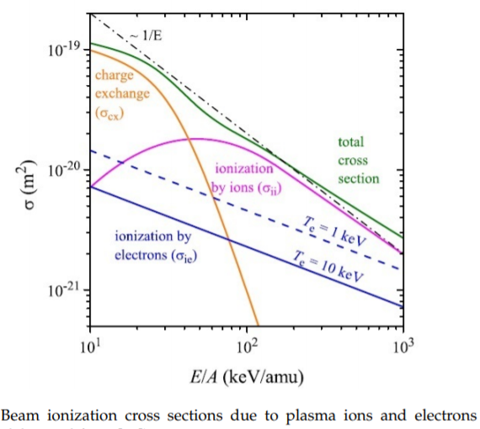plasma densities, the effects of multiple collisions between the neutral atoms in the beam and the plasma constituents become important, leading to the cross-section enhancement (*δ)*.

The energy of the injected beam atoms essentially exceeds the thermal energy of the plasma particles. The rates of ions generation due to the fast neutral collisions with plasma ions and electrons depend on the effective cross-sections of ionization and charge-exchange, fig.1. These cross sections depend on the energy and mass of the fast atoms, and the plasma impurities content (or effective charge). Atoms with energy per nucleon Eb/A < 40 keV are primarily ionized by charge exchange, whereas higher energy neutrals (DEMO-FNS, ITER, etc) are primarily ionized in collisions with ions.

Fig. 1 Beam ionization cross-sections due to plasma ions and electrons. The electron impact is shown for electron temperatures 1keV and 10 keV

Multistep processes, such as excitation with subsequent ionization, start to play an important role in the beam attenuation and may considerably enhance the effective stopping cross-section. For beam energies above 1 MeV/u and plasma densities of the order of 1014cm-3 or above, this enhancement can increase the stopping cross-section from -50% up to a factor of two (or more).

The effective beam stopping cross-section depends on the beam energy E, the plasma density ne and the plasma Zeff, and very weakly on the plasma electron temperature Te. For a given beam energy, the results are practically insensitive to the value of B (< 1 %).

**Dependence of and *δ* on beam energy**

Fig. 2 (figs 5a, 6a in [3]) gives the dependence of and *δ* on the beam energy ***E*** in the range 10 keV/u to 104 keV/u, for Zeff = 1, and for ne = 1013, 1014 and 1015 cm-3. The energy dependence of as in the region above 80-100 keV/u is (E-1 In E), consistent with the energy behavior of the dominant excitation and electron loss (ionization) processes in this region. In the region below 50 keV/u, the slope of the cross-section changes, since the dominant electron loss mechanism in this region becomes the electron capture on plasma protons (see Fig. 1). Fig. 2 also shows that increases with both plasma density (and Zeff, which is not shown here). The effect of multistep processes on the energy dependence of is more clearly demonstrated by the dependence of *δ* =*δ*(E).

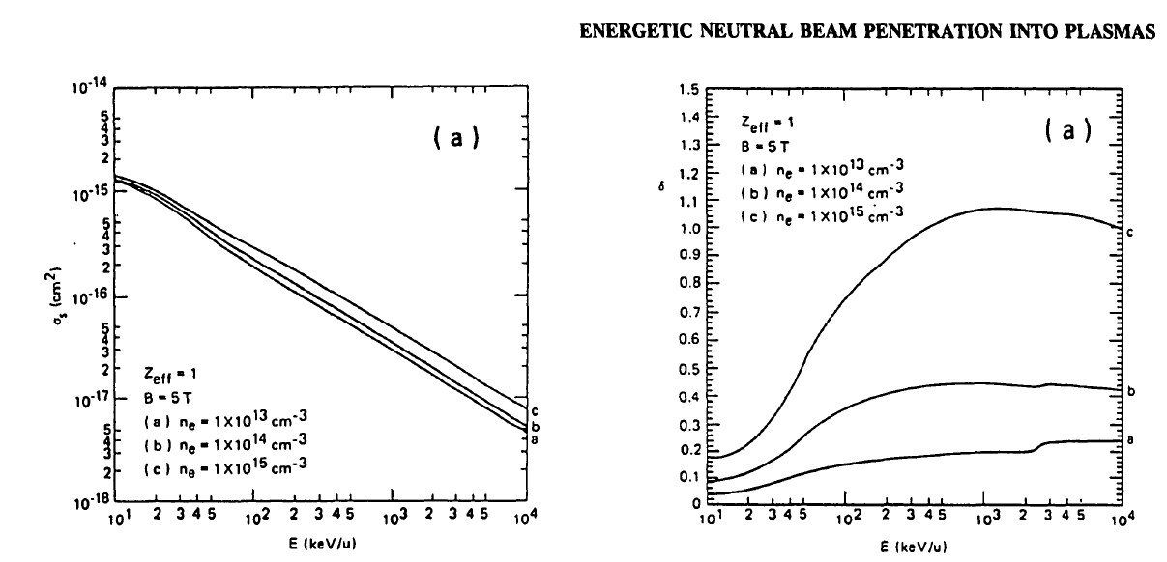

Fig. 2 Energy dependence of the effective beam stopping cross-section and enhancement factor ***δ*** for 3 values of plasma density and for Zeff = 1.

**Dependence of and *δ* on plasma density**

Fig. 3 (figs 7a, 8a in [3]) shows the dependence ofand *δ*  on the plasma density ***ne*** for a number of beam energies and for Zeff = 1. The dependence of is fairly weak for ne < 1014 cm-3 and becomes appreciable only above this density value and for beam energies above 200 keV/amu. However, the effect of the plasma density on the beam attenuation enhancement ***δ***is quite dramatic for densities of > 1013 cm-3 and beam energies above 150-200keV/u, as is evident from Fig. 3.

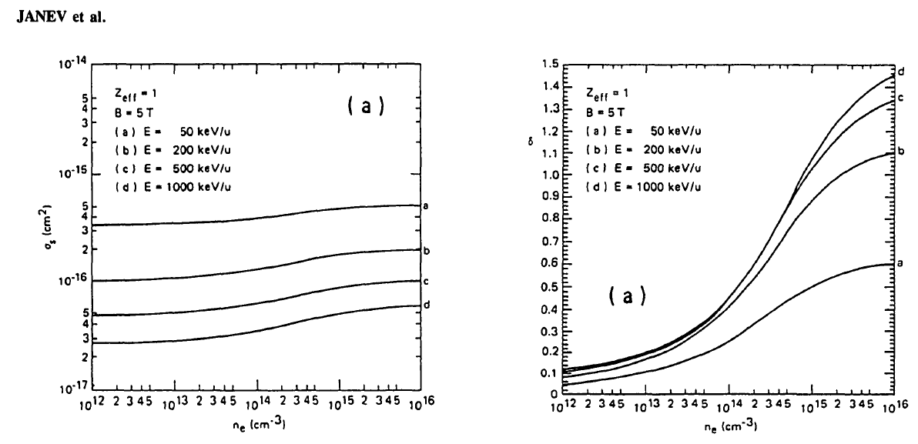

Fig. 3 Density dependence of and *δ* for Zeff = 1 and a number of beam energies.

**Dependence of and *δ*****on Zeff**

Fig. 4 (i.e. figs 9, 10 in [3]) displays the dependence of and *δ* on the effective plasma ion charge ***Zeff*** for ne = 1014 cm-3 and E= 50, 200, 500 and 1000 keV/amu. The linear dependence of on Zeff is apparent from the figure. This

linearity holds also for other values of plasma density.

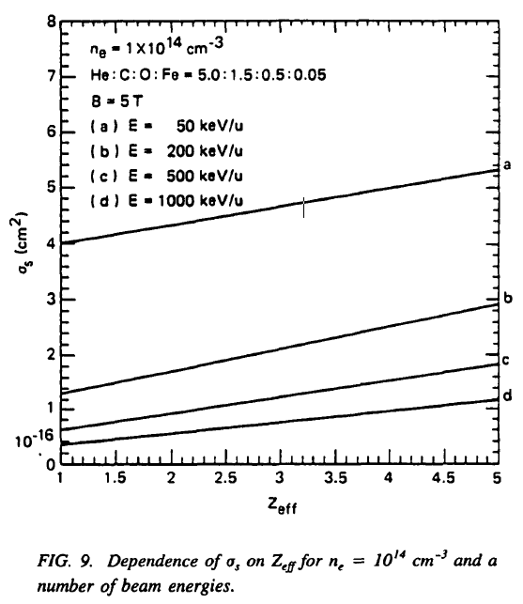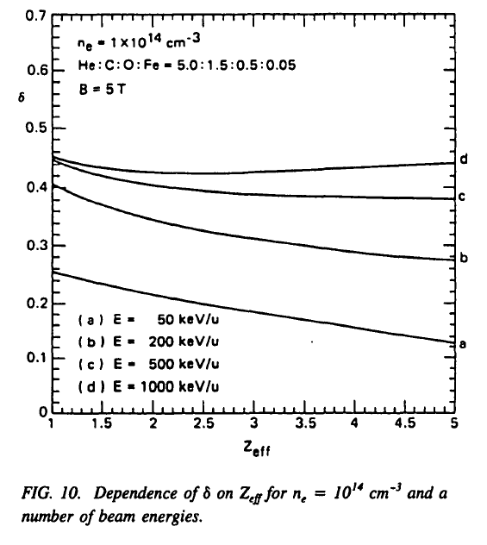

Fig. 4 Dependence of and *δ on* Zeff for ne = 1014 cm-3 and a number of beam energies.

**Dependence of and *δ* on Te**

The stopping cross-section varies with Te and Ti because of the Maxwellian averages involved in the rate coefficients. The dependence on Ti can always be ignored for ***E > Ti***, which we assume to be the case. A weak dependence on Te, however, is always present.

**Resume**

Inspection of the behavior of the beam stopping cross-section on the parameters E, ne, Zeff and Te ( Figs 2,3,4) shows that only the dependences of on **E** and **Zeff** are **strong**, while the dependences of  on **ne** and **Te** are relatively **weak**. The E-dependence of  in the energy region above 100 keV/amu is dominated by the Bethe-Born behavour (E-1 In E) of the most important atomic processes contributing to in this region (excitation and ionization). The linear dependence of on Zeff in a broad range of variation of the E, ne and Te parameters was noted. Separating out explicitly the dominant E-1 part in (E) and the linear Zeff dependence of , all other parametric dependences of as are weak (logarithmic).

**BTR MODEL and METHODS**

The BTR model of beam capture calculates the neutral beam current decrease in plasma from the entry point (injection port) till the ‘terminal’ point, where beam residuals meet the FW solid surface (First Wall of plasma chamber, FW). The neutral beam current decay is brought by ionization of beam particles, the 3 main branches include ionization by impact on electrons and ions and charge exchange with plasma ions. Their cross-sections are defined from atomic database (discussed below), they are dependant on the atoms energy and plasma local parameters (see fig. 1 ). It is shown above, the dominant process for the higher beam energies (of our interest) is the ion branch (including impurities), and the electron branch is less important, while charge-exchange of atoms with plasma ions becomes negligible for beam energies > 100keV/amu.

The result ionization rate for each track step can be expressed as a sum of these branches of ionization: electron collisions, proton collisions, charge exchange with plasma particles and ionization on impurities.

The main 3 processes of atomic beam ionization are the following (same for H, D or T particles):

  - collisional ionization on plasma ions ( – for protons) – ‘II’

  - collisional ionization on plasma electrons – ‘EI’

 - charge exchange collision with plasma ions – ‘CX’

Fast atoms can also be ionized by plasma impurities. Finally, the beam intensity attenuation along the path is:   
 *=* **(1)**

We can write a beam total stopping (ionization) cross-section as

where - the rate coefficient averaged over a Maxwellian velocity distribution.

The mean free path ***λ*** of the beam atom can be written as .

Beam stopping cross section can increase up to 200% if we take into account *multistep ionization*. The actual ionization model should take into account of additional (multi-step) processes, so that the result beam stopping is represented by 2 terms: direct and cascade (multistep enhancement), and the enhancement factor δ is given by:

 , δ ~ 20%, E ≤ 80keV/amu),

δ ~ 100%, E ≥ 600keV/amu

Finally, the beam intensity decay along its path in plasma at each point (L – current path length) is naturally expressed as

≈ =  **(2)**

To determine the next ionization point along the beam particle track, there are 2 obvious methods. The ionized part of beam current can be fixed (P0), so that an integration along the path is performed until the probability hits the condition P = P0  along the step [l, l+Δl]. As the beam current (and ionization rate) falls exponentially along the beam path, the spatial step rises also as exponent, and the constant value of P0  for thick plasma leads the current perish before the particle meets FW. Thus, the better approach is to fix the tracking step (Δ*l* = const), and to calculate the ionization probability P and the neutral current detached along each step [*l, l+Δl*].

To define the local plasma parameters, including the cross-sections, the particle local point is mapped to the coordinate system (poloidal flux or other radial coordinate) in plasma. Thus each point in toroidal coordinates (R, Z, ϕ) is converted to a point (ψ, ϕ), where azimuth angle ϕ along the toroidal axis can be omitted for axial symmetry, and ψ (R, Z) is the normalized poloidal flux – a kind of magnetic surfaces ‘labels’. Next, the preset plasma parameters (*Te, Ti, ne, Zeff*) are set as profiles on ψ (R, Z). These tabulated plasma parameters are then used for calculating the stopping cross-sections (or the mean free path λ) at the current track point. To retrieve the cross-sections data for beam ionization BTR invokes a separate script (C++), which is written for extracting the relevant data from the ADAS resource library [4], and for their tabulation onto ψ (R, Z). When the profiles of cross-sections are added to the set of plasma profiles, BTR applies them to calculate the local values of target thickness and the current decay Fb. The non-ionized part of the beam Fb at the FW surface is added to the shine-through power load on FW.

To calculate the ionized part of a ray at each track step, BTR calculates the beam decay and the plasma target thickness. The calculation procedure for each trace step includes:

* convert the 3D point position of particle from NBI coordinates to tokamak reference coordinates (R,Z,ϕ);
* define the poloidal flux value ψ = ψ(R,Z);
* define the values of plasma density, temperature and Zeff from the known 1D profiles as f(ψ);
* define the local cross-sections, including the correction factor;
* define the mean free path λ along the step;
* define the plasma target thickness along the step (the ionization probability) Lb/ λ;
* calculate the ionization rate according to **(1)**
* calculate the decrease the atomic particle current on this thickness according to **(2)**.

The value of plasma target thickness is calculated using the atomic cross-sections data [4], the plasma density profiles are provided by ASTRA code [9], the profiles are tabulated along the radial coordinate ψ(R,Z). The poloidal flux field (2D matrix) is defined in EQDSK [10] standard format (R,Z) and also delivered by ASTRA. The cross-sections of beam ionization are depend on the plasma parameters (n, T, Zeff), so they can be also defined and tabulated as 1D profiles versus the same radial coordinate ψ. The magnetic configuration (ψ field) and plasma n/T/Z profiles BTR takes from ASTRA as an input data (no verification), while the cross-sections values, which are highly critical for the entire model of beam decay and shine-through calculation, can be retrieved independently by BTR and then compared with the data used by NUBEAM. For this purpose and to serve BTR beam-plasma future calculations, a separate module (C++) was made, which allows to check the cross-sections data for different beam energies (500keV for DEMO-FNS, 1MeV for ITER).

**BENCHMARK PURPOSES and METHODS**

**The reasons of BTR extension to plasma**

BTR beam model is *simple* and manually *tuned*, it can calculate with high accuracy the 3D *distribution of ionization points* in plasma using the greater amount of particles, comparing with other beam codes (MC), which results in BTR better *particles statistics* - for any region of interest, including plasma.

BTR runs the most *detailed spatial* neutral beam geometry, which includes 1280 total beamlets, each beamlet cone is split to 100 – 10000 rays (or ‘big’ particles) according to bi-gauss angular distribution, and typically all the beamlets have their *individual parameters* of bi-gauss profile, i.e. the angular thickness along horizontal and vertical. Each big particle of the beamlet is 3D traced with account of all the background *electro-magnetic fields*, which are deflecting the ions tracks, leading to the atoms velocity *scattering*. The secondary particles arising in the atomic processes on gas (or plasma) targets are also traced.

The NBL channels and components intercept some parts of the beam, along with the beam deflection in background fields the *final shape* of the injected beam and its *velocity distribution* are changed. It means that, unlikely other beam-plasma codes which perform the straightforward beam tracing, the injected beam calculated by BTR, is not the same as simply extrapolated from the ion beam source (idealized). To calculate the accurate beam deposition in plasma, any beam-plasma code should accept not only the beam *power profile* at the entrance, but also the 3D *velocity distributions* of the beam particles, otherwise the calculation model is less accurate (compared with BTR)). This can be important in particular for the calculations of the fast ions losses and plasma current generation, where *the pitch angle* precision (i.e. the angle between the ion velocity and magnetic field vector) should be very high, as even small deviations lead to erroneous *losses* of fast ions and the resulting power loads on FW.

BTR models of beam tracing/transforms are usually simpler and more ‘straightforward’ if compared with Monte-Carlo methods, and BTR particles never lose their total current and are traced as long as necessary, allowing to have a good statistics even when the amount of particles is not high (and the running time is small). As a result, it was found, that BTR model works better in the dense (thick) plasmas, than some MC codes, intended to simulate the beam penetration.

The beam ionization model in plasma implements the same code procedures used by all ‘BTR specific’ models for particles/current conversions, based on the cross-sections and target thickness. These procedures were properly tested and *benchmarked* against other calculations several years ago by IO stuff. The detailed verification was made for neutralization and re-ionization regions, thus the model application to plasma seems quite natural.

There are codes currently used, which just take density profile of the beam (from BTR or PDP codes) and calculate the further beam deposition based on these profiles. We’ve shown here, that this approach is not too accurate, even if several profiles are used for ‘interpolation’. For more refined tracing, a code needs to know not only the injected beam profile, but also the velocity distribution of the injected atoms.

**BTR plasma model limitations and the main benchmark purpose**

BTR typically applies simplified models of current conversions (but not for the beam geometry). The reductions are made for the code general purpose - to provide the User a relatively simple, quick and practically independent tool for beam behavior and physics study along the beamline, and currently also for beam stopping in plasma. BTR performs non-consistent beam modelling in plasma, by applying the “frozen” plasma configuration, with minimum parameters needed. BTR calculates the atomic beam decay and ionization rate - without any feed-back to plasma properties. The input data for plasma can be provided either by the experiment, by other transport codes, or even ‘created’ by the User via BTR interactive GUI.

BTR does not trace the fast ions in plasma, and not evaluate the additional losses of the beam due to charge exchange, atoms ionization in SOL, or first-orbit ion losses in the core. Although BTR *allows* to extend the current beam tracing model to ions in plasma, this is not the main interest for BTR Users (at least now). According to ‘global’ BTR idea, the beam losses and shine-through power loads can be evaluated with a minimum input data, and without complicated codes engagement. But it is clear, that to make this tool available for usage, the reduced model should be thoroughly tested and compared with other beam-plasma codes (complicated), the difference between the results must be evaluated and understood. Therefore the main reason behind the current benchmarks was not to obtain the high results quality with more detailed codes, but to evaluate the BTR model precision and limitations comparing with more accurate data available from other codes. And for this purpose we use NUBEAM (Monte Carlo beam code) bundled with the transport code ASTRA (1D). We ensure that codes apply the same input data, concerning the plasma geometry and scenario, we verify the beam geometries, we compare the tables of cross-sections which are derived independently by these codes (yet from the same database – ADAS), and finally overlap the beam ionization profiles –along the beam track and along the radial plasma coordinate (ψ). As the possible next extension of the beam-plasma model, BTR could evaluate the beam losses due to ionization in SOL and the fast ion losses due to charge-exchange.

**BTR Input (beam-plasma)**

These following input data are used *only* for BTR model comparisons against ASTRA+NUBEAM [5, 9]. As explained below, the User will not need to load all these data sets to evaluate the shine-through power and to obtain the load profiles at the FW, indeed, BTR reduced model, after the comparisons, would need a very small amount of input data.

* The tokamak (toroid) center position in NBI coordinates
* Plasma major (R) and minor (a) radii
* Tangential targeting point radius of beam injection
* FW geometry (2D profile) for shine-through calculation
* The plasma profiles ne /Te /Zeff are given as functions of poloidal flux ψ(R, Z). They can be either specified in terms of the plasma radius - or any other radial coordinate (e.g. toroidal flux ϱ)
* The 2D equilibrium magnetic configuration of ψ (R, Z) should be set. BTR currently applies the ‘standard’ EQDSK format [10], but other formats are possible too. The only requirement is the explicit definition of magnetic structure (in tokamak ref. coordinates), and the plasma profiles defined on it.

**BTR Output**

* the profiles of neutral beam decay for thin and thick beam models;
* the ionization rates along the beam path (for separate branches);
* several beam perpendicular cross-sections ‘located’ at different distance within plasma camera;
* the final (terminal) beam footprint at the far wall, the shine-through power loss.

**ASTRA code**

Transport analysis for steady-state scenarios is performed by ASTRA [9]. The model includes the self-consistent calculation of energy transport in plasma ions and electrons, which is normalized to the scaling for the tokamaks with a low aspect ratio, with calculation of magnetic poloidal flux and plasma core equilibrium. The spatial profiles of thermal conductivity are set as variable parameters. For electrical current generation, the neoclassical model of conductance and bootstrap current equations are applied, while the beam generated current is calculated by NUBEAM code [5]. Plasma density profile and its mean value are set as the model external parameters, while the temperature profiles (for plasma electrons and ions), as well as the poloidal flux profile, form the problem solution.

Simulations of the (main) plasma core parameters are typically carried out by the transport code ASTRA [9], a modular system for running transport simulations, with great flexibility in defining which equations are solved and allowing the user to easily specify additional information by hand. The basic set of ASTRA equations includes the expressions for the electron density ne, the temperatures Te/Ti and the poloidal flux Ψр. Two-dimensional equilibrium of the plasma core is calculated by three-momentum(?) approximation with a fixed boundary.

**NUBEAM code as a first benchmarking tool for beam stopping**

NUBEAM is PPPL's Monte Carlo package for evaluation of the deposition, slowing down, and thermalization of fast ion species in tokamaks. It considers the neutral beam as a source of fast ions [5].

In NUBEAM the fast ion species are created as a result of neutral beam injection or as the product of nuclear fusion reactions. The ions slowing down calculation includes the effects of collisions with charged species, collisions with beam-injected and background neutral species (leading to charge exchange losses), and the orbit guiding center and finite larmor radius excursions of the fast ion trajectories. Profiles of fusion reaction rates are also computed, taking into account both fast ion - thermal and fast ion - fast ion reaction categories. NUBEAM code (1D) is chosen for BTR beam stopping model primary verification – due to its high availability and because it has much in common with BTR model in the part, concerning the account of different channels of atomic beam capture in plasma, i.e. beam ionization as a result of collisions with charged species (including charge-exchange collisions). Thus NUBEAM model can be adjusted to calculate the same beam current profile along its path in tokamak to compare with BTR procedures. However, due to some limitations (result of 1D) of the beam geometry model, NUBEAM doesn’t allow (or maybe hardly allows) to set the detailed beam focusing structure likewise in BTR, so throughout this report we perform the comparison of BTR beam profiles versus NUBEAM profiles only for “thin beam” (in NUBEAM) or “single ray” (in BTR) beam models. It should be noted, that the NUBEAM model of beam-plasma interaction and result beam losses is more detailed that that of BTR, as it calculates not only the fast ion source due to the primary beam atoms collisions with the plasma charged species (ions and electrons), but also the “secondary” beam losses due to the fast ions collisions with charged and neutral species. These features are not included to BTR beam-plasma model (not yet).

In 2009, NUBEAM was upgraded to make available ADAS [4] atomic physics. This allows a more accurate treatment of deposition with high energy beams in high density target plasmas where collisional excitation effects play a large role. Note, the ADAS data was acquired for NUBEAM through a software license and is distributed by agreement.

Finally, NUBEAM has been used for over twenty years, during which time it has been extensively validated against data from the PLT, PDX, PBX, TFTR, DIII-D, Asdex, JET, JT-60, and Textor tokamaks. And it is a relevant tool for a benchmark of BTR code as it is used in numerous applications for different tokamaks in particular for ITER [7]. NUBEAM code standalone version [8] is incorporated into the ASTRA transport code [9] and can be used in all ITER scenarios, calculated with the ASTRA code. The example of usage of ASTRA code with NUBEAM for ITER NBI is shown in fig. 5 taken from [7].

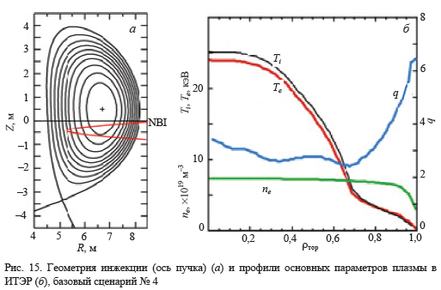 Fig.5 Example of plasma equilibrium configuration, beam injection geometry, and plasma profiles for ITER base scenario #4 (ASTRA code output)

The primary benchmarks of BTR beam stopping in the plasma include the atomic processes including the electron and ion impact ionization and charge exchange of fast atoms with thermal light ion species. Next, the impurities contribution to stopping cross section, as well as beam-beam charge-exchange and beam-beam impact-ionization can be gradually added. Beam-beam interaction includes the impact of hot ions on beam neutrals causing the ionization and charge exchange processes that is important when the hot ion component is large, but this is probably not the ITER case(?).

The *simple case* of NUBEAM run for two different neutral beams for DEMO-FNS facility (R/a=3.2m/1m, k=2, Ipl=4.5MA, B=5T) is presented in a Fig 6 from [11]. Beam attenuation and beam density as a function of magnetic surfaces are calculated for two cases taking into account the electron impact and ion impact ionization of beam neutrals. The mono-energetic horizontal beam of 30MW power and 500keV particle energy with a target parameter 3.4m is taken for these runs of two different sizes of the beam rectangular cross section: thin beam (1mm x 1mm) and 0.4m x 0.8m. Here rays of beam neutrals are parallel, neutral ray distribution in beam cross section is uniform.

|  |  |
| --- | --- |
|  |  |
| Fig 6 NUBEAM code output: beam attenuation rate (left) and density of beam neutrals (right) vs the normalized poloidal flux inside the main plasma for ‘thin’ beam (black) 1mm x 1mm, and for ‘wide’ parallel beam (red) 0.4m x 0.8m. Taken from [11]. | |
|  |  |

**BTR vs NUBEAM comparison**

BTR neutral beam, both for ITER and DEMO-FNS injectors, is composed by beamlets (1280, corresponding to the beam source grids structure), the beamlets axes are focused in horizontal and vertical planes to fit the injection window. The angular distribution of each beamlet is represented by splitting the beamlet cone to a large amount of rays along polar and azimuthal angles, each ray carrying its part of beamlet current (105 total rays per beamlet). The track step is about 1cm, while the total beam path in plasma is ̴13m in ITER and 5.5m in DEMO-FNS.

**Collisions cross-sections and multistep correction data**

NUBEAM code derives the data for atomic cross sections from NTCC PREACT Module [6]. To ensure the access of BTR code to the same atomic data and procedures (i.e. to use the same library, ADAS, described next), a special BTR servicing program, CS-module (C++ standalone) was written. The cross-sections deliveries then were carefully compared between both codes. The correction factor, i.e. the parameter of cross-section enhancement δ (here we use the multiplication coefficient *δ* = δ + 1*) which is caused by the excited states ionization, is taken into account according to [7]. Note, the calculation procedure of ***δ*** is currently available from *NUBEAM package only*, it is not calculated by BTR or any BTR servicing module (like CS-module), and therefore it is used as input data for BTR code.

NTCC Modules Library website (<https://w3.pppl.gov/NTCC>) is used to download the source code of **PREACT** module. PREACT module [6] performs lookups and interpolation of the rate (weighted product of cross-section and velocity) of various charge exchange, ionization, and fusion reactions. It has independent interfaces for use in both C++ and Fortran-77 codes. The C++ interface is fully object-oriented, and the Fortran-77 interface provides a layer above this C++ interface so that PREACT may be embedded in legacy Fortran-77 transport codes. An option to use ADAS cross sections is now supported by PREACT.

The Atomic Data and Analysis Structure [4] is an interconnected set of computer codes and data collections for modelling the radiating properties of ions and atoms in plasmas. It can address plasmas ranging from the interstellar medium through the solar atmosphere and laboratory thermonuclear fusion devices to technological plasmas. ADAS assists in the analysis and interpretation of spectral emission and supports detailed plasma models. ADAS provides a very large database of fundamental and derived atomic data. ADAS data and ADAS-generated data are incorporated in many plasma modelling codes such as B2-IRENE, CHEAP, DIVIMP, EDGE2D, SANCO and STRAHL and analyses such as differential emission measure.

PREACT module [6] generates data tables with real*8 precision, and for convenience supports both a real and a real*8 programming interface. The interface is "vector oriented", returning a list of reaction rate coefficients given a list of input parameters appropriate to the type of data sought; taking advantage of the vector feature can significantly benefit applications performance. PREACT is now used for all atomic and nuclear rate data in TRANSP. Installing PREACT and exploiting its vector capabilities resulted in a 10-15% speed-up of TRANSP's serial Monte Carlo fast ion calculation.

PREACT available reaction table groups are (the reactions applied by current model are marked bold):

**CX** -- (neutralizing) charge exchange between light neutrals and light fully stripped ions (H, He, Li)

**II** -- impact ionization + non-neutralizing charge exchange ionization of light neutrals by light ions (H, He, Li)

FS -- various fusion reactions involving D, T, He3

**EI** -- electron impact ionization and H+, e- recombination

SV -- stopping on fully stripped light impurities (C+6, O+8, scaled by Z for other impurities)

From C++ code, the ‘reactions’ are available by the user interfaces with the PREACT module via the six C++ classes

* + CXReaction - for charge exchange reactions
  + IIReaction - for ion impact ionization reactions
  + FSReaction - for fusion reactions)
  + EIReaction-for electron impact ionization and recombination reactions (vs. Te only)
  + SVReaction - for impurity stopping cross section tables (vs. Erel only)
  + ImpReaction - for impurity ionization, recombination and radiation

To retrieve the cross-sections data for beam ionization BTR invokes a separate script (C++), which is built to include the PREACT libraries and to call the methods calculating the reactions rates and cross-sections, which are then tabulated onto the preset ψ (R, Z) profile.

The results of cross-sections calculation by BTR and NUBEAM tools and their comparison are shown in Fig 7. The detailed verification was mainly performed for DEMO-FNS, and the same procedures were later applied to ITER too.



Fig 7 The results of cross-sections verification of BTR CS-module over NUBEAM procedures. Left - BTR ‘non-corrected’ cross-sections compared with NUBEAM “corrected” values; Right - the correction factor δ* applied by both codes

The profiles of the correction factor (cross-section enhancement δ***\* = δ + 1***) calculated and delivered by NUBEAM code are shown in Fig 8. They are represented as a function of plasma density ne (according to [7]) for different plasma temperatures Te, calculated for FNS facility parameters (beam energy 500 keV, Zeff ≈ 1.4) These data is not currently verified by BTR, and therefore it is used as a mere input data for BTR code.

It can be seen, and this is already shown in the Preface [3], for a fixed beam energy and Zeff, the profiles of δ* depend on plasma temperature *Te* quite weakly, so the correction factor data for each machine can be *tabulated* and used next by a beam stopping model (e.g. by BTR) as an input profile, similar to plasma parameters.

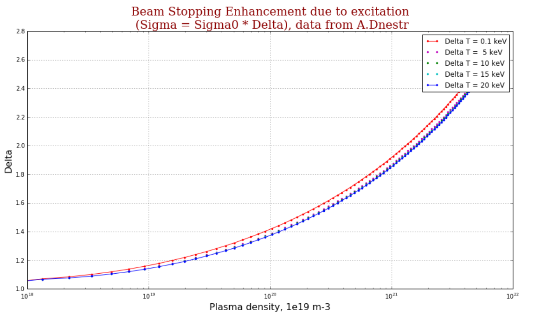

Fig 8 Ionization cross-section enhancement *δ* = δ + 1* versus plasma density *ne* for different plasma temperatures *Te*. Beam energy is 500 keV, Zeff ≈ 1.4 (for DEMO-FNS machine)

**RESULTS**

**DEMO-FNS machine for BTR benchmarks**

The one dimensional transport code ASTRA and the Monte Carlo code NUBEAM are used for simulations of a compact ST neutron source DEMO-FNS [2] steady state regime. The short description of procedure and the results of self-consistent simulations of the thermal energy transport, plasma-beam interaction and current drive are presented. The steady state regime in DEMO-FNS facility with averaged plasma density along minor radius <*ne*> ≈ 1020 m–3, with plasma current 1.5 MA, toroidal field 1.5 T and neutron output up to 5·1017 s–1 was obtained [12].

In the tokamak DEMO-FNS (neutron source) the neutrons are mainly generated in D-T reaction, taking place between the hot beam particles and core plasma ions. The neutral beam penetration, the hot particles thermalization (stopping) and the energy transfer to the ‘cold’ plasma components are calculated by NUBEAM code [5], which is integrated to ASTRA. The fast (energetic) particles losses include the orbital losses, the charge-exchange losses and the neutral particles shine-through the plasma core. The main difference of DEMO-FNS tokamak from experimental regimes on low aspect ratio tokamaks (ST) is a high density of injected power. This leads to the specific scenarios (working conditions): especially high fraction of fast (hot) particles, high rotation velocity, and low collisions rates.

|  |  |
| --- | --- |
| For DEMO-FNS the *density profiles* vs the poloidal flux are prescribed (see the figure on the right), and the temperature profiles of ions and electrons are calculated according to the energy balance model in the ASTRA code, taking into account the heating from the Neutral Beam, from the EC waves and from the D-T fusion reaction [13]. The calculated parallel current density profile is driven by the NB and the bootstrap current mechanism. Equilibrium with a prescribed plasma boundary is calculated by the SPIDER code. The magnetic configuration (poloidal flux 2D field in R/Z coordinates) is delivered by ASTRA as EQDSK file, which is further used by BTR code. The plasma parameters (density, temperature, and Zeff) are mapped as 1D profiles vs poloidal flux value and applied by both NUBEAM and BTR codes. |  |

The procedures for BTR calculation of the atomic beam decay, ionization rates and shine-through are described in the part *BTR MODEL and METHODS*. After the mutual verifications of local cross-sections (see *Cross-sections*), the ionized part of the beam, the total beam current decrease are calculated for the ray (incl. the correction factor). The result profiles of beam current from BTR and NUBEAM were overlapped, the maximum difference is evaluated for different beam geometries (single ray, rectangular, focused), and the possible reasons for deviations are considered.

For primary verifications against NUBEAM, BTR applies 3 main options of beam geometry:

* thin beam (single ray)
* parallel beam (rectangular beam box)
* realistic beam (converged box, with beamlets focusing)

The scheme of ‘realistic’ injected beam geometry in DEMO-FNS facility, which is used for BTR-NUBEAM benchmarks, is shown in Fig 9. The picture also presents the normalized poloidal flux field, loaded from EQDSK file (from ASTRA code) and the normalized plasma profiles, either preset (Ne) or calculated (Te) by ASTRA.

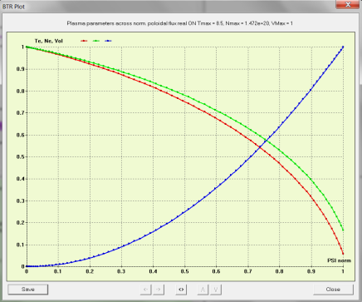 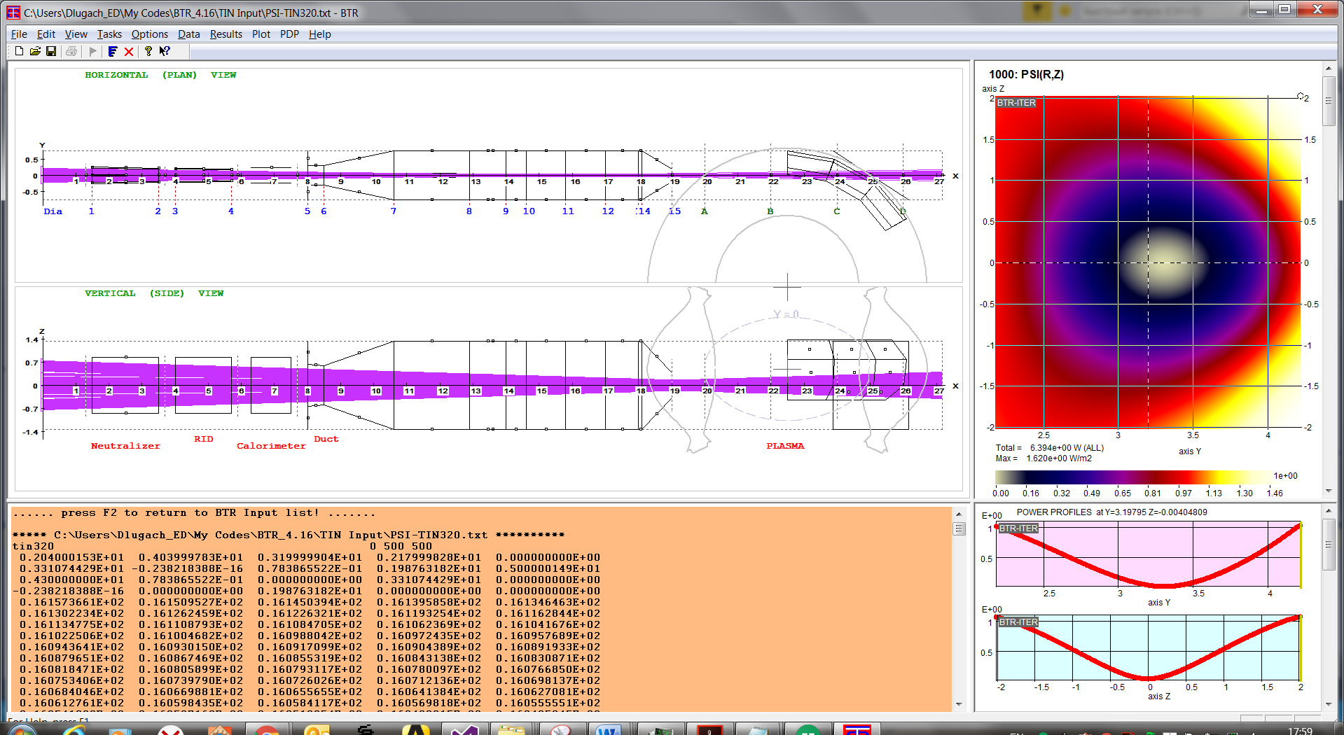

Fig. 9The beam geometry and poloidal flux field in DEMO-FNS facility with plasma profiles (right bottom chart).

The beam decay and partial ionization rates, calculated by BTR code for DEMO-FNS are shown in Fig 10. The profiles correspond to an ideal ‘thin’ beam or single ray, which is traced along the injected beam axis.

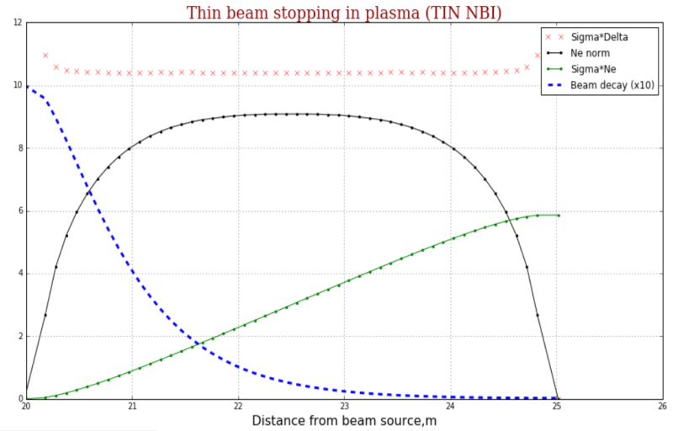 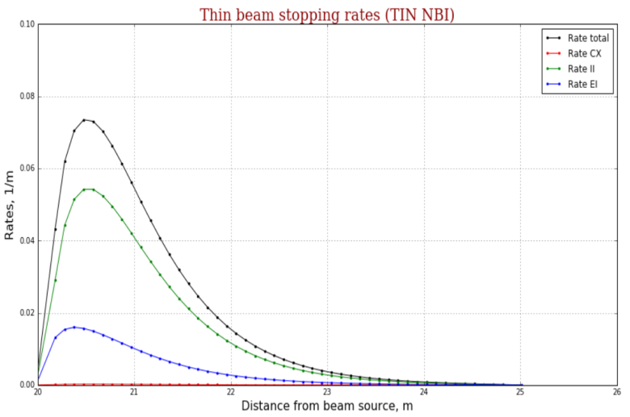

**BTR results**

Fig. 10 Beam decay (left, blue dotted line) and partial ionization rates (right) calculated by BTR code for DEMO-FNS. The profiles correspond to a ‘single ray’ traced along the injected beam axis. The results are used for primary verification against NUBEAM code.

‘Parallel beam’ option is the 2nd beam option applied in BTR-NUBEAM benchmarks is shown in Fig. 11. DEMO-FNS plasma configuration is visualized by poloidal flux ψ- surfaces, taken from EQDSK, calculated by ASTRA and then normalized to fit ψ = 1 at the separatrix, and ψ = 0 at the magnetic axis.

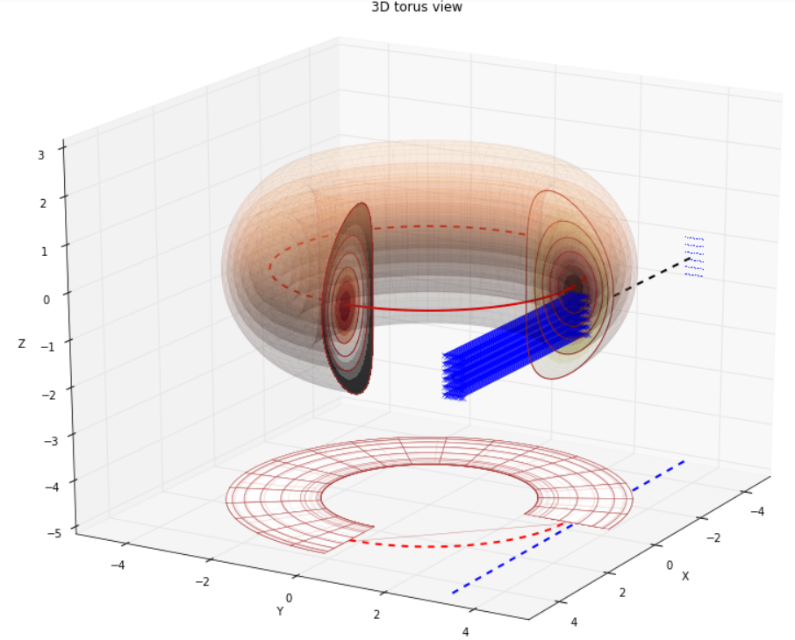 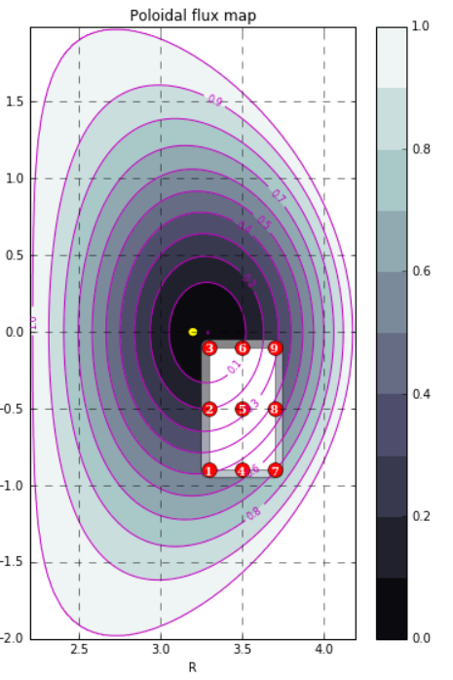

Fig 11. ‘Parallel beam’ option, the 2nd beam option applied in BTR-NUBEAM benchmarks for DEMO-FNS plasma. Plasma is represented by poloidal flux ψ- surfaces, taken from EQDSK file and normalized (ψ = 1 at the separatrix, ψ = 0 at the axis).

The profiles of the atomic current decay and the ionization rate, calculated by BTR for different beam geometry options are shown in Fig 12. : a – a single ray (thin beam approximation), b – parallel set of rays (rectangular box), c – converged (realistic), with account of beamlets focusing at the beam source GG. The left charts show the profiles plotted along the beam path, the right chart show the profiles plotted along the poloidal flux ψ coordinate (radial). Green profiles in the left charts show the normalized poloidal flux (ψ) value along the beam path. The partial volume, i.e. the volume between the ψ-surface and (ψ+dψ)-surface (green line on the right charts) is used for the averaging procedures for atoms and ions quantities. These ‘ψ - volumes’ are calculated by BTR while reading the poloidal flux matrix from EQDSK file – the cells with the value [ψ , ψ+dψ] are added to the partial volume, so that the result volume *Vψ* is a sum of the relevant cells. The accuracy of *Vψ* calculation depends on the matrix resolution (size) and on the step dψ. To have the smooth *Vψ* profile the step dψ should be large enough to contain more cells, but as result we have a small number of the ‘surfaces’ along which we apply the averaging procedures. As a result, we’d have rather coarse profiles for the beam current and ionization rate (red and blue lines on the right charts). If we want to obtain more detailed current profiles, to be able to compare them with NUBEAM, we need to reduce the interval between the surfaces dψ, which leads to ‘zigzags’ in ψ and *Vψ* profiles, and this can be observed in Fig 12 (green).

|  |  |
| --- | --- |
| a |  |
| b |  |
| c |  |

Fig 12. Injected beam current decay (blue) in plasma and atoms ionization rate (red) profiles - for different beam geometry options applied in BTR calculations and benchmarks against NUBEAM for DEMO-FNS plasma: a – single ray (thin beam), b – parallel set of rays (rectangular), c –focused (realistic, calculated by BTR only). The left profiles are along the beam path, the right – along the poloidal flux ψ. Green profiles show ψ value along the beam path (left charts) and *Vψ* (the ‘volume’ of ψ-surface, right charts), used for the averaging procedures in BTR. The ‘ψ - volumes’ are calculated based on EQDSK file.

Fig. 13 illustrates the comparison basic procedures between BTR and NUBEAM. Both codes apply the same plasma input configuration (parameters profiles and EQDSK). The following items are compared:

* the partial cross-sections,
* total beam decay
* partial ionization rates (all 3 branches are calculated separately).

All the profiles in fig 13 correspond to a ‘single ray’ beam option (in BTR) and ‘thin beam’ approximation (in NUBEAM). It can be seen, the difference between BTR and NUBEAM profiles is hardly noticeable, so we can assume, that BTR and NUBEAM models of beam ionization are identical, if they use the same cross-section database, and this result was not unexpected indeed.

|  |  |
| --- | --- |
|  | |
|  |  |
|  |  |

Fig. 13 DEMO-FNS tokamak. Examples of the comparison for the profiles calculated by BTR and NUBEAM codes with the same input (plasma profiles and EQDSK): the partial cross-sections, total beam decay and partial ionization rates (all 3 branches are calculated separately). BTR ‘single ray’ beam option is compared against NUBEAM ‘thin beam’ approximation. The results illustrate the basic procedure for BTR model verification.

After comparing a single ray option, it is interesting to study the effect of finite beam box on the beam capture. The set of parallel rays (see Fig. 11) are ‘injected’ and the result profiles are overlapped. Fig. 14 shows the result profiles for a bunch of 5 parallel rays, representing the ‘parallel beam’ option (4 edge rays and one axial ray). Black profiles are obtained by adding the 5 ‘single ray’ profiles. Left chart shows the atomic current decay, right chart – the total ionization rate. All the profiles shown are calculated by BTR code and verified over NUBEAM output. The results of comparison between the codes are similar to Fig 13 (a good agreement).

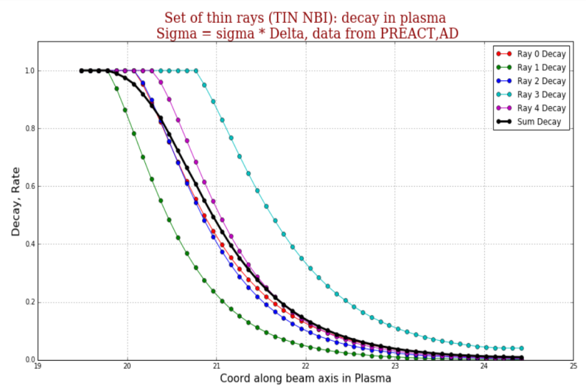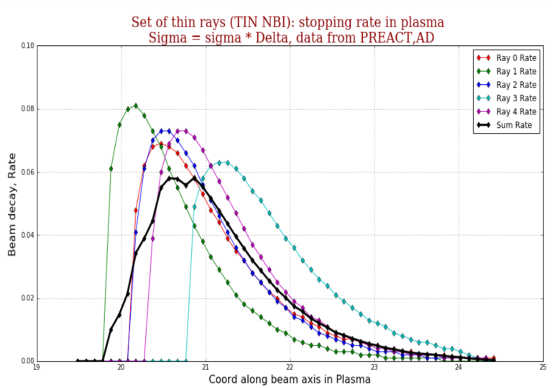

**BTR results**

**BTR results**

Fig. 14 DEMO-FNS. Beam decay (left) and total ionization rate (right) calculated by BTR code for a set of 5 parallel beam rays. The rays 0,1,3,4 are parallel to the beam axis (ray 2 is the axis) and represent the 4 ‘edges’ of rectangular beam box (Fig. 11). The black profiles correspond to the rays’ sum.

Similar procedures are performed for realistic beam geometry, where a set of 1280 beamlets is ‘injected’ to plasma (DEMO-FNS). The result profiles are shown in Fig 12c. The 2D distributions of beam ionization density can be also obtained by BTR – in vertical and horizontal planes, see Fig 15. It can be seen, that almost full part of the beam is captured before the half way is passed, and at least in this scenario the expected shine-through power is very small. The shine-through losses and power, calculated after, prove this expectation (< 1%).

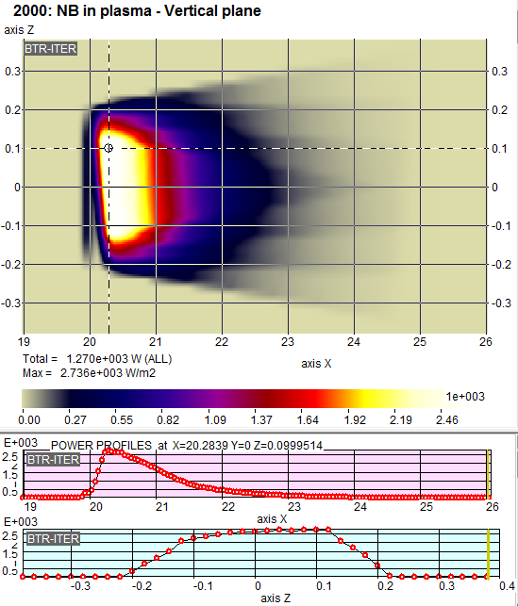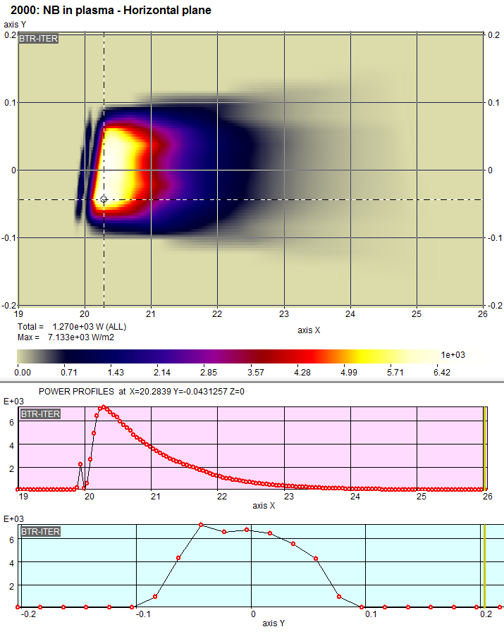

Fig. 15 DEMO-FNS. Beam ionization density maps in plasma: vertical (XZ) and horizontal (XY) beam ‘sections’. The horizontal axis of the plots is directed along NBI main axis (no inclination).

**Thermal loads onto the far wall due to the shine-through losses (TIN)**

At the plasma density corresponding to the base scenarios, the fraction of injected beam shine-through losses is very small (<1%). Due to the beam focusing at the injection port at the plasma entry, the refocused beam imprint on the opposite FW is wider, than at the entrance. Thus, to calculate the distribution of thermal loads onto the FW surface with high accuracy, the amount of traced particles (beam splitting model) should be enough to obtain the smooth and refined power density map. Note, in BTR we *don’t need* to reduce the plasma density proportionally with keeping the shape of the profile, as other beam-plasma codes [7] have to do (and this approach is not valid, see Fig. 0). The obtained beam direct losses trend versus plasma chord-average density is the same as shown in Fig 0. The first wall of ITER (and DEMO-FNS) is designed for thermal load not exceeding 1 MW/m2. Thus, for operation at a plasma density below 5⋅1019 м–3, additional protective elements at the beam facing FW surface are necessary.

BTR allows the user to define the FW geometry as 2D profile, the example is shown in fig. 16.

|  |  |
| --- | --- |
|  |  |

Fig 16. BTR for DEMO-FNS. The first wall (FW) 2D profile (left) used for shine-through imprint (beam direct losses), and the poloidal flux configuration used for plasma profiles mapping (right)

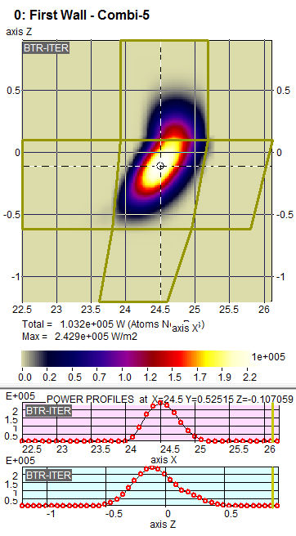The thermal power load distribution on the FW calculated by BTR for the full beam option is shown in Fig. 17.

Fig 17. DEMO-FNS. Thermal loads at the far wall due to the shine-through beam losses.

From fig. 17 the total power load is about 0.1 MW ( ̴1% of injected), with the peak power density is 0.24 MW/m2 for the steady-state operation scenario (DEMO-FNS) with Nemax ≈ 14.7*1019 m-3 (or <Ne> = 9.7*1019 m-3).

**Benchmarks for ITER**

Benchmarks of beam-plasma model against NUBEAM code were performed the same way for ITER geometry. Briefly the verification procedure is as following (if we resume the steps brought above).

The plasma profiles, i.e. the density, temperatures of ion and electrons versus Rho-normalized root square of the toroidal flux (got from ITER team Nov 2018) were used to calculate the equilibrium (in ASTRA) with a prescribed fixed boundary, by using the Spider equilibrium code [..]. The plasma boundary is taken from the EQDSK file. Next, NUBEAM code was used to calculate all the cross-sections and beam ionization rates along the beam axis based on the calculated equilibrium and plasma profiles. BTR applied the configuration of magnetic surfaces (EQDSK) and plasma profiles, then calculated all the tables of cross-sections (with special module), verified them with NUBEAM code output, and finally BTR calculated the rates and beam capture, which again converged with the NUBEAM output with high precision.

Note. The input data used to simulate the scenario for ITER plasma was not enough to calculate the equilibrium, thus a kind of ‘simulation’ (or imitation) was used to generate the plasma configuration, in order to have the input data for benchmarks. As it was not possible to obtain a *self-consistent* ASTRA-NUBEAM solution for this artificial scenario, this data are not of great value, and not provided here.

Hence, the benchmarks for ITER should be performed next. They’d require the data on the real plasma conditions in various scenarios of operation, and possibly with and without the beam injection. This is needed not only to ensure the accuracy of BTR beam-plasma model, but also to evaluate the beam back effect on plasma, because (for BTR User) it would be rather exciting - to know how much the ‘virtual’ beam changes the plasma :). This *multi-iterated* verification procedure suggests the amounts of data to be exchanged between the codes. However, we believe this work is a need, and not only for BTR verification. It also helps other codes to become more ‘friendly’ and more debugged, as some problems (unknown before!) were fixed during the benchmarks with BTR... But the most important result of the detailed verification for BTR users would be the possibility to reduce BTR model (as explained in Preface), so that BTR user would require minimum input data to run fast and simple shine-through calculations (to get 2D thermal load on FW), to study ‘experimentally’ the model behavior (by *playing* with the model settings). For these *limited purposes*, there is no need for BTR user to engage any other personnel or skills. And indeed, this goes well with the general *BTR concept*.

**CONCLUSION**

The beam ionization model in plasma implements the same code procedures used by all ‘BTR specific’ models for particles/current conversions, based on the cross-sections and target thickness. These procedures were properly tested and *benchmarked* against other calculations several years ago by IO stuff. The detailed verification was made for neutralization and re-ionization regions, thus the model application to plasma seems quite natural.

BTR calculates the neutral beam current decrease in plasma from the injection port till the final surface, where beam residuals meet the opposite FW. The beam current decay is brought by ionization of beam particles, the 3 main branches include ionization by impact on electrons and ions and charge exchange with plasma ions. Their cross-sections are defined from atomic database, currently used by many other NBI related codes.

BTR beam model is *simple* and manually *tuned*, it calculates with high accuracy the 3D *distribution of ionization points* in plasma using the greater amount of particles, and finally gets better statistics for any region of interest, comparing with other beam codes (MC), including plasma.

BTR runs the most *detailed spatial* neutral beam geometry and angular distribution, and allows all the beamlets to have their *individual parameters*. Along with 3D tracing with account of all the *fields and secondary particles*, this ensures the highest level of refinement in obtaining the velocity *scattering* of the beam particles. NBL channels and components interception of the beam is also included, and the result *shape* of the injected beam and its *velocity distribution* are not the same when compared with the profiles obtained by a direct extrapolation from the ion beam source, usually implemented by other codes (considered as the most accurate!). The injected beam shape and velocity distribution are critical in particular for the calculations of the fast ions losses and plasma current generation, where *the pitch angle* precision (between the ion velocity and magnetic field vector) should be very high, and even small deviations lead to erroneous *losses* of fast ions and the resulting power loads on FW.

The primary benchmarks of BTR beam stopping in the plasma are performed against the Monte Carlo code NUBEAM bundled with 1D transport code ASTRA. They included the atomic data verification, and beam ionization and charge-exchange of fast atoms on electrons and light ions. The simulations were made for a compact neutron source DEMO-FNS steady state regime.

The result profiles of beam current from BTR and NUBEAM were overlapped, the maximum difference is evaluated for different beam options. Three main options of beam geometry are considered: thin beam, parallel rectangular and ‘realistic’ - 1280 beamlets focusing. It is shown, that the difference between BTR and NUBEAM profiles is hardly noticeable, it has proved that BTR and NUBEAM models of beam ionization are identical, if they use the same cross-section database, and this result was expected.

For the nominal steady-state scenario of DEMO-FNS the shine-through beam losses are calculated and the 2D thermal load on the FW is obtained. It is shown that the total power and the peak power density onto the FW due to the atomic beam residual part does not exceed the acceptable levels – when the plasma density averaged along the beam is kept within the *operational limits*. These density limits depend on the ratio Lb/ λ (beam track length referred to the mean free path of fast atoms before ionization). For acceptable injected beam losses ( < 1%) the ratio should be Lb/ λ ≈ 5. On the other hand, for more dense plasma, this parameter can increase, so that the beam would be totally vanished at plasma edge (periphery), before reaching the core plasma, and this is not too effective for heating and current drive.

**REFERENCES**

1. A.A. Golikov, B.V. Kuteev, Choice of parametres for steady state operation in a compact токамак, VANT, Termoyaderny Sintez, 2010, 33, No. 2, p. 50—58
2. S.Ananyev, E.Dlougach, A.Krylov, A.A.Panasenkov, et al, Concept of plasma heating and current drive neutral beam system for fusion neutron source DEMO-TIN, VANT, Termoyaderny Sintez, 2018, 40, No.1, p.5-17 https://www.researchgate.net/publication/326802101_Concept_of_plasma_heating_and_current_drive_neutral_beam_system_for_fusion_neutron_source_demo-tin
3. R.K. Janev et al, Penetration of energetic neutral beams into fusion plasmas, 1989 Nucl. Fusion 29 p2125.
4. ADAS Atomic Data and Analysis Structure <http://www.adas.ac.uk/about.php>
5. McCune D. — NUBEAM help, NTCC PPPL; <http://w3.pppl.gov/~pshare/help/nubeam.htm>
6. PREACT module <https://w3.pppl.gov/ntcc/PREACT/>
7. P.Aleynikov, E.Dlougach, VANT, Termoyaderny sintez, 2012, #1 31
8. Pankin A, et al., Comp. Phys. Comm., 2004, vol. 159, 157
9. Pereverzev G.V., Yushmanov P.N. ASTRA — Automated System for Transport Analysis in a Tokamak: Preprint IPP 5/98. Garching, Germany, 2002.
10. EQDSK https://w3.pppl.gov/ntcc/TORAY/G_EQDSK.pdf
11. DEMO-FNS Kuteev et al., Nuclear Fusion, vol. 57, p. 076039, 2017
12. A.Yu. Dnestrovskij, A.A. Golikov, B.V.Kuteev, R.R. Khairutdinov, M.P. Gryaznevich, Tthe investigation of the steady state regime for the tokamak neutron source, VANT, Termoyaderny Sintez, 2010, 33, No. 4, 26—35
13. A.Yu. Dnestrovskij et al, Integrated modelling of DEMO-FNS current ramp-up scenario and steady-state regime, Nucl. Fusion 55 (2015) 063007