|  |
| --- |
| Goldsmiths University – Creative Project Year 1 |
| The [Your_Name] Game |
| Team EdNans |

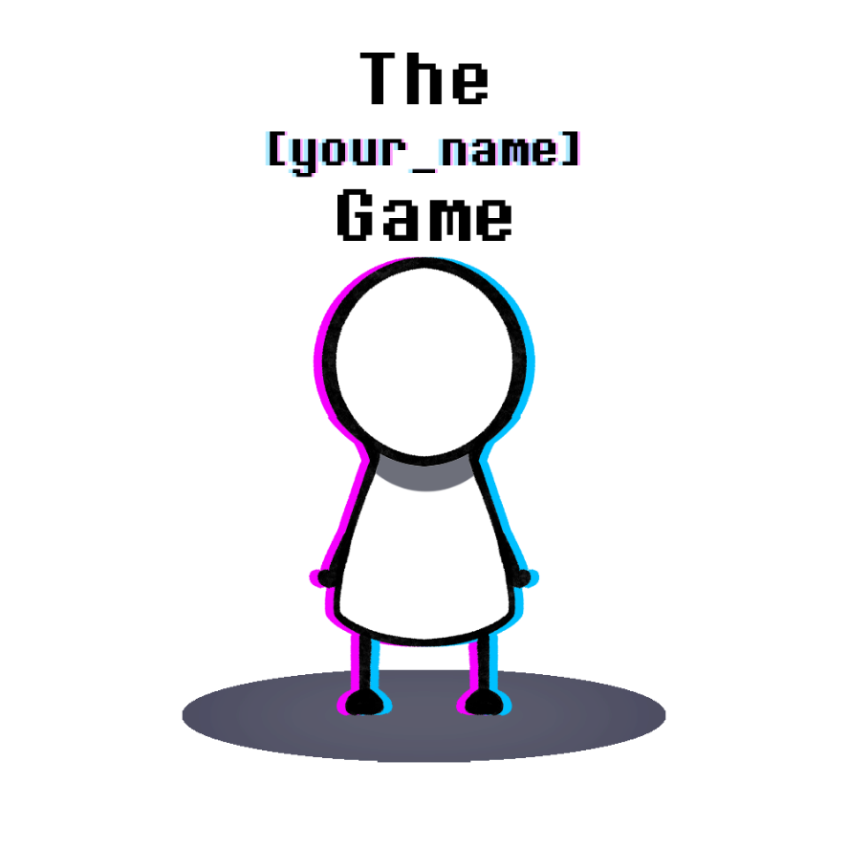

The [Your Name] Game – Proposal Poster

EdNan Team, Stephano Naressi and JeongHo Lee(Edward Lee)

# Project description

Type of Work

* We created a narrative-driven digital game, inspired by visual novels and the ‘point and click adventure’ genre games which were popular around the late 90s. The game follows the narrative structure of a ‘choose your adventure’ style storybook, which the player is given several options to choose what direction the story could take.
* Depending on the choices made, it leads to drastically different outcomes. Each endings and possible game routes are carefully designed to incite various emotions, from satisfaction to despondency.

The atmosphere and game progression

* 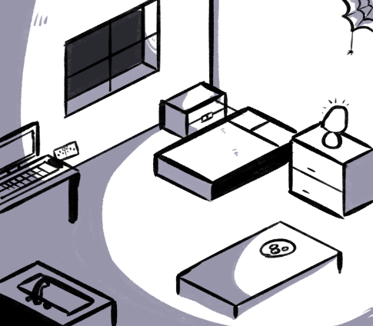The game takes place in a modern urban setting, with the character’s room being the primary stage.
* As the title, ‘your name’ game suggests, it’s supposed to represent the player’s room. The narrator will insist the player to perform mundane task in a provoking and annoying tone.
* The narrator forces you to be a ‘good kid’ in a condescending manner, which is intended to incite a rebellious attitude from the player.
* The further the player strays from their instructions, the more the game falls into a spiral of weirdness.
* We utilized satire and fourth wall breaking narratives to achieve comedic effects. Despite some of the deeper messages we wish to convey, first and foremost, we intend to create an enjoyable experience.

Our Theme

* Our aim in this project is to create an interactable digital media to entertain and explore the boundaries between fiction and non-fiction.
* Just like how food fuels our physical body, it is our belief that what we observe and experience feeds our mind. Personalities or self-identities are formed, or at least influenced by an individual’s experiences and knowledge. By creating a fictional narrative which actively intends to influence its perceiver, it is our goal to hit that uncanny valley.
* We aim to remind people of how various interactions through media may reshape ourselves in ways we didn’t realize, within the context of entertainment.

Key Elements, Features and Sections

* The emphasis of this story is its interactiveness. By presenting multiple options and choices, it creates an illusion of a two-way interaction despite following a scripted scenario.
* The narrator of the story plays a critical role as a power figure, which the player could choose to cooperate or antagonize. He has his own vision of ‘how the story must play’, and thus will try to actively impose his ideologies onto the player.
* This creates a unique situation where a fictional being attempts to take control of you, a non-fictional entity, creating a baffling yet potentially disturbing tug of war for control over the narrative.

# Supplementary Materials

Diagrams

The diagram below shows the basic flow of gameplay. This helps to streamline the journey of the user through the game.

Concept Art

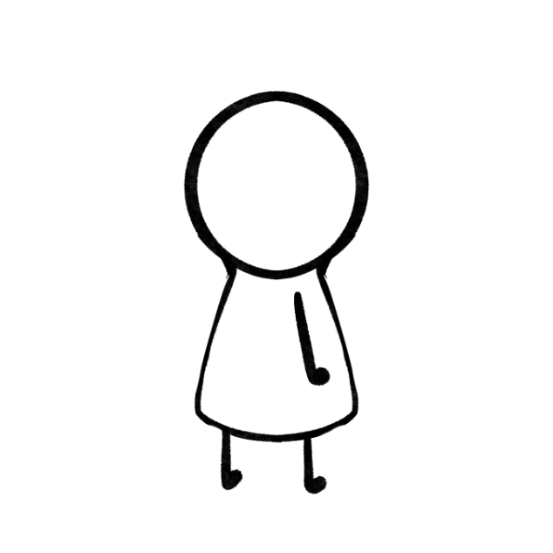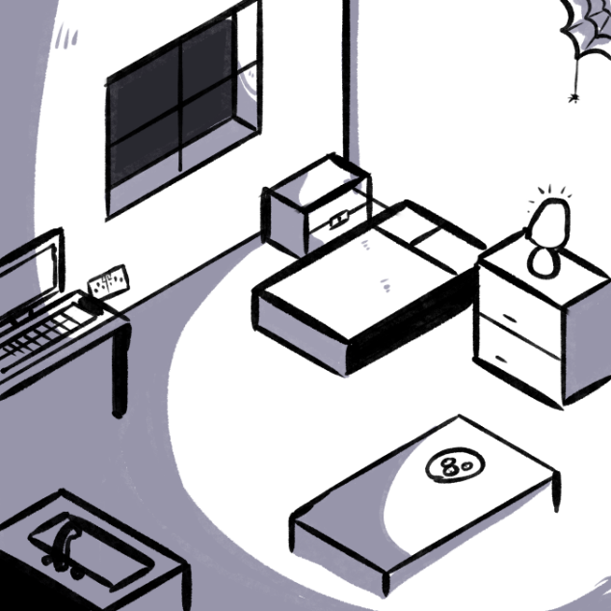Early concept arts for the game. We wanted to present a unique art-style, and making prototypes helped solidify the visual feel of the game.

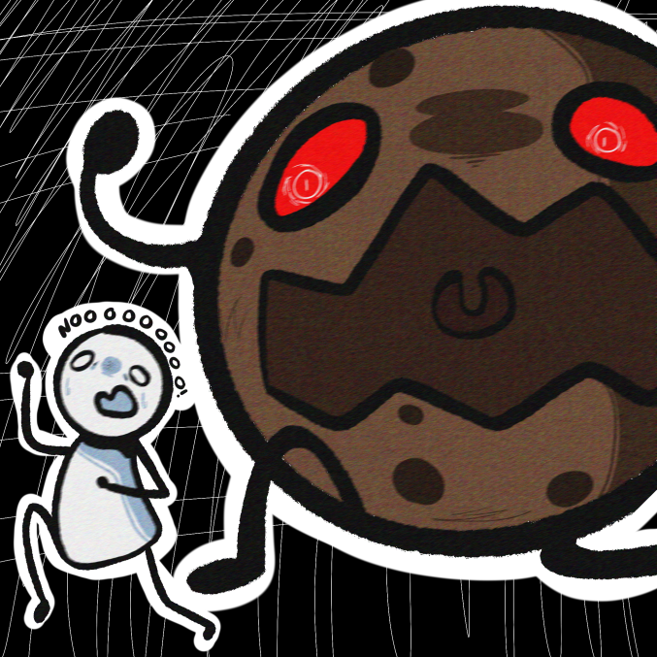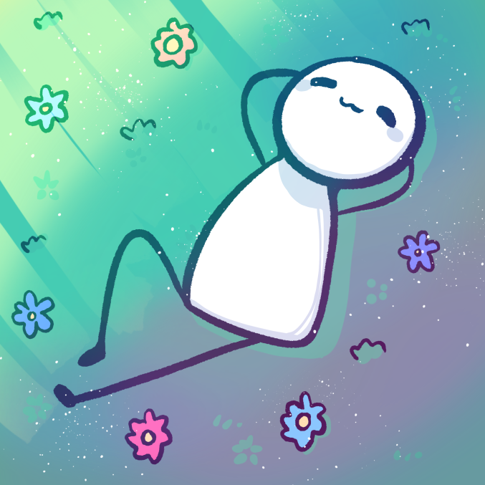We also made two concept drawings for the main two endings. The ‘Good’ ending and the ‘Bad’ ending. Note that the final version turned out quite different from what we present here.

Storyboards

For the story, we also made storyboards to help us solidify the narrative flow of the game while also testing its visual presentation.

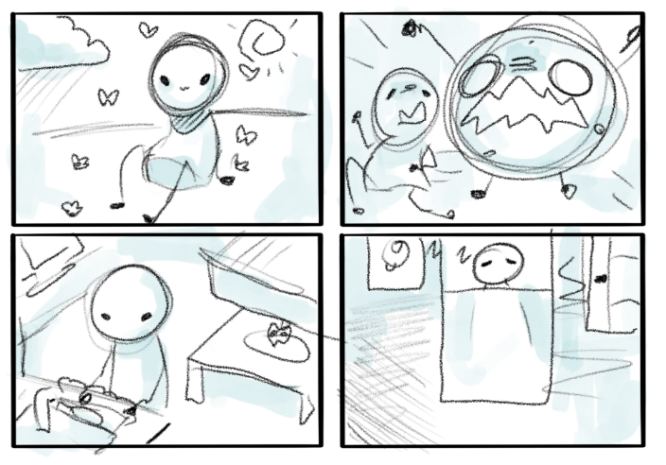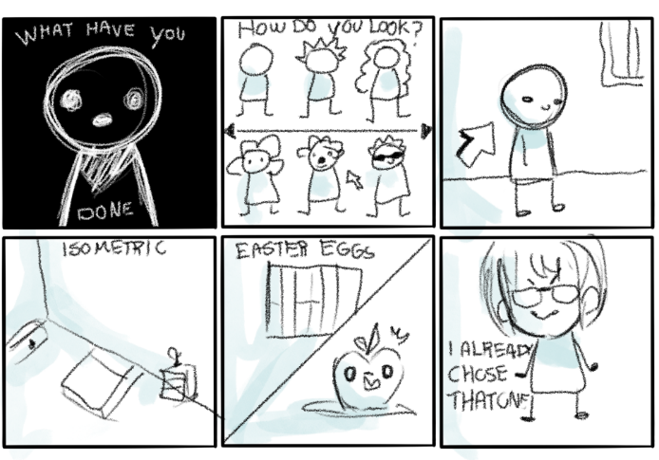

# Audience

Age group

* This game is mainly pitched toward the teenage to young adult demographics. Being limited to a digital medium may limit access from age groups with overall, less interest in handling computers.
* We did not include overly violent elements which may be inappropriate for younger audiences. However, some story routes could lead to some potentially disturbing situations, and we expect some level of intellect and understanding of fictional media.
* It is the meta aspect that we utilized to deliver our message and sarcastic jokes, so demographics completely unfamiliar or unable to understand such concepts may have difficulty in finding entertainment from the experience.

Skills needed to play the game

* We unfortunately lacked the manpower to develop a separate version for the visually impaired, however we do not require much else physically.
* A willingness to enjoy a narrative driven story is all we ask from our audiences.
* Plus, due to being on a digital medium, we require basic knowledge on computer use.

User feedback

* 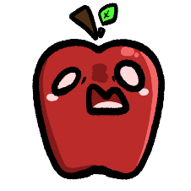We got an overwhelming amount of positive feedback from our testers. Most complemented on the witty and sarcastic writings and how the visual designs complemented the style of writing. We also observed that the game gave enough visual hints for progression, as nobody really had trouble navigating or felt stuck and unable to progress while playing the game.

# Challenges

* With dozens visual assets, we expected to run into some asset loading issues. It was our utmost priority to optimize our code for the game to run smoothly. We took notes form movie production tricks and found our solution by hiding the screen with black outs (in the narrative, the lights go off) while the assets load behind the scenes.
* We also considered uploading assets in the cloud and call them with something such as REST APIs or just web links to reduce file size. This was unnecessary in the end.
* The sheer amount of dialogues and coding them to behave properly was quite a challenge.

(sample code)

if (dialogueCount == 6) {

if (timer > 80) {

narratorMainText = "At least something pleasant comes from art."

}

if (timer > 150) {

narratorSubText = "And, no. This does not count as modern art.";

}

if (timer > 220) {

showIcon = true;

}

}

this.mousePressed = function (){

//

// if(showIcon == true)

// {

// dialogueCount ++;

// showIcon = false;

// timer = 0;

// narratorMainText = "";

// narratorSubText = "";

// }

* The ‘dialogueCount’ variable pinpoints at what part this dialogue should be shown. We added a timer for each dialogue sets so the viewer isn’t bombarded with walls of text at the same time. ShowIcon visually shows the arrow key on the screen (indicating the text can progress).
* When the mouse is Pressed while the arrow icon is present, it refreshes the textboxes (narratorMainText = " " ;) and moves onto the next dialogue while resetting the timer for use again.

# Tools, equipment and knowledge

Hardware

* PC for main development.
* Drawing tablets for creating assets.

Software

* ‘P5js / JavaScript’ as our main coding tool using ‘Brackets’ as our code editing software.
* Various libraries associated with ‘P5js’ or ‘JavaScript’.
* Art software such as ‘Photoshop’, ‘Procreate’ and ‘Clip Studio Paint’ to create assets for the game.

# Key references

Narrative

- *The Stanley Parable*

( <https://store.steampowered.com/app/221910/The_Stanley_Parable/> )

- *Doki Doki literature club*

( <https://store.steampowered.com/app/698780/Doki_Doki_Literature_Club/> )

- *Undertale / Deltarune*

( <https://store.steampowered.com/app/391540/Undertale/> )

- *Nous les dieux*

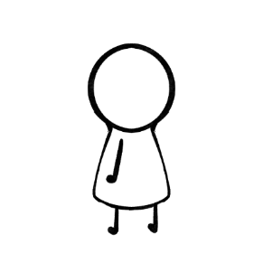(Book by Bernard Werber, Published 2004)

Visual style

- *Undertale / Deltarune*

( <https://store.steampowered.com/app/391540/Undertale/> )

*- Homestuck*

(Webcomic, <https://www.homestuck.com/> )