**1. Introduction**

Have you ever wondered how your computer performs basic tasks like addition, subtraction, or logical operations? At the heart of every microprocessor lies a set of instructions that tell it what to do. In the world of **RISC-V**, an open-source and highly efficient processor architecture, one of the most important instruction formats is the **R-Type (Register-Type)**.

R-Type instructions are the workhorses of RISC-V, handling **register-to-register operations** like arithmetic, logic, and shifts. In this article, we’ll break down the **R-Type instruction format**, explore how it works, and understand why it’s so crucial for modern computing.

**2. What is RISC-V?**

Before diving into R-Type instructions, let’s quickly cover what **RISC-V** is:

* **RISC** stands for **Reduced Instruction Set Computer**, a design philosophy that emphasizes simplicity and efficiency.
* **V** stands for the **fifth generation** of RISC architectures developed at the University of California, Berkeley.
* RISC-V is **open-source**, meaning anyone can use, modify, and implement it without licensing fees. This has made it a popular choice for everything from tiny IoT devices to massive supercomputers.

**3. What Are R-Type Instructions?**

R-Type instructions are used for operations where both the **source operands** and the **destination** are **registers**. These instructions are essential for performing:

* **Arithmetic Operations**: Addition, subtraction, multiplication, and division.
* **Logical Operations**: AND, OR, XOR, and NOT.
* **Shift Operations**: Shifting bits left or right.

The beauty of R-Type instructions lies in their **simplicity** and **efficiency**. They are designed to execute quickly, often in a single clock cycle, making them ideal for high-performance computing.

**4. The Structure of R-Type Instructions**

R-Type instructions have a **fixed 32-bit format**, divided into several fields. Here’s what each field does:

**Bit Range Field Name Description**

31:25 funct 7 7-bit function code, used to specify the operation (e.g., ADD, XOR).

24:20 rs2 5-bit source register 2, specifying the second operand.

19:15 rs1 5-bit source register 1, specifying the first operand.

14:12 funct3 3-bit function code, used with funct7 to specify the operation.

11:7 rd 5-bit destination register, result of the operation is stored here.

6:0 opcode 7-bit opcode, identifying the instruction as R-Type (0110011).

**5. Example: The ADD Instruction**

Let’s look at an example to understand how R-Type instructions work. Consider the **ADD instruction**, which adds two numbers stored in registers and stores the result in a third register.

1. **Assembly Syntax**: ADD x3, x1, x2

* x1 and x2 are the source registers.
* x3 is the destination register.

2. **Binary Encoding**:

* funct7: 0000000 (for ADD)
* rs2: 00010 (binary for x2)
* rs1: 00001 (binary for x1)
* funct3: 000 (for ADD)
* rd: 00011 (binary for x3)
* opcode: 0110011 (R-Type)

The binary representation of ADD x3, x1, x2 would look like this:

| funct7 | rs2 | rs1 | funct3 | rd | opcode |

| 0000000| 00010 | 00001 | 000 | 00011 | 0110011|

**6. Why Are R-Type Instructions Important?**

R-Type instructions are the backbone of RISC-V’s efficiency. Here’s why they matter:

1. **Speed**: They execute in a single clock cycle, making them incredibly fast.
2. **Flexibility**: They support a wide range of operations, from basic arithmetic to complex logic.
3. **Scalability**: RISC-V’s modular design allows for custom R-Type instructions, enabling specialized applications like AI and cryptography.

**7. Challenges and Future Trends**

While R-Type instructions are powerful, they come with challenges:

* **Limited Opcode Space**: The 7-bit opcode limits the number of unique instructions.
* **Decoding Complexity**: The combination of funct7 and funct3requires careful hardware design.

To address these challenges, RISC-V is evolving with:

* **Custom Extensions**: Adding new instructions for specialized tasks.
* **Hardware Optimization**: Improving decoding logic for faster execution.

**Diagrams**

1. **R-Type Instruction Format**: A visual breakdown of the 32-bit R-Type instruction.

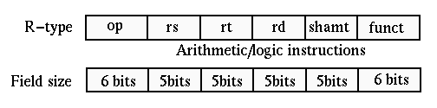

Instruction format in RISC-V

2. **ADD Instruction Example**: Binary encoding of the ADD instruction.

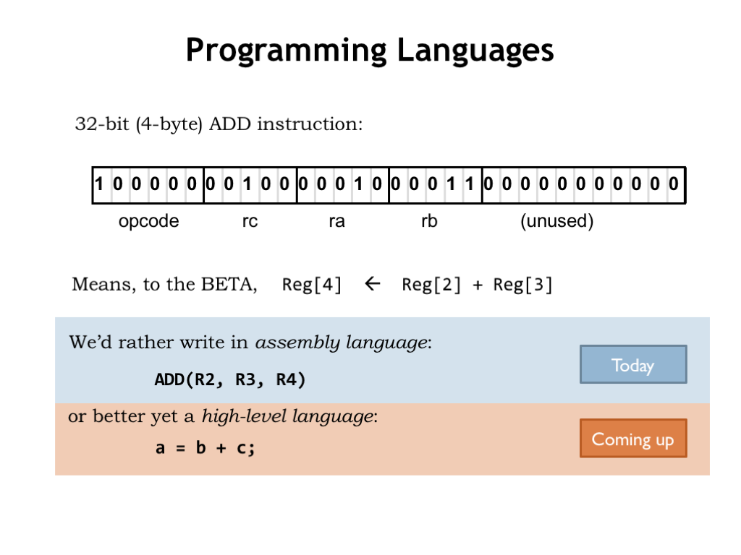

An example of the ADD Instruction in RISC-V

3. **RISC-V Datapath**: A simplified diagram showing how R-Type instructions are executed in the processor.

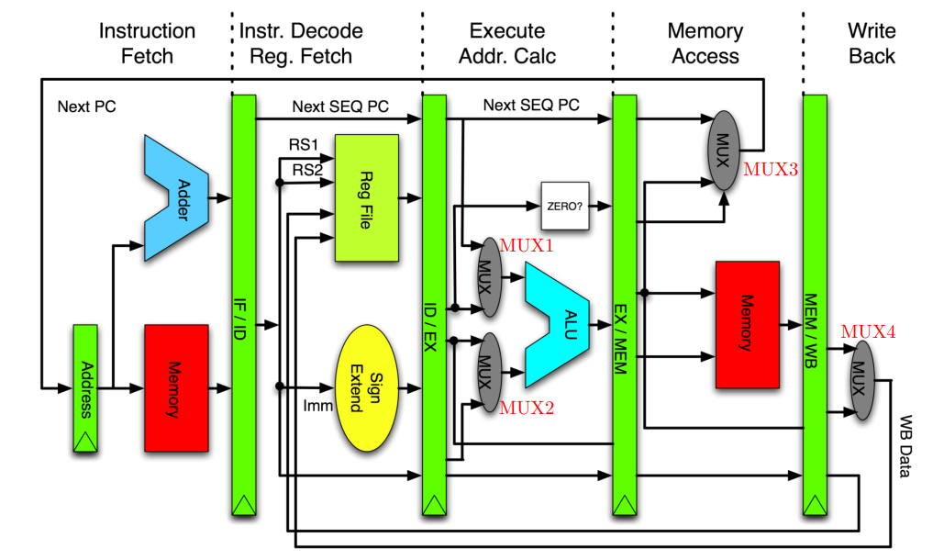

RISC-V Datapath

**8. Conclusion**

The **R-Type instruction format** is a cornerstone of the RISC-V architecture, enabling efficient and flexible register-to-register operations. Its simplicity and modularity make it a key factor in RISC-V’s growing popularity. Whether you’re building a tiny IoT device or a high-performance supercomputer, R-Type instructions are essential for achieving speed and efficiency.

**References**

1. Patterson, D. A., & Waterman, A. (2017). *The RISC-V Reader: An Open Architecture Atlas*. Strawberry Canyon LLC.
2. RISC-V Foundation. (2023). *RISC-V Instruction Set Manual*. [**https://riscv.org**](https://riscv.org/)
3. Hennessy, J. L., & Patterson, D. A. (2017). *Computer Architecture: A Quantitative Approach*. Morgan Kaufmann.