**Model:**

lmer(therm_t ~ pos_beh + time_od + sun + date + hab_type + (1|individual), data = prelim_temp3)

**Model Output:**

Linear mixed model fit by REML ['lmerMod']

Formula: therm_t ~ pos_beh + time_od + sun + date + hab_type + (1 | individual)

Data: prelim_temp

REML criterion at convergence: 3094.3

Scaled residuals:

Min 1Q Median 3Q Max

-3.0960 -0.6327 0.0449 0.5870 3.4943

Random effects:

Groups Name Variance Std.Dev.

individual (Intercept) 0.1752 0.4186

Residual 2.6304 1.6219

Number of obs: 804, groups: individual, 12

Fixed effects:

Estimate Std. Error t value

(Intercept) 988.827990 117.509071 8.415

pos_behLy -1.417785 0.317448 -4.466

pos_behSq -0.309867 0.678958 -0.456

pos_behSt -0.142941 0.255754 -0.559

pos_behQW -0.291805 0.269212 -1.084

pos_behBp -0.688576 0.276029 -2.495

pos_behSu -0.084324 0.571319 -0.148

pos_behVC -0.641358 0.407064 -1.576

time_odl_morning 1.327314 0.182314 7.280

time_ode_afternoon 2.600920 0.228448 11.385

time_odl_afternoon 3.030599 0.192486 15.745

time_odevening 2.347881 0.194366 12.080

sun 0.042861 0.003053 14.039

date -0.054118 0.006635 -8.157

hab_typeBMWD 0.281813 0.781626 0.361

hab_typeGA 1.205522 0.780149 1.545

hab_typeGL 1.234348 0.799732 1.543

hab_typeWD 1.104371 0.749518 1.473

**Results Table**

|  |  |  |  |  |
| --- | --- | --- | --- | --- |
|  | Estimate | Std. Error | t-value | Confidence Interval |
| Intercept | 988.83 | 117.51 | 8.415 | 759.12, 1215.38 * |
| Lie | -1.418 | 0.317 | -4.466 | -2.03, -0.79* |
| Squat | -0.310 | 0.679 | -0.456 | -1.63, 1.01 |
| Sit | 0.143 | 0.256 | 0.559 | -0.64, 0.35 |
| Quadrupedal Walk | -0.292 | 0.269 | -1.084 | -0.81, 0.23 |
| Bipedal | -0.689 | 0.276 | -2.495 | -1.22, -0.15* |
| Suspensory | 0.084 | 0.571 | 0.148 | -1.19, 1.03 |
| Vertical Climb/Cling | -0.641 | 0.407 | -1.576 | -1.43, 0.15 |

**Plots**

1. Predicted vs. observed effect of positional behavior on body temperature

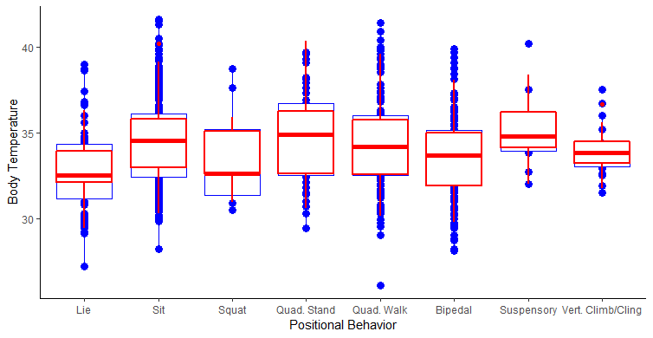

1. Effect of positional behavior on body temperature

