Addi $5 ,$0, 1; //

Addi $6, $0, 64; //

Addi $2, $0, 4096; //

Sll $2, $2, 16; //

Addi $7, $2, 40; //

Lw $3, 0($2); //

Slt $4, $6, $3; //

Beq $5, $4, 2; //

Sub $6, $6, $3;

Sw $0, 0($2);

Addi $2, $2, 4; //

Bne $7, $2, -7;

Sw $6, 0($7);

Int x=[10, 9, 8, 700, 5, 6, 400, 1, 2 , 3];

Int r5 =1;

Int r6=64;

R2 = x; (0x1000 0000)

R7 = r2 + 10;

Do{

R3 = \*r2

if (r5 != r4){

r6 = r6 – r3;

\*r2 = 0;

R2++;

}

}while(r2!=r7);

X[10] = r6;

add $5, $0, $0  
addi $7, $0, 2^12  
sll $7, $7, 16  
add $6, $0, $7  
addi $6, $6, 40  
lw $4, 0($7)  
addu $5, $4, $5  
addi $7, $7, 4  
bne $6, $7, -4  
sw $5, 0($7)

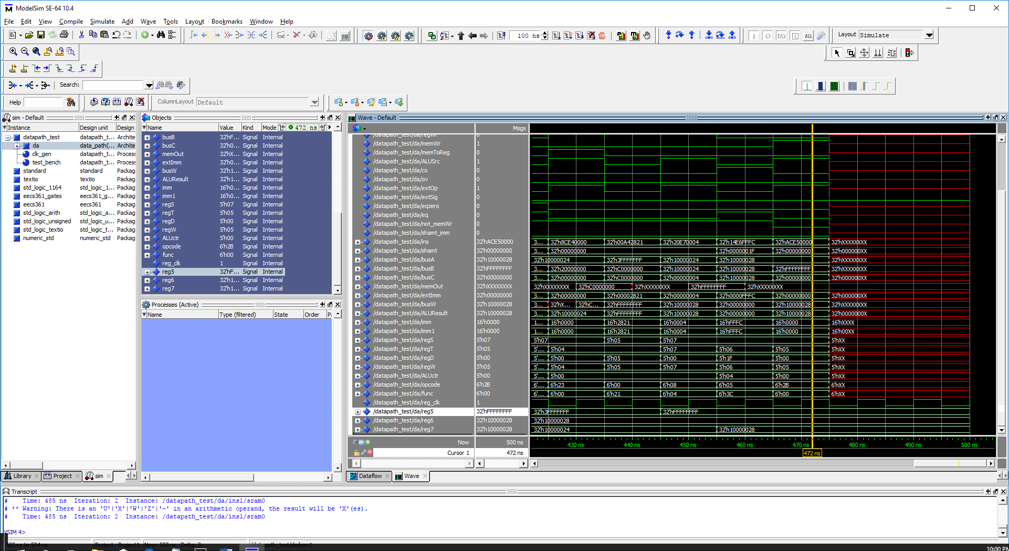

Addi $2, $0, 4096

Sll $2, $2, 16

Addi $4, $2, 36

Addi $5, $2, 40

Lw $7, 0($2)

Addi $3, $2, 4

Lw $1,0($3)

Slt $6, $7, $1

Bgtz $6, 3

Sw $1,0($2)

Sw $7, 0($3)

Add $7, $1, $0

Addi $3, $3, 4

Bne $5, $3, -8

Addi $2,$2, 4

Bne $4, $2, -12

