Романов Эдуард ПР23/2
Отчет по ПР2
БД для проекта (рис 1):
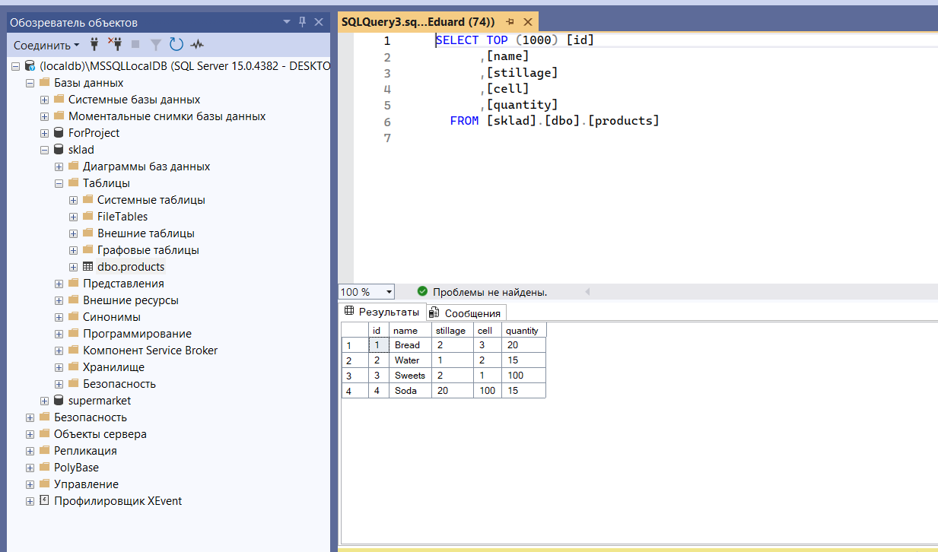
Рисунок 1 – БД к проекту.

Код к проекту на главной форме:
using System;
using System.Data;
using System.IO;
using System.Windows.Forms;

namespace SkladApp
{
public partial class Sklad : Form
{
private DatabaseHelper dbHelper;
private DataTable productsTable;

public Sklad()
{
InitializeComponent();
dbHelper = new DatabaseHelper();
LoadProducts();
}

private void LoadProducts()
{
productsTable = dbHelper.GetProducts();
dataGridViewProducts.DataSource = productsTable;
}

private void btnUpdate_Click(object sender, EventArgs e)
{
if (dataGridViewProducts.CurrentRow != null)
{
DataGridViewRow row = dataGridViewProducts.CurrentRow;
int id = Convert.ToInt32(row.Cells["id"].Value);
string name = row.Cells["name"].Value.ToString();
int stillage = Convert.ToInt32(row.Cells["stillage"].Value);
int cell = Convert.ToInt32(row.Cells["cell"].Value);
int quantity = Convert.ToInt32(row.Cells["quantity"].Value);

if (dbHelper.UpdateProduct(id, name, stillage, cell, quantity))
{
MessageBox.Show("Продукт успешно обновлен!");
LoadProducts();
}
}
}

private void btnDelete_Click(object sender, EventArgs e)
{
if (dataGridViewProducts.CurrentRow != null)
{
int id = Convert.ToInt32(dataGridViewProducts.CurrentRow.Cells["id"].Value);
if (MessageBox.Show("Вы уверены, что хотите удалить этот продукт?", "Подтверждение",
MessageBoxButtons.YesNo) == DialogResult.Yes)
{
if (dbHelper.DeleteProduct(id))
{
MessageBox.Show("Продукт успешно удален!");
LoadProducts();
}
}
}
}

private void btnSearchByName_Click(object sender, EventArgs e)
{
string searchText = txtSearchByName.Text.Trim();
if (!string.IsNullOrEmpty(searchText))
{
DataTable result = dbHelper.SearchByName(searchText);
dataGridViewProducts.DataSource = result;
}
else
{
LoadProducts();
}
}

private void btnSearchByCoords_Click(object sender, EventArgs e)
{
if (int.TryParse(txtStillage.Text, out int stillage) && int.TryParse(txtCell.Text, out int cell))
{
DataTable result = dbHelper.SearchByCoordinates(stillage, cell);
dataGridViewProducts.DataSource = result;
}
else
{
MessageBox.Show("Введите корректные значения для стеллажа и ячейки!");
}
}

private void btnSaveToFile_Click(object sender, EventArgs e)
{
SaveFileDialog saveFileDialog = new SaveFileDialog();
saveFileDialog.Filter = "Text files (*.txt)|*.txt|All files (*.*)|*.*";
saveFileDialog.Title = "Сохранить данные о продуктах";

if (saveFileDialog.ShowDialog() == DialogResult.OK)
{
using (StreamWriter writer = new StreamWriter(saveFileDialog.FileName))
{
writer.WriteLine("ID\tНазвание\tСтеллаж\tЯчейка\tКоличество");
foreach (DataRow row in productsTable.Rows)
{
writer.WriteLine($"{row["id"]}\t{row["name"]}\t{row["stillage"]}\t{row["cell"]}\t{row["quantity"]}");
}
}
MessageBox.Show("Данные успешно сохранены в файл!");
}
}

private void btnRefresh_Click(object sender, EventArgs e)
{
LoadProducts();
txtSearchByName.Clear();
txtStillage.Clear();
txtCell.Clear();
}

private void Sklad_Load(object sender, EventArgs e)
{

}
}
}

Код к классу «DatabaseHelper.cs»:
using System;
using System.Data;
using System.Data.SqlClient;
using System.Windows.Forms;

namespace SkladApp
{
public class DatabaseHelper
{
private string connectionString = @"Data Source=(localdb)\MSSQLLocalDB;Initial Catalog=sklad;Integrated Security=True";

public DataTable GetProducts()
{
using (SqlConnection connection = new SqlConnection(connectionString))
{
string query = "SELECT * FROM products";
SqlDataAdapter adapter = new SqlDataAdapter(query, connection);
DataTable table = new DataTable();
adapter.Fill(table);
return table;
}
}

public bool UpdateProduct(int id, string name, int stillage, int cell, int quantity)
{
using (SqlConnection connection = new SqlConnection(connectionString))
{
string query = "UPDATE products SET name = @name, stillage = @stillage, cell = @cell, quantity = @quantity WHERE id = @id";
SqlCommand command = new SqlCommand(query, connection);
command.Parameters.AddWithValue("@id", id);
command.Parameters.AddWithValue("@name", name);
command.Parameters.AddWithValue("@stillage", stillage);
command.Parameters.AddWithValue("@cell", cell);
command.Parameters.AddWithValue("@quantity", quantity);

connection.Open();
return command.ExecuteNonQuery() > 0;
}
}

public bool DeleteProduct(int id)
{
using (SqlConnection connection = new SqlConnection(connectionString))
{
string query = "DELETE FROM products WHERE id = @id";
SqlCommand command = new SqlCommand(query, connection);
command.Parameters.AddWithValue("@id", id);

connection.Open();
return command.ExecuteNonQuery() > 0;
}
}

public DataTable SearchByName(string name)
{
using (SqlConnection connection = new SqlConnection(connectionString))
{
string query = "SELECT * FROM products WHERE name LIKE @name";
SqlDataAdapter adapter = new SqlDataAdapter(query, connection);
adapter.SelectCommand.Parameters.AddWithValue("@name", "%" + name + "%");
DataTable table = new DataTable();
adapter.Fill(table);
return table;
}
}

public DataTable SearchByCoordinates(int stillage, int cell)
{
using (SqlConnection connection = new SqlConnection(connectionString))
{
string query = "SELECT * FROM products WHERE stillage = @stillage AND cell = @cell";
SqlDataAdapter adapter = new SqlDataAdapter(query, connection);
adapter.SelectCommand.Parameters.AddWithValue("@stillage", stillage);
adapter.SelectCommand.Parameters.AddWithValue("@cell", cell);
DataTable table = new DataTable();
adapter.Fill(table);
return table;
}
}
}
}
Интерфейс программы (рис 2):
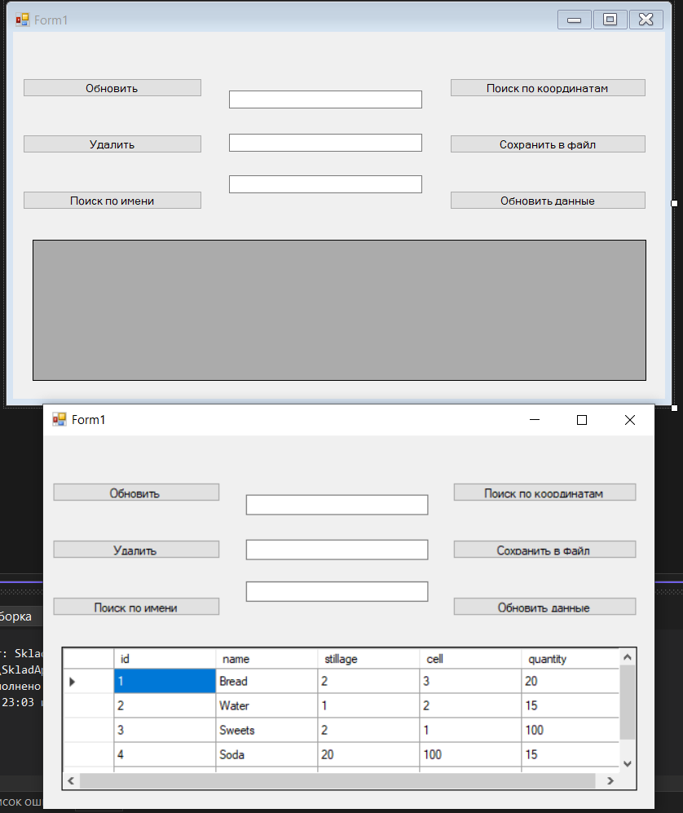
Рисунок 2 – интерфейс программы.

