*Романов Эдуард ПР23/2*

Отчет по ПР2

БД для проекта (рис 1):

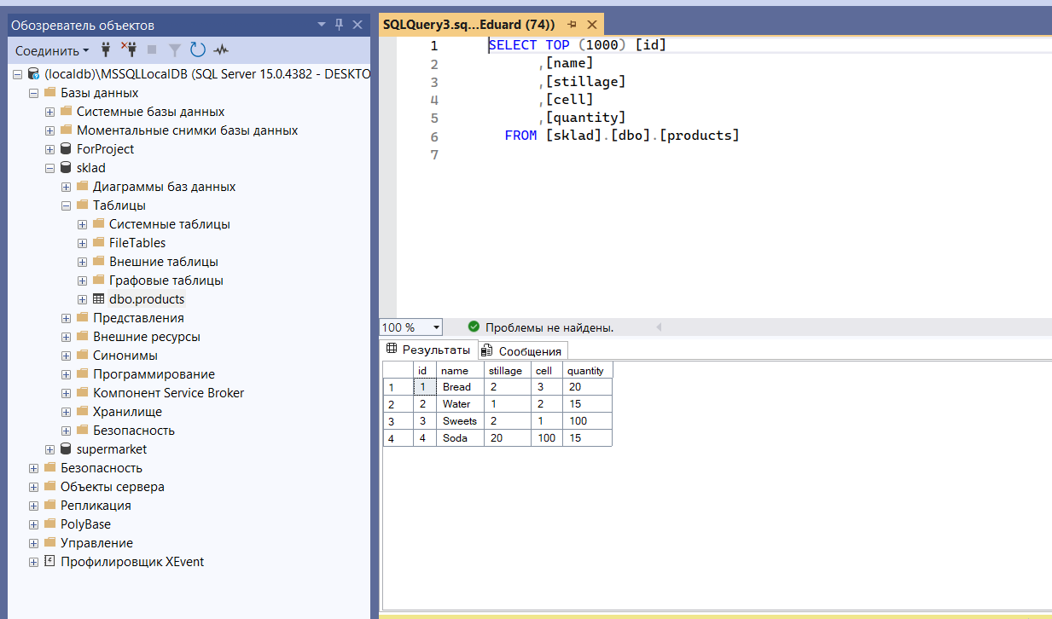

Рисунок 1 – БД к проекту.

Код к проекту на главной форме:

using System;

using System.Data;

using System.IO;

using System.Windows.Forms;

namespace SkladApp

{

public partial class Sklad : Form

{

private DatabaseHelper dbHelper;

private DataTable productsTable;

public Sklad()

{

InitializeComponent();

dbHelper = new DatabaseHelper();

LoadProducts();

}

private void LoadProducts()

{

productsTable = dbHelper.GetProducts();

dataGridViewProducts.DataSource = productsTable;

}

private void btnUpdate_Click(object sender, EventArgs e)

{

if (dataGridViewProducts.CurrentRow != null)

{

DataGridViewRow row = dataGridViewProducts.CurrentRow;

int id = Convert.ToInt32(row.Cells["id"].Value);

string name = row.Cells["name"].Value.ToString();

int stillage = Convert.ToInt32(row.Cells["stillage"].Value);

int cell = Convert.ToInt32(row.Cells["cell"].Value);

int quantity = Convert.ToInt32(row.Cells["quantity"].Value);

if (dbHelper.UpdateProduct(id, name, stillage, cell, quantity))

{

MessageBox.Show("Продукт успешно обновлен!");

LoadProducts();

}

}

}

private void btnDelete_Click(object sender, EventArgs e)

{

if (dataGridViewProducts.CurrentRow != null)

{

int id = Convert.ToInt32(dataGridViewProducts.CurrentRow.Cells["id"].Value);

if (MessageBox.Show("Вы уверены, что хотите удалить этот продукт?", "Подтверждение",

MessageBoxButtons.YesNo) == DialogResult.Yes)

{

if (dbHelper.DeleteProduct(id))

{

MessageBox.Show("Продукт успешно удален!");

LoadProducts();

}

}

}

}

private void btnSearchByName_Click(object sender, EventArgs e)

{

string searchText = txtSearchByName.Text.Trim();

if (!string.IsNullOrEmpty(searchText))

{

DataTable result = dbHelper.SearchByName(searchText);

dataGridViewProducts.DataSource = result;

}

else

{

LoadProducts();

}

}

private void btnSearchByCoords_Click(object sender, EventArgs e)

{

if (int.TryParse(txtStillage.Text, out int stillage) && int.TryParse(txtCell.Text, out int cell))

{

DataTable result = dbHelper.SearchByCoordinates(stillage, cell);

dataGridViewProducts.DataSource = result;

}

else

{

MessageBox.Show("Введите корректные значения для стеллажа и ячейки!");

}

}

private void btnSaveToFile_Click(object sender, EventArgs e)

{

SaveFileDialog saveFileDialog = new SaveFileDialog();

saveFileDialog.Filter = "Text files (*.txt)|*.txt|All files (*.*)|*.*";

saveFileDialog.Title = "Сохранить данные о продуктах";

if (saveFileDialog.ShowDialog() == DialogResult.OK)

{

using (StreamWriter writer = new StreamWriter(saveFileDialog.FileName))

{

writer.WriteLine("ID\tНазвание\tСтеллаж\tЯчейка\tКоличество");

foreach (DataRow row in productsTable.Rows)

{

writer.WriteLine($"{row["id"]}\t{row["name"]}\t{row["stillage"]}\t{row["cell"]}\t{row["quantity"]}");

}

}

MessageBox.Show("Данные успешно сохранены в файл!");

}

}

private void btnRefresh_Click(object sender, EventArgs e)

{

LoadProducts();

txtSearchByName.Clear();

txtStillage.Clear();

txtCell.Clear();

}

private void Sklad_Load(object sender, EventArgs e)

{

}

}

}

Код к классу «DatabaseHelper.cs»:

using System;

using System.Data;

using System.Data.SqlClient;

using System.Windows.Forms;

namespace SkladApp

{

public class DatabaseHelper

{

private string connectionString = @"Data Source=(localdb)\MSSQLLocalDB;Initial Catalog=sklad;Integrated Security=True";

public DataTable GetProducts()

{

using (SqlConnection connection = new SqlConnection(connectionString))

{

string query = "SELECT * FROM products";

SqlDataAdapter adapter = new SqlDataAdapter(query, connection);

DataTable table = new DataTable();

adapter.Fill(table);

return table;

}

}

public bool UpdateProduct(int id, string name, int stillage, int cell, int quantity)

{

using (SqlConnection connection = new SqlConnection(connectionString))

{

string query = "UPDATE products SET name = @name, stillage = @stillage, cell = @cell, quantity = @quantity WHERE id = @id";

SqlCommand command = new SqlCommand(query, connection);

command.Parameters.AddWithValue("@id", id);

command.Parameters.AddWithValue("@name", name);

command.Parameters.AddWithValue("@stillage", stillage);

command.Parameters.AddWithValue("@cell", cell);

command.Parameters.AddWithValue("@quantity", quantity);

connection.Open();

return command.ExecuteNonQuery() > 0;

}

}

public bool DeleteProduct(int id)

{

using (SqlConnection connection = new SqlConnection(connectionString))

{

string query = "DELETE FROM products WHERE id = @id";

SqlCommand command = new SqlCommand(query, connection);

command.Parameters.AddWithValue("@id", id);

connection.Open();

return command.ExecuteNonQuery() > 0;

}

}

public DataTable SearchByName(string name)

{

using (SqlConnection connection = new SqlConnection(connectionString))

{

string query = "SELECT * FROM products WHERE name LIKE @name";

SqlDataAdapter adapter = new SqlDataAdapter(query, connection);

adapter.SelectCommand.Parameters.AddWithValue("@name", "%" + name + "%");

DataTable table = new DataTable();

adapter.Fill(table);

return table;

}

}

public DataTable SearchByCoordinates(int stillage, int cell)

{

using (SqlConnection connection = new SqlConnection(connectionString))

{

string query = "SELECT * FROM products WHERE stillage = @stillage AND cell = @cell";

SqlDataAdapter adapter = new SqlDataAdapter(query, connection);

adapter.SelectCommand.Parameters.AddWithValue("@stillage", stillage);

adapter.SelectCommand.Parameters.AddWithValue("@cell", cell);

DataTable table = new DataTable();

adapter.Fill(table);

return table;

}

}

}

}

Интерфейс программы (рис 2):

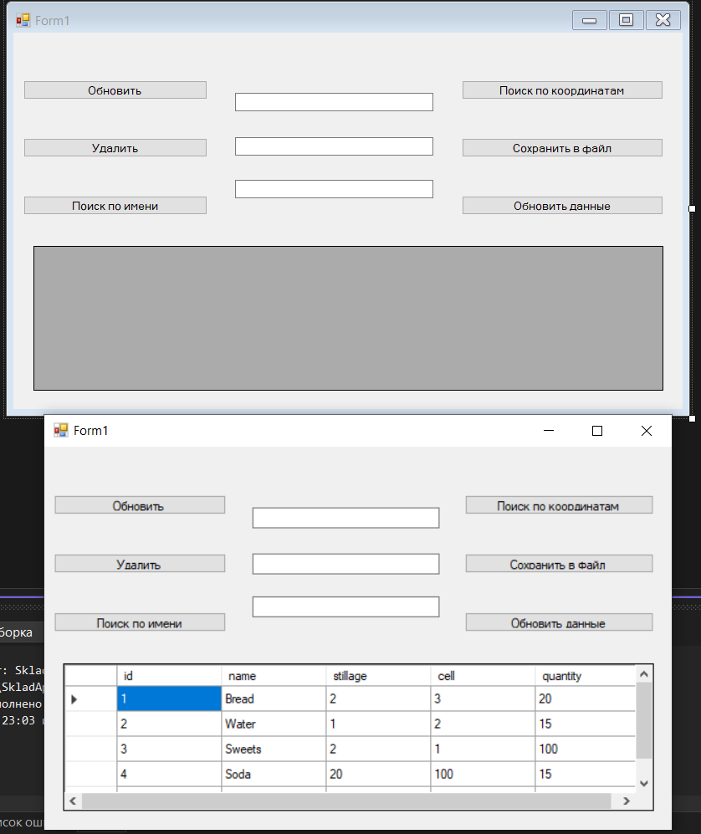

Рисунок 2 – интерфейс программы.