OK heres an example pre-line for the channel: #sum-pre

<sum1> [PRE] :: [0DAY] :: Charm Real Converter Pro v6 1 iNDUCT

Now i am assuming you have the interface open on the PRE OPTS tab.

You are allowed to add 2 pre-chans in total if you need to.

We will assume you have not added a pre-chan so lets start.

In this example the top CHANNEL NAME will be #sum-pre and the nick will be sum1. (MAKE SURE YOU ADD THE # TO THE CHANNEL NAME)
Now click the “T” button at the right hand end and if you paste the line into the ENTER PRELINE box (WITHOUT THE NICK) so:

[PRE] :: [0DAY] :: Charm Real Converter Pro v6 1 iNDUCT

You will end up with what you see below. Now you need to set TYPE/RLZ/END/CATCH.

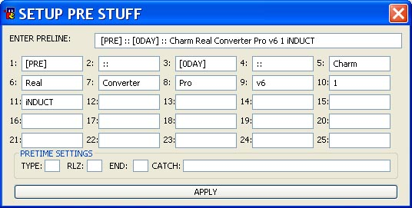

Now TYPE is the CATEGORY which in this case is 0DAY. [0DAY] is in the box numbered 3. So enter 3 into the box to the right of TYPE.
RLZ is the rlz name. The release name starts at box number 5. So enter 5 into the box to the right of RLZ.
END is the end of the rlz name. You enter characters in here so for the example:

[PRE] :: [0DAY] :: [ Charm Real Converter Pro v6 1 iNDUCT ]

you could enter ] as the end. But in our current example the release name continues to the end of the line so we just leave the END blank.
CATCH is the text that we need to catch to ensure it’s a pre line. Here I would enter *[PRE]*::*
Notice the use of *’s. These are wildcards and we use those to separate the individual parts we want to match.

Then simply hit APPLY and you are done.

