APAI2026 - LAB04
PULP_NN

Authors: Călin Diaconu, Davide Nadalini, Alberto Dequino, Francesco Conti
Contacts: calin.diaconu2@unibo.it, seyedahmad.mirsalar2@unibo.it, ihor.sachok@unibo.it
Links: GitHub Link (code)

Summary
- Subject(s):
  - Parallelization on the PULP architecture
  - Matrix multiplication
  - Fully connected layer
  - 2D convolution
  - Profiling code execution
- Programming Language: C
- Lab duration: 3h
- Assignment:
  - Time for delivery: 1 week
  - Submission deadline: Sunday November 8th 2026 (end of day, 23:59)

How to deliver the assignment
You will deliver ONLY THIS TEXT FILE, no code
- Download this file.
- Fill in the required results.
- Export to PDF format.
- Rename the file to: LAB<number_of_the_lesson>_APAI_<your_name>.pdf
- Use the Virtuale platform to upload ONLY your .pdf file

LAB STARTS HERE

0.1. Access to the local VM
- On the lab’s PCs, open the file explorer and go to This PC, C:/VM_APAI
- Double click on PULP-box.ova
- VirtualBox opens, just click on “Fine”
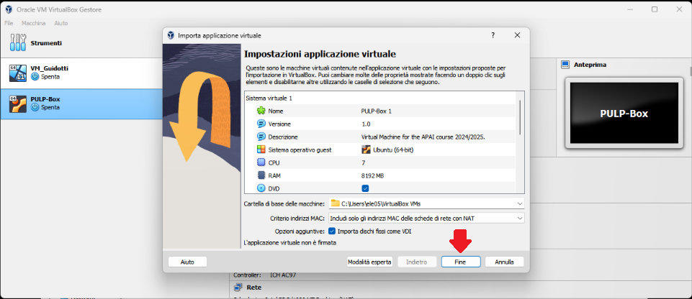
- Wait for the VM to be imported
- Open the VM with “Avvia”
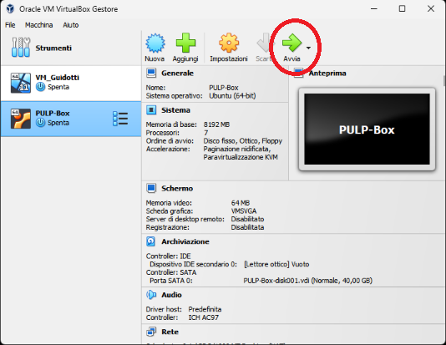
- Password is ‘pulp’

0.2. (ALL) Open Docker Container with VSCode
Option A (recommended): your own laptop
- Requirements: Docker, VSCode and the Dev Containers extension.
- Clone the GitHub repository of today’s lab: git clone https://github.com/EEESlab/APAI26-LAB04-PULP-NN
- cd APAI26-LAB04-PULP-NN
- Open it with VSCode: code .
- Select the pop-up option “Reopen in container” (the first time, this downloads the container image).
- Open a new terminal. The PULP SDK is configured automatically: there is nothing to source.
Option B: lab machines
- Open the VirtualBox VM (see section 0.1), then open a terminal (right click – open a new terminal)
- Go to the APAI-Docker folder: cd APAI-Docker
- Open Docker with VSCode: code .
- Select the pop-up option “Reopen in container”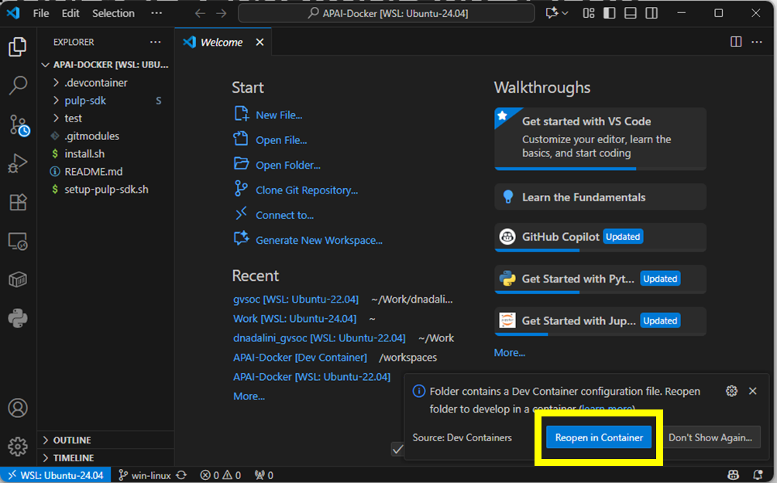
- Open a new terminal
- Clone the GitHub repository of today’s lab: git clone https://github.com/EEESlab/APAI26-LAB04-PULP-NN
- cd APAI26-LAB04-PULP-NN
- In EVERY new terminal, set up the PULP SDK: source setup-pulp-sdk.sh
Run the code (both options): go into the exercise folder and run make
- cd <exercise_folder>
- make clean all run
- Or, to choose the number of cores (N = 1..8): make clean all run CORES=N

Task 1: Matrix Multiplication
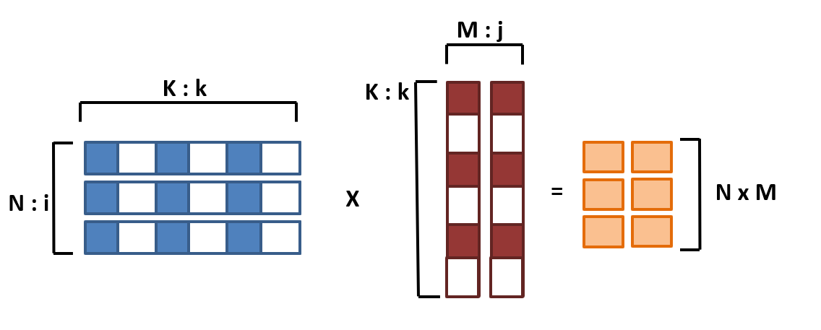
Matrix sizes: N x K * K x M = N x M
Initial sizes: N=32, M=16, K=16

1.0. Setup
- If working in the virtual machine, don’t forget to source the SDK in new terminals: source setup-pulp-sdk.sh
- Go to 01_matmul_parallelization/ folder
- Every time you want to run the code, SAVE your file and write in the terminal:
make clean all run

1.1. Speedup and Amdahl’s law
Task Location: 01_matmul_parallelization/cluster.c
Setup:
- CORES=<varying>
- N=32, M=16, K=16
Sub-tasks:
- Enable performance counters. You will find them in the code → uncomment them
- Fill in the table below: Measure the execution cycles, and calculate the speedup w.r.t. a single core.
Tip: for executing with different numbers of cores, use the “CORES” flag.
Example: make clean all run CORES=8

Cores (#N) | Cycles | Speedup  (w.r.t. CORES=1)
1
2
4
8

1.2. Explore different input sizes
Task Location: 01_matmul_parallelization/cluster.c
Setup:
- CORES=8
- N=<varying> M=16 K=16
Sub-tasks:
- Activate the necessary counters in the code
- Measure performance of each individual core (Instructions executed, and IPC)

Matrix size: N | Instructions executed (each individual core)
Matrix size: N | 0 | 1 | 2 | 3 | 4 | 5 | 6 | 7
4
8
80
81

Matrix size: N | IPC (each individual core)
Matrix size: N | 0 | 1 | 2 | 3 | 4 | 5 | 6 | 7
4
8
80
81
Answer the following questions:
Is the workload equally balanced with N=4? Why?
[ANSWER]:

Is the workload equally balanced with N=8? Why?
[ANSWER]:

Is the IPC higher for N=80 or N=81? Why?
[ANSWER]:

Measure the overall performance of the GEMM: Cycles, MACs, MAC/cycle
Tip: Calculate the MACs by hand

N | MACs | Cycles (same for all cores) | MAC/cycle (same for all cores)
4
8
80
81
Answer the following question:
Why is the MAC/cycle lower when N=81 than when N=80?
[ANSWER]:

1.3. Load stalls & unrolling the MatMul
Task Location:
- 01_matmul_parallelization/cluster.c
- 01_matmul_parallelization/matmuls.c
Setup:
- 8 CORES
- N=32 M=16 K=16
Sub-tasks:
- Enable the performance counters of interest. We want to profile:
  - Execution cycles (total)
  - Number of instructions executed
  - Load stalls (not in the code yet: you must add this counter)

Complete the code where you find /* YOUR CODE HERE */ with the right performance counters
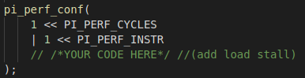
Put your solution below (code)
[ANSWER]:

Tip: Here’s the full list of the performance counters
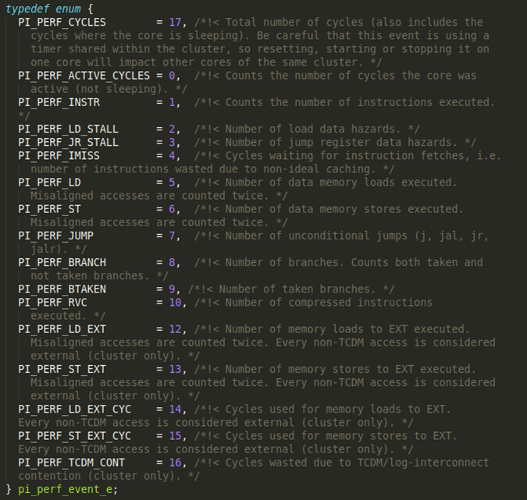
Ref for the VIRTUAL MACHINE: /rtos/pmsis/pmsis_api/include/pmsis/chips/default.h
Ref for the DOCKER CONTAINER: /app/pulp-sdk/rtos/pmsis/pmsis_api/include/pmsis/chips/default.h

- Implement the missing code in gemm_unroll() (in matmuls.c). Then manually fix the code in order to unroll 2-4-8-16 operations.

- Now, fill in the table, comparing the naive gemm() vs. the unrolled version gemm_unroll()

 | Stalls | Instructions | Cycles | IPC | MACs | MAC/cycle
Naive
Unrolled 2
Unrolled 4
Unrolled 8
Unrolled 16
Answer the following questions:
Compare the stalls of “naive” vs. unrolled (2-4-8). Which has more? Why?
[ANSWER]:

Why does Unrolled 16 have more stalls than Unrolled 8?
[ANSWER]:

Task 2: Fully Connected Layer
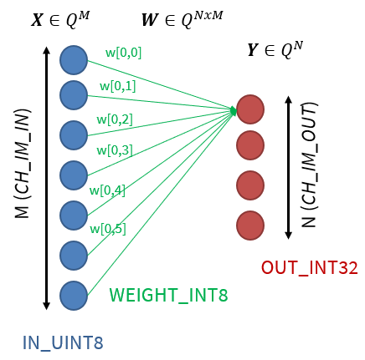

2.0. Setup
- If working in the virtual machine, don’t forget to source the SDK in new terminals: source setup-pulp-sdk.sh
- Go to 02_fully_connected/ folder
- Every time you want to run the code, SAVE your file and write in the terminal:
make clean all run
- Layer dimensions default to the values in include/data_allocation.h (CH_IM_IN=1024, CH_IM_OUT=16). You can override them (and the number of cores) from the command line:
make clean all run CORES=N CH_IN=<x> CH_OUT=<y>
- Inputs and weights are generated at runtime and the output is checked against a reference, so any layer size is valid. If your code is correct, the program prints:
FullyConnected layer executed without errors.

2.1. MACs: FullyConnected without vs. with SIMD
Implement the SIMD dot product, then compare the number of executed instructions in the normal FullyConnected layer and the SIMD version.
- Calculate the number of MACs by hand
- Use the performance counters to measure the number of executed instructions with the default (non-SIMD) dotp_u8_i8_i32
- Implement dotp_u8_i8_i32_simd in fully_connected.c (see the TASK 2.1 comment there)
- In fully_connected(), switch the call from dotp_u8_i8_i32 to dotp_u8_i8_i32_simd (look for the comment “Task 2.1”)
- Run again and check that the result is still correct (the program must print “FullyConnected layer executed without errors.”), then measure the number of executed instructions again
Hints for dotp_u8_i8_i32_simd:
- Use the v4u (4 × uint8) and v4s (4 × int8) vector types to load 4 inputs and 4 weights at a time.
- Look at the SumDotp4 macro in include/pulp_nn_utils.h: it performs 4 MACs with a single SIMD instruction.
- The vector length is not always a multiple of 4: make sure the leftover elements are also processed.
Note: the number of executed MAC operations is dictated by the size of the fully connected layer, not the way operations are implemented (non-SIMD/SIMD). The formula used to calculate the total number of MAC operations is:

$$MACs = Channels_{in}*Channels_{out}$$

You can find the FullyConnected layer dimensions in the include/data_allocation.h header file (default values; see 2.0 to override them).
TIP: 8-bit SIMD instructions perform 4 MACs in 1 cycle.

Cores  (#N) | SIMD | Operations  (MAC) | Instructions  (#N)
1 | No
1 | Yes
Answer the following question:
What is the ratio of instructions before/after the new SIMD implementation? Why?
[ANSWER]:

2.2. Calculate speedup

Measure the latency of a fully connected layer and fill out the table below.
From the measured latency calculate the performance and speedup relative to the single-core latency.

Note: to calculate the performance you will have to divide the total number of MAC operations by the measured latency.

Cores  (#N) | SIMD | Latency  (cycles) | Performance  (MAC/cycle) | Speedup  w.r.t. #Cores=1 SIMD=No
1 | No |  |  | 1.0x
1 | Yes
8 | No
8 | Yes

2.3. Leftovers and alignment
Study what happens to correctness and performance when the number of input channels is not a multiple of 4.
Setup:
- CORES=1, SIMD on (your dotp_u8_i8_i32_simd)
- CH_OUT=16
- CH_IN=1024, 1020, 1023, 1027
Example:
make clean all run CORES=1 CH_IN=1023 CH_OUT=16
Fill in the table below. Calculate the MACs by hand.
CH_IN | MACs | Instructions  (#N) | Cycles | Performance  (MAC/cycle)
1024
1020
1023
1027
Answer the following questions:
Is the result still correct for CH_IN=1023 and CH_IN=1027? Which part of your code makes it so?
[ANSWER]:

Compare the MAC/cycle across the four sizes. Why is it lower when CH_IN is not a multiple of 4? (Hint: think about the address where each weight row starts, and about the leftover loop.)
[ANSWER]:

How could the data layout be changed to avoid the problem?
[ANSWER]:

2.4. (OPTIONAL) Load imbalance and input-channel parallelization
So far the 8 cores split the output channels among them. Study what happens when there are few output channels, and try splitting the input channels instead.
Setup:
- CORES=8, SIMD on
- CH_IN=1024
- CH_OUT = 16, 12, 8, 4
Part 1: per-core load
In 02_fully_connected/Makefile, uncomment the following line, so that each core prints its own cycle count:
#APP_CFLAGS += -DPER_CORE_PERF
Run the four CH_OUT values and look at the cycles of each core.
How many output channels does each core get with CH_OUT=12? And with CH_OUT=4?
[ANSWER]:

How many cores are idle in each case?
[ANSWER]:

Part 2: split the input channels
- Implement fully_connected_split_in() in fully_connected.c, following the 4 steps of the TASK 2.4 comment.
- In main.c, switch the call to fully_connected_split_in() (look for the comment “Task 2.4”) and check that the result is still correct.
- Comment out APP_CFLAGS += -DPER_CORE_PERF again in the Makefile before measuring the latency.
Fill in the table below for both versions (output-channel split = fully_connected(), input-channel split = fully_connected_split_in()).
CH_OUT | Latency (cycles)  output split | Latency (cycles)  input split | MAC/cycle  output split | MAC/cycle  input split
16
12
8
4
Answer the following questions:
Why is a barrier needed before the reduction?
[ANSWER]:

What does the reduction cost? For which values of CH_OUT does the input split pay off?
[ANSWER]:

Task 3: Convolution Layer

3.0. Setup
- If working in the virtual machine, don’t forget to source the SDK in new terminals: source setup-pulp-sdk.sh
- Go to 03_convolution/ folder
- Every time you want to run the code, SAVE your file and write in the terminal:
make clean all run

3.1. Speedup over multiple cores

Measure the latency of a Convolution layer and fill out the table below. From the measured latency calculate the performance and speedup relative to the single-core latency.

Note: to calculate the performance you will have to divide the total number of MAC operations by the measured latency. The formula to calculate the total number of MAC operations is:

$$MACs = Kernel Height*Kernel Width*Channels_{in}*Height_{out}*Width_{out}*Channels_{out}$$

You can find the Convolution layer dimensions in the include/data_allocation.h header file.

Cores  (#N) | MACs | Latency  (cycles) | Performance  (MAC/cycle) | Speedup  w.r.t. #Cores=1
1 |  |  |  | 1.0x
2
4
8

3.2. Where does the time go: im2col vs matmul
Measure how the convolution time is split between its two phases.
The convolution kernel works in two phases. First, im2col copies the 3x3xCH_IN input patch of an output pixel into a contiguous buffer (two output pixels at a time). Then, the matmul kernel multiplies this buffer with the weights.
Setup:
- In 03_convolution/Makefile, uncomment the following line (remove the leading #):
#APP_CFLAGS += -DPROFILE_SPLIT
- Each core now prints its im2col cycles and its matmul cycles.
- Run with CORES=1 and CORES=8. Report the values of core 0, together with the total latency of the layer.
Fill in the table below. im2col share (%) = im2col cycles / total latency × 100.
Cores  (#N) | im2col cycles  (core 0) | matmul cycles  (core 0) | Total latency  (cycles) | im2col share  (%)
1
8
Answer the following questions:
What fraction of the time is spent in im2col? Is the im2col parallelized?
[ANSWER]:

Using Amdahl’s law: if you made the matmul 2x faster, what would the overall speedup be?
[ANSWER]:

Why do the im2col and matmul cycles not add up to the total latency?
[ANSWER]:

3.3. Non-power-of-2 number of cores
Measure how the convolution scales when the number of cores is not a power of 2.
Setup:
- CORES = 3, 5, 6, 7 (reuse your results from 3.1 for CORES = 1, 4 and 8)
- Measure the latency with PROFILE_SPLIT commented out, as in 3.1.
- Then enable PROFILE_SPLIT to count how many cores do work: idle cores report 0 cycles.
Example:
make clean all run CORES=6
Cores  (#N) | Latency  (cycles) | Speedup  w.r.t. #Cores=1 | Cores doing work  (#N)
3
4
5
6
7
8
Answer the following questions:
Why is the latency with 6 cores almost the same as with 4?
[ANSWER]:

Find the reason in pulp_nn_conv_u8_u8_i8.c (look at how Log2Core and chunk are computed). How would you change the work split so that all cores get work?
[ANSWER]:

