APAI2025 - LAB05
Tiny Transformers, Tiny Stories

Authors: Luca Bompani, Davide Nadalini, Alberto Dequino, Francesco Conti
Contacts: d.nadalini@unibo.it
Links: GitHub Link (code)

Summary
- Subject(s):
  - Attention on the PULP architecture
  - LLama Transformer
  - profiling code execution
- Programming Language: C
- Lab duration: 3h
- Assignment:
  - Time for delivery: 2 weeks
  - Submission deadline: Nov 7th 2025

How to deliver the assignment
You will deliver ONLY THIS TEXT FILE, no code
- Download this file.
- Fill in the required results.
- Export to pdf format.
- Rename the file to: LAB<number_of_the_lesson>_APAI_<your_name>.pdf
- Use Virtuale platform to load ONLY your .pdf file

Introduction: LLama2 in tiny pills
⚠ STEP 0 – REQUIRED before any task: open a terminal in today’s exercise folder and run:
$ source initialization.sh
Starting from the Transformer architecture:
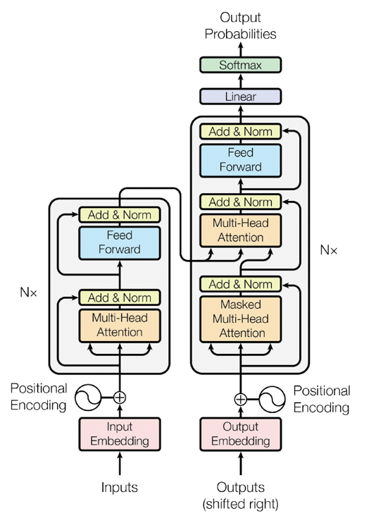
It is commonly divided into two parts: the encoder, on the left, and the decoder, on the right.
This structure was the original one proposed in Attention is All You Need.
For text generation, however, another architecture is more commonly used.
It is called decoder-only: the encoder and the cross-attention block of the decoder are removed, and a single stack of decoder blocks (masked self-attention + feed-forward) processes both the input prompt and the tokens it generates auto-regressively.
Input & Output Embedding
The Transformer we are seeing today is called LLama and it is based on this second approach.

Task 1: Attention
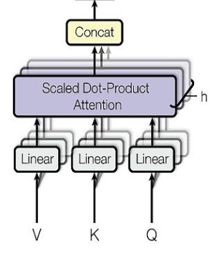

1.1 Size of the Q, K and V weights
LLAMA2, as all transformers, is based on the attention mechanism. Such a mechanism is based on three tensors, computed from the input data, which are the Value (V), the Key (K) and the Query (Q). These tensors are divided between multiple heads, which provide attention to only a subset of the input features. In particular, LLAMA2 uses grouped query attention, which shares K and V among multiple heads. This means that, given $N^{H}$ attention heads, if every head will feature a different Q tensor, there will be groups of heads sharing the same K and V. The number of different groups of K and V tensors is, then, $N^{KV}$ , which are key-value heads. Instead, every token in the input sequence (i.e., the input which is then transformed into Q, K and V) will feature a size equal to dim. The weights related to Q, K and V, which project the input embedding into the attention block, feature a size of:
$$W^{Q } =dim*dim *\frac{N^{H}}{N^{H}}$$
$$W^{K} =dim*dim * \frac{N^{KV}}{N^{H}}$$
$$W^{v} =dim*dim * \frac{N^{KV}}{N^{H}}$$
Calculate the size of each of these tensors for a single layer, as a number of elements, using the formula above (the data values can be found in the conf_and_weights_fp16.h header file):
Your solution here

1.2 Moving the weights to L1 with the DMA
After computing the size of these weights, let’s implement their computation. In the provided code, substitute the missing parts in the forward function. These weights are stored in the TransformerWeights data structure. In order to execute the attention block, the data should be moved into the Cluster memory, called the L1. To do so, we will use the Cluster DMA, which can move the data between the system level memory (L2) and the Cluster memory (L1). Complete the code in the net.c file to move the weights for the Q, K and V projections in the L1 memory. Note that the K and V weights are stored in two separate arrays (wk and wv), but they are loaded one after the other into the same L1 buffer (BUFF_W_2), reusing the same DMA command (kv_weight): for the K transfer, only the source address has to change. The Q weights use their own buffer (BUFF_W_1).
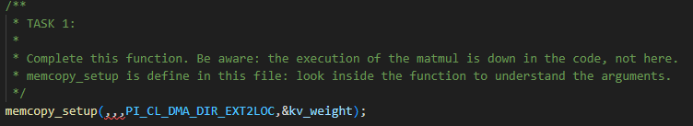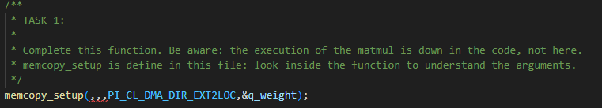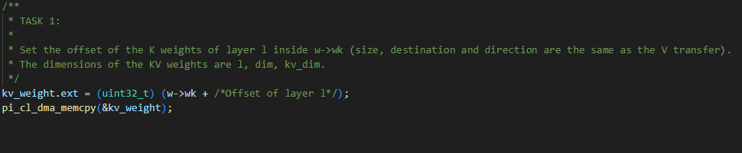
Put a screenshot or copy your code here:
Your solution here

1.3 The KV cache
After moving the weights in the L1 memory, the code will then compute their multiplication with the input embedding, obtaining the K, V, and Q tensors.
You may have noticed a so-called “KV cache”. This is an optimization to reduce the number of computations during the autoregressive phase. During this phase, the output of TinyStories LLaMA is a function of both the input embedding and the previous outputs of the model. During the iterative autoregressive phase, which is the one in which the model generates text related to the input prompt, the model will start generating a single output token per iteration, based on the input and the previously generated outputs. The generation process will start when the input sequence is provided to the model (generating a starting token) and will progress until the model produces a stop token.
During every iteration of this phase, without optimizations, the model should recompute the K and V tensors and the attention matrix based on all the previous tokens in the sequence (i.e., the input and the previous outputs). However, this increases the computation costs a lot. Therefore, the KV cache is a matrix that stores the K and V vectors already computed for every previous position, so at each step only the K and V of the new token have to be computed. In our implementation the cache has a fixed size of STEPS positions per layer (see KEY_CACHE and VALUE_CACHE in conf_and_weights_fp16.h): the vectors of position pos are written at row pos, nothing is ever discarded, and generation stops after STEPS tokens at most. Its behaviour is depicted in the image below.
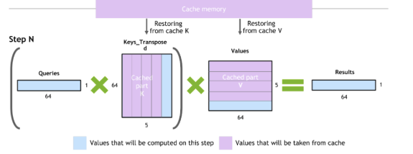

1.4 Multi-Head Self-Attention (MHSA)
We now have all the elements to perform the attention, which is composed of a series of matrix vector operations. We will now implement missing code concerning the attention block (the Multi-Head Self-Attention or MHSA).
Complete the code in the MHSA.c file: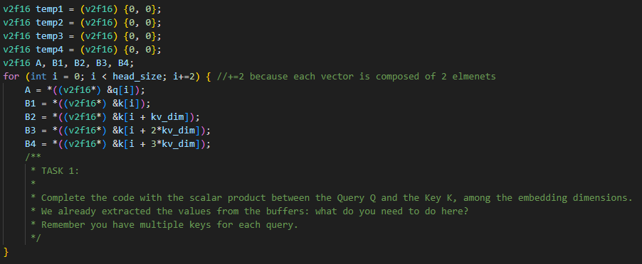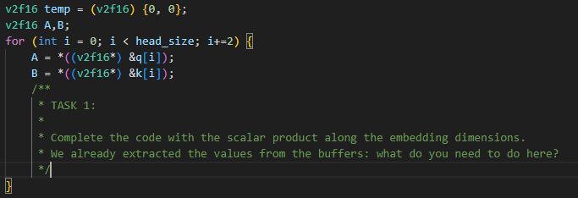
Put a screenshot or copy your code here:
Your solution here

Task 2: Using your transformer

2.1 Completing net_step()
Now, let’s go to TinyStories LLaMA’s execution. In every iteration, the transformer will, at first, do a forward step to compute the prediction with respect to its inputs and the previous tokens (stored in the KV cache). Then, the model will sample the correct token among the outputs of the current inference. Finally, it will do the decoding. Following the scheme of the transformer architecture, complete the code in the “net_step()” function of net.c file. Try to read their source code to gain more insights of the inner mechanisms on how the model actually works.
To complete this exercise, simply call the correct function for each location.
First, uncomment this code:
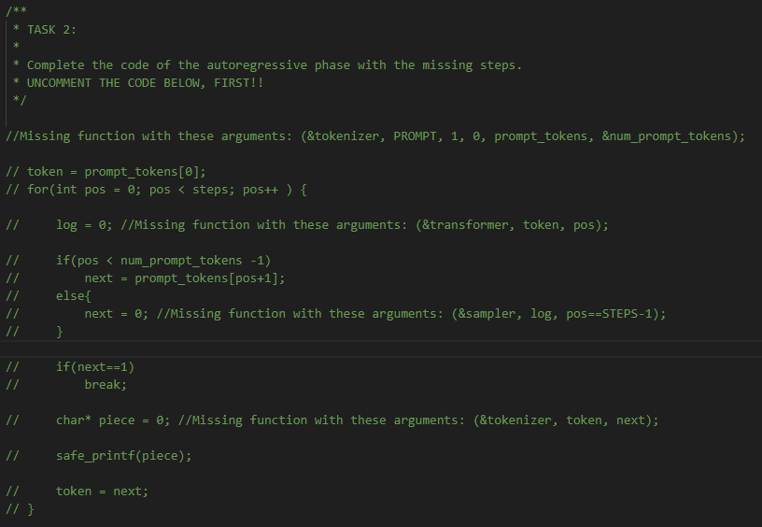
Then, complete it with the missing functions:
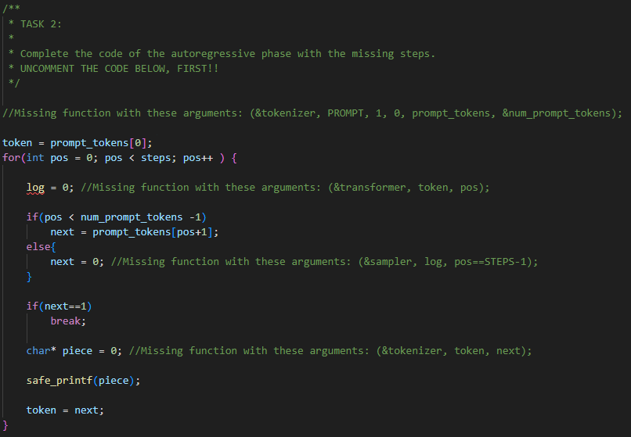
All the functions are already declared and defined in the various .c files included in this laboratory.
Put a screenshot or copy your code here:
Your solution here

2.2 Profiling the attention
After completing the task, activate profiling for layer l == 0 using the RESET_STATS(), START_STATS() and STOP_STATS() macros defined in the stats.h header.
You must also enable them by uncommenting the following line in the main folder’s Makefile:
# APP_CFLAGS += -DSTATS
Answer the following questions:
What is the number of cycles to compute the K, Q, and V tensors? You can see there are many of them (autoregressive mode), please report one of the values. Your solution here
What is the number of cycles necessary for the calculation of the attention? If you look at the numbers of every iteration, do you notice a change in their value? Your solution here

Answers must be commented on.
Try to give an explanation of the obtained results.

Task 3: Run the model
With the previous steps, we then completed the code of our TinyStories LLaMA. In this step, we will generate a story with our transformer! To do so, run “make clean all run”.
Run the full model and copy the story that has been generated:
Your solution here

