EEID Workshop: Chronic Wasting Disease (CWD) Spatial Modeling Exercise
Instructor Guide

This module challenges students to apply spatial ecology and epidemiological modeling to a real-world wildlife crisis: the management of Chronic Wasting Disease (CWD). By manipulating host movements, population densities, and disease transmission vectors across varied geographic networks, students move beyond static equations to see how the physical landscape shapes the velocity and persistence of an epidemic. The entire module is driven by a base R simulation script and four distinct landscape data profiles. Students will test how different environmental realities interact with resource management decisions.

Required Script Files

Students will interact with and generate two primary script files during this module:
- Run_CWDSimulation.R (Download and ready to use for baseline runs and students will modify slightly.
- Run_MitigationQuarantine.R (Generated by students in Module 3 – after coping previous script and modifying slightly.)

Underlying Data Files (.rds)

The simulations run on four specialized landscape matrices. Keep these file names exact if you wish to modify their baseline parameters or redistribute them to your students:
- Random Landscape (cwd_data_random.rds): The control group. Simulates a uniform, homogenous landscape with no structural barriers or corridors to establish a baseline transmission velocity.
- Patchy Landscape (cwd_data_patchy.rds): Simulates naturally fragmented habitat pockets with high spatial isolation.
- Corridor Landscape (cwd_data_corridor.rds): Simulates a linear travel highway or migratory corridor network that links populations.
- Encroachment Landscape (cwd_data_encroachment.rds): Simulates high-density host crowding into a compressed southern refuge due to habitat loss.

Code Outputs
Running either script generates two kinds of output
- RStudio Plot Pane: The console immediately renders a couple plots
- Local Directory Video Export: The script makes a .mp4 video file saved directly to the user's active working directory.

*If you ever want to regenerate fresh .rds files for your students (i.e. change movement rules, carry capacities, alter grid dimensions, etc…) use the following generative R scripts
generate_random_deerMovement.R
generate_patchy_deerMovement.R
generate_Corridor_deerMovement.R
generate_UrbanEncroachment_deerMovement.R
Solutions and sample outputs:

Module 1: Landscape comparison Outputs
Random | 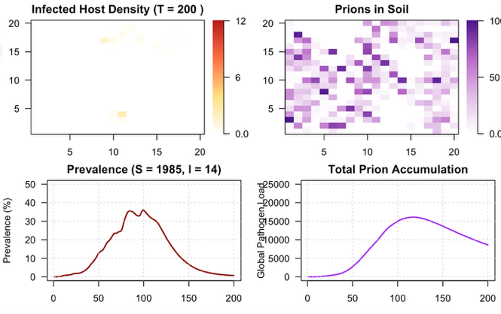

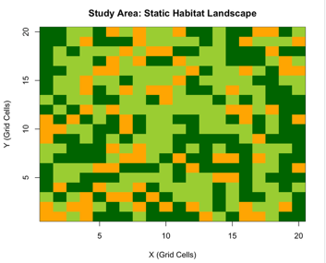
Patchy | 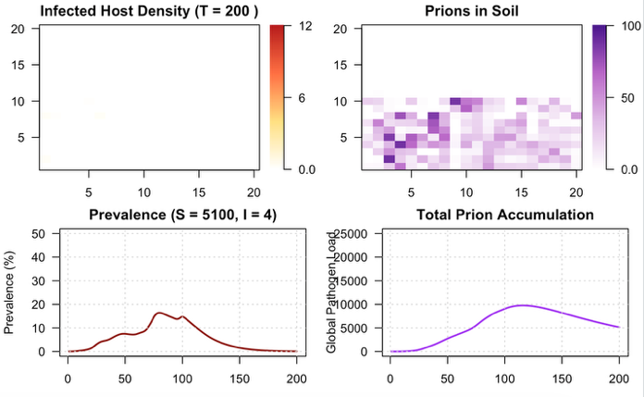

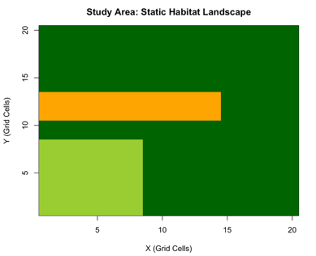
Corridor | 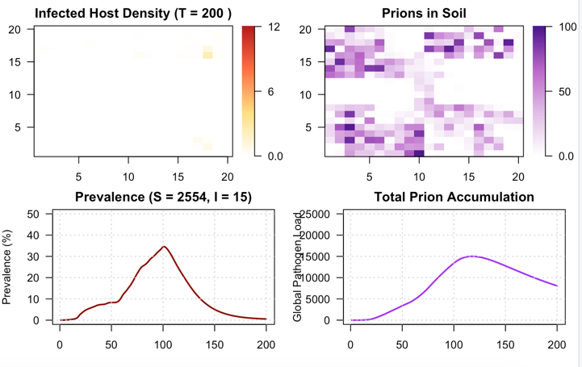

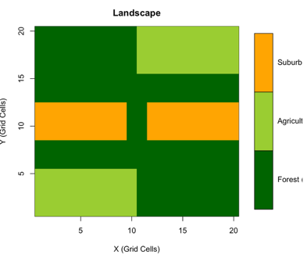
Encroachment | 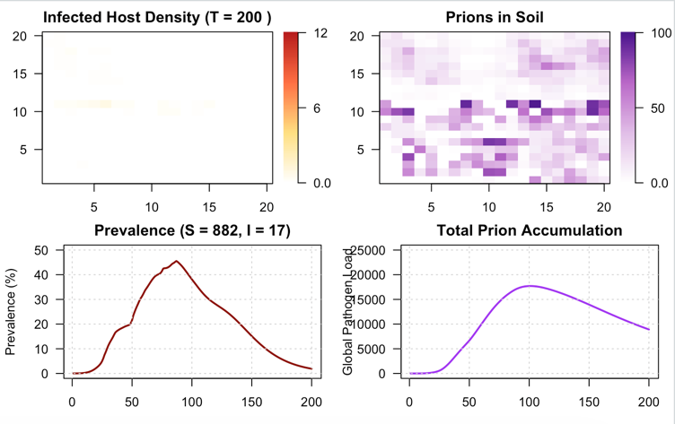

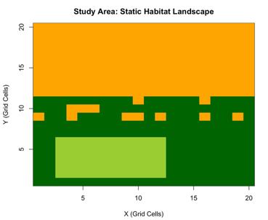

Data Collection & Analysis Questions
- For each landscape, look at Plot 3 (Host Dynamics Over Time). At what time step does the infected population reach its absolute peak?

Random landscape: Peak occurs around T = 90 to 100 (reaching a high peak of ~35%).

Patchy landscape: Peak occurs much earlier and flatter around T = 75 to 85 (never exceeding ~15%).

Corridor landscape: Peak occurs around T = 100 to 110 (reaching ~35% with a broad, sustained shoulder)

Encroachment landscape: Peak occurs around T = 100 to 110 (reaching the highest overall peak of ~45%).
- Why did the disease move at such different speeds? Look at how the deer are distributed spatially on the top-left map to justify your answer.

Random Landscape: The infected density map shows widespread, diffuse speckling across the whole grid. High connectivity allows the disease to cascade continuously through the population.
Patchy Landscape: The map shows infection isolated to a tight horizontal band in the lower half. The surrounding clean habitat types act as "social distancing" boundaries. The disease moves slowly (and dies down early) because it runs out of local susceptible hosts before it can bridge the gaps into other patches.
Corridor Landscape: The map reveals a cluster of infections localized along a central path or edge. This acts as a vector highway, funneling animals together and sustaining a prolonged, rolling transmission wave.
Encroachment Landscape: The map shows a highly compressed, dense band of infection across the lower third of the grid. Because wildlife are squeezed into a tiny refuge due to urban pressure, high crowding drives up direct contact rates, causing prevalence to explode to 45%.

- Look closely at the bottom-right plot (Total Prion Accumulation) alongside the Prevalence curve. When the infected host population plummets or burns out, does the global prion load instantly plummet too? Describe the shape of the purple line at the very end of the simulation.
Expected Answer: No, it does not drop instantly. While the red prevalence curve plummets toward zero at the end of the timeline, the purple prion curve lags significantly behind. Near the end the purple line shows a very slow, gradual, linear downward slope. It does not drop sharply. This visualizes the biological reality of environmental persistence: because the decay rate (gamma = 0.01) is so small, the environmental reservoir outlasts the living infected hosts that created it.
- Look at the final frame (T=200) on the Prion Soil Map (Top Right) across all four landscapes. Even if total infected deer are zero, what does the remaining purple spatial pattern tell you about the future safety of reintroducing healthy deer into those specific patches?
Expected Answer: The persistent purple grid cells mean these patches are highly unsafe for reintroduction. Even when a patch reports zero active sick deer (I = 0), the soil matrix remains heavily contaminated with infectious prions. If manager reintroduce healthy deer (S) into these areas, the indirect transmission pathway can trigger a secondary outbreak, showing that local disease eradication probably cannot be achieved by host culling alone
Module 2: Parameter manipulation for simplified mitigation

Baseline Encroachment environment

Scenario 1: Feeding and Baiting Bans
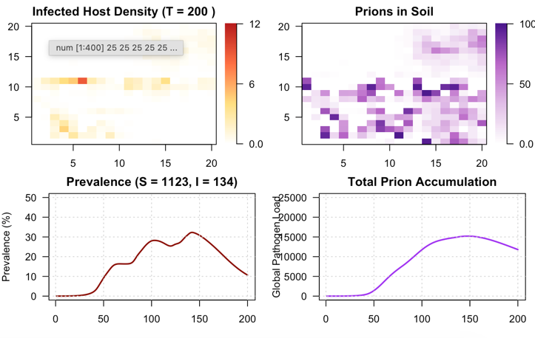

Scenario 2: Soil Remediation
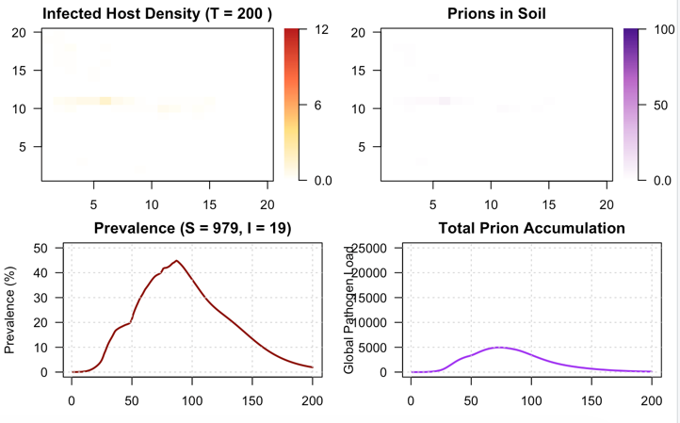

Scenario 1: Feeding and Baiting Bans: Lowering direct transmission significantly suppresses and flattens the epidemic curve
- Peak Height: The peak prevalence is significantly lower and flattened (dropping from a baseline peak of ~45% down to a suppressed peak of ~28%).

Timeline Speed: The outbreak's velocity slows down drastically. Instead of completing a rapid burning cycle and dropping back down before T=150, the infection lingers as a low-grade, slow-moving wave that stretches outward, remaining elevated all the way past T=200
- It mostly just delayed the accumulation curve rather than stopping environmental contamination. While the feeding ban successfully limits immediate deer-to-deer contact shedding and indirect environmental transmission are still active. Because the outbreak is drawn out over a longer timeline, the infected deer population (I = 134 at T=200 compared to I = 17 in the baseline) continues to consistently shed prions into the soil matrix. Around T=100, the global pathogen load is still steadily climbing and has not peaked.

Scenario 2: Soil Remediation Treatments
  - The Prions in Soil Map appears almost completely white at T=200. The lingering "ghost trails" of dark purple seen in the baseline environment are entirely gone, because the decay rate is 8 times higher, the soil matrix is clearing out shed pathogens faster than the local host population can accumulate them.
  - The purple line peaks at a maximum value of only ~4,000 to 5,000 units around T=90, before dropping close to zero by T=200.
This is a massive reduction compared to the baseline, which spiked up past 15,000 and left a huge environmental footprint at the end of the timeline.

Module 3: Programing spatial interventions for more complex mitigation

Part A: Guided Coding (Copy, Paste, & Analyze):
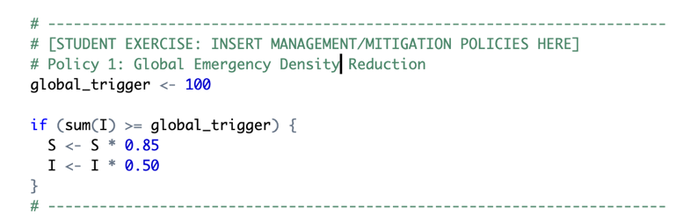

Baseline Random environment  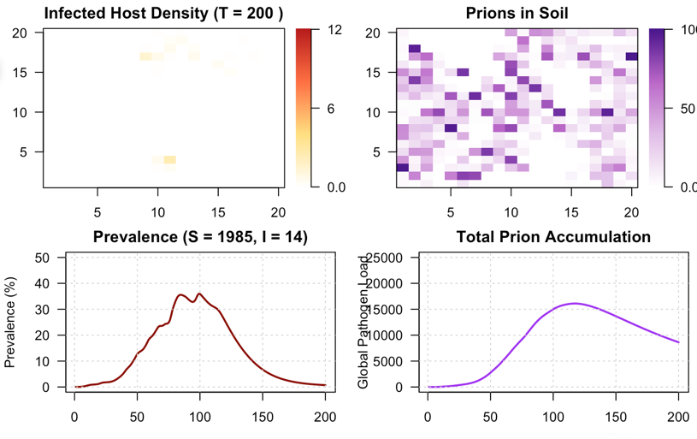 | - The Jagged "Sawtooth" Pattern: A repeating, sharp "up-and-down" zig-zag line. The Mechanism: Every time total infections hit 100, the code triggers a cull, instantly cutting infected deer by 50% (the sharp drop). Once the cull ends, the remaining deer re-infect each other from the contaminated soil, causing numbers to climb again until the next cull hits.  - Surviving Healthy Hosts (S): No, it did not save more deer. The healthy population collapsed from 1,985 down to just 607. This is because the cull triggers continuously, the 15% accidental killing of healthy deer repeats over and over. This collateral damage ends up wiping out far more healthy deer than the disease ever would have on its own.  - Impact on Soil: Highly successful at protecting the soil. Because culling constantly keeps the total number of sick, shedding deer very low, prions never get the chance to pile up. The total soil contamination stays flat and close to zero, leaving the final map almost entirely clean.
Policy 1: Culling once above 100 I, 50%I and 15%S

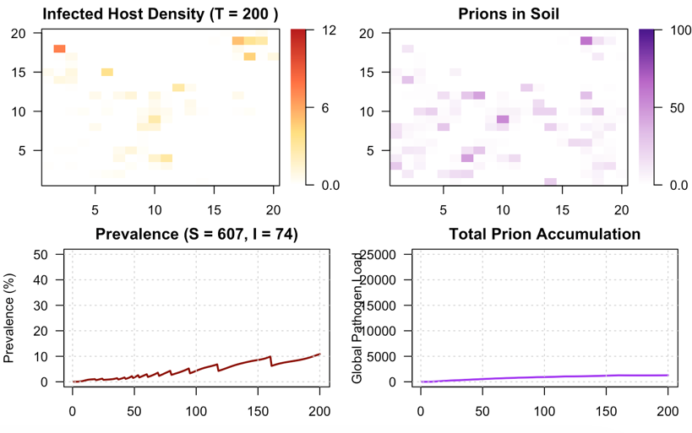

PART B: Independent Coding Challenge (Write Your Own Policy!)

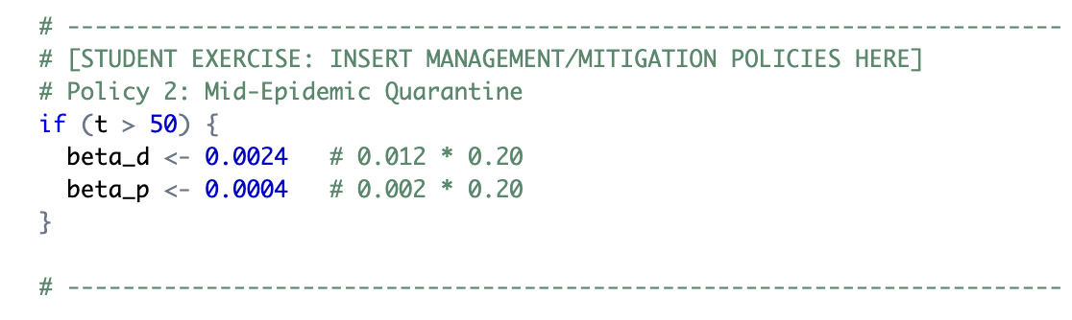
Mitigation Strategy | Patchy Landscape cwd_data_partchy.rds | Corridor Landscape cwd_data_corridor.rds | Encroachment Landscape cwd_data_encroachment.rds
Baseline | 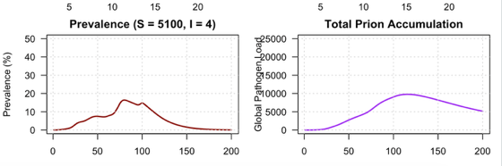 | 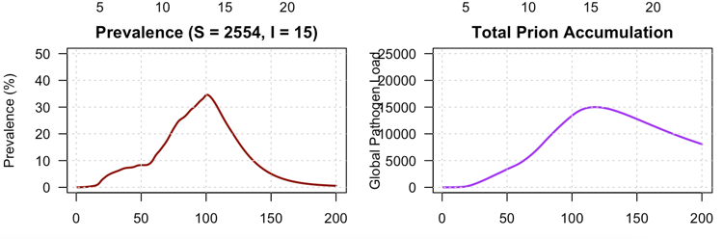 | 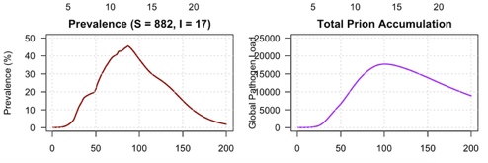
Reactive Local Culling (Part A) | 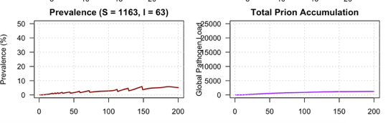 | 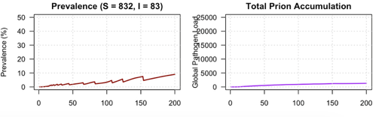 | 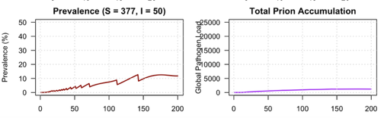
Delayed Quarantine at T=80 (Part B) | 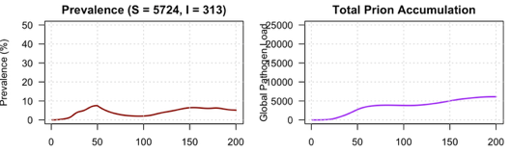 | 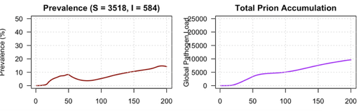 | 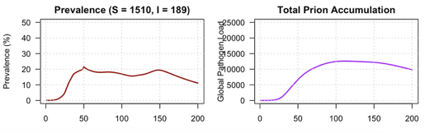

Mitigation Strategy | Output Measure | Patchy | Corridor | Encroachment
Reactive local culling (Part A) | Herd Preservation | Ineffective  S: 5100 1163 | Ineffective  S: 2554 832 | Ineffective  S: 882 377
 | Environmental Protection | Highly effective  Pathogen 0 | Highly effective  Pathogen 0 | Highly effective  Pathogen 0
Delayed Quarantine  (Part B) | Herd Preservation | Highly effective  S: 5100 5724 | Highly effective  S: 2554 3518 | Moderately effective  S: 882 1520
 | Environmental Protection | Moderately effective  Curved flattened | Ineffective | Ineffective

2. If your local hunting community demands high deer numbers today, but your long-term goal is preventing permanent, generational soil contamination, which policy wins? Explain the fundamental trade-off between a "Host-Targeted" policy (Culling) and a "Transmission-Targeted" policy (Quarantine).
3. Based on how these strategies perform across the different maps, would you recommend a single, "one-size-fits-all" statewide regulation policy for this disease? Why or why not?
Expected Answer: A one-size-fits-all policy should not be recommended. Identical rules have different outcomes depending on landscape structure.
  - Patchy: Natural isolation does most of the work; a quarantine easily knocks the disease out.
  - Corridor: The policy saves the living herd, but because deer continuously travel the same linear paths, they keep slowly dripping prions into the soil network.
  - Encroachment: High host crowding acts as an overriding force. Dropping transmission parameters early helps flatten the herd's sickness peak, but it cannot stop a massive, permanent pileup of prions in the soil because the animals are forced too close together.

