**Community Site for Dog Lovers**

As stated in our earlier milestone report, this project aims to foster interaction between dog lovers, increase probability of finding dogs who are designated as missing (return to previous owners or find them a new home), give stray dogs same benefits and find new homes for dogs through adoption. Milestone one contained updates on the initial draft of the website development progress. Updates were given on data structure, backend, frontend, and tools used in the process. We also attached links to support this progress on the document. This document (Milestone two) outlines further progress made in this project:

**Frontend**

Firstly, we have further developed the frontend, working on the adoption page, home page and missing dogs’ page. A base html page was created and can be viewed here:

<https://github.com/singla007/Dog_Community_FS/blob/main/dog_community_app/templates/base.html>

Each page designed for the website takes on some characteristics of the base html page. Figure 1 shows the initial draft of the adoption page. We are still working on perfecting some little details such as appropriate texting/catchy text to use for this page. To aid dynamism, Filter logics developed using JavaScript have also been developed for the adoption page (see figures 2 and 3). A corresponding views.py file was created in Django framework and can be seen in figure 4. Figure 5 shows the second draft of the reporting missing dogs’ page. This second draft has been integrated into the website application and given the base.html template. The homepage has been updated to have a more user-friendly look with updates on texts used on the page (see figure 6).

**AZURE Deployment**

Secondly, we have attained one step in application management through realization of our project on azure. This is still being worked on as we have currently achieved this without MySQL. The build pipeline has been completed and we are still in the process of actualizing continuous development (CD). Further progress would be reported in the milestone 3 document. The Azure deployment can be viewed via the link below:

<https://dogs-community.azurewebsites.net/>

Figure 1. Community for Dog lover Adoption page

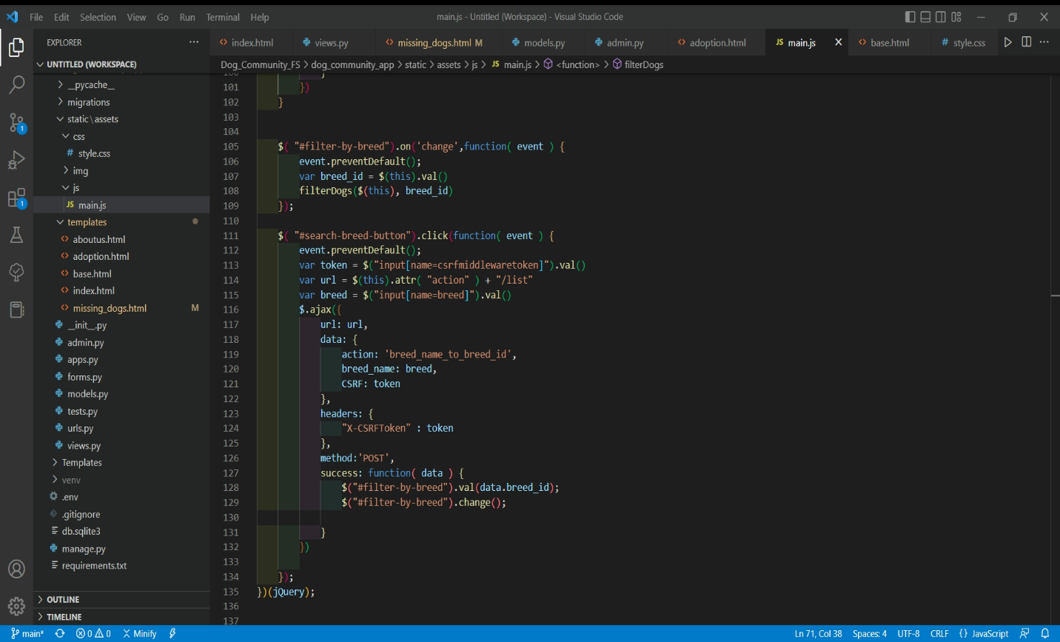

Figure 2. Filter logic 1 for adoption page

Figure 3. Filter logic 2 for adoption page

Figure 4. views.py for adoption page

Figure 5. Second draft for report a missing dog page

Figure 6. updated home page