Brobot Project Summary

Braceroot-robot (known as Brobot) is a project that resulted from a 2018 CAT EPoC grant. This grant proposed the development of a sub-canopy robot that could capture hard to reach data in corn fields. You can read more about the developments related to the CAT grant in the 2018_cat_epoc_seeterra project folder. The code for this project is on the Brobot computer and the rospackage is here labeled brobot, the joystick arduino code, this is in a folder named rc_joy. You should never have to change this code.

*To adjust the velocity of the robot edit lines for max and min v,w in the joy_driver.py

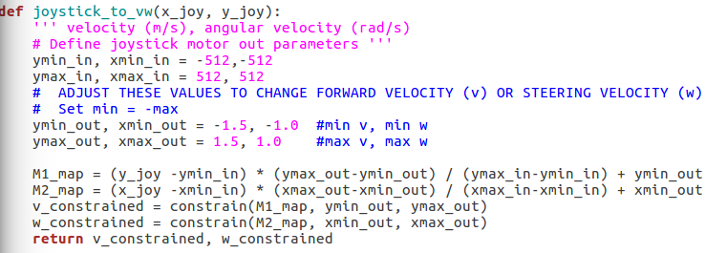

*If you get a new hard drive you have to edit several lines in the data_collector.py, edit anywhere you see the filepath by replacing “aaac50a8-6183-4b03-a5be-34cf403af78e” with the ID of the new hard drive.