THE OPEN UNIVERSITY OF SRI LANKA
DEPARTMENT OF ELECTRICAL AND COMPUTER ENGINEERING
BACHELOR OF SOFTWARE ENGINEERING
Academic Year – 2024/2025
EEX5362 – Performance Modelling

Mini Project Report

Y. Thilukshan
REG NO: 321429753
Student ID: S92069753
Fuel station with multi fuel and payment System

Background
The chosen system in the current mini project is a Fuel Station Operation System, which is improved to reflect a more real world scenario. This simulation is used to represent the way vehicles come to a fuel station, queues, take fuel, and get payments.
This improved system is more complex and realistic in the sense that it considers various types of fuel and various methods of payment as opposed to a simple queue-based model.

1.1 System Components
Fuel Pumps - The pumps can serve one vehicle at a time. Pumps are grouped by types of fuel
- Octane 92 Petrol
- Diesel
- Kerosene
Vehicles - Each vehicle has a type of fuel required and quantity. The arrivals of vehicles are random.
Payment method - Vehicles are refueled and then sent to payment. It may be paid either in cash or by card with a transaction in card paying a bit longer as there is a delay in the processing of the payment.

1.2 Performance Aspects within the System
Queue Length - This is the number of vehicles under waiting service.
Average Waiting Time - The period a vehicle takes before beginning to fuel.
Throughput - The total number of vehicles attended during a certain period.
Pump Utilization - Percent of time spent working on all pumps.
Payment Delay - Extra time used in card payments as compared to cash payment.

Performance Objectives
The main aim of the project is to examine and enhance the efficiency of the fuel station system by researching the major operational measurements at different load conditions.

2.1 Specific Objectives
- Minimize Vehicle Waiting Time - Minimize the waiting time of vehicles.
- Maximize System Throughput - Increase the number of vehicles served within a specific simulation time.
- Identify Performance Bottlenecks - Find out whether lines occur more at the fueling pumps or payment counters.
- Analyze Resource Utilization - Assess the efficiency of the use of pumps and payment counters.
- Compare Payment Methods - Determine the impact of card and cash payments on total system delay.
- Optimize Pump Allocation by Fuel Type - Identify whether increasing the number of pumps for high-demand fuel types improves performance.

Modeling Approach and Assumptions

Selected Modelling Technique
The fuel station system is represented using a Discrete Event Simulation (DES) method. This method is suitable because the system changes only at certain moments in time. These moments include vehicle arrivals, starting the fueling process, finishing fueling, making payment, and finally leaving the station. In the selected fuel station, there are different types of fuel, shared dispensers, a limited number of employees, and a connected payment process. Because of this complexity, using only analytical queueing models is not enough to properly describe how the system works.
By using simulation, it is possible to show the real interactions between different resources such as fuel pumps, dispensers, and employees. The model can also handle different types of customers and different service times. This makes Discrete Event Simulation a suitable and flexible approach to study the system performance under various operating conditions.

Relation to Queueing Theory
The system is based on simulation but follows queueing theory ideas. Vehicles arrive randomly and wait in queues of fuel type. Fueling and payment are services with limited resources. Waiting time and resource usage are used to study the results. Because the system has many steps and shared employees, simulation is a better choice.

Application of the Model
Vehicles arrive using a Poisson process and are grouped by fuel type. A vehicle starts service only when a dispenser and an employee are free. Fueling time depends on fuel type. Payment is made by the same employee and takes different time for cash or card. After payment, the vehicle leaves. The model records arrival, service, and departure. It measures waiting time, queue length, throughput, and resource use.

Justification for Model Selection
The discrete event simulation approach is selected for the following reasons,
- The system has different fuel types and limited resources.
- Employees and dispensers are shared.
- Payment is part of the service and changes by payment method.
- system behavior changes under different arrival rates and employee availability.
- Simulation enables what-if analysis without disrupting real-world operations.
Simulation helps test different situations without affecting the real station. So, simulation fits better than simple queueing models.

Modelling Assumptions
To simplify the modeling process while maintaining realism, the following assumptions are made:
- Vehicle arrivals are independent and follow a Poisson distribution.
- Fuel demand varies around an average value for each fuel type.
- Each fuel dispenser can serve only one vehicle at a time.
- A vehicle can begin service only when both a dispenser and an employee are available.
- Fueling and payment are handled by the same employee.
- Card payments require additional processing time compared to cash payments.
- All queues follow a First-Come-First-Served (FIFO) order.
- Vehicles do not leave the queue once they arrive.
- Equipment failures and breakdowns are not considered.

Simulation Setup and Performance Measurement

Simulation Setup
The simulation was set up to match the real fuel station as closely as possible. The system was run for a fixed time to represent normal daily operation. There were 2 arrival conditions. One is normal hours and the other one is peak hours.
The number of employees was used as a changeable parameter. In most cases, two employees were used because this is the usual situation at the station. In some runs, three employees were used to see how system performance changes when extra staff is available.
Fuel dispensers were grouped by fuel type. The number of dispensers for petrol, diesel, and kerosene was kept the same in all simulations. Payment was handled by the same employee who assists with fueling. There was no separate payment counter in the model.

Performance Evaluation
The collected data was used to compare different system conditions. The normal arrival case was treated as the base case. Results from peak hours and increased employee scenarios were compared against it. This comparison helped identify delays in the system and showed how changes in staffing affect waiting time and overall performance.

Analysis of System Behavior and Findings
Here we can see how the fuel station system behaves under different conditions. The analysis is based on the simulation results collected for normal hours, peak hours, different employee counts, and different fuel demand patterns. The main focus is on waiting time, throughput, and resource utilization.

System Behavior During Normal Hours
During normal hours, the system served 138 vehicles in 8 hours. The average fuel queue waiting time was 1.38 minutes, which is quite low. However, the average payment waiting time was higher at 4.83 minutes. The average total time spent in the system was 8.84 minutes.
Employee utilization was 75%, which means the employee was busy most of the time but still had free time. Fuel pump utilization was very low for all fuel types. Petrol pumps had only 4% utilization, diesel 11%, and kerosene 18%.
These results show that during normal hours, the system works smoothly. There are no serious queues, and the available resources are enough to handle customer demand without delay.

System Behavior During Peak Hours
During peak hours with only one employee, system performance became much worse. The system served 183 vehicles, but the average fuel queue waiting time increased sharply to 50.13 minutes. The payment waiting time also increased to 15.63 minutes. As a result, the average system time became 63.12 minutes.
Employee utilization reached 99%, which means the employee was almost always busy. In contrast, fuel pump utilization stayed low. Petrol pumps were used only 7%, diesel 14%, and kerosene 21% of the time.
This clearly shows that the system could not handle peak demand with only one employee. Long queues were created mainly because vehicles had to wait for the employee, not for fuel pumps.

5.3 Effect of High Petrol Demand
In the peak-hour scenario with high petrol demand and one employee, the system served 275 vehicles. The average system time was 27.07 minutes. Employee utilization was again 99%, showing heavy workload. Petrol pump utilization increased to 15%, while diesel and kerosene pumps were used much less.
When the number of employees increased to two, performance improved clearly. The average system time reduced to 5.69 minutes, and employee utilization dropped to 63%.
This shows that even when petrol demand is high, the main issue is still employee availability, not pump availability.

5.4 Effect of High Diesel Demand
The worst performance was seen in the high diesel demand case with one employee. Only 152 vehicles were served. The average fuel waiting time increased to 86.94 minutes, and the average system time became 99.06 minutes.
Diesel pump utilization increased to 23%, which is much higher than other fuel types. Employee utilization stayed at 99%, showing extreme congestion.

Even with two employees, performance was still poor. The average system time was 48.96 minutes, and employee utilization was 97%. Diesel pump utilization increased further to 51%.
This shows that when diesel demand is high, both the employee and diesel pumps become bottlenecks, causing very long delays.

5.5 The Main Bottleneck
From all scenarios, employee utilization was always higher than fuel pump utilization. During peak hours, the employee was fully busy while many pumps were idle.
This happens because the same employee is needed for both fueling and payment. Even if a pump is free, a vehicle cannot be served without an employee. Because of this, the employee becomes the main bottleneck in the system.

5.6 Effect of Increasing Employees During Peak Hours
To reduce delays, the number of employees increased during peak hours. With two employees, system performance improved a lot. The system served 312 vehicles. The fuel waiting time dropped to 2.84 minutes, and payment waiting time dropped to 3.3 minutes. The average system time became 8.74 minutes. Employee utilization reduced to 85%, showing better workload sharing.
When three employees were used, waiting times became very small. Fuel waiting time was only 0.13 minutes, and payment waiting time was 0.33 minutes. The average system time dropped further to 2.95 minutes. Employee utilization fell to 52%.
This shows that adding employees helps reduce waiting time. However, using three employees may not be efficient because they are idle for a large part of the time.

5.7 Overall Findings
From the analysis, several important points can be identified. The system works well during normal hours but fails during peak hours if staffing is not increased. Employees are the main bottleneck in most situations. Increasing employees during peak times greatly improves performance. Fuel demand imbalance, especially high diesel demand, can create additional bottlenecks at pumps.
Overall, the simulation shows that proper staffing and better resource planning are necessary to reduce waiting times and improve customer service at a fuel station.

System Summary and Visualization

6.1 Overall Summary
Scenario | Arrival Rate | Employees | Fuel Demand (Percentage) | No. of Vehicles Served | Waiting Time (Fuel) | Waiting Time (Payment) | Waiting Time (System) | Employee Utilization
 |  |  |  |  | (Minutes) |  |  | Employee Utilization
1 | Normal | 1 | petrol92: 0.7  diesel: 0.25  kerosene: 0.5 | 138 | 1.38 | 4.83 | 8.84 | 0.75
2 | Peak | 1 | petrol92: 0.7  diesel: 0.25  kerosene: 0.5 | 183 | 50.13 | 15.63 | 63.12 | 0.99
3 | Peak | 2 | petrol92: 0.7  diesel: 0.25  kerosene: 0.5 | 312 | 2.84 | 3.3 | 8.74 | 0.85
4 | Peak | 3 | petrol92: 0.7  diesel: 0.25  kerosene: 0.5 | 296 | 0.13 | 0.33 | 2.95 | 0.52
5 | Peak | 1 | petrol92: 0.85  diesel: 0.12  kerosene: 0.03 | 275 | 18.59 | 7.04 | 27.07 | 0.99
6 | Peak | 2 | petrol92: 0.85  diesel: 0.12  kerosene: 0.03 | 284 | 2.2 | 1.65 | 5.69 | 0.63
7 | Peak | 1 | petrol92: 0.25  diesel: 0.7  kerosene: 0.5 | 152 | 86.94 | 13.49 | 99.06 | 0.99
8 | Peak | 2 | petrol92: 0.25  diesel: 0.7  kerosene: 0.5 | 267 | 41.94 | 4.09 | 48.96 | 0.97
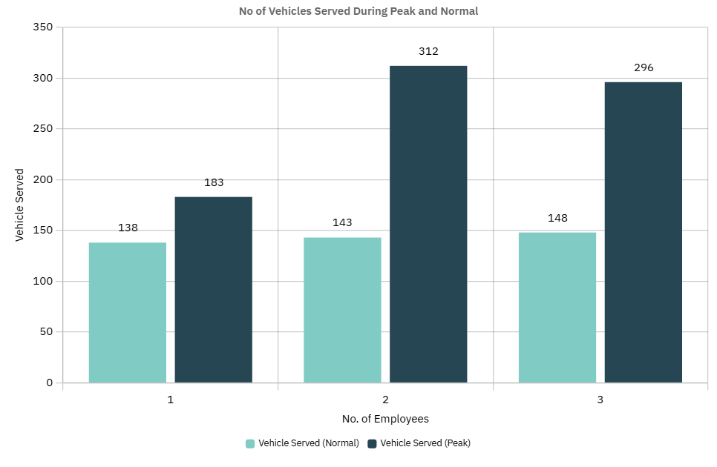Figure 1
In this graph we can see that, when Vehicle Arrival Rate is Normal Only 1 employee is enough to handle customer demand without delay.
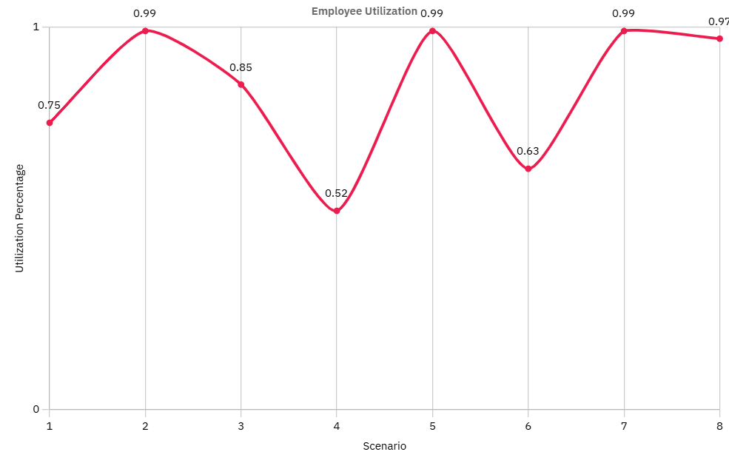
Figure 2
In this Graph we can see, the Employee Utilization is high when, No of Employee is 1 and we can see Normal Utilization during No of Employees are 2. Clearly we can determine Employee count is the main Bottleneck of the System.

Limitations and Future Extensions
This simulation gives useful results, but it also has some limitations. These limitations come from simplifying the real fuel station to make the model easier to build and analyze.
The model does not include equipment failures or pump breakdowns. In real fuel stations, pumps can stop working or need maintenance. This can increase waiting time, but it was not considered in this study.
Vehicles are assumed to wait until service is completed. In reality, some customers may leave the station if the queue is too long. This behavior was not included in the simulation.
Payment times were kept simple. Cash and card payments were given fixed service times. In real situations, payment time can change based on customer behavior, network delays, or system issues.
Traffic movement inside the fuel station was not modeled. Issues such as limited space, vehicle blocking, or entry and exit congestion were ignored.
Because of these limitations, the results represent an ideal operating condition and may differ slightly from real-world behavior.

Future Extensions
There are several ways this model can be improved in future work. Customer behavior can be made more realistic by allowing vehicles to leave the queue if waiting time becomes too high. This would help study customer satisfaction.
Equipment failures and maintenance periods can be added to better reflect real station conditions. Separate payment counters can be introduced instead of using the same employee for fueling and payment. This would help reduce employee workload.
Appendix

