Step 1. Install Python

Step 2. Run the following commands to install dependencies:

pip3 install PyQt5

pip3 install tkinter

pip3 install kivy

Step 3: Download Library.db or create Library.db from the LMS.sql file

Step 4. Run python program using 'python Library.py' to open GUI

Checkout Book Example

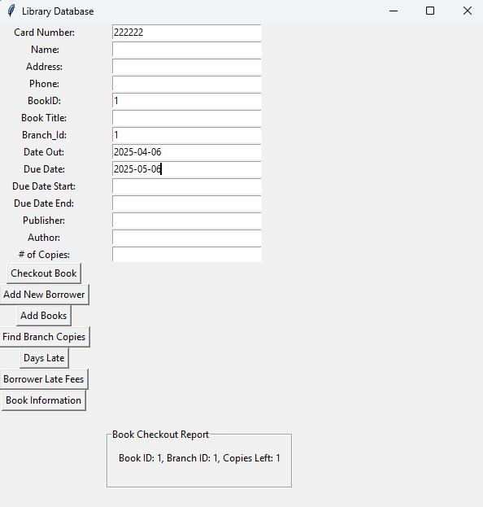

Add New Borrower Example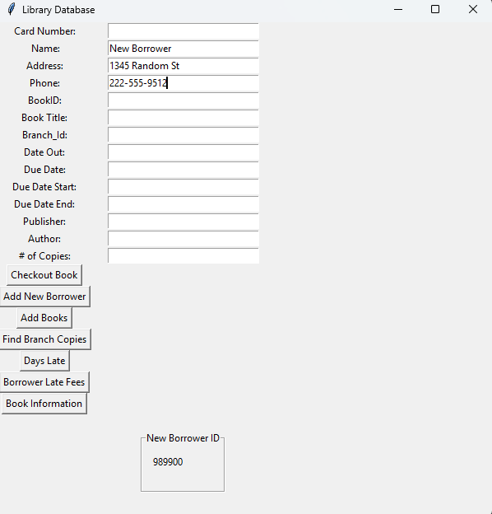

Add Books Example

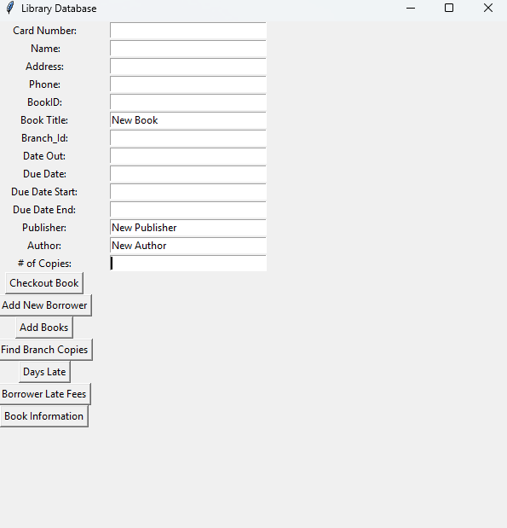

Find Branch Copies Example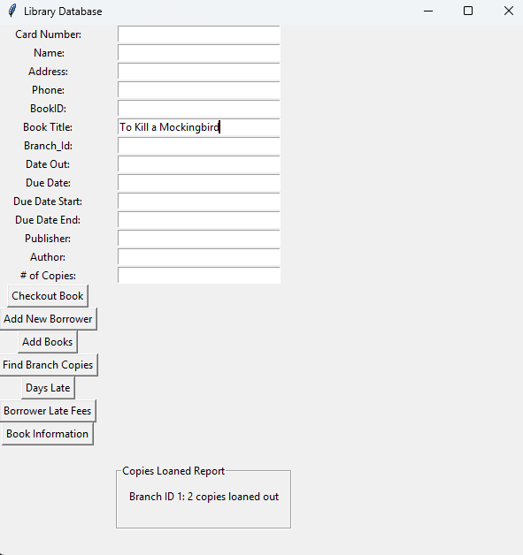

Days Late Example

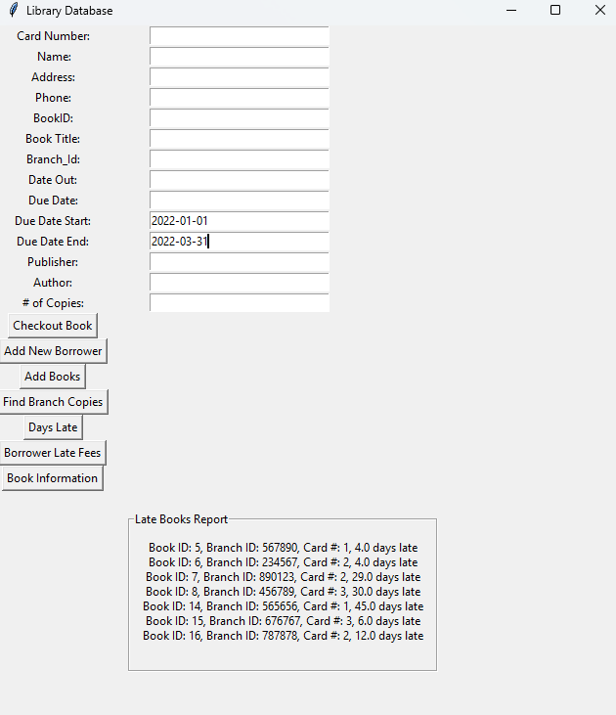

Borrower Late Fees Example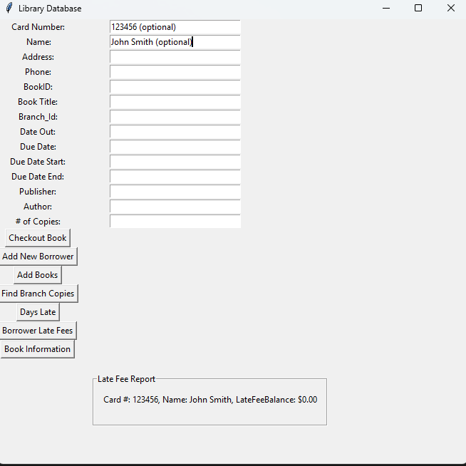

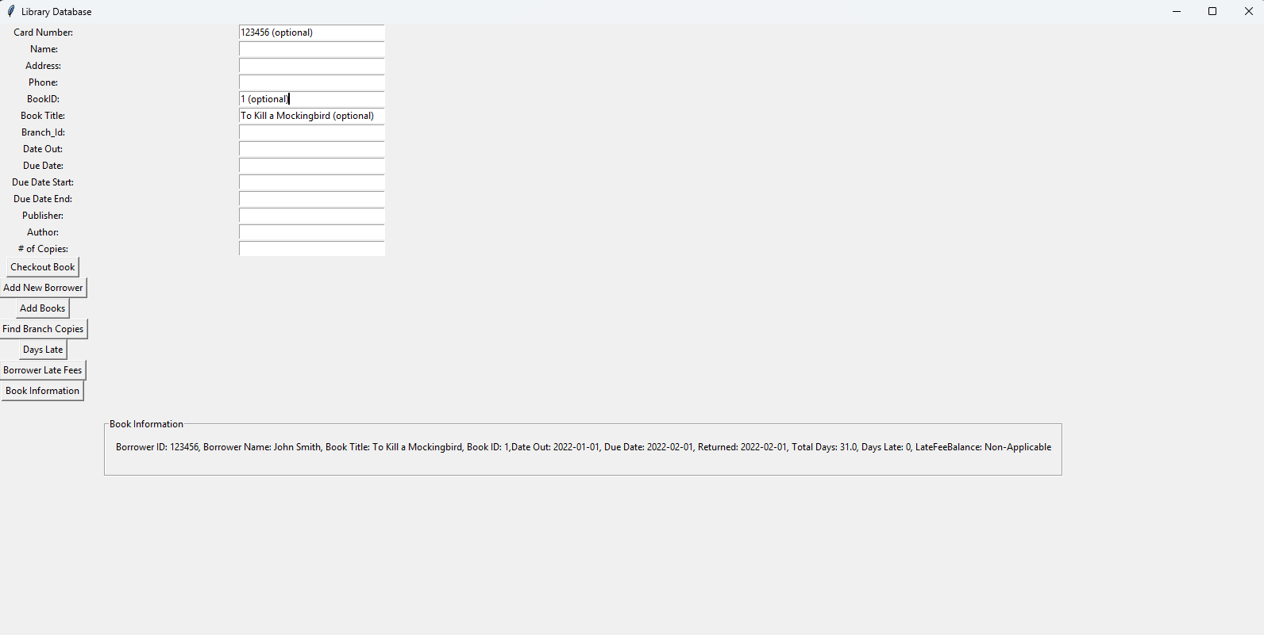

Book Information Example