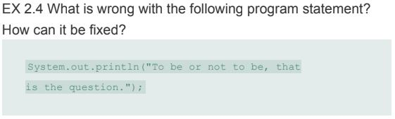

1. **What is wrong with the following program statement?**
   1. The compiler tries to read line 1 separately from line 2. It throws the error “String literal is not properly closed by a double-quote” because the compiler does not recognize that we are trying to use the println function across lines 1 and 2, so it reads the statement as incomplete.
2. **How can it be fixed?**
   1. It could be fixed by moving the contents of line 2 up to the end of line 1. This completes the statement as the string is fully enclosed by double quotes and it has a proper statement terminator.
      1. System.out.println("To be or not to be, that is the question");
   2. If you need the string to continue onto line 2, you could concatenate the two strings together using the “+” operator. This tells the compiler to concatenate the string on line 1 with the string on line 2, assuming proper formatting.
      1. System.out.println("To be or not to be, that" +

" is the question");