Integration of the model InVEST with the model EFForTS-ABM: new tool for dynamic simulation of biodiversity and socio-economic functions

Julia Henzler1,✉, Nils Beyer1, Sebastian Hanss1, Craig Eric Simpkins1,2, Jan Salecker1, and Kerstin Wiegand1

27 June, 2021

1 University of Goettingen, Department of Ecosystem Modelling, 37077 Goettingen  
2 University of Auckland, School of Environment

✉ Correspondence: [Julia Henzler <[julia.henzler@uni-goettingen.de](mailto:julia.henzler@uni-goettingen.de)>](mailto:julia.henzler@uni-goettingen.de)

**Keywords:** biodiversity, ecological functions, economic functions, EFForTS-ABM, InVEST, software integration

**Running headline:** Integration of InVEST with EFForTS-ABM (34 characters)

**Alternative titles:**

* “(Dynamic) simulation of biodiversity and socio-economic functions (simultaneously): Integration of the model InVEST with the model EFForTS-ABM.”
* “Integration of the model InVEST with the model EFForTS-ABM: new tool for dynamic simulation of biodiversity and socio-economic functions simultaneously”
* “(Dynamic) simulation of biodiversity and socio-economic functions (simultaneously): Integration of two spatially-explicit models.”

**Author contributions:**

JH, NB, SH, JS and KW conceived the ideas and designed methodology, JH and NB analyzed the data, JH, CS and KW led the writing of the manuscript. All authors contributed critically to the drafts and gave final approval for publication.

**Target Journals:** Methods in Ecology and Evolution, PLOS Computational Biology, Ecological Modeling

**Key message:** Demonstration of the integration of the static terrestrial biodiversity model InVEST with the dynamic land-use change model EFForTS-ABM. As a result, synergies and trade-offs between biodiversity and socio-economic functions can be assessed simultaneously and dynamically at multiple temporal and spatial scales.

# 1 Abstract

The Abstract must not exceed 350 words and should list the main results and conclusions, using simple, factual, numbered statements:

Point 1: set the context for and purpose of the work;

Point 2: indicate the approach and methods;

Point 3: outline the main results;

Point 4: identify the conclusions and the wider implications.

# 2 Introduction

In the past decades, specialization and intensification of land-use has effected social-ecological systems around the world. On the one hand, the ecological part, consisting of multiple ecological functions and biodiversity, does in total not benefit from land-use changes. Biodiversity is the key index on the ecological sphere and is important for stability and efficiency of ecosystems and provision of ecological functions and services (Bradley J. Cardinale et al., 2012). The main result of the Millenium Ecosystem Assessments is that two-third of the world’s ecosystem services were declining (Millenium Ecosystem Assessment, 2005). Whereas the socio-economic part, comprising for example economic functions like household consumption, benefits from these changes (Klasen et al., 2013). In recent years, there has been an increasing interest in the analysis of trade-offs and synergies within these systems, since the relationship between biodiversity, ecological functions and socio-economic functions over time and over space is not predictable (Dislich et al., 2018).

Models are capable of examining relationships over multiple temporal and spatial scales. Several models simulate either the economic part or the ecological part, some integrated models deal with both parts. For example…

#```{r differences of models,echo=FALSE} #Create dataframe from txt file #models <- read.table(“tables\model_differneces.txt,” header = TRUE) #models <- data.frame(models)

#Create table #pander::pander(sens, caption = ‘Table 1: **Main differences between the tools to simulate biodiversity, ecological functions and socioeconomic functions.**’) ```

We have, therefore developed the integration of InVEST with EFForTS-ABM. Description of InVEST. Description of EFForTS-ABM. Benefit of their integration. See table 1.

Our first aim is to provide a tool for dynamic and simultaneous analysis of biodiversity and socio-economic functions at multiple temporal and spatial scales. Our second aim is to make our tool reproducible to be adopted for a wide range for analysis of socio-ecological systems.

* Relationship between ecological and socio-economic functions for conservation issues
  + Ecological and socio-economic sphere (biodiversity as key index)
  + Trade-offs and Synergies and possible problems when unbalanced
  + Open question: Unclear relationship over time and space and the consequence for conservation

*Rethink the audience and address first paragraph of introduction accordingly.*

* Representation of both models separately and their issues
  + Models are capable of examining relationships over multiple temporal and spatial scales….
  + InVEST was developed for changes of ecosystems at different spatial and temporal scales but is a static model (as only 2 different points in time can be compared, not development across time). Rapid assessment of biodiversity patterns and status : ecological functions + biodiversity via ecological production functions, static model, proven model: examples of applications
  + EFForTS-ABM is a land-use change model where landscape is managed: socio-economic function, dynamic model, explain main parameters
* Benefits of connection of EFForTS-ABM and InVEST:
  + EFForTS-ABM can be used as dynamic input for InVEST
  + EFForTS-ABM fits requirements to generate input for InVEST
  + Output of InVEST can be processed dynamically within EFForTS-ABM
* Aim and Hypotheses
  + Aim 1: Tool for simultaneously model socio-economic functions and biodiversity over time and space
  + Aim 2: Reproducibility of results: execute simulations on server or on hpc.
  + Connection is possible through narrow integrationlayer it can be easily implemented, maintained and comprehended (maybe to Abstract).

# 3 Methods

## 3.1 Integration of InVEST with EFForTS-ABM

To simultaneously simulate biodiversity and socio-economic functions within a single analysis over multiple temporal and spatial scales, we integrated the model InVEST with the model EFForTS-ABM. EFForTS-ABM generated the land-use and land-cover maps (LULC-maps), the impact-maps and the parameter settings used as inputs for InVEST. InVEST calculated the habitat quality as proxy for biodiversity which is integrated into EFForTS-ABM for further trade-off and synergy analysis along with socio-economic functions. We developed functional and non-functional requirements for testing correct implementation. *Mention at first in intro or at first in methods?* *I suggest in the introduction as functional and non-functional requirements may need explanation especially if the target journal is more ecologically focused*

The static production function model InVEST-Terrestrial Biodiversity (Version 3.9, Tier 1) was used to simulate biodiversity (Kareiva et al., 2012). The model is spatially-explicit and calculates a grid-cell level degradation score and a grid-cell level habitat-quality score for every grid cell which was assigned suitable habitat. Suitable habitat depends on the selected research objective (general biodiversity, species-specific needs). The degradation score depends on proximity of habitat-types to user-defined impacts to biodiversity. The calculation is based on (i) the distribution of land use and land cover (LULC-map) for the area of interest, (ii) the distribution and intensity of user-defined impacts to biodiversity (impact-maps), (iii) the assignment of suitable habitats and their sensitivity to impacts (sensitivity-table), and (iv) the relative impact weighting and how quickly the impact decays over space (impact-table). For a full description of the calculation see (Sharp, R. et al., n.d.). The degradation score is then standardized to a grid cell-level habitat quality score (Figure 3.1) via a half-saturation function. Resulting in a habitat-degradation map and a habitat-quality map as inputs for EFForTS-ABM. The habitat-quality score is a proxy for biodiversity based on a simple habitat-analysis, enabling rapid assessment of biodiversity patterns. The biodiversity indicator habitat quality is well suited for trade-off and synergy analysis in combination with economic functions. InVEST is scientifically grounded and is widely applied to simulate biodiversity and ecological functions based on spatially-explicit maps. A detailed user guide was published in Sharp, R. et al. (n.d.).

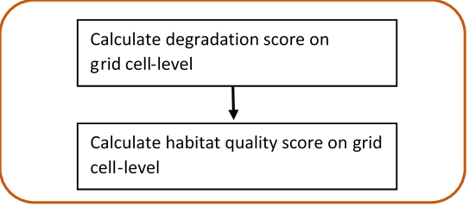

Figure 3.1: **InVEST-Terrestrial Biodiversity.** Calculation of grid cell-level degradation score and grid cell-level habitat quality score

To simulate the socio-economic component of the analysis, the dynamic and spatially-explicit land-use change model, EFForTS-ABM (version xyz), was used. The initial landscapes for EFForTS-ABM are *JH: initial landscapes are always generated by LGraf :)* generated with the landscape generator EFForTS-LGraf. It provides agricultural landscapes cultivated by small-scale farms. The landscapes comprise a regular grid of cells, whereby each grid cell is assigned one specific land cover (vegetation-type) and a corresponding land use (management). Moreover, roads and villages that consist of smallholder farming households are generated. Every year households make rational land-use decisions with the aim to maximize their economic benefit (Figure3.2 ). Detailed descriptions of EFForTS-LGraf and EFForTS-ABM were published in Salecker, Dislich, et al. (2019) and Dislich et al. (2018), respectively. EFForTS-ABM is able to investigate how the decisions of households affect economic functions (e.g. household consumption) and landscape structure from a local to a landscape scale and vice versa at various points in time. The distribution of land use and land cover and the impacts to biodiversity (from either land use or land cover) can easily be derived from EFForTS-ABM. The ABM is also suitable to integrate the generated habitat-quality maps from InVEST. Therefore, EFForTS-ABM fits the requirements to dynamically generate and process the spatially-explicit inputs and outputs of InVEST.*JH: I chose to describe the initial landscape more general (not specific to lowland rainforest transformation systems) here, in order to later highlight the advantage of our integration, which is the broad application possibility with different initial landscapes. What is your opinion on that?*

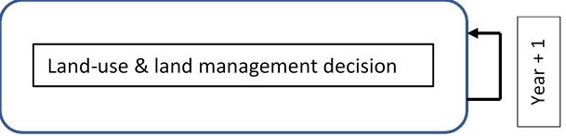

Figure 3.2: **EFForTS-ABM.** Yearly land-use and land management decision of households.

The implementation of both models was achieved by an two-way Input-Output-Transfer. We mapped the outputs from EFForTS-ABM as the inputs for InVEST and mapped the outputs from InVEST as the inputs for EFForTS-ABM. First, EFForTS-ABM generates (i) the LULC-map and (ii) one impact-map for each defined impact, (iii) the corresponding sensitivity-table and (iv) impact-table. The LULC-map and the impact-maps are in Tag Image File format (tif-format) and the sensitivity-table and impact-table are in comma-separated value format (csv-format). Second, InVEST integrates the generated inputs of EFForTS-ABM and calculates the habitat-degradation map and the habitat-quality map in tif-format for further processing in EFForTS-ABM (Figure3.3). Since EFForTS-ABM is only able to process asc-format and InVEST is only able to process tif-format, asc- and tif-formats were converted by Geospatial Data Abtraction Library (Version 3.2.0, (**gdal?**)).

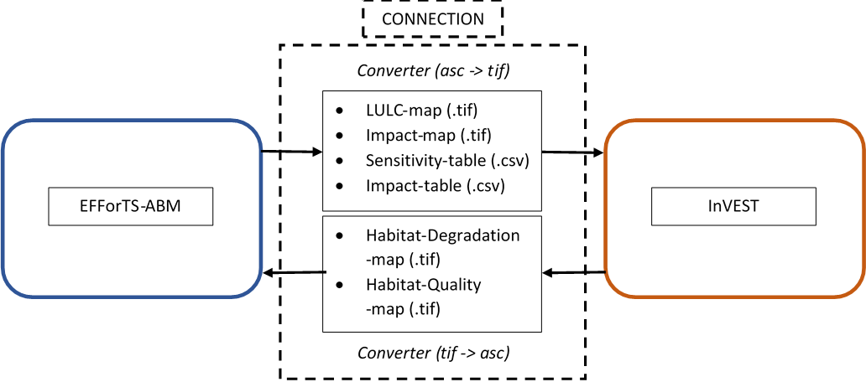

Figure 3.3: **Input-Output-Transfer between EFForTS-ABM and InVEST**. The input of InVEST (LULC-map, Impact-map, Sensitivity-table, Impact-table) are generated by EFForTS-ABM. The input of EFForTS-ABM (Habitat-Degradation-map, Habitat-Quality-map) are generated by InVEST. For the transfer a converter is needed.

## 3.2 Evaluation of integration of InVEST with EFForTS-ABM

To evaluate the integration between InVEST and EFForTS-ABM, we adopted a widely applied software testing system as our requirement plan (Bashar & Easterbrook, Steve, 2000). This plan was divided into functional and non-functional requirements.

The functional requirements included a testing scheme beginning from unit-tests to integration-tests and ending with an acceptance-test (A. Contan et al., 2018). Unit-tests were applied to verify the correct implementation of processes. This was realized by an isolated unit-testing module within EFForTS-ABM. This module comprised each particular process implemented by the integration of InVEST with EfforTS-ABM. We compared the simulated output of each particular process to its expected output (Table A in Supplementary Materials). Integration-tests were applied to verify the correct integration between InVEST and EFForTS-ABM. This could be proven by correct Input-Output-Processing. It was realized by an isolated integration-testing module within EFForTS-ABM. For more convenient comparison of results, we chose a simplified parameter setting (see table 1 and table 2, TODO: automated referencing) - with binary approaches for all assignment of values (habitat, sensitivity, intensity of impacts, impact weighting) - and two simplified landscapes - forest-landscape and single-field-landscape. First, to verify the correct calculation of habitat-quality scores, the simulated grid-cell level habitat-quality scores for the forest-landscape were compared to the expected output. Second, the simulated grid cell-level habitat-quality scores for the single-field-landscape were compared to the expected output to verify the correct reduction of habitat-quality scores by the defined impacts. *JH: Must we prove this, as this should already be proven by InVEST?: I think yes, as we then know, that the integration delivers correct results. Maybe compare results of integration with results of only using InVEST and manually hand over maps and tables generated by ABM?*

Table 1: **Sensitivity table.** Classification (LULC) and names (NAMES) of LULC-types and their corresponding habitat assignment (HABITAT) and sensitivities to defined impacts (L_oilpalm, L_rubber).

|  |  |  |  |  |
| --- | --- | --- | --- | --- |
| LULC | NAME | HABITAT | L_oilplam | L_rubber |
| 1 | village | 0 | 0 | 0 |
| 2 | oilpalm | 0 | 1 | 1 |
| 3 | rubber | 0 | 1 | 1 |
| 4 | forest | 1 | 1 | 1 |

Table 2: **Impact table.** Maximal distance of each impact over space (MAX_DIST in km), its corresponding impact weighting (WEIGHT) and how impacts decay over space (DECAY).

|  |  |  |  |
| --- | --- | --- | --- |
| IMPACT | MAX_DIST | WEIGHT | DECAY |
| village | 0.05 | 1 | linear |
| oilpalm | 0.05 | 1 | linear |
| rubber | 0.05 | 1 | linear |

The acceptance-test was applied to verify the dynamic simulation of socio-economic functions and biodiversity simultaneously. The initial landscape was calibrated with data from a lowland rainforest transformation system in Sumatra, Indonesia. This region is a global biodiversity hotspot with proceeding agricultural expansion (Ingo Grass et al., 2020). Resulting in a landscape comprising of regular grids of 100 x 100 cells, with each cell representing a 50 m x 50 m area creating a total landscape dimension of 25km2. These grids represent a forested landscape in Sumatra (Indonesia) with roads and villages of smallholder farming household agents and agricultural fields (oilpalm and rubber) owned and farmed by individual households. The test is calibrated with simplified parameter settings for both models. For the biodiversity component, we chose binary approaches for all assignment of values (habitat, sensitivity, intensity of impacts, impact weighting). For the economic component we look at a constant price scenario for oilpalm and rubber, where all farmers are perfectly efficient and therefore must not learn from each other. Fallow land can not be purchased and is simply excluded from analysis.Parameter settings for InVEST and EFForTS-ABM are shown in tables 1 and 2 and table 3 TODO: automated referencing,respectively. The temporal extend of the acceptance-test is 50 years. We simulate 20 replications for the test, to capture model stochasticity. The household consumption of all households was analyzed as one representative for socio-economic-functions. The landscape-level habitat-quality score, which is a aggregation of all grid cell-level habitat-quality scores, was analyzed as the representative for biodiversity.

Table 3: **Parameter setting for EFForTS-ABM** (Maybe move to Supplementary Materials)

|  |  |
| --- | --- |
| Parameters | Value |
| Prices | constant prices |
| Learning | no learning |
| Inefficiency | no inefficiency |
| which-map | five-farmers2 |
| land-use-change-decision | only-one-field-per-year |
| initial-wealth-distribution | constant |
| landmarket | no landmarket |
| biodiv_plants | invest_pyhton |
| biodiv_plants_objective | general |

The non-functional requirement include the reproducibility of the integrated InVEST-EFForTS-ABM software tool. We designed a docker image as a standardized unit of the integration to quickly and reliably execute it on a linux-based server. It ensures the correct version of InVEST along with its required dependencies, the correct version of EFForTS-ABM and the correct integration of both models. To conveniently execute the simulations an RStudio Server is started within the docker container. *Describe more detailed the development of the docker image. What are the requirements for development….blabla?*

For the execution of the simulations on a high-performance-cluster, we designed a singularity container, which duplicates the dockerfile into a singularityfile on the cluster. (or on a high-performance-cluster with uniform software management, shared batch management environment, cross-system monitoring and accounting, and cross-system file systems.) *Here, we have to wait for further progress. Actually, there is no function within cluster_mq to run a singularity container on the hpc. We opened an issue and wait for response. If there is no convenient way to run singularity on hpc, we have to work with an manual installation of InVEST on the cluster. Update (18.06.2021: we work with a manual installation, sadly :(*

Simulations on the linux-server were executed with the R package nlrx (0.4.3, Salecker, Sciaini, et al. (2019)) and submitted to the high-performance-cluster with the R package clustermq (0.8.95.1, Schubert (2019)). Results were analyzed with R (4.0.3, (**R?**)).

# 4 Results

## 4.1 Integration of InVEST with EFForTS-ABM

The integration was achieved by extending EFForTS-ABM with the/a biodiversity submodel (Figure4.1). First, InVEST is set up and the input for InVEST (i)-(iv) is generated within EFForTS-ABM: At initialization (1) the InVEST model - Terrestrial Biodiversity is set up and (2) depending on research objective (general biodiversity or species-specific needs) the sensitivity table and impact-table are generated. Every year the ABM (3) generates the LULC-map and the corresponding impact-maps which are (4) stored as tif-files after conversion. Second, the habitat quality is calculated within InVEST. Every year the ABM (5) invokes InVEST and transfers the previous generated output (i)-(iv). Based on the transferred output (7) the model InVEST calculates the Habitat-Degradation map and Habitat-Quality map. Within EFForTS-ABM (8) the maps are converted and (9) the habitat-quality scores of the Habitat-Quality map are stored in the grid cells of the landscape of EFForTS-ABM as an additional landscape property. Finally, the ABM (10) aggregates the grid-cell level habitat-quality scores to (10) a landscape-level habitat-quality score.

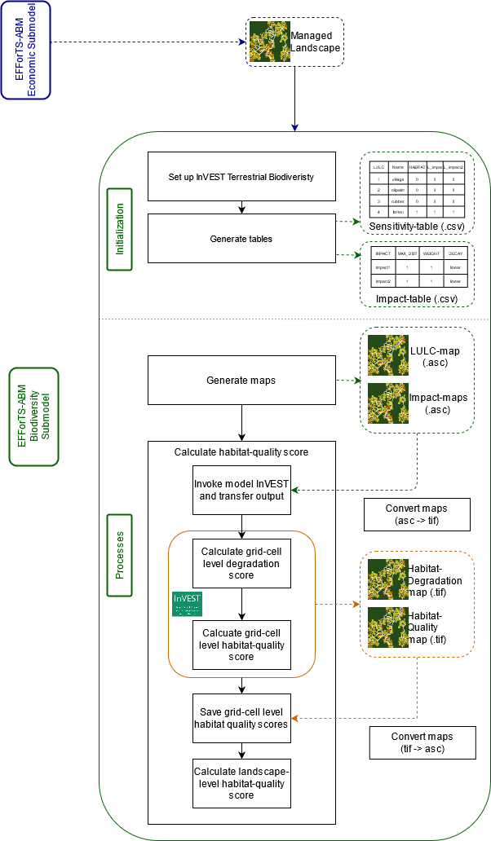

Figure 4.1: **Software-Architecture:** Implementation of the biodiversity submodel within EFForTS-ABM and corresponding processes involved in the integration of InVEST with EFForTS-ABM. *keep numbers for processes and also present them in figure?*

## 4.2 Evaluation of integration of InVEST with EFForTS-ABM

We confirmed all evaluated functional requirements stated in our requirement plan for the correct integration of InVEST with EFForTS-ABM. The implementation of processes was verified, as the expected output of each particular process equaled its simulated output (Table 1 TODO: automated referencing, Supplementary Materials). The integration of both models was further verified by the correct calculation of habitat-quality and correct reduction of habitat-quality by impacts *Statement is not fully clear to me*. Within the forest-landscape all grid cells showed the highest possible habitat-quality score of 1. For the single-field-landscape, the habitat-quality score of the agricultural field showed the highest reduction of habitat-quality (value x). The neighboring forest grid cells in a radius of 50 m showed less reduction of habitat quality (value x). All other forest grid-cells showed no reduction of habitat-quality (Habitat-quality score = 1), as the greatest distance of all impacts is 50 m. The dynamic and simultaneous simulation of socio-economic functions and biodiversity was achieved. Our results showed the yearly household consumption and yearly biodiversity (landscape-level habitat-quality score) over the simulated time and over the simulated landscape within one single analysis (Figure 5). *The focus of this paragraph is not clear, are you focused on the integration being achieved or on the results produced by the integrated models*

[Figure 5 (Coming soon): **Dynamic simulation of economic function and biodiversity simultaneously.** Mean household consumption in USD (red) and mean landscape-level habitat quality (green) over time. The dark lines refer to mean values of the 20 model replications and the shaded polygon surrounding each line refers to the respective standard deviations.]

The non-functional requirement reproducibility was achieved by a docker image. First, a linux-based server has to be set up, where the ports 80, 443 and 20 are open. Second, docker and docker-compose have to be installed. Third, the repository containing the integration has to be cloned. Finally, the containers have to be started on the server. This results in a standardized unit of an RStudio Server combined with the integrated InVEST-EFForTS-ABM software tool.

*singularity container (wait for description of results, until we know if it works or not)*

# 5 Discussion

Trade-offs and synergies of biodiversity and socio-economic functions and their mutual effect must jointly be assessed at the same multiple temporal and spatial scales (*Mention rationale in intro:realistic, less errors,feedback*). The integration of InVEST with EFForTS-ABM fulfills the need for a new tool to simultaneously and dynamically analyze functions from different spheres within one single analysis. This tool has two advantages in comparison to the simulation of biodiversity and socio-economic functions separately and statically: (a) the integration enables joint simulation of biodiversity and socio-economic functions. Resulting in applying only one tool for trade-off and synergy analysis and in straightforward incorporation of feedback between the two spheres; (b) the dynamic simulation enables detection of relationships between functions at the same multiple temporal and spatial scales. The presented acceptance test reflects the simultaneous and dynamic analysis of biodiversity and socio-economic functions within one single model execution. It is sufficient to singularly execute EFForTS-ABM to automatically get results for biodiversity and socio-economic functions. When starting the simulation, within EFForTS-ABM the socio-economic functions are simulated, the needed input for InVEST is generated, InVEST is invoked to simulate biodiversity and results of InVEST are transferred back to EFForTS-ABM at every time step and spatial resolution.  
New tools for assessing trade-offs and synergies of different spheres must also be reproducible (*Mention rationale in intro*). Reproducibility was accomplished by a docker-container for executing the tool on a linux-server and by a singularity container for executing the tool on a high-performance cluster. The advantages of making the integration reproducible are (a) the guarantee of executing the correct model versions with their correct dependencies; (b) and the assurance to have the integrationlayer already implemented. Thus, the tool can easily be applied.

Relation to literature (rough draft) To dynamically and simultaneously assess trade-offs and synergies between biodiversity and economic functions tools are needed. Name literature which also deals with that (Mouysset et al, Wu et al, Yee et al). But need for reproducible tool: we can deliver. (Chopin et al:, Mouysset et al: integration: simultaneous and dynamic simulation BUT NOT spatially explicit, Wu et al: Integration: effect of land-use change on ecological functions, spatially explicit BUT NOT simutaneously with economic functions, land-use effect on ecological functions BUT NOT spatially explicit,Yee et al: )

The integration of InVEST with EFForTS-ABM is a first step to provide a new tool for the dynamic analysis of functions from different spheres at multiple temporal and spatial scales. Future work might to achieve a broader opportunity of applications by adjusting the narrow integrationlayer to other land-use change models and to extend the analysis by adding further ecological functions available within InVEST.  
The docker-container can be accessed on github (<https://github.com/ecomod-code/rstudio-docker/tree/invest>)

# 6 Acknowledgements

Funded by the Deutsche Forschungsgemeinschaft (DFG, German Research Foundation) – project number 192626868 – SFB 990 in the framework of the collaborative German-Indonesian research project CRC 990. We thank Matthias Christian Spangenberg for valuable feedback on a earlier version of the manuscript.

# 7 Supplementary material

* Include more detailed Software-Architecture with every in- and output of both models (especially for economic submodel of EFForTS-ABM)

Table A: **Individual tested processes, input values for each tested process, expected output for each tested process and verification of correct implementation**. Sorry, have to find a way in R how to generate nicer tables. (continued below)

|  |  |
| --- | --- |
| Processes | Input |
| set-up-invest | which-machine? = server |
| write-tables | dummy sensitivity table, dummy impact-table |
| translate-lulc-to-invest | p_landuse and p_homebase |
| write-maps | patch-raster of p_landuse_invest and patch-raster of p_landuse_invest 2/3 |
| convert-maps | lulc.asc, rubber_c.asc, oilpalm_c.asc |
| run-invest | half-saturation-constant, working directory, path to lulc-map and tables, determination of impact_raster_folder |
| convert-habitat-quality-to-asc | quality_c_test.tif |
| save-habitat-quality-to-patch | quality_c_test.asc |
| aggregate-habitat-quality | sum of p_habitat-quality values |

|  |  |
| --- | --- |
| Expected | Pass |
| setting up python invest | yes |
| sensitivity_table.csv and impact_table.csv in output folder | yes |
| forest: p_landuse_invest = 4, rubber: p_landuse_invest = 3, oilpalm: p_landuse_invest = 2, village:p_landuse_invest = 1 | yes |
| lulc.asc, rubber_c.asc and oilpalm_c.asc in output folder | yes |
| lulc.tif, rubber_c.tif and oilpalm_c.tif in output folder | yes |
| quality_c_test.tif in output folder | yes |
| quality_c_test.asc in output folder | yes |
| p_habitat_quality {0,1} for every grid-cell in EFForTS-ABM | yes |
| mean of all p_habitat_quality values | yes |

### 7.0.1 Open questions:

* Include ODD-protocol for models? I would say no, because the focus is not on the models itself, but more on the connection, its realization and the benefit. *Include more complex software architecture with information of LGraf and more information of economic part of EFForTS-ABM in the appendix?
* How to deal with provision of docker-image where also the EFForTS-ABM is delivered. The aim of this tool is that it is reproducible and that others can also use it. But I think the model should nevertheless be accessible for everybody? (Kerstin? Sebastian? Craig?)

# 8 References:

Text-citations: One author: Gabriel (2000) and (Gabriel, 2000) Two authors: (Mathes & Severa, 2004) and Mathes and Severa (2004) Three or more authors (first occurrence): Waterman et al. (1993) and (Waterman et al., 1993).

If two papers have first-listed authors with the same name in the reference list: To avoid ambiguity, list as many names as needed to differentiate the papers, followed by “et al.” in citations.

Fannon, Chan, Ramirez, Johnson, and Grimsdottir (2019) … and Fannon, Chan, Montego, Daniels, and Miller (2019)… can be cited as (Fannon, Chan, Ramirez, et al., 2019) or Fannon, Chan, Ramirez et al. (2019), and (Fannon, Chan, Montego, et al., 2019) or Fannon, Chan, Montego et al. (2019), respectively.

Reference-List:

+ Book edition

The publisher location is no longer included in the reference.

Bradley-Johnson, S. (1994). Psychoeducational assessment of students who are visually impaired or blind: Infancy through high school (2nd ed.). Pro-ed.

+ Edited book

Hawkley, L. C., Preacher, K. J., & Cacioppo, J. T. (2007). Multilevel modeling of social interactions and mood in lonely and socially connected individuals: The MacArthur social neuroscience studies. In A. D. Ong & M. Van Dulmen (Eds.), Oxford handbook of methods in positive psychology (pp. 559–575). Oxford University Press.

+ Data sets

For any data with a unique identifier the format should be as follows:

Prugh, L. & Golden, C. (2013). Data from: Does moonlight increase predation risk? Meta-analysis reveals divergent responses of nocturnal mammals to lunar cycles. Dryad Digital Repository, <http://dx.doi.org/105061/dryad.tm723>.

Olden, J. (2015). Integrating landscape connectivity and invasion vulnerability to guide offensive and defensive invasive species management. figshare. <https://dx.doi.org/10.6084/m9.figshare.1285847.v2>

Citations from web pages:

Authors may sometimes wish to cite information available from the internet in similar ways to the citation of published literature. In using this option, authors are asked to ensure that:

+ fully authenticated addresses are included in the reference list, along with titles, years and authors of the sources being cited;  
  
+ the sites or information sources have sufficient longevity and ease of access for others to follow up the citation;  
the information is of a scientific quality at least equal to that of peer-reviewed information available in learned scientific journals;  
hard literature sources are used in preference where they are available.

It is likely that official web sites from organisations such as learned societies, government bodies or reputable NGOs will most often satisfy quality criteria.

A. Contan, C. Dehelean, & L. Miclea. (2018). Test automation pyramid from theory to practice. *IEEE International Conference on Automation, Quality and Testing, Robotics (AQTR)*, 1–5. <https://doi.org/10.1109/AQTR.2018.8402699>

Bashar, N., & Easterbrook, Steve. (2000). Requirements Engineering: A Roadmap. *Association for Computing Machinery*, 35–46. <https://doi.org/10.1145/336512.336523>

Bradley J. Cardinale, J. Emmett Duffy, Andrew Gonzalez, David U. Hooper, Charles Perrings, Patrick Venail, Anita Narwani, Georgina M. Mace, David Tilman, David A. Wardle, Ann P. Kinzig, Gretchen C. Daily, Michel Loreau, James B. Grace, Anne Larigauderie, Diane S. Srivastava, & Shahid Naeem. (2012). Biodiversity loss and its impact on humanity. *Nature*, *486*, 59–67.

Dislich, C., Hettig, E., Salecker, J., Heinonen, J., Lay, J., Meyer, K. M., Wiegand, K., & Tarigan, S. (2018). Land-use change in oil palm dominated tropical landscapes—An agent-based model to explore ecological and socio-economic trade-offs. *PLOS ONE*, *13*(1), e0190506. <https://doi.org/10.1371/journal.pone.0190506>

Ingo Grass, Christoph Kubitza, Vijesh V. Krishna, Marife D. Corre, Oliver Mußhoff, Oliver Mußhoff, Jochen Drescher, Katja Rembold, Eka Sulpin Ariyanti, Andrew D. Barnes, Nicole Brinkmann, Ulrich Brose, Bernhard Brümmer, Damayanti Buchori, Rolf Daniel, Kevin F.A. Darras, Heiko Faust, Lutz Fehrmann, Jonas Hein, … Meike Wollni. (2020). Trade-offs between multifunctionality and profit in tropical smallholder landscapes. *Nature Communications*, *11*, 1186. https://doi.org/<https://doi.org/10.1038/s41467-020-15013-5>

Kareiva, P., Tallis, H., Ricketts, T. H., Daily, G. C., & Polasky, S. (2012). *Natural Capital. Theory and Practice of Mapping Ecosystem Services.* Oxford University Press.

Klasen, S., Priebe, J., & Rudolf, R. (2013). Cash crop choice and income dynamics in rural areas: Evidence for post-crisis Indonesia. *Agricultural Economics*, *44*(3), 349–364. <https://doi.org/10.1111/agec.12015>

Millenium Ecosystem Assessment. (2005). *Ecosystems and Human Well-being: The Assessment Series (Four Volumes and Summary)*. Island Press, Washington, DC.

Salecker, J., Dislich, C., Wiegand, K., Meyer, K. M., & Pe´er, G. (2019). EFForTS-LGraf: A landscape generator for creating smallholder-driven land-use mosaics. *PLOS ONE*, *14*(9), e0222949. <https://doi.org/10.1371/journal.pone.0222949>

Salecker, J., Sciaini, M., Meyer, K. M., & Wiegand, K. (2019). The nlrx r package: A next‐generation framework for reproducible NetLogo model analyses. *Methods in Ecology and Evolution*, *10*(11), 1854–1863. <https://doi.org/10.1111/2041-210X.13286>

Schubert, M. (2019). Clustermq enables efficient parallelization of genomic analyses. *Bioinformatics*, *35*(21), 4493–4495. <https://doi.org/10.1093/bioinformatics/btz284>

Sharp, R., Douglass, J., Wolny, S., Arkema, K., Bernhardt, J., Bierbower, W., Chaumont, N., Denu, D., Fisher, D., Glowinski, K., Griffin, R., Guannel, G., Guerry, A., Johnson, J., Hamel, P., Kennedy, C., Kim, C.K., Lacayo, M., Lonsdorf, E., … Wyatt, K. (n.d.). *InVEST 3.9.0.post77+ug.g875ac02 User’s Guide*. The Natural Capital Project, Stanford University, University of Minnesota, The Nature Conservancy,; World Wildlife Fund.