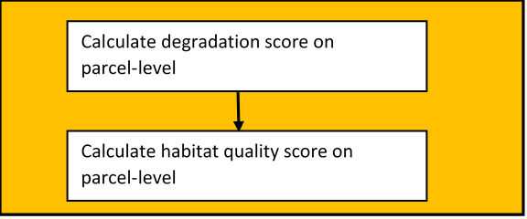

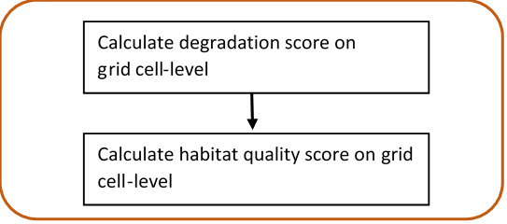

Calculate degradation score on

grid cell-level

Calculate habitat quality score on grid cell-level