EFForTS-ABM

Economic-Submodel

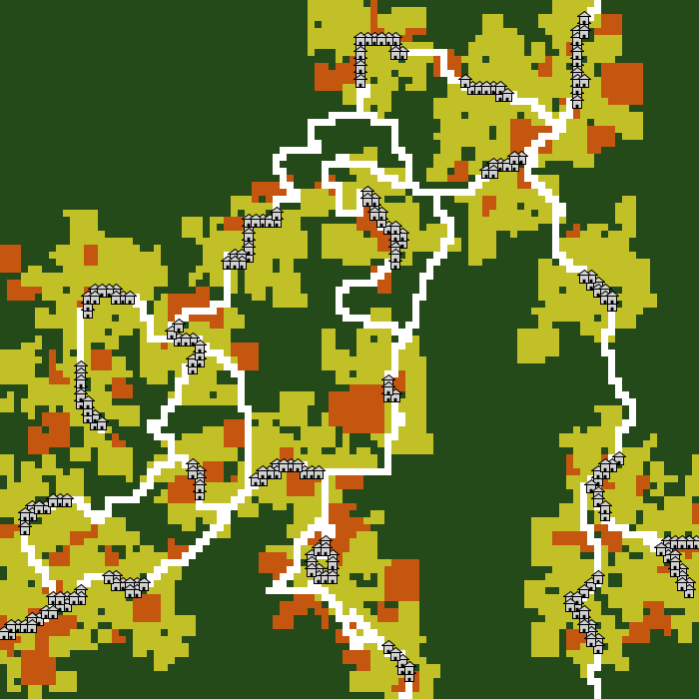

Landscape-map

Managed landscape

Generation of LULC-map

Generation of Impact-maps

Sensitivity of LULC-types to impacts

Habitat-suitability

Impacts’s importance and impact over space

EFForTS-ABM

Ecological Submodel

-Biodiversity-

Converter (asc-> tif)

* Habitat-Degradation-map (.tif)
* Habitat-Quality-map (.tif)

|  |  |  |  |  |
| --- | --- | --- | --- | --- |
| LULC | Name | Habitat | L_impact1 | L_impact2 |
| 1 | forest | 1 | ½ | ½ |
| 2 | oilpalm | 0 | 0 | 0 |
| 3 | rubber | 0 | 0 | 0 |

Sensitivity-table (.csv)

|  |  |  |  |  |
| --- | --- | --- | --- | --- |
| Impact | MAX_DIST | WEIGHT | DECAY |  |
| impact1 | 1 | ½ | exponential |  |
| impact2 | 1 | ½ | exponential |  |

Impact-table (.csv)

Calculate habitat quality score

Invoke model InVEST and transfer Output

Calculate landscape-level habitat quality score

Calculate Habitat quality score on grid cell level

Calculate Degradation score on grid cell level





Converter (tif-> asc)

Initialization

Processes

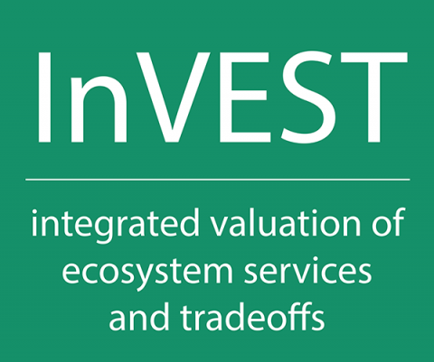

Generation of

LULC-map

Generation of threat-map

Sensitivity of LULC-types to threat

Update habitat-relation

Threat’s importance and impact over space

LULC-map(.asc)

Impact-maps(.asc)