Integration of the model InVEST into the model EFForTS-ABM: new tool for dynamic simulation of socio-economic functions and ecological functions (biodiversity) simultaneously

Julia Henzler1*, Nils Beyer1, Sebastian Hanss1, Craig Eric Simpkins2, Jan Salecker^ 3^, Kerstin Wiegand1

4/19/2021

order have to be discussed

1 Ecosystem Modeling, Faculty of Forest Sciences and Forest Ecology University of Goettingen, Goettingen, Germany, 2 Craig: please fill in, 3 Jan: please fill in

* [Julia.henzler@uni-goettingen.de](mailto:Julia.henzler@uni-goettingen.de)

**Target Journals:**Methods in Ecology and Evolution, PLOS Computational Biology, Ecological Modeling

**Keywords:**ecological functions, biodiversity, socio-economic functions, EFForTS-ABM, InVEST, trade-offs, software connection

**Key message:** Demonstration of the integration of the static terrestrial biodiversity model InVEST into the dynamic land-use change model EFForTS-ABM. As a result, synergies and trade-offs between biodiversity and socio-economic functions can be assessed simultaneously and dynamically at multiple temporal and spatial scales.

# 1. Introduction

* Relationship between ecological and socio-economic functions for conservation issues
  + Ecological and socio-economic sphere (biodiversity as key index)
  + Trade-offs and Synergies and possible problems when unbalanced
  + Open question: Unclear relationship over time and space and the consequence for conservation *Rethink the audience and address first paragraph of introduction accordingly.*
* Representation of both models separately and their issues
  + Models are capable of examining relationships over multiple temporal and spatial scales….
  + InVEST was developed for changes of ecosystems at different spatial and temporal scales but is a static model (as only 3 different landscapes can be used as input for simulation). Rapid assessment of biodiversity patterns and status : ecological functions + biodiversity via ecological production functions, static model, proven model: examples of applications
  + EFForTS-ABM is a land-use change model where landscape is managed: socio-economic function, dynamic model
* Benefits of connection of EFForTS-ABM and InVEST:
  + EFForTS-ABM can be used as dynamic input for InVEST
  + EFForTS-ABM fits requirements to generate input for InVEST
  + Output of InVEST can be processed dynamically within EFForTS-ABM
* Aim and Hypotheses
  + Aim: Tool for simultaneously model socio-economic functions and biodiversity over time and space
  + Connection is possible through narrow integrationlayer it can be easily implemented, maintained and comprehended (maybe to Abstract).

# 2. Methods

* Models and procedures
  + EFForTS-ABM: Economic submodel (mention LGraf as input-maps for ABM):

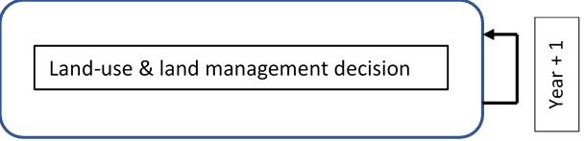

Figure x: Processes EFForTS-ABM:Economic Submodel

* InVEST: habitat analysis:
* 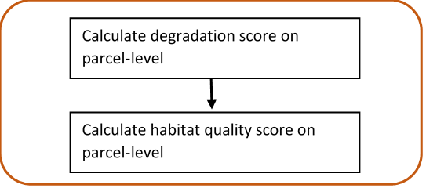
* Figure x: Processes of InVEST:Terrestrial biodiversity
* Connection points and Input-Output-Transfer
* EFForTS-ABM: generates input for InVEST (LULC-map, Impact-map, Sensitivity-table, impact-table, conversion (asc->tif)
* InVEST Habitat Quality: generates input for EFForTS-ABM (habitat quality map) (tif->asc)
* Mapping of output EFForTS-ABM to input InVEST
* Mapping of output InVEST to input EFForTS-ABM

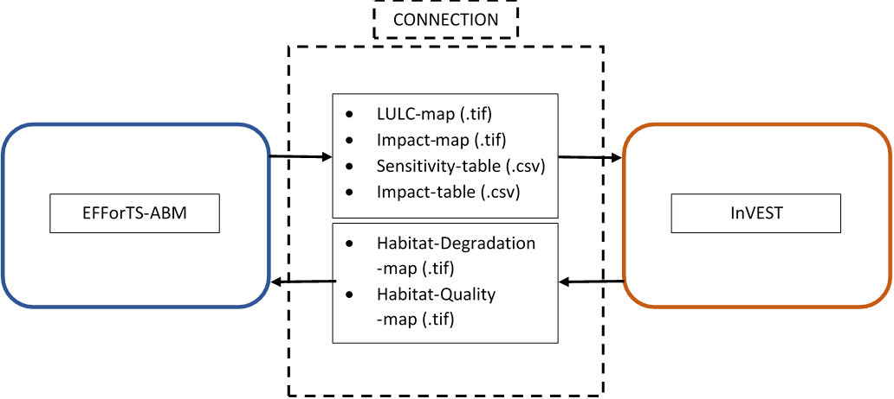

Figure x: Input-Output-Transfer

* Functional and non-functional requirements
  + Functional requirements: calculation of parcel-level habitat quality by invoking model InVEST
  + Test functional requirements with Test Pyramid, built of unit-testing, integration-testing, acceptance-testing (theoretical application example: Parameter setting for InVEST, Parameter setting for EFForTS-ABM)
* Non-functional requirements: reproducibility

# 3. Results

* Connected Models:

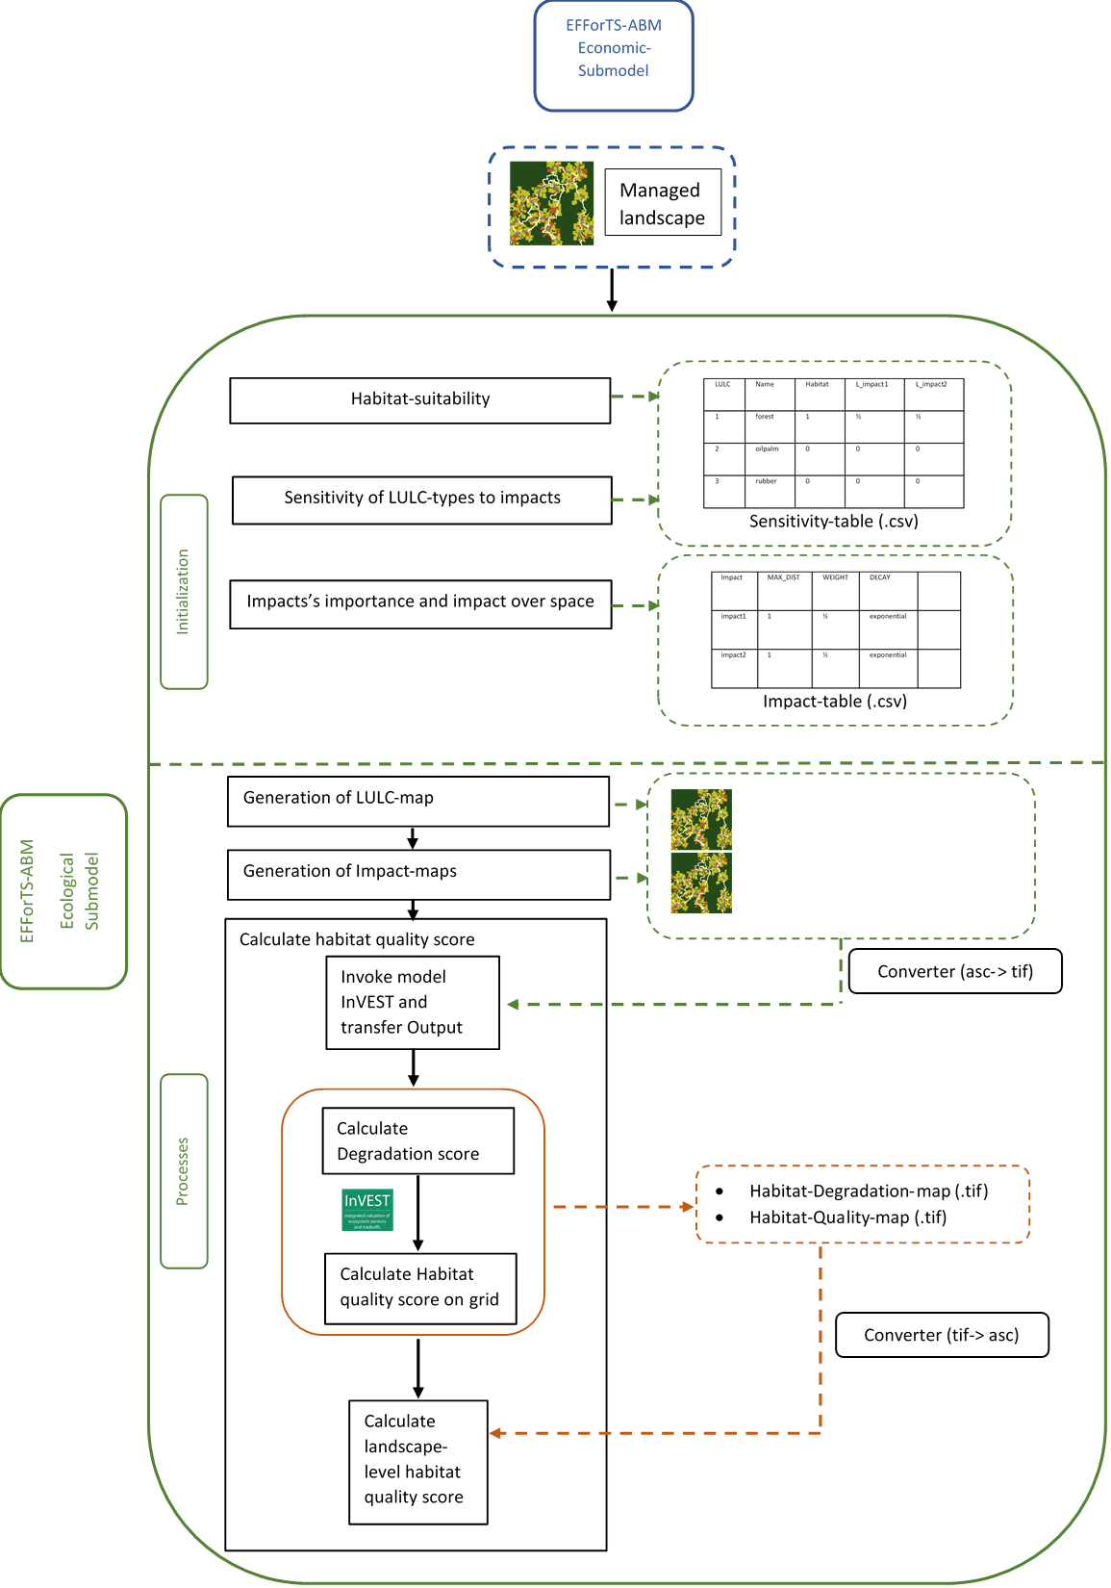

Figure x: Software-Architecture

* Implementation of biodiversity submodel as connection point and realization of Input-Output-Transfer:
  + set-up-invest, write-tables, write-maps, convert-maps, run-invest, convert-habitat-quality-to-asc, save-habitat-quality-to-patch, aggregate-habitat-quality
* Functional requirements: results from test pyramid
* Non-functional requirements: dockerfile and singularity-container

# 4. Discussion

* Possible points to discuss
  + Benefit of connection instead of usage separately (dynamic simulations, feedback between economic functions and biodiversity,….)
  + Reference to Acceptance Test
* Conclusions
  + Easy implementation, easy adjusting to different models
  + New tool for assessing socio-economic functions simultaneously with ecological functions and biodiversity over time and space

# 5. Acknowledgements

Funded by the Deutsche Forschungsgemeinschaft (DFG, German Research Foundation) – project number 192626868 – SFB 990 in the framework of the collaborative German-Indonesian research project CRC 990. Thank reviewers.

# 6. Supplementary material

* Include more detailed Software-Architecture with every in- and output of both models (especially for economic submodel of EFForTS-ABM)

# Open questions:

* Include ODD-protocol for models? I would say no, because the focus is not on the models itself, but more on the connection, its realisation and the benefit.

# References:

<https://graberj.wordpress.com/2013/03/10/die-testpyramide/>

<https://martinfowler.com/articles/practical-test-pyramid.html#TheTestPyramid>

<https://files.ifi.uzh.ch/rerg/amadeus/teaching/courses/requirements_engineering_I_ws0607/Kapitel_01_Grundl.pdf>

Virtual Environment: Reference?

Unit Testing: Reference?

## R Markdown

This is an R Markdown document. Markdown is a simple formatting syntax for authoring HTML, PDF, and MS Word documents. For more details on using R Markdown see <http://rmarkdown.rstudio.com>.

When you click the **Knit** button a document will be generated that includes both content as well as the output of any embedded R code chunks within the document. You can embed an R code chunk like this:

summary(cars)

## speed dist   
## Min. : 4.0 Min. : 2.00   
## 1st Qu.:12.0 1st Qu.: 26.00   
## Median :15.0 Median : 36.00   
## Mean :15.4 Mean : 42.98   
## 3rd Qu.:19.0 3rd Qu.: 56.00   
## Max. :25.0 Max. :120.00

## Including Plots

You can also embed plots, for example:



Note that the echo = FALSE parameter was added to the code chunk to prevent printing of the R code that generated the plot.