Key message: Demonstration of the integration of the (Python-based) static terrestrial biodiversity (habitat quality) model InVEST into the (NetlLogo-based) dynamic land-use change model EFForTS-ABM. As a result, synergies and trade-offs between biodiversity and socio-economic functions can be assessed simultaneously at multiple temporal and spatial scales.
Outline | Notes
1. Introduction  - Relationship between ecological and socio-economic functions for conservation issues  - Ecological and socio-economic sphere (biodiversity as key index)  - Trade-offs and synergies and possible problems when unbalanced  - Open question: Unclear relationship over time and space and the consequence for conservation  - Representation of both models separately  - InVEST: ecological functions + biodiversity via ecological production functions, static model, examples for applications  - EFForTS-ABM: socio-economic functions via land-use change model, dynamic model  - Benefits of connecting of EFForTS-ABM and InVEST:  - InVEST was developed for changes of ecosystems at different spatial and temporal scales but is a static model (as only 3 different landscapes can be used as input for simulation). Rapid assessment of biodiversity patterns and status.  - EFForTS-ABM is a land-use change model where landscape is managed and therefore changed at every time step, which can be used as dynamic input for InVEST  - EFForTS-ABM fits requirements to generate input for InVEST  - Output of InVEST can be processed dynamically within EFForTS-ABM  - Aim and Hypotheses  - Aim: Develop a tool to simultaneously model socio-economic functions and biodiversity over time and space  - Hypothesis: As connection is possible through narrow integration layer it can be easily implemented, maintained, and comprehended. | NCP,  Groot(2022), Grass(2020), Klasen(2013), Dislich(2018), Clough(2016)  NCP  Bai(2011), Baral(2014), Bhagabati(2014, Laurance(2014), Nelson(2008), Terrado(2016),  Dislich(2018)  NCP
2. Methods  - Models and procedures  - EFForTS-ABM: Economic submodel  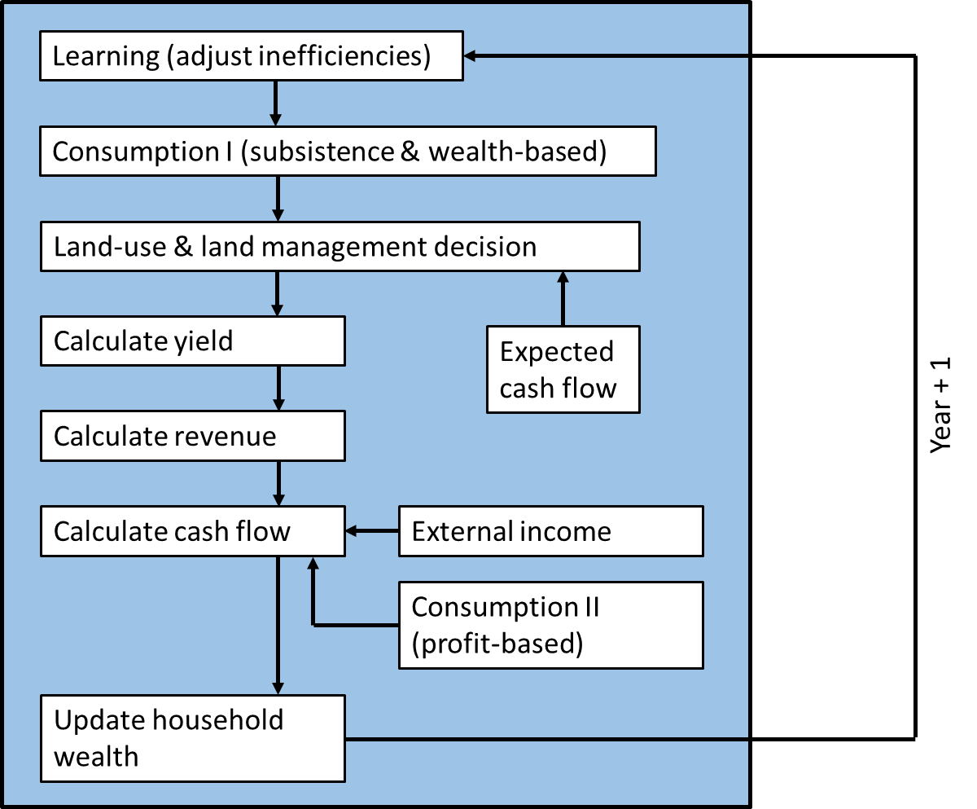  - InVEST: habitat analysis  Calculate degradation score on  parcel-level  Calculate habitat quality score on parcel-level  - Connection points and Input-Output-Transfer  - EFForTS-ABM: generates input for InVEST (LULC-map, Impact-map, Sensitivity-table, impact-table, conversion)  - InVEST Habitat Quality: generates input for EFForTS-ABM (habitat quality map)  - Mapping of output EFForTS-ABM to input InVEST  - Mapping of output InVEST to input EFForTS-ABM  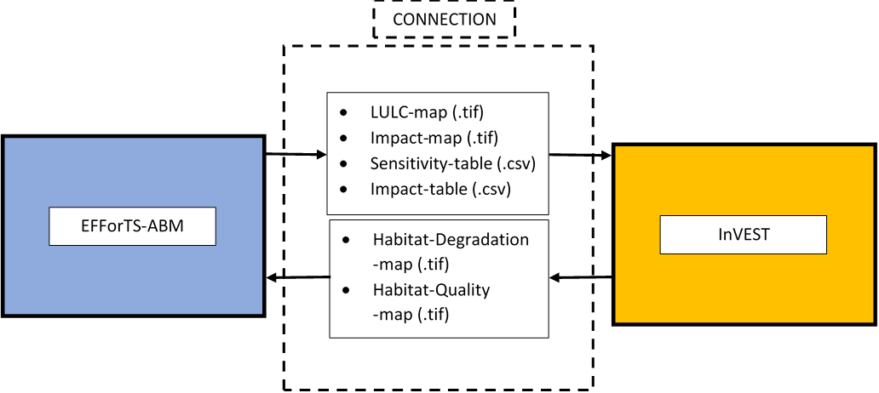  - Virtual environment for reproducibility  - Testing software-implementation: unit testing  - Application example  - Parameter setting for InVEST  - Parameter setting EFForTS-ABM | Virtual Environment: Reference?  Unit Testing: Reference?
3. Results (same structure and order as Methods)
- Connected Models: Software architecture
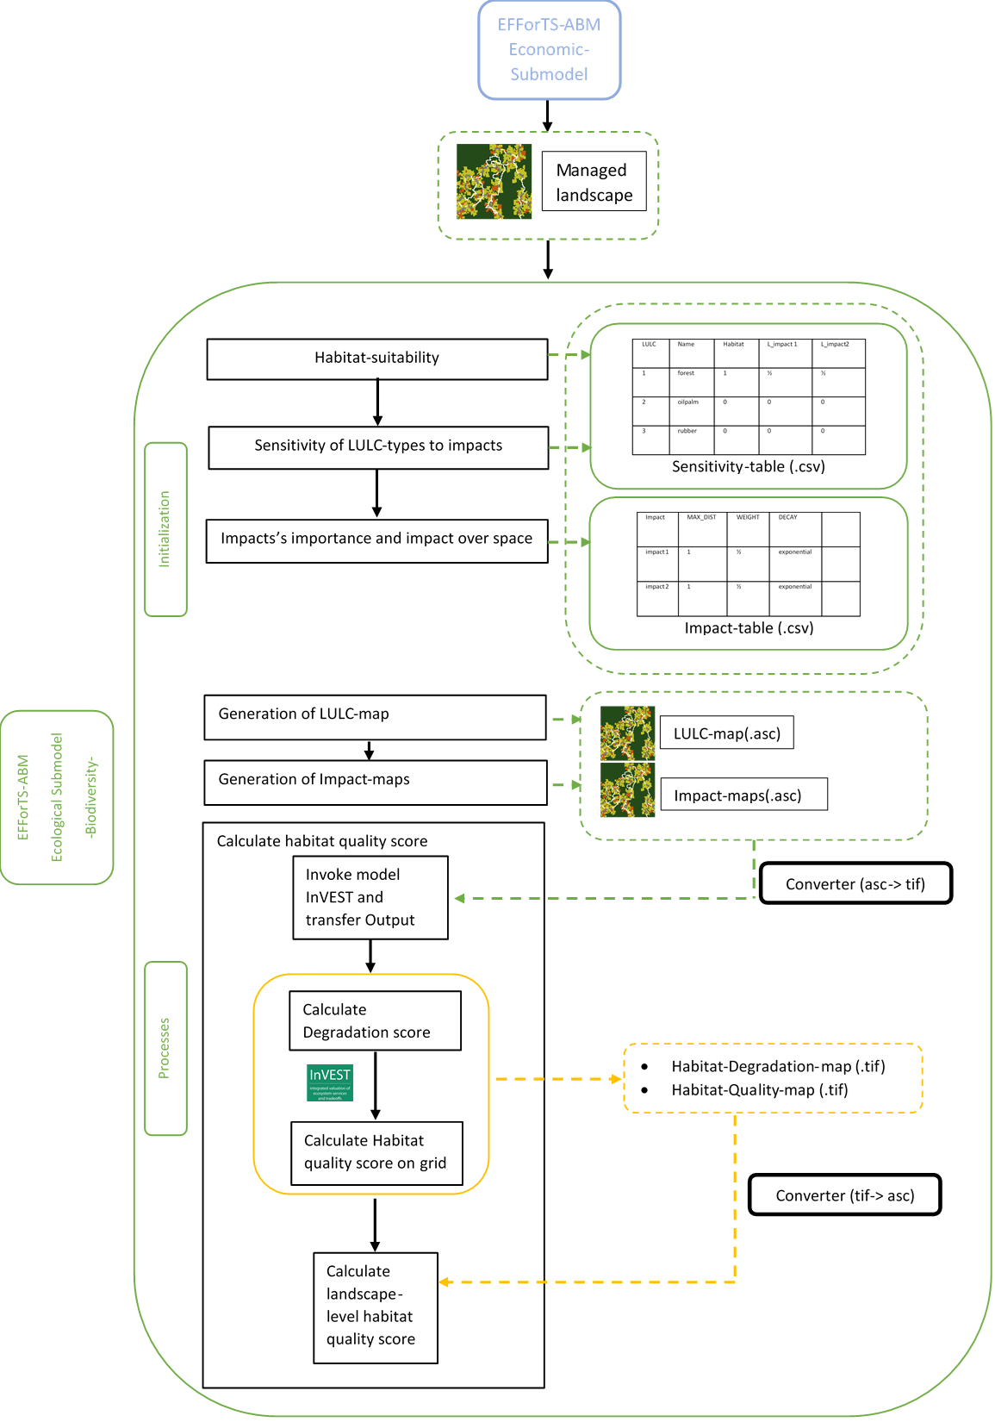
- Implementation of biodiversity submodel as connection point and realization of Input-Output-Transfer:
- set-up-invest, write-tables, write-maps, convert-maps, run-invest, convert-habitat-quality-to-asc, save-habitat-quality-to-patch, aggregate-habitat-quality
- Reproducibility: Docker-File and singularity-container
- Results of testing software-implementation
- Application example
- Outcome

4. Discussion
- Possible points to discuss
- Benefit of connection instead of usage separately (dynamic simulations, feedback between economic functions and biodiversity,….)
- Reference to application example
- Conclusions
- Easy implementation, easy adjusting to different models
- New tool for assessing socio-economic functions simultaneously with ecological functions over time and space

5. Acknowledgements
- Funded by the Deutsche Forschungsgemeinschaft (DFG, German Research Foundation) – project number 192626868 – SFB 990 in the framework of the collaborative German-Indonesian research project CRC 990. Thank reviewers.

Open questions:
- Also mention or even implement model EFForTS-LGraf into figures, as model EFForTS-LGraf generates the initial landscape used by EFForTS-ABM?
- Also include more detailed software-architecture with every in- and output of both models (especially for economic submodel of EFForTS-ABM)?

