Site-specific dehydration of olivines from San Carlos and Kilauea Iki

# Experimental methods

## Sample selection and preparation

Olivines from San Carlos, AZ and Kilauea Iki were chemically characterized and used for H diffusion experiments. The San Carlos olivine similar to that used in previous hydration experiments (Mackwell and Kohlstedt 1990; Kohlstedt and Mackwell 1998) was provided by David Kohlstedt. Here we extend that work by examining site-specific dehydration behavior. The Kilauea Iki olivines were collected from scoria from the 1959 Episode 1 eruption of Kilauea Iki and have been described in detail by David Ferguson (Ferguson et al. 2016), who provided the samples. The Kilauea Iki samples are of great interest because they provide the first direct experimental measurements of H diffusion in all 3 crystallographic directions of inclusion-free olivine phenocrysts.

A large crack and inclusion-free piece of San Carlos olivine, SC1 (IGSN: IEFERSCO1), and oriented by Laue camera at Cornell University and then cut into a series of smaller pieces approximately 2-3 mm long on each side using a diamond saw. One of the resulting sub-pieces, SC1-1 (IGSN: IEFERJAI3), was diamond polished to 0.25 μm and used to estimate the initial water concentration by FTIR. Additional pieces of SC1 were used to test the hydration procedure, and pieces SC1-7 (IGSN: IEFERJAI9) and SC1-2 (IGSN: IEFERJAI4) were partially hydrated and then polished to 0.25 μm for FTIR. SC1-2 was then sequentially dehydrated with FTIR profiles measured after each dehydration step and afterwards analyzed by EMPA and SIMS.

A large, relatively clear piece of the Kilauea Iki olivine, Kiki (IGSN: IEFERJAIC), was oriented based on morphology and polished into a block shape of dimensions 2 × 1 × 1.3 mm. The orientations were then confirmed by electron backscatter diffraction (EBSD) at the American Museum on Natural History (AMNH). The untreated Kiki sample was characterized by EMPA, SIMS, and polarized FTIR prior to dehydration.

Sample thicknesses in all three directions were measured with a digital micrometer accurate to within ± 5 μm. Additional details for all samples, including images and sample dimensions, are available online at geosamples.org.

## Electron microprobe analysis

Major elements of SC1-2 and Kiki were analyzed by electron microprobe at AMNH along traverses parallel to those on which water measurements were made to confirm homogeneity of the samples. The beam current was 20 nA, and the accelerating voltage was 15 kV.

## Initial water concentrations

The initial water concentration in each olivine was estimated using both polarized FTIR and SIMS. Polarized FTIR measurements were performed at AMNH using the Thermo Nicolet Nexus 670 infrared spectrometer and Thermo Nicolet Continuum 15× infrared microscope with a resolution of 4 cm-1, spot sizes of 100 × 100 μm, an average of 200 scans, and a ZnSe polarizer. Initial water concentrations were estimated from 3 orthogonal polarized measurements (Libowitzky and Rossman 1996; Shuai and Yang 2017) by applying the Bell and Withers calibrations (Bell et al. 2003; Anthony C Withers et al. 2012). To account for the large error associated with baseline choice, 3 different baselines were drawn, and the resulting areas were averaged. Traverses along all three directions did not show significant zonation in bulk or peak-specific water in the untreated samples.

Erik Hauri measured the C, H, F, P, and Cl concentrations by nanoSIMS along traverses parallel to [001] in SC1-2 and parallel to [010] in Kiki as part of the CIDER workshop on electrical conductivity in hydrous olivine. SIMS measurements were made before Kiki was dehydrated but after the final dehydration heating step for SC1-2. Because the area under the O-H stretching peaks with the electric vector E || [100] is equal to that in the untreated SC1-2 (7±5 cm-2) and dehydrated SC1-2 (7±6 cm-2), the SIMS measurements were taken as a reasonable estimate of the initial water concentration in SC1.

## Hydration of San Carlos olivine

Two pieces of previously oriented San Carlos olivine SC1, SC1-7 and SC1-2, were partially hydrated in a ¾” Boyd-type piston cylinder apparatus with a BaCO3 pressure medium using a procedure broadly similar to that of Jollands et al. (2016). Here the samples were placed in copper capsules and surrounded by liquid distilled H2O and a powdered mixture of Ni and NiO to control oxygen fugacity and San Carlos olivine and enstatite to control silica activity (Figure 1). Temperatures were controlled with a **W-type thermocouple, with estimated errors of**. After rapid quenching followed by relatively slow decompression, the capsules were pierced with a drill to confirm water was still present and then dissolved overnight in a mixture of 1:1 H2O to HNO3. The rectangular parallelepiped samples were then mounted in CrystalBond, polished to 0.25 μm on all sides, and cleaned in acetone.

SC1-7 was heated for 7 hours at 10 kbar and temperature readings of 1000°C, but the experiment ended when capsule began to melt, suggesting the true temperature in the capsule was closer to 1085°C, the melting point of copper. This temperature range and pressure correspond to water fugacities of 1.9-2.0 GPa (A. C. Withers 2013). At either temperature, given the dimensions of the sample and the diffusivities reported by Kohlstedt and Mackwell (1998), the experiment time of 7 hours should allow the completion proton-polaron diffusion and enter into the stage of diffusion dominated by the slower proton-vacancy mechanism without fully saturating the sample. This experiment allows a direct comparison with previous work (Kohlstedt and Mackwell 1998; Demouchy and Mackwell 2006).

To more thoroughly understand the transition between proton-polaron-dominated diffusion and pure proton-vacancy diffusion, SC1-2 was hydrated at a nominal temperature of 800 °C and 10 kbar pressure, which corresponds to a water fugacity of 1.6 GPa (A. C. Withers 2013), for 17.5 hours. That time was chosen in order to reach, but not pass, what Kohlstedt and Mackwell (1998) call “metastable equilibrium”, the point at which all of the initial Fe3+ is reduced as H+ diffuses into the sample following the proton-polaron mechanism. If the model used by Kohlstedt and Mackwell (1998) is correct, the hydrogen concentration in SC1-2 after it comes out of the piston cylinder should be homogeneous, and the concentration should be lower than the true solubility and presumably determined by the initial concentration of ferric iron. As with the experimental hydration of SC1-7, if the actual temperature was somewhat higher than the measured temperature of 800°C, perhaps 850°C, it would still not be so high that significant proton-vacancy mechanism diffusion would be expected. If the “metastable equilibrium” hydrogen concentration is both large enough to easily measure and homogeneous, then SC1-2 is a suitable starting material for step-wise dehydration experiments.

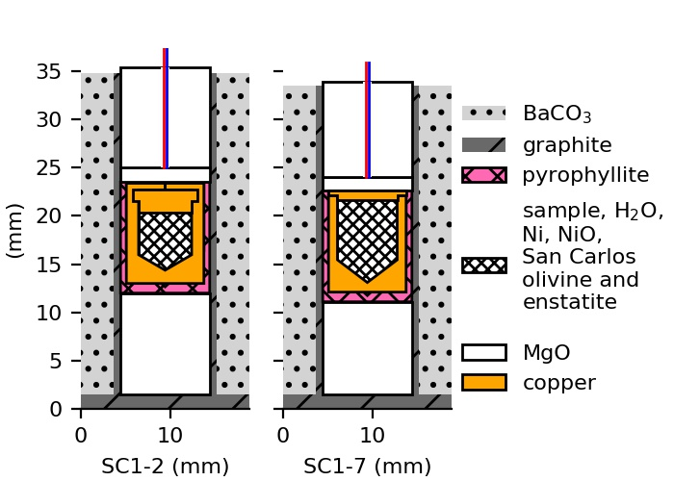

Figure 1. Schematic cross-sections illustrating the experimental design for hydrating San Carlos olivine samples SC1-2 and SC1-7 in a piston cylinder apparatus showing the BaCO3 pressure medium, graphite furnace and pyrophyllite sleeve surrounding an unwelded copper capsule containing the sample, liquid water, and a powdered mixture of nickel, nickel oxide, San Carlos olivine, and San Carlos enstatite. The sleeve and capsule are supported by MgO, and **W-type** thermocouples (colored lines) extend through cylindrical holes in the MgO.

## Dehydration

Olivine samples Kiki (untreated) and SC1-2 (partially hydrated according to procedure described above) were dehydrated in increments using the vertical furnace used in previous dehydration experiments (Ferriss 2015), and oxygen fugacity was controlled with a mixture of CO and CO2. SC1-2 was heated at 800 °C for 1, 3, 7, 13, 19, 43, and 68 hours at an oxygen fugacity 10-16.5 bars, equivalent to NNO-2.6, where NNO is the nickel-nickel oxide buffer. Kiki was heated at 800°C for 1 and 8 hours; then 3, 6, 7, and 8 hours at 1000°C. All heating steps for Kiki were conducted at oxygen fugacity of NNO-2.6 except for the final step at 1000°C, which was conducted at relatively oxidizing conditions, NNO+2.

## FTIR

Before heat treatment and in between each heating step, samples were analyzed by polarized FTIR content along 3 orthogonal traverses parallel to the three crystallographic directions in the uncut crystal. These analyses use the same conditions described above for estimating the initial water and were in all cases conducted with polarized radiation with the electric vector E || [100]. A set of 3 quadratic baselines were drawn based on the curve of the spectrum of the untreated and/or the dehydrated sample, with typical wavenumber ranges of 3200-3700 cm-1.

A series of Gaussian curves was fit to each spectrum at wavenumbers …

Each profile is normalized to the initial measurements to produce a ratio of the final to initial area A/A0 and scaled up to a true concentration based on the initial concentrations, A0, determined above. These “whole-block” concentrations represent the average concentration through the entire path of the infrared beam, and the forward models used to determine hydrogen diffusivities in each direction are modified accordingly following the models described in E. Ferriss et al. (2015) and Elizabeth Ferriss, Plank, and Walker (2016) and implemented using the free, open-source software package pynams (E. Ferriss 2015). All FTIR spectra, baselines, peak-fitting information, and computer code used to produce the calculations and figures reported in this paper will be made available on GitHub.

# Results

## Characterization of the starting material

Microprobe analysis did not reveal any significant zonation along the measured profiles and were generally consistent with previous work (Ruprecht and Plank 2013; Ferguson et al. 2016) with somewhat lower forsterite numbers: 87.7±0.2 in SC1-2 and 86.2±0.2 in Kiki.

The initial water concentration was estimated from the polarized FTIR measurements and baselines shown in Figure 2 using both the Bell calibration and the Withers calibration and also by nanoSIMS (Table 1). These three estimates were averaged to produce initial water concentration estimates of 15±2 ppm H2O in the Kilauea Iki olivine and 4±1 ppm H2O in the San Carlos olivine. These low concentrations are consistent with previous work on San Carlos olivine **(Peslier and Luhr 2006; Kurosawa, Yurimoto, and Sueno 1997) ?? Who measured things, and what did they find?**

## 

Figure 2. Polarized FTIR spectra (blue) with electric vector E parallel to three orthogonal directions and baselines (black) used to estimate the initial water concentrations of Kilauea Iki olivine (Kiki) and San Carlos olivine (SC1-1 and SC1-2) reported in Table 1.

Table 1. Water concentration estimates for Kilauea Iki olivine and San Carlos olivine based on polarized FTIR areas (Figure 2 and Figure 3) and SIMS measurements.

|  |  |  |  |
| --- | --- | --- | --- |
|  | Kilauea Iki olivine; Kiki | San Carlos olivine; sub-samples of SC1 | |
| FTIR area E || [100] (cm-2) | 52+/-10 | 7+/-5  63+/-12  25+/-2  7+/-6 | untreated SC1-1  partially hydrated SC1-7  partially hydrated SC1-2  dehydrated SC1-2 |
| FTIR area E || [010] (cm-2) | 31+/-13 | 8+/-5 | untreated SC1-1 |
| FTIR area E || [001] (cm-2) | 18+/-9 | 9+/-4 | untreated SC1-1 |
| FTIR area summed over 3 directions (cm-2) | 101+/-19 | 24+/-8 | untreated SC1-1 |
| Water, Bell calibration (ppm H2O) | 19+/-4 | 4.5+/-1.5 | untreated SC1-1 |
| Water, Withers calibration (ppm H2O) | 12+/-2 | 3+/-1 | untreated SC1-1 |
| Water, SIMS (ppm H2O) | 14+/-1 | 5+/1 | dehydrated SC1-2 |
| Average initial water (ppm H2O) | 15+/-2 | 4+/-1 | SC1 |
| Average water (ppm H2O) after piston cylinder experiment | Not treated with pressure | 42+/-13  17+/-5 | partially hydrated SC1-7  partially hydrated SC1-2 |
|  |  |  |  |

## Hydration

Hydrogen was successfully incorporated into San Carlos olivine samples SC1-7 and SC1-2 (Figure 3A). To quantify the amount of water incorporated and construct profiles, quadratic baselines were drawn based on the curve of the spectrum of the untreated sample (Figure 3B and C), and the area under each curve was determined. The hydrogen in SC1-2 was homogeneous, with O-H stretching areas of 15±1 cm-2, a 6% variation, while SC1-7 showed significant zonation, with O-H stretching areas of 63±12 cm‑2, a 19% variation. The hydrogen concentrations are estimated to be 10±3 ppm H2O in SC1-2 and 42±13 ppm H2O in SC1-7 after the hydration experiments based on the initial water concentration estimate and the ratio of final to initial areas (Table 1).

The hydrogen zonation in SC1-7 is primarily observed || [001], consistent with previously reported work (Kohlstedt and Mackwell 1998; Demouchy and Mackwell 2006).

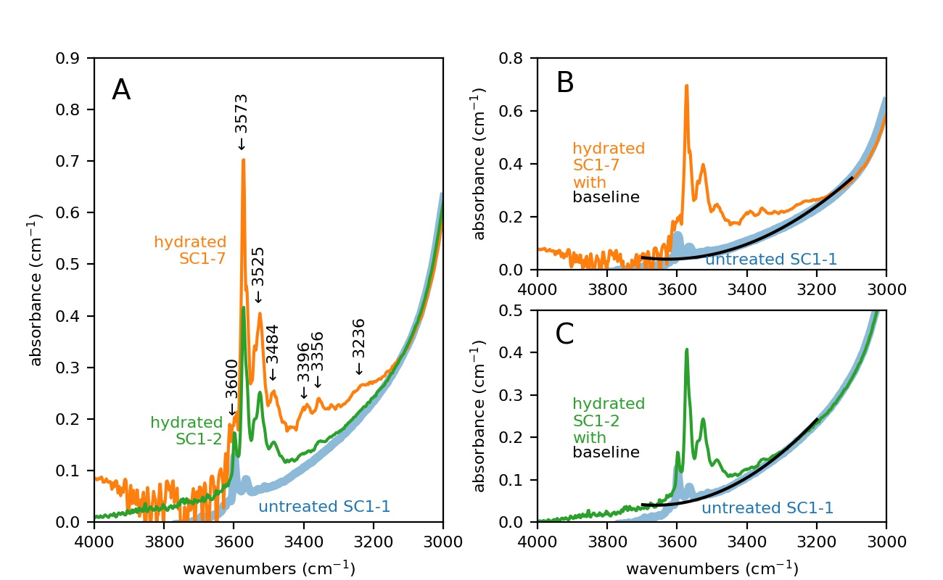

Figure 3. (A) Polarized FTIR spectra with electric vector E || [100] averaged across all traverses in three directions of San Carlos olivine SC1 pieces that were untreated (SC1-1, blue); hydrated in a piston cylinder for exactly the amount of time needed to reach “metastable equilibrium” by the proton-polaron mechanism (SC1-2, green) at 800°C; and hydrated long enough to enter into proton-vacancy-dominated diffusion without saturating the sample (SC1-7, orange) with major peaks labeled. Examples are also provided of the shapes of the quadratic baselines used to calculate the areas under each curve for spectra measured on SC1-7 (B) and SC1-2 (C). Note the differences in the y-axis scale.

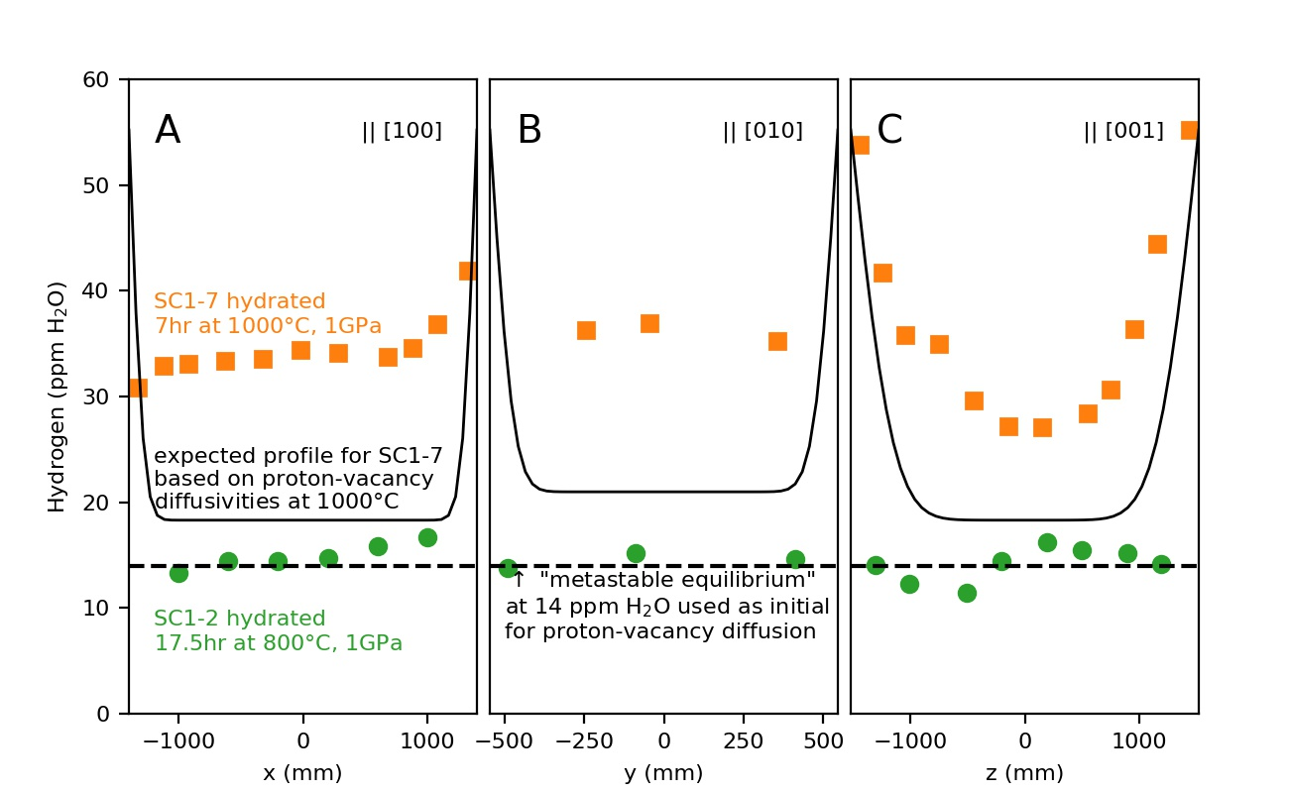

Figure . Concentration profiles across San Carlos olivine samples SC1-2 and SC1-7 after partial hydration in a piston cylinder as measured through the uncut block by FTIR polarized || [100]. Hydrogen concentrations are estimated from FTIR spectra based using the areas under the baselines shown in Figure 3 and initial hydrogen contents from Table 1.

# Bibliography

Bell, D. R., G. R. Rossman, J. Maldener, D. Endisch, and F. Rauch. 2003. “Hydroxide in Olivine: A Quantitative Determination of the Absolute Amount and Calibration of the IR Spectrum.” *Journal of Geophysical Research-Solid Earth* 108 (B2). doi:10.1029/2001jb000679.

Demouchy, S., and S. Mackwell. 2006. “Mechanisms of Hydrogen Incorporation and Diffusion in Iron-Bearing Olivine.” *Physics and Chemistry of Minerals* 33 (5): 347–55. doi:10.1007/s00269-006-0081-2.

Ferguson, David J., Helge M. Gonnermann, Philipp Ruprecht, Terry Plank, Erik H. Hauri, Bruce F. Houghton, and Donald A. Swanson. 2016. “Magma Decompression Rates during Explosive Eruptions of Kīlauea Volcano, Hawaii, Recorded by Melt Embayments.” *Bulletin of Volcanology* 78 (10): 71. doi:10.1007/s00445-016-1064-x.

Ferriss, E. 2015. *Pynams: A Python Package for Interpreting FTIR Spectra of Nominally Anhydrous Minerals (NAMs)* (version v0.1.0). New York. https://github.com/EFerriss/pynams.

Ferriss, E., T. Plank, D. Walker, and M. Nettles. 2015. “The Whole-Block Approach to Measuring Hydrogen Diffusivity in Nominally Anhydrous Minerals.” *American Mineralogist* 100 (4): 837–51.

Ferriss, Elizabeth, Terry Plank, and David Walker. 2016. “Site-Specific Hydrogen Diffusion Rates during Clinopyroxene Dehydration.” *Contributions to Mineralogy and Petrology* 171 (6): 1–24. doi:10.1007/s00410-016-1262-8.

Jollands, Michael C., José Alberto Padrón-Navarta, Jörg Hermann, and Hugh St.C. O’Neill. 2016. “Hydrogen Diffusion in Ti-Doped Forsterite and the Preservation of Metastable Point Defects.” *American Mineralogist* 101 (7): 1560–1570. doi:10.2138/am-2016-5568.

Kohlstedt, D. L., and S. J. Mackwell. 1998. “Diffusion of Hydrogen and Intrinsic Point Defects in Olivine.” *Zeitschrift Fur Physikalische Chemie-International Journal of Research in Physical Chemistry & Chemical Physics* 207: 147–62.

Kurosawa, M., H. Yurimoto, and S. Sueno. 1997. “Patterns in the Hydrogen and Trace Element Compositions of Mantle Olivines.” *Physics and Chemistry of Glasses* 24: 385–95.

Libowitzky, E., and G. R. Rossman. 1996. “Principles of Quantitative Absorbance Measurements in Anisotropic Crystals.” *Physics and Chemistry of Minerals* 23 (6): 319–27.

Mackwell, S. J., and D. L. Kohlstedt. 1990. “Diffusion of Hydrogen in Olivine - Implications for Water in the Mantle.” *Journal of Geophysical Research-Solid Earth and Planets* 95 (B4): 5079–88. doi:10.1029/JB095iB04p05079.

Peslier, A. H., and J. F. Luhr. 2006. “Hydrogen Loss from Olivines in Mantle Xenoliths from Simcoe (USA) and Mexico: Mafic Alkalic Magma Ascent Rates and Water Budget of the Sub-Continental Lithosphere.” *Earth and Planetary Science Letters* 242 (3–4): 302–19. doi:10.1016/j.epsl.2005.12.019.

Ruprecht, Philipp, and Terry Plank. 2013. “Feeding Andesitic Eruptions with a High-Speed Connection from the Mantle.” *Nature* 500 (7460): 68–72.

Shuai, Kang, and Xiaozhi Yang. 2017. “Quantitative Analysis of H-Species in Anisotropic Minerals by Polarized Infrared Spectroscopy along Three Orthogonal Directions.” *Contributions to Mineralogy and Petrology* 172 (2–3): 14. doi:10.1007/s00410-017-1336-2.

Withers, A. C. 2013. “The Pitzer and Sterner Equation of State for Water.” http://www.geo.umn.edu/people/researchers/withe012/fugacity.htm.

Withers, Anthony C, Hélène Bureau, Caroline Raepsaet, and Marc M Hirschmann. 2012. “Calibration of Infrared Spectroscopy by Elastic Recoil Detection Analysis of H in Synthetic Olivine.” *Chemical Geology* 334: 92–98.