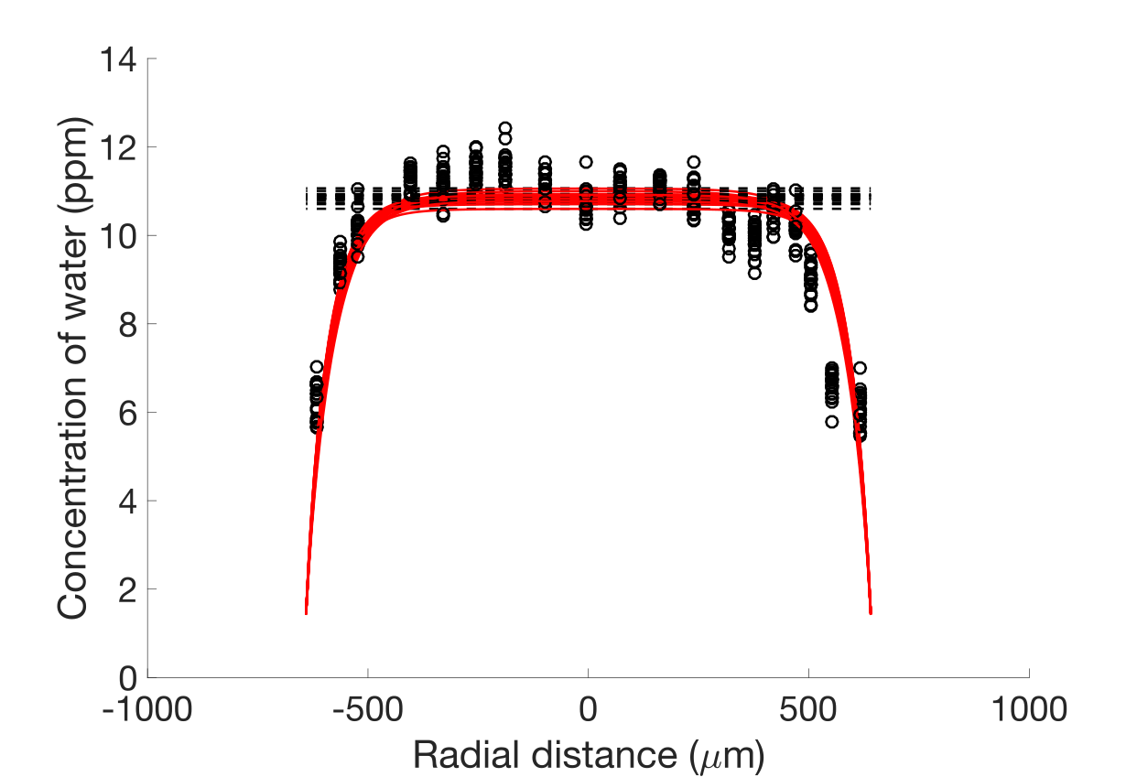

This figure shows the fitting procedure in action. All 20 ‘synthetic’ water concentration profiles are shown here (each water data point is varied assuming a normal distribution with a standard deviation of 0.35 ppm, which is the standard deviation of the central five data points). The collection of black dashed lines at ~11 ppm shows the variability in the initial condition (calculated from the best-fit Kd, assuming a water concentration in the melt of 0.75 wt% H2O). The red lines are the best-fit model curves.

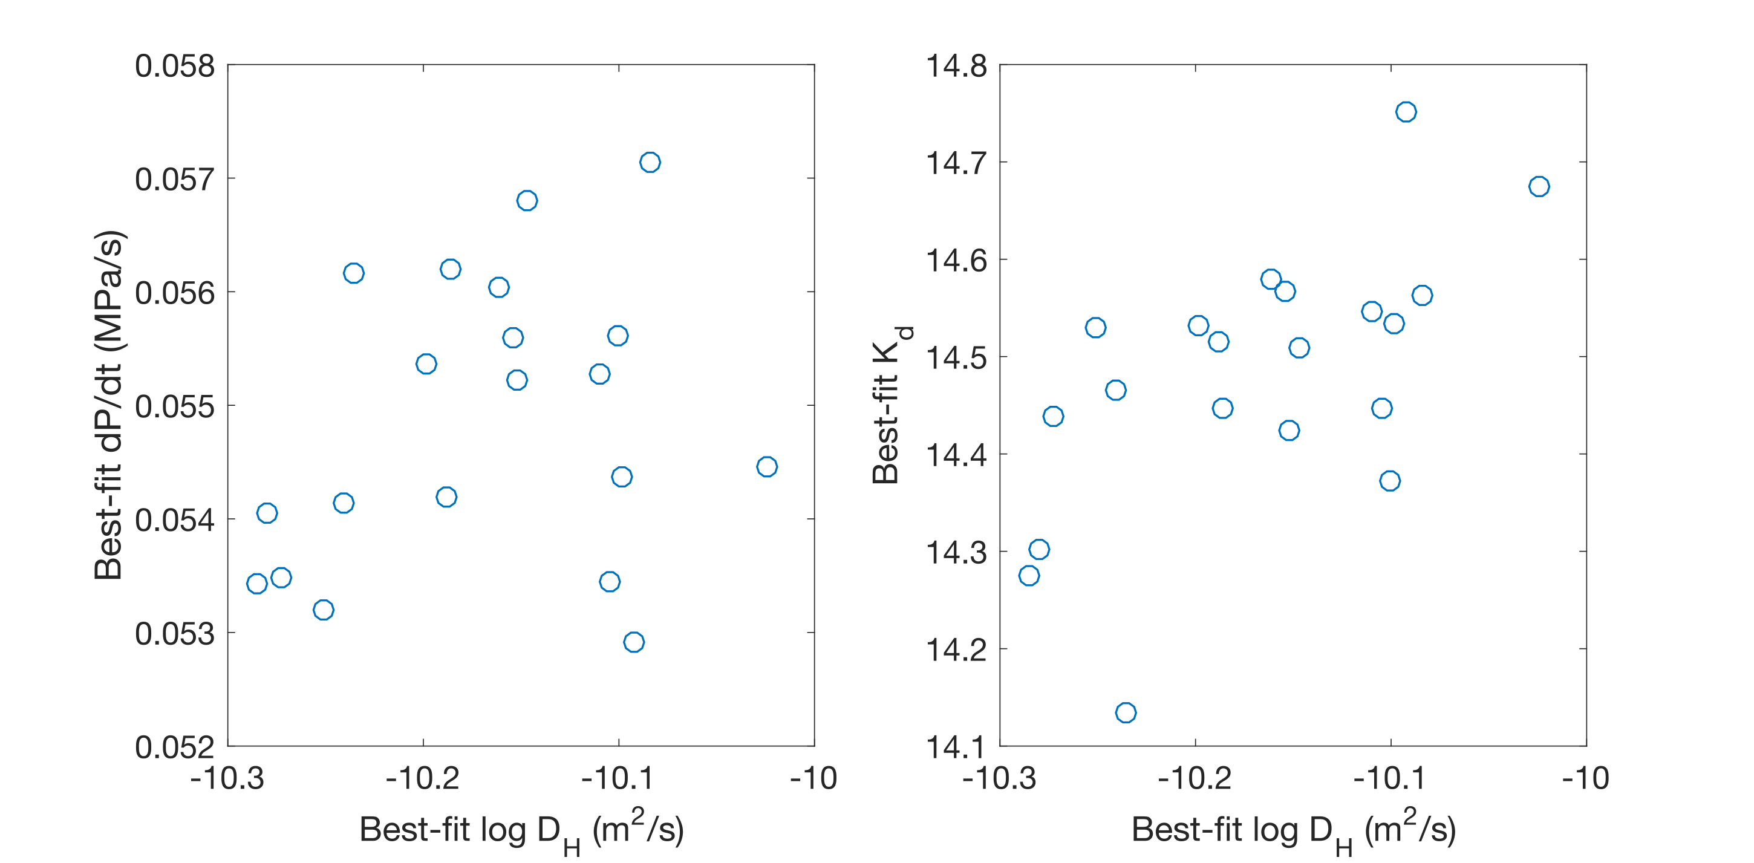

This figure shows the distributions of best-fit values of log D, Kd, and dP/dt. There is a slight positive correlation between best-fit values of log D and Kd. I think this is because high Kd translates into a high starting water concentration in the olivine, and if you look closely at the first figure, you can see that the best-fit profiles that start with higher water concentrations have shorter ‘plateaus’ and wider regions of water loss at their edges than the best-fit profiles with low initial water concentrations.