# CAN 2 Ethernet and vice versa

Upon request of Boris and Isaiah, inspired by Casey, I created a CAN 2 Ethernet gateway.

The gateway is working with standard linux, SPI enabled and a CAN module connected.

CAN Module: <https://joy-it.net/en/products/SBC-CAN01> and is ~ 7 EUR !

It has the transceiver and the can controller on board, but no isolation.

The can2ethernet software can be found here and is written in C/C++ (for realtime reasons) by Frédéric.:

<https://github.com/FluenceEnergy/controller_software/tree/master/LeafController/can2ethernet>

# Development setup

CAN Modules are connected to RPi SPI Interface (multicolor cables), can is available as an interface (ifconfig) and could be used in code as a socket. CAN Bus are the two wires on the top, CAN High and CAN Low.

With this setup I was able to send CAN Messages from one Pi to the other one and vice versa.

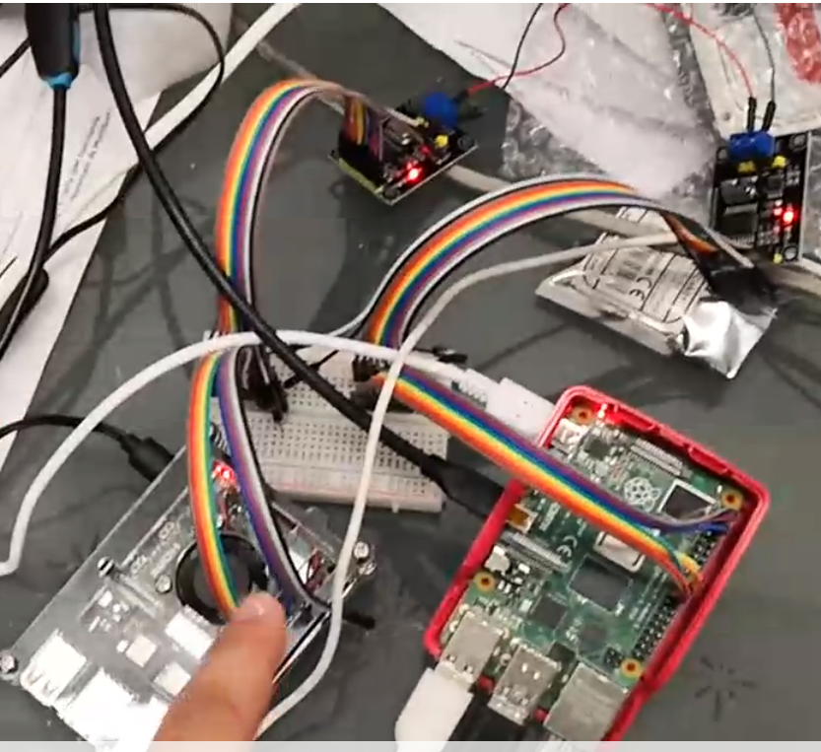

The next setup was for testing if the can2ethernet gateway software is working properly.

The basic idea is to forward a CAN packet to an IP Multicast address. The software is also listening on the multicast address and forwards the packet to the CAN Bus.

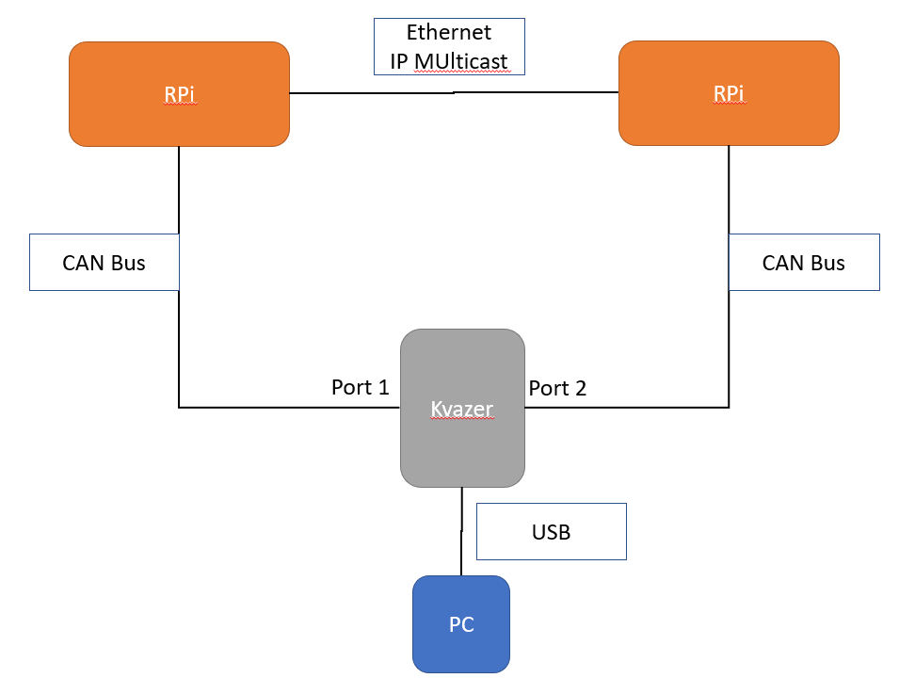

With this setup I am able to produce CAN traffic in different variations with a PC software on the Kvazer, for example on Port 1, and I can see the traffic coming in on Port 2. (Note: The Kvaser is a two-channel CANbus interface (controller area network) for USB 1.1 and 2.0 to plug on a PC. ) This means the CAN packets were sent on Port 1 to the RPi with can2ethernet, converted to IP MUlticast, sent to the second RPi, can2ethernet reconverted to CAN and send to Port 2 on the kvazer.

# Test Setup Lab Erlangen on a Samsung battery

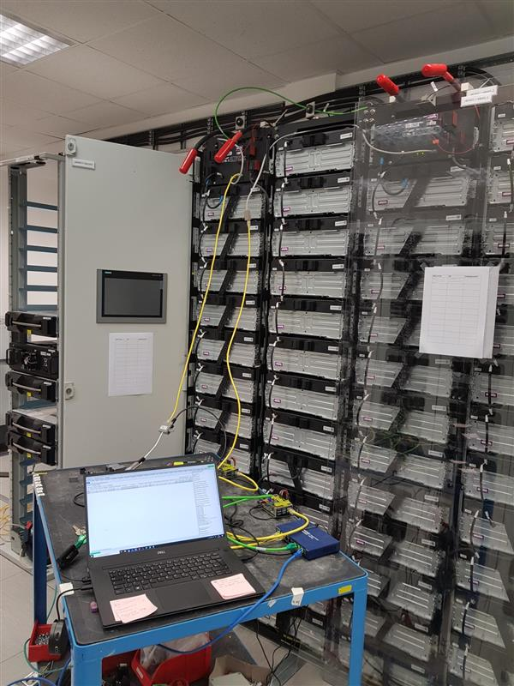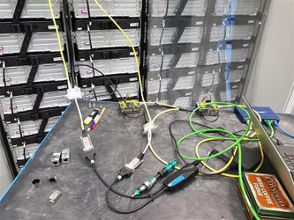

Previous two photos made by Tobi Lang

The Setup in ERL is slightly a bit different from the development setup.

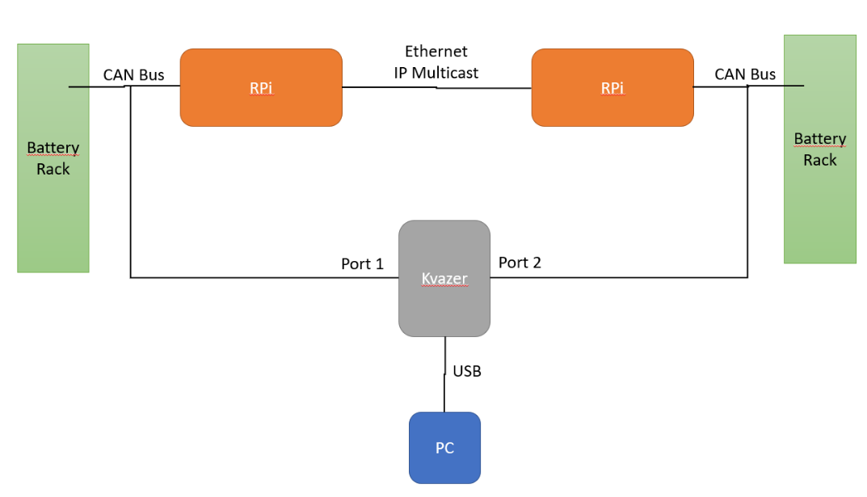

With this setup the entire battery CAN communication flows as requested over the IP Multicast to the next rack.

Intensive tests outstanding.

Tryout now with BananaPi works. Modberry will be the nextone.