A high capacity HEVC steganography using intra prediction modes in multi-sized prediction blocks
First Author¹[0000-1111-2222-3333] and Second Author²[1111-2222-3333-4444]
¹ Princeton University, Princeton NJ 08544, USA
² Springer Heidelberg, Tiergartenstr. 17, 69121 Heidelberg, Germany
lncs@springer.com
Abstract. The existing video steganographic schemes based on intra prediction modes for H.264/AVC and HEVC all use single-sized blocks to embed the secret payload. Thus, the steganographic properties of HEVC multi-sized tree-structured intra partition still need to be studied. In this paper, a novel video steganography is presented. Base on the fact that degradation in visual quality caused by steganography is almost the same for both large size PUs and small size PUs, this algorithm tries to exploit intra prediction modes in multi-sized prediction units(PU) in each Coding Tree Units (CTU). In addition, a distortion function defined by rate distortion function is designed to preserving coding efficiency. By incorporating the syndrome trellis coding, high capacity and low rate distortion can be achieved. The Experimental results show that this algorithm outperforms the existing intra prediction modes based HEVC steganography algorithm in capacity while well preserving coding efficiency and perceptibility especially when QP is high.
Keywords: HEVC, intra prediction modes, video steganography.
- Introduction
With the development of broadband network and mobile Internet technology, the transmission and service based on video media are showing an explosive growth trend. The growing popularity of HD video, and the beyond-HD formats (e.g., 4k×2k or 8k×4k resolution) are creating even stronger opportunity for video steganography. Video media in HEVC format, because of its large resolution and low file size, is very suitable for the carrier of secret communication, and provides a possibility for the realization of large capacity communication. On the other hand, unlike image steganography, HEVC video steganography can naturally conceal the fact that communication is occurring from user behavior. For large capacity secret communication applications, the conventional image steganography generally needs to transmit a number of uncorrelated loaded images, which makes the attacker easy to find abnormality from the user's behavior, and the HEVC video steganography can ensure the rationality of the user's behavior and reduce the risk of the hidden communication.
The intra prediction modes is a potential and excellent cover for video steganography. It introduces little distortion in video quality after embedding the secret message and has moderate capacity. Many works have been done in both H.264/AVC and HEVC. Hu et al. [?] have proposed a steganography algorithm based on intra prediction mode in H.264/AVC. Yang et al. [?] have improved Hu’s method by matrix coding. Bouchama et al. [?] divided the intra prediction modes in H.264/AVC into four groups according to their prediction direction, the result shows a better video quality while ensuring high capacity. Zhang et al. [?] analyzes the texture of the video, and propose a high security adaptive embedding algorithm using STC. Wang et al. [?] proposed intra prediction mode based method for HEVC, a mapping between angle difference and secret message was established to embed the data. Dong et al. [?] have further proposed the prediction mode steganography technology under the HEVC standard. By defining the distortion function and analyzing the HEVC coding process, the author breaks through the capacity limitation of the previous HEVC intra prediction mode based algorithm, and improves the security.
As far as selection of intra prediction modes is concerned, previous steganography methods in H.264/AVC all choose intra prediction modes in 4x4 macroblock to embed the secret message. This selection role is reasonable in H.264/AVC because that the capacity of 16x16 macroblock is low, and this kind of macroblock usually concern homogeneous areas for which the human visual system (HVS) is more sensitive to small degradations. Thus, in the previous HEVC steganography schemes, authors in [?] still use the PU of 4x4 size as the embedding cover. However, this selection role ignores some objective conditions:1) HEVC partitioning is achieved using tree structures. It supports variable-size PUs selected according to needs of encoders in terms of video content and resolution. 2) Previous H.264/AVC steganography schemes are all tested under low resolution video dataset. But in high resolution dataset for HEVC, larger size PUs occur more frequently. Only using small size PUs will limit capacity to a great extent. In summary, the capacity of previous HEVC steganography schemes is limited, since unique techniques in HEVC are not considered sufficiently.
In order to solve the problem mentioned above, and make full use of new features introduced by HEVC, we make an extension of our previous work in [?]. This paper includes several new contributions: 1) Improving capacity by utilizing angular intra prediction modes in multi-sized PUs. 2) Detailed analysis why larger size PUs can be modified without introducing great degradation in visual quality. 3) Maintaining coding efficiency by defining cost function based on rate distortion. 4) New indicator to measure capacity under different bit increase ratio.
The rest of paper is organized as follows. In Sect. 2, detailed analysis why larger size PUs can be modified without introducing great degradation in visual quality is presented. Sect. 3 describes the proposed HEVC steganography algorithm. In Sect. 4, experiments and analysis on multi-resolution dataset are presented. Finally, conclusion is drawn in Sect. 5.
- Analysis of HEVC intra coding scheme for steganography
In this section, the HEVC intra coding scheme will be first described, with which analysis of dominant distortion in HEVC intra steganograhy can be clearly introduced next.
  - HEVC intra coding scheme
The HEVC standard introduces coding tree units and coding tree block (CTB) structure to intra coding scheme. Each frame in a video is firstly split into block-shaped coding tree units (CTUs), which each contain luma CTBs and chroma CTBs. The blocks specified as CTBs can be directly used as coding blocks(CBs) or can be further partitioned into multiple CBs. Partitioning is achieved using tree structures. An intra predicted CB of size M×M may have one of two types of PB partitions referred to as PART-2Nx2N and PART-NxN, the first of which indicates that the CB is not split and the second indicates that the CB is split into four equal-sized PBs.
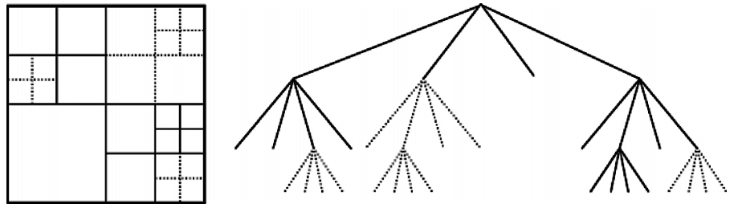

The PB size, which is the block size at which the intra prediction mode is established is the same as the CB size except for the smallest CB size (usually 8x8) is allowed in the bitstream. For the latter case, a flag is present that indicates whether the CB is split into four PB quadrants that each have their own intrapicture prediction mode. The actual region size at which the intrapicture prediction operates depends on the residual coding partitioning.

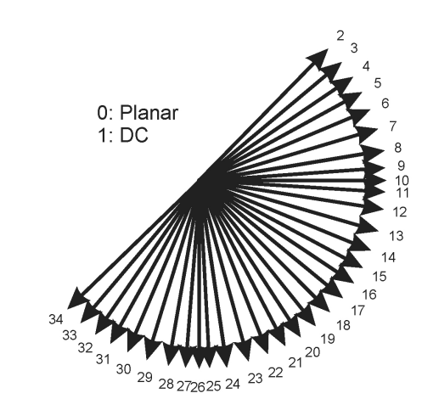

For residual coding, a CB can be recursively partitioned into transform blocks (TBs). The partitioning is signaled by a residual quadtree. Intra prediction operates according to the TB size, and previously decoded boundary samples from spatially neighboring TBs are used to form the prediction signal. Directional prediction with 33 different directional orientations is defined for (square) TB sizes from 4x4 up to 32x32. The possible prediction directions are shown in Fig. ?
  - Analysis of Dominant Distortion in HEVC intra steganography
According to the HEVC intra coding scheme, this subsection will present analysis of dominant distortion caused by HEVC steganography to illustrate why larger size PUs can be modified without introducing great degradation in visual quality.
Spatial-domain intra prediction has previously been successfully used in H.264/ AVC. The intra prediction of HEVC similarly operates in the spatial domain, but is extended significantly—compared to the eight prediction directions of H.264/AVC, HEVC supports a total of 33 angular prediction directions with DC and Planar mode.
The residual signal of the intra prediction, which is the difference between the original block and its prediction, is transformed by a linear spatial transform. The transform coefficients are then scaled, quantized, entropy coded, and transmitted together with the prediction information. When the prediction mode m₁ of i^{th} NxN size PU is modified to m₂. The original residual of this PU, denoted as RS_{o,i,N}, can be expressed as:
${RS}_{o,i,N}=P_{o,i,N}-{Pre}_{o,i,N}$ (2)
Where P_{o,i,N} denotes the original pixel value in the i^{th} PU, and Pre_{o,i,N} denotes the prediction value calculated by original mode m₁.After obtaining the RS_{o,i,N}, the bits B_{o,i,N} used to encode this PU can be expressed as follows:
$B_{o,i,N}=Ent(RT(\frac{DCT\left({RS}_{o,i,N}\right)}{Q×QS}))$ (3)
Where DCT(.) denotes the integer discrete cosine transform, RT(.) denotes the rounding and truncating operations, Ent(.) denotes entropy coding, Q denotes the fixed quantization matrix, QS denotes the quantiser scale. At the decoding process, the reconstruction residual ${RS}_{o,i,N}^{r}$ can be calculated as:
${RS}_{o,i,N}^{r}=IDCT\left(IEnt\left(B_{o,i,N}\right)×Q×QS\right)$ (4)
Where IDCT(.) denotes the inverse integer discrete cosine transform, IEnt(.) denotes the inverse entropy coding, and decoded pixel value $P_{o,i,N}^{r}$can be expressed as:
$P_{o,i,N}^{r}=FTR({RS}_{o,i,N}^{r}+{Pre}_{o,i,N})≈P_{o,i,N}$ (5)
Where FTR(.) denotes deblocking filter and Sample Adaptive Offset (SAO) operations. Equation (?) shows that the difference between decoded pixel value and original value is mostly depended on quantization. For the next MxM size PU, its predition value is determined as:
${Pre}_{o,i+1,M}= {SF}_{N} (P_{o,i,N}^{r})$ (6)
${SF}_{N}(.)$ denote the intra estimation, prediction and smoothing opration applied by HEVC according to the block size. It shows that as long as we keep the size of candidate PU unchanged, the prediction value of next PU will not be affected significantly. After modifying the prediction modes to m₂, the sum of modified prediction value and its residual is still equal to the true pixel value. So, after processing the modified residual value with same parameters as the original, following equation can be obtained:
$P_{md,i,N}^{r}=FTR({RS}_{md,i,N}^{r}+{Pre}_{md,i,N})≈P_{o,i,N}$ (7)
Where $P_{md,i,N}^{r}$ denotes the modified reconstruction value and ${RS}_{md,i,N}^{r}$ denotes the modified reconstruction residual. Thus, the conclusion can be drawn:
${{P_{md,i,N}^{r}≈P}_{o,i,N}≈P}_{o,i,N}^{r}$ (8)
From equation (8), it shows that visual quality of videos generated by this kind of steganography algorithms will not degrade significantly. Another conclusion can be drawn that difference among values in equation (8) is mainly caused by the choice of Q and QS. Thus, the degradation of visual quality will be mainly caused by the increment of QP, not increment of embedded bits. Intra mode steganography has more potential capacity with multi-sized PUs.
In summary, the visual quality of generated video file won’t be affected by changing the HEVC intra coding process. Thus, improving capacity by utilizing angular intra prediction modes in multi-sized PUs is feasible in theory.
- The proposed HEVC steganography
In this section, based on the above analysis, larger size PUs can be modified without introducing great degradation in visual quality. The remaining problem is to keep the coding efficiency during the process of embedding secret message. The framework of the proposed algorithm is showed in Fig.?.
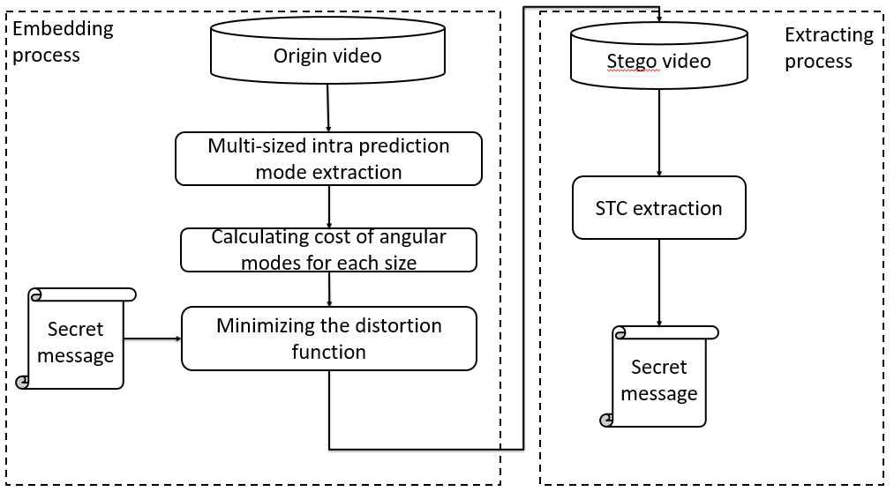

  - Selection rule of Intra prediction mode
According to the recursive procedure of block partition in HEVC, when QP increases, the number of small blocks decreases. Utilizing larger size of PU will improve the steganography cacpcity in videos with high QP.
Observing the 35 intra prediction directions used in HEVC, it can be noticed that unlike the prediction directions in H.264/AVC, modes of HEVC have a regular pattern. In HEVC, two number-adjacent directions have similar prediction direction. The common way to modify the intra prediction mode is to replace it with a mode that is similar in prediction direction. In this case, these modes are grouped as follows:
$\left\{\left(M_{i},M_{j}\right)\right| 2 \left| M_{i}=2 \right|{ M}_{j}, i,j∈(0,34)\}$ (11)
Where the $|$symbol means exact division,$M_{i}$ mean the current PU prediction mode has the i^{th} prediction direction. One element in the group denotes the bit 0, another denotes the bit 1. According to equation (11), the final grouping is {(0, 1), (2, 3)…}. However, changing mode 0 and mode 1 will significantly affect coding efficiency since they are usually used to encode homogeneous areas. Thus, the first group (0, 1) is removed. Finally, all the qualified prediction modes of PUs in I frames are extracted, and taken as cover sequence.
  - Rate control method
However, according to the analysis in the above section, if the best mode is replaced with suboptimal one, coding efficiency will be reduced. In HEVC, rate distortion optimization (RDO) technique is used to achieve the best prediction direction:
$J=D+λR$ (1)
Where $J$ denotes the RD cost, $λ$ denotes the Lagrangian multiplier which depends on quantization parameter QP, D and R represent the distortion and the estimated bitrate of the current PU respectively. The best intra prediction mode is corresponding to the lowest RD cost. if the corresponding RD cost of current PU is increased, which means residual signal of stego block is larger than its of original block, the number of bits used to encode this block will be increased. Thus, the total coding efficiency will be reduced.
In order to reduce the influence on coding efficiency of the proposed algorithm. The STC method is utilized to embed the secret message into cover:
$Hx^{T}=m$ (12)
Where H denotes the parity check matrix generated by STC algorithm, m is the secret message and x is the modified cover sequence. Detail description and implement of STC can be found in [10]. According to the selection rule of Intra prediction mode, one prediction mode has one candidate mode that can replace it. Thus, this is a binary STC problem. After grouping these prediction modes, the following equation is used to map them into binary sequence:
${c_{i}= m}_{i} mod 2$ (13)
Where $c_{i}$ denotes the binary cover and $m_{i}$ denotes the original cover.
From equation (?), each RD cost is calculated through estimated bitrate and distortion of each PU. Thus, difference in RD cost can represent the coding efficiency reduction caused by changing the prediction mode of the current PU. The cost of changing one PU is defined as:
$φ_{i}=\left|J_{i}-J_{j}\right| , i,j is from the same group$ (14)
Where $φ_{i}$ is the cost of changing the i^{th} PU and$J_{i}$ is the RD cost of the prediction mode with the i^{th} prediction direction. The difference of RD cost between two prediction modes is used in the same group as the cost for changing one to another. The total distortion $D_{c}$is present as:
$D_{c}=\sum_{k=1}^{n}{φ_{k}}$ (15)
Where n presents the total number of all qualified PUs in the video file. Finally, the secret data can be embedded into a video with little distortion.
- Experiments and Analysis
Since the proposed algorithm is the first intra prediction modes based algorithm using multi-sized PB designed specifically for HEVC, previous single-sized PB based algorithm in [?] is performed for comparison. Performance comparisons between the proposed steganography algorithm and the previous one are made in terms of embedding capacity, SSIM, and bitrate. Moreover, effect of introducing large size PB on visual quality and effect of different QP sets will also being analyzed in this section.
  - Experiment Environment
The proposed steganography algorithm has been implemented in an open source software X265. HEVC is the state-of-art video codec standard, it is specially designed for high definition videos for higher coding efficiency. For this reason, the proposed algorithm was tested on HEVC standard test dataset with multi-resolution. In these experiments, pseudo random binary sequences are generated as secret data, and payload is set to α=0.5, to produce the stego sets. The GOP size is 10 and coding structure is IPPP. The video coding playform for HEVC decoding is HM16. The steganography algorithm are developed with Visual C++ 2013. The detail of experiment datasetin listed in Table 1.
Table 1. Details of the dataset.
Video name | Resolution | Frame number
Traffic | 2560x1600 | 150
PeopleOnStreet | 2560x1600 | 150
ParkScene | 1920x1080 | 240
BasketballDrive | 1920x1080 | 501
Johnny | 1280x720 | 600
FourPeople | 1280x720 | 600
  - Comparison Experiment
In this section, the proposed steganography algorithm will be compared with another algorithm on a common dataset to illustrate the advantage of ours. As far as we know, the latest work on HEVC intra prediction mode [?] is compared with our algorithm to illustrate our advantage in this section. Comparison results in capacity, BIR and SSIM is showed in Table 3. The Bit Increase Ratio (BIR) is defined as:
$BIR=\frac{TB_{steg}-TB_{ori}}{TB_{ori}}×100\%$ (16)
Where TB_{steg} is the total bits of original video and TB_{ori} is the total bits of modified video. Because the origin cover length is different for these two algorithms, a new indicator is proposed to measure the capacity under different. BIR is normalized with 1 Kbits to show the coding efficiency reduction, named as NCKR. The physical meaning of NCKR is the bit increase ratio using secret payload of the same size. This is very common in a real application. The definition of NCKR is：
$NCKR=BIR/Capacity$ (17)
Table 3. Comparison results with another HEVC algorithm
Sequences | Algorithms | QP | Resolution | SSIM | Capacity(bits) | BIR | NCKR  (%/Kbits)
Traffic | Proposed | 40 | 2560x1600 | 0.9577 | 155037 | 0.0519 | 0.0335
Traffic | [?] | 40 | 2560x1600 | 0.9433 | 60418 | 0.0240 | 0.0397
PeopleOnStreet | Proposed | 40 | 2560x1600 | 0.9318 | 254517 | 0.0291 | 0.0114
PeopleOnStreet | [?] | 40 | 2560x1600 | 0.9288 | 122208 | 0.0157 | 0.0128
ParkScene | Proposed | 40 | 1920x1080 | 0.9481 | 81581 | 0.0340 | 0.0417
ParkScene | [?] | 40 | 1920x1080 | 0.9303 | 31006 | 0.0168 | 0.0542
BasketballDrive | Proposed | 40 | 1920x1080 | 0.9431 | 215051 | 0.0702 | 0.0326
BasketballDrive | [?] | 40 | 1920x1080 | 0.9394 | 73222 | 0.0243 | 0.0332
Johnny | Proposed | 40 | 1280×720 | 0.9784 | 105433 | 0.0911 | 0.0864
Johnny | [?] | 40 | 1280×720 | 0.9746 | 44005 | 0.0396 | 0.0899
FourPeople | Proposed | 40 | 1280×720 | 0.9547 | 173580 | 0.0758 | 0.0437
FourPeople | [?] | 40 | 1280×720 | 0.9363 | 79865 | 0.0396 | 0.0496
From Table ?, it shows that our algorithm outperforms the algorithm [?] in capacity, SSIM, but has higher bit increase ratio. However, If both capacity and bit increase ratio are considered, our algorithm can achieve smaller bit increase ratio at the same capacity, which is showed by NCKR. For videos in all resolution, our algorithm has better NCKRs, which are 0.0335, 0.0114, 0.0417, 0.0326, 0.0864 and 0.0437.
The effectiveness of utilizing multi-sized PBs is well proven by capacity. Algorithm [?] only uses 4x4 PB to embed the message which leads to a low capcity. Even if they embed less payload, the SSIM is still lower that ours. The reason for causing this phenomenon may be that in our algorithm, all the block partitioning is exactly the same as that in the original video, but in algorithm[?], only the position of 4x4 PB is preserved. As showed in equation ?, different smoothing filter (usually stronger filter) may applied to other PBs, which may leads to the degradation in SSIM.
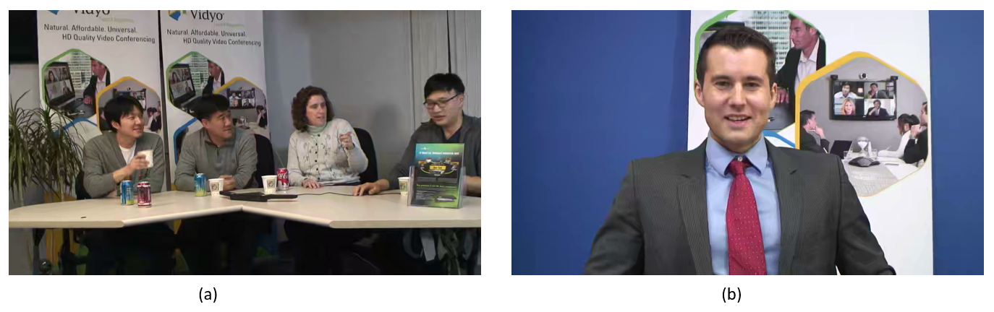
It can be observed that NCKR is different even when the resolution of video is the same, such as 0.0035 for 2K video Traffic or 0.0014 for PeopleonStreet. Several tools were used to analyze the different among these videos. It shows that TBs with complex texture often has a higher residual signal. This kind of TBs can tolerate more bit changes than other blocks. In addition, in a high-resolution video, larger size PBs also often occurs in texture-rich area. As showed in Fig. ?, the conclusion is drawn that under the same resolution, videos with lower NCKR always has more complex texture that videos with higher NCKR. Thus, a texture-rich video is more suitable for our algorithm than plain video in term of preserving coding efficiency.
(a)content of fourpeople in 720P. (b) content of Johnny in 720P. Johnny has more homogeneous areas than fourpeople. Texture-rich video always has a lower NCKR.
  - Performance Experiments and Analysis
In this section, two algorithm will be performed to prove the conclusion that utilizing multi-sized PB for steganography will not cause great degradation in visual quality. The first one is the proposed algorithm with multi-sized PB, another is the algorithm exactly the same as the proposed one except for using single-sized PB. Experiments were conducted on different QPs.

Analysis on visual quality with different QPs.
As explained in Section 2, video quality of stego video will not greatly degrade when larger size PBs are used. To prove this, SSIM between original video and modified video to demonstrate the perceptibility and visual quality of the proposed HEVC algorithm. PSNR is not used here because SSIM can present visual quality better. The results are showed in Fig. 3 and Fig. 4. Every bar in Fig denote one video sequence.
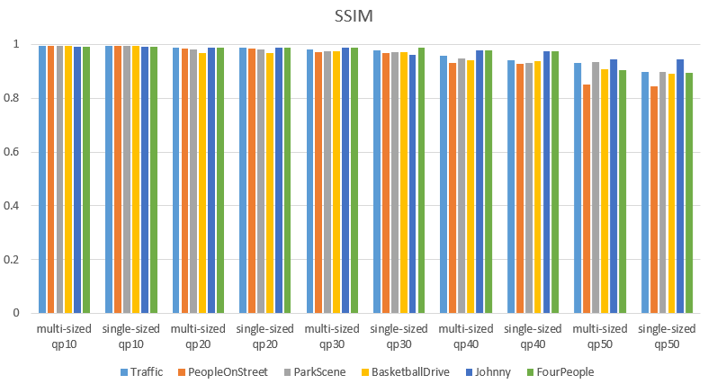
FIG
It shows that SSIMs Between algorithm using multi-sized PBs and algorithm using single-sized PBs are similar under the same QP. The decreasing trend of SSIM is mainly caused by the incensement of QPs, not by the selection of PB size. Thus, it is totally safe to utilizing larger size PB for embedding the secret payload.
From these results, the overall SSIM value range from 0.85 to 0.99 and decreases with the increase of QP. It shows that under the same resolution and QP, videos with more homogeneous areas have higher SSIM than texture-rich videos, such as Johnny and Fourpeople. The reason may be that although texture-rich area can tolerate more bits changes, it also leads to more pixel changes. The requirement of perceptibility and coding efficiency cannot be satisfied simultaneously. From section 2 and fiG, the distortion in visual quality cannot be distinguished by the human eye, so coding efficiency and capacity should be main problem for intra prediction mode based algorithm.
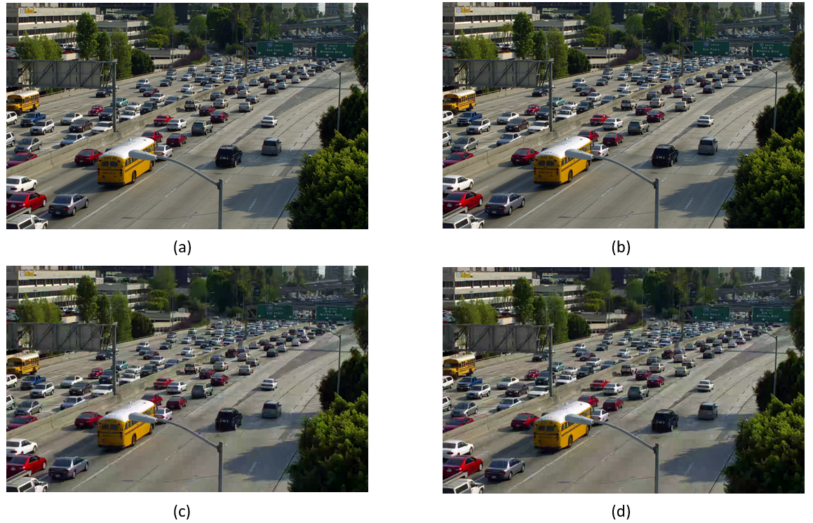
(a)origin video with QP20(b) stego video with QP20(a)origin video with QP50(b) stego video with QP50.
Analysis on capacity and coding efficiency with different QPs
Fig and Fig demonstrate the influence on coding efficiency and capacity of proposed algorithm and the one using single sized PBs.
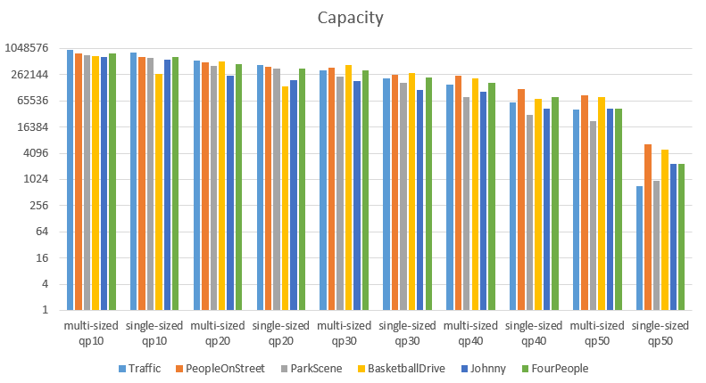
The vertical coordinate of Fig? is logarithmic, which means the capacity of algorithms decrease logarithmically with increment of QPs. When QP increases, more reconstruction pixels will be calculated from same quantized value, which leads to a smaller RD cost for large partition mode. The sizes of PUs are exponential {4, 8, 16, 32}, meaning the larger size PUs exponentially merge the smaller size PUs during this process. This may be the reason for logarithmically decrement in capacity. This also cause another phenomenon that the number of larger size PBs increases with QPs, which leads to a significant degradation in capacity for algorithm using single-sized PBs. For example, the capacity of Traffic using multi-sized PU with QP50 is 40681, but reduces to 718 when using single-sized PBs. The bigger the QP, the bigger the advantage of the proposed algorithm using multi-sized PBs.
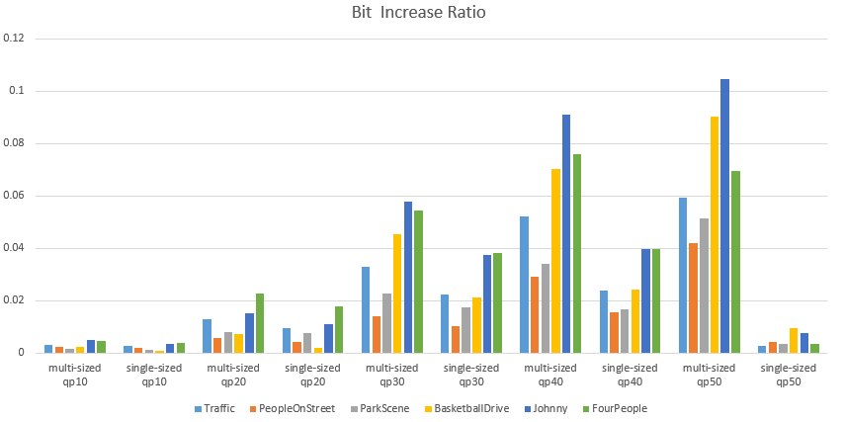

Fig. ? shows that algorithm using multi-sized PBs always has higher BIR the algorithm using single-sized PBs, epically when QP equals to 50. However, combining the results on capacity, The proposed algorithm still has the advantage when the payload is the same. For example, the BIR of Traffic using multi-sized PU with QP50 is 0.059207,and reduces to 0.00257when using single-sized PBs. But the NCKR is 0.145 and 0.358 correspondingly. Fig.? shows that with the increase of QPs, the NCKR increases. The reason for this phenomenon is similar to that in section 4.2. With QP increases, more TBs with homogeneous areas appears. This kind of TBs can tolerate less bit changes than other blocks. The conclusion is drawn that under the same videos, lower NCKR can be achieve by lower QP. Thus, a small QP video is more suitable for our algorithm in term of preserving coding efficiency.
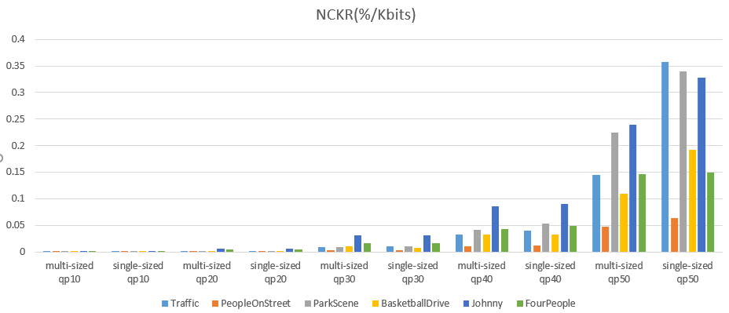

In summary, our algorithm outperforms the existing HEVC intra prediction mode algorithm with higher capacity and better perceptibility. Results prove that utilizing multi-sized PB for steganography will not cause great degradation in visual quality, but has great improvement in capacity. A texture-rich high-resolution video with low QP is more suitable for our algorithm in term of preserving coding efficiency. Some interesting phenomenon in the experiment results is discussed, which may be helpful to improving the performance of the proposed steganography algorithm in the future.
- Conclusion
The existing video steganographic schemes based on intra prediction modes for H.264/AVC and HEVC all use single-sized blocks to embed the secret payload. Thus, the steganographic properties of HEVC multi-sized tree-structured intra partition still need to be studied. In this paper, a novel video steganography is presented. Several contribution have been made in this paper: 1) Improving capacity by utilizing angular intra prediction modes in multi-sized PUs. 2) Detailed analysis why larger size PUs can be modified without introducing great degradation in visual quality. 3) Maintaining coding efficiency by defining cost function based on rate distortion. 4) New indicator to measure capacity under different bit increase ratio. Detailed experiments have been conducted to prove the effeteness of the proposed algorithm. Our algorithm outperform the latest HEVC intra predition mode based steganography.The conclusion is drawn from results that a texture-rich high-resolution video with low QP is preferred for our algorithm. Future work can be made in security improvement or adopt the algorithm to an adaptive algorithm or error propagation free algorithm.

References
- Aparna R, Ajish S. A Review on Data Hiding Techniques in Compressed Video[J]. International Journal of Computer Applications, 2016, 134(13): 1-4.
- Juneja M, Sandhu P S. Information hiding using improved lsb steganography and feature detection technique [J]. International Journal of Engineering and Advanced Technology (IJEAT) ISSN, 2013, 2(4): 2249-8958.
- Hu Y, Zhang C, Su Y. Information hiding based on intra prediction modes for H. 264/AVC[C]//Multimedia and Expo, 2007 IEEE International Conference on IEEE, 2007: 1231-1234.
- Yang, G., Li, J., He, Y.: An information hiding algorithm based on intra-prediction modes and matrix coding for H.264/AVC Video stream. International Journal of Electronics and Communications 65(4), 331-337 (2011)
- Bouchama S, Hamami L, Aliane H. H. 264/AVC data hiding based on intra prediction modes for real-time applications[C]//Proceedings of the World Congress on Engineering and Computer Science. 2012, 2200(1): 655-658.
- Zhang L, Zhao X. An Adaptive Video Steganography Based on Intra-prediction Mode and Cost Assignment[C]//International Workshop on Digital Watermarking. Springer, Cham, 2016: 518-532.
- Chang P C, Chung K L, Chen J J, et al. A DCT/DST-based error propagation-free data hiding algorithm for HEVC intra-coded frames[J]. Journal of Visual Communication and Image Representation, 2014, 25(2): 239-253.
- Tew Y, Wong K S. Information hiding in HEVC standard using adaptive coding block size decision[C]// IEEE International Conference on Image Processing. IEEE, 2015:5502-5506.
- Sheng Q, Wang R, Pei A, B Wang. An Information Hiding Algorithm for HEVC Based on Differences of Intra Prediction Modes[J]. Guangdianzi Jiguang/journal of Optoelectronics Laser, 2016, 25(8):1578-1585.
- Filler T, Judas J, Fridrich J. Minimizing additive distortion in steganography using syndrome-trellis codes[J]. IEEE Transactions on Information Forensics and Security, 2011, 6(3): 920-935.
- LNCS Homepage, http://www.springer.com/lncs, last accessed 2016/11/21.

