A PU based Data Hiding Algorithm for HEVC Videos
First Author¹[0000-1111-2222-3333] and Second Author²[1111-2222-3333-4444]
¹ Princeton University, Princeton NJ 08544, USA
² Springer Heidelberg, Tiergartenstr. 17, 69121 Heidelberg, Germany
lncs@springer.com
Abstract. Currently, many data hiding methods were proposed in H.264/AVC, but only a few were proposed in HEVC. In the state-of-the-art video codec, high efficiency video coding (HEVC), many advanced coding structures, such as coding unit (CU), prediction unit (PU) and transform unit (TU), are introduced to decrease the bit rate of coded videos with higher visual quality. However, the existing data hiding algorithm for H.264/AVC cannot adapt to these new structures effectively. This paper presents a novel PU based data hiding algorithm for HEVC intra coded frames where the intra prediction mode of each candidate PU is taken as cover. Data hiding algorithms based on intra prediction mode always have the problem of reducing coding efficiency. In this work, we utilized STC algorithm to overcome this shortage. Moreover, statistical characteristics of intra PUs are further analyzed to reduce the suspicious degree of generated videos. This algorithm is tested under large dataset consisting of 1080p sequences to verify the practicability. The Experimental results confirm the effectiveness of the proposed algorithm.
Keywords: video steganography, prediction unit, HEVC, intra-coded frames.
- Introduction
Internet is one of the most important way for people to access all kinds of information. Government and companies have the need of secret transmission of a variety of complex data and multimedia objects. Securing the content of sensitive as well as personal transactions over open networks while ensuring the privacy of information has become essential but increasingly challenging. Encrypting a secret message transforms it to a noise-like data which is observable but meaningless. Modern data hiding techniques are new research areas for these problems [1]. Compared with other kind of steganography, hiding data in videos have the advantage of high capacity and low distortion.
In general, there are two commonly used domains for video steganography: compression domain and pixel domain. In pixel domain, LSB is the most commonly used method [2] with high capacity, but it is fragile and easy to detect compared with compression domain method [3-9]. In compression domain, data hiding techniques are well researched for the previous state-of-the-art compression standards H.264/AVC. Hu et al. [3] have proposed a data hiding algorithm based on intra prediction mode in H.264/AVC, the embedding process is done by mapping the modes into secret data. Yang et al. [4] have improve Hu’s method by matrix coding, and improve the embedding capacity. Bouchama et al. [5] divided the intra prediction modes in H.264/AVC into four groups according to their prediction direction, the result shows a better video quality while ensuring high capacity. Zhang el al. [6] analyzes the texture of the video, and propose an adaptive embedding algorithm using STC. Costs are assigned by the texture of the video content. Results verifies the high security of this method.
Although many work have been done in H.264/AVC, only a few was researched in HEVC. Chang et al. [7] proposed an error propagation free method based on DST/DCT modulation. They classified the intra prediction mode for different error propagation module, the signal characteristics of DCT/DST are analyzed to locate the QDCTs/QDSTs that can be perturbed without propagating errors to neighboring intra coded blocks. Tew et al. [8] present an approach manipulating the CB (coding block) size decision on every coding tree unit to embed information based on the predefined mapping rules. Each CB is forced to assume certain size to encode the external information without significantly compromising perceptual quality. Wang et al. [9] has proposed intra prediction mode based method in HEVC, a mapping between angle difference and secret message was established to embed the data. However, their method has limited capacity. In addition, because of the very slow encoding speed of HM encoder , the method mentioned above were unable to do experiments on large dataset to verify their performance comprehensively.
To overcome the limitation described above and fill the gaps between HEVC and H.264/AVC. We propose a novel PU based data hiding algorithm for HEVC intra coded frames where the intra prediction mode of each candidate PU is taken as cover. In this work, we utilized STC algorithm to overcome the shortage of reduction in coding efficiency, which is a common issue for intra prediction mode based algorithm. Moreover, statistical characteristics of intra PUs are further analyzed to reduce the suspicious degree of generated videos. The Experiments are conducted with a multi-thread open source software X265, using a large dataset consisting of 1080p sequences to verify the practicability.
The rest of paper is organized as follows. In Section 2, theoretical model of PU based data hiding algorithm is introduced. Section 3 describes the proposed data hiding algorithm. Framework of this algorithm is showed in Section 4. In Section 5, experiments and results are present. Finally, conclusion are drawn in Section 6.
- Theoretical Model of PU based data hiding algorithm in HEVC
In this section, theoretical model of PU based data hiding algorithm is introduced. First, the intra coding process of HEVC is present to illustrate its difference with H.264/AVC, and the distortion caused by changing prediction modes of PUs will be analyzed. Then, the statistical characteristics of PU intra prediction modes will be demonstrated in order to avoid making abnormality in it during the embedding process.
  - Intra coding scheme and stenographic distortion in HEVC
The main achievement of the HEVC standard is its significant improvement in compression performance when compared with the previous state-of-the-art standard H.264/AVC, with at least 50% reduction in bitrate for producing video of similar perceptual quality. Similar to H.264/AVC, HEVC is a block based video coding standard. However, HEVC gives up the concept of macro block, and introduces three new structures: coding unit (CU), prediction unit (PU) and transform unit (TU), which will lead to a different data hiding strategy from H.264/AVC. Because of those difference between H.264 and HEVC, data hiding algorithms for H.264/AVC need to be improved to apply on HEVC in order to achieve higher capacity and security. Table 1 shows the main difference between H.264/AVC and HEVC in the intra coding process.
Table 1. Main difference of intra coding between H.264/AVC and HEVC
Functionality | H.264/AVC | HEVC
Prediction block size | 4×4,8×8 and 16×16 | 4×4,8×8,16×16 and 32×32
Intra prediction mode | 9 | 35
Most probable modes | 1 | 3
Block partition | Flexible partition of Macro Block | Recursive quadtree partition of CU,PU and TU
In the intra coding procedure of HEVC, coding tree unit (CTU) is the basic unit to perform coding for each video frame. One video frame is first split into non-overlapping CTUs, each of which is further split into smaller coding units (CU) with a recursive quadtree decomposition. For one N×N intra CU with $N∈\{32,16,8\}$, two prediction unit (PU) partition mode is available: N×N and N/2×N/2. For intra CU with size of 64×64, only the later is available. Thus, the size of one intra PU is range from 4×4 to 32×32. As showed in Fig. 1, for one N×N intra PU, the HEVC encoder generates 35 prediction blocks from corresponding neighboring pixels and intra prediction modes. These reference pixels for intra prediction are encoded pixels from upper-right, upper, upper-left, left and lower-left neighboring blocks. Rate distortion optimization (RDO) technique is used to achieve the best coding performance:

$J=D+λR$ (1)
Where D and R represent the distortion and the estimated bitrate respectively. To calculate the RD cost on the corresponding residual signal, coding operations such as transform, quantization, and entropy coding have to be carried out. The intra prediction mode that yields the minimum RD cost is selected as the optimal one to predict and encode the current PU.
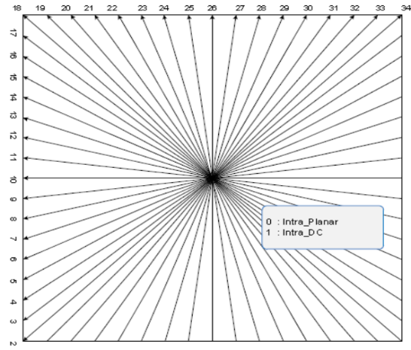
Fig. 1. Intra prediction modes in HEVC
When the prediction mode m₁ of a PU is modified to m₂, the corresponding RD cost of current PU will increase, which will cause a larger residual in its TU, and coding efficiency will be reduced. In this process, the prediction value and the residual value are changed simultaneously, sum of which is still equal to the true pixel value. Thus, video quality of PU based data hiding algorithm will be high. This phenomenon has been proven in the experiment section. However, these kind of algorithms have low coding efficiency problem. The proposed algorithm solves this problem by apply STC algorithm with proper cost assignment. Bit Increase Ratio (BIR) is used to measure the influence on coding efficiency, and the effectiveness has been proven in section 5.
  - Statistical characteristics of intra prediction mode in HEVC
The statistical characteristics of PU intra prediction modes is analyzed in this section. As is mentioned in Section 2.1, number of the most probable modes (MPM) in HEVC is different from that in H.264/AVC. In the process of RD cost calculation, only three MPMs and several candidate modes are calculated. Prediction mode 0 (Planar) is the most commonly used mode according to MPM selection rules. Fig. 2 show the histogram of all 4×4 prediction modes in an I frame from blue sky sequence. We can see that mode 0 has the highest frequency among all the prediction modes. During the data hiding procedure, the shape of the histogram shouldn’t be altered, otherwise it will be very easy to detect the existence of the secret message.
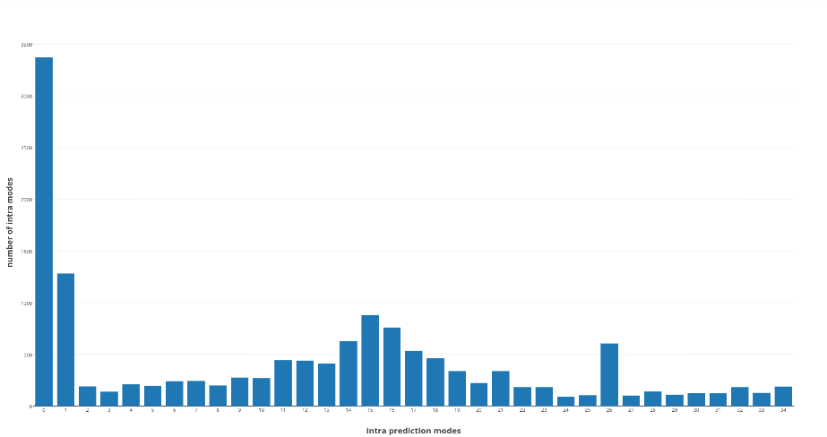
Fig. 2. Histogram of prediction modes in an I frame from database
- The Proposed Data Hiding Algorithm
Based on the theoretical model described in Section 2. There are two problems need to be solved: one is how to reduce the influence on coding efficiency of the proposed method; another is how to keep the shape of histogram of prediction similar to the original during the process of embedding secret message.
The proposed algorithm embeds message into 4×4 PUs by modulating their prediction modes according to the mapping rules. Then, for each PU, a proper cost will be assigned based on the theoretical model described before. STC algorithm will be applied to further improve the performance of the algorithm.
  - PU extraction and selection rule
According to the recursive procedure of Block partition decision, plain area tends to use large block partition, and texture rich area tends to use small block partition. Moreover, when QP increases, the number of small blocks decreases. Texture rich areas are more suitable for steganography. For this reason, we select the PU with size of 4×4 as cover in our algorithm.
Observing the 35 intra prediction modes showed in Fig. 1, it can be noticed that unlike the prediction modes in H.264/AVC, modes of HEVC has a regular pattern. In HEVC, two adjacent prediction modes have similar prediction direction. The common way to modify the intra prediction mode is to replace it with a mode that is similar in prediction direction. In this case, we can group these mode as follows:
$\left\{\left(m_{i},m_{j}\right)\right| 2 \left| m_{i}=2 \right|{ m}_{j}\}$ (2)
Where the $|$symbol means exact division. According to equation (2), the final grouping is {(0, 1), (2, 3)…}. However, this grouping method will change the histogram of prediction modes significantly. Number of mode 1 will be close to mode 0 after embedding, which will indicate the existence of secret message. Thus, we removed the first group (0, 1) to keep the shape of histogram unchanged. Finally, all the qualified prediction modes of PUs in I frames with size of 4×4 are extracted, and taken as cover sequence.
  - STC and cost assignment scheme
In order to reduce the influence on coding efficiency of the proposed method. We utilizes the STC method to embed the secret message into cover:
$Hx^{T}=m$ (3)
Where H denoted the parity check matrix generated by STC algorithm, m is the secret message and x is the modified cover sequence, which can be achieved by STC algorithm through the cover and the corresponding cost. Detail description and implement of STC can be found in [10]
According to the PU selection rule, one prediction mode has one candidate mode that can replace it. Thus, this is a binary STC problem. After grouping these prediction modes, the following equation is used to map them into binary sequence:
${c_{i}= m}_{i} mod 2$ (4)
Where $c_{i}$ denotes the binary cover and $m_{i}$ denotes the original cover.
As mentioned in Section 2, the main distortion caused by intra prediction mode data hiding algorithm is the reduction in coding efficiency, which can be measured by RD cost. So, the cost of each prediction mode is defined as:
$φ_{i}=\left|J_{i}-J_{j}\right| , i,j is from the same group$ (5)
Where $φ_{i}$ is the cost of ith cover and $J$ is the RD cost of the prediction mode. We use the difference of RD cost between two prediction modes in the same group as the cost for changing one to another.
Finally, the secret data can be embedded into a video by the use of STC.
- Framework of the Proposed Scheme
In this section, the frame work of the proposed PU-based algorithm is present. For a given video, the flowchart and the data hiding algorithm is illustrated as follows.
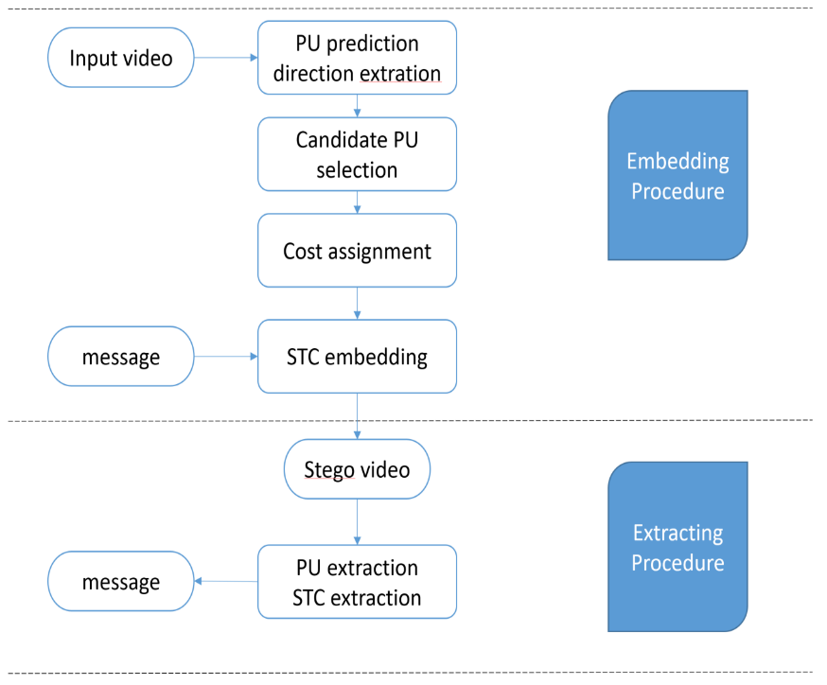
Fig. 3. Framework of the proposed algorithm
Embedding algorithm:
Step 1 Choose one I frame from video stream.
Step 2 4×4 PUs with intra direction range from (2,33) are chosen to get a cover sequence. Cover sequence is denoted as {x_{i} | x_{i} is the ith intra direction of candidate PU}
Step 3 Compute cost value for each PU. Cost sequence is denoted as {p_{i} | p_{i} is the ith cost of candidate PU}
Step 4 Convert the cover sequence into a binary sequence using parity check function, denoted as {c_{i} | c_{i} is the ith bit of the binary cover}. Generate a pseudo random binary sequence as secret data, denoted as {m_{i} | m_{i} is the ith bit of the secret data}
Step 5 Apply STC algorithm to generate the modified cover sequence {$\hat{c}$_{i} | $\hat{c}$_{i} is the ith bit of the modified cover}.
Step 6 Generate the stego video. To keep the number of 4×4 PU unchanged, in coding process of each CTU, RD cost is changed. For PUs which have the size of 4×4 in the original video, its RD cost is set to negative to keep the partition mode; For PUs which have larger size than 4×4 in the original video, 4×4 mode calculation is skipped, and its other partition mode is chosen by encoder automatically.
Extracting algorithm:
Step 1 Decode the video file. Get the candidate cover sequence Y in all I frames.
Step 2 Apply STC extraction scheme, use the equation (3) to get the message m.
- Experiments and Performance Results
  - Experiment environment
The proposed data hiding algorithm has been implemented in an open source software X265. HEVC is the state-of-art video codec standard, it is specially designed for high definition videos for higher coding efficiency. For this reason, twenty two YUV sequences (aspen, blue sky, controlled burn, crowd run, ducks take off, factory, in to tree, life, old town cross, park joy, pedestrian area, red kayak ,riverbed, rush field cuts, rush hour, snow mint, speed bag, station, sunflower, touchdown pass, tractor, west wind easy) with 1080P resolution are selected in this paper. Performance are made in terms of embedding capacity, PSNR, bitrate, etc. These sequences are tested to achieve the performance of the proposed algorithm with different contents. However, not all of these sequences have the same frame numbers, which will lead to difficulty in analyzing the capacity and the security. Thus, all these sequences are further divided into small sequences with 100 frames each, and 112 subsequences are generated. Variable Bitrate (VBR) mode is used and several commonly used QPs are selected to encode videos, the GOP size is set to 10. In these experiments, we have used a pseudo random binary sequence as secret data which were inserted in I frame according to the method described previously, and the different payload rates α∈{0.25,0.5,0.75} are chosen to produce the stego sets. Finally, a total number of 4480 modified videos are generated. The detail of experiment environment in listed in Table 2.
Table 2. Environment of experiments.
Environment | Values
Encoder | X265
Decoder | HM16
YUV sequences number | 112
Resolution of sequences | 1920×1080
QP range | {6,7,…,45}
Video number | 112×40=4480
GOP size | 10
Frames to be encoded | 100
GOP structure | IPPP…
  - Performance evaluations of the proposed algorithm
In this section, PSNR, SSIM, capacity and bit incensement ratio (BIR) of all 4480 videos with different QPs are evaluated. The results are investigated from several different points of view, i.e. perceptibility, capacity, impact with different QPs, etc.

Analysis on perceptibility of the proposed algorithm
First, video quality and perceptibility of the proposed algorithm are tested. Because of lacking steganalysis method for HEVC PU-based steganography, we use PSNR and SSIM between original video and modified video to demonstrate the perceptibility of the proposed HEVC algorithm. As is well known, PSNR is the function of pixel difference between the original and the target. In this case, a higher PSNR means less pixel difference, which in some degree, represents the security of the steganography algorithm as well as the visual quality of the generated video. We count the PSNR and SSIM of the dataset with different QPs and payloads. The results is showed in Fig. 4 and Fig. 5. For each column in these figures, it is the average number of PSNR/SSIM from 112 videos with same QP.
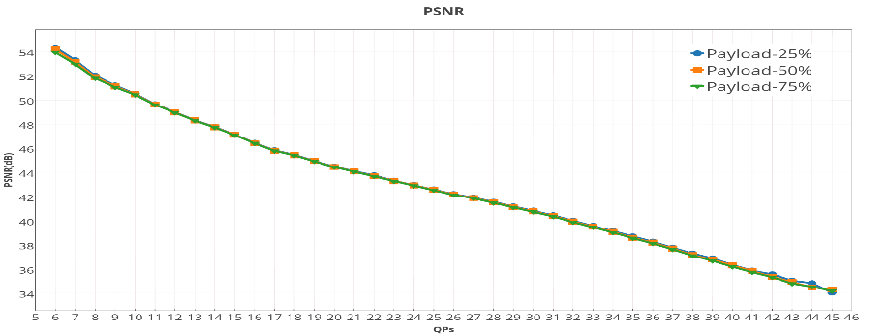
Fig. 4. PSNR of the proposed algorithm with different QPs
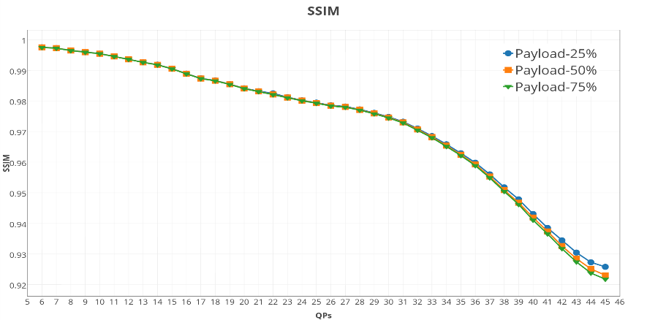
Fig. 5. SSIM of the proposed algorithm with different QPs
From these results, we can see that the overall PSNR value is range from 34 dB to 55 dB and decreases with the increase of QP. QP20 to QP30 are the most commonly used coding parameters in a real application. PSNR value of these QPs are higher than 40dB, and SSIMs are higher than 0.974, which indicates the excellent perceptibility of the proposed algorithm. From another point of view, for many data hiding algorithms, allocating higher embedding capacity often causes lower PSNRs and SSIMs. In our algorithm, PSNRs/SSIMs of different embedding capacity are similar, the decrease trend of PSNRs/SSIM is mainly caused by the incensement of QPs, not incensement of embedding bits. The reason is that when PU-based data hiding algorithm changes the CU partition mode and PU intra directions, which will lead to different prediction value, the residuals of current TU will change correspondingly to keep the reconstruction value similar to the true pixel value. In this case, when the embedding bits are increased, the quality of generated video is preserved. This phenomenon verifies the advantage of the proposed data hiding algorithm in perceptibility.

Analysis on coding efficiency of the proposed algorithm
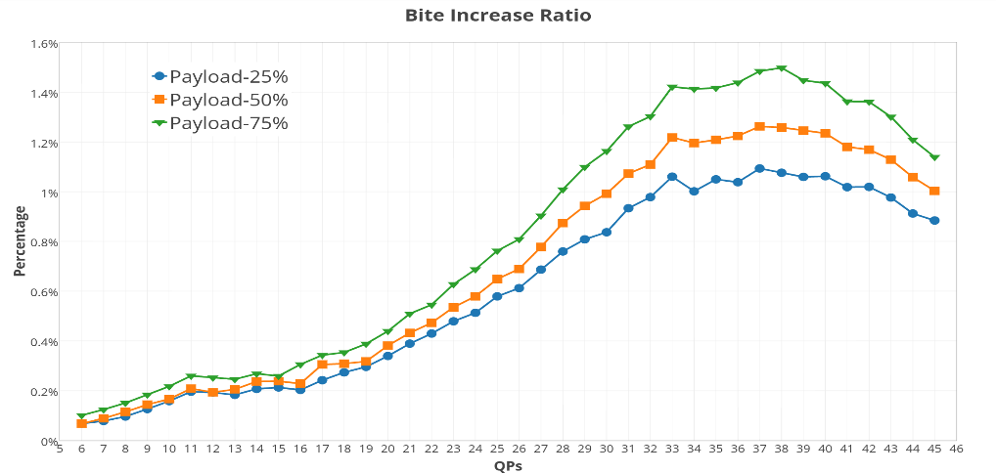
Fig. 6. Bit Increase Ratio of the proposed algorithm with different QPs
As described in section 2, PU based algorithms have low coding efficiency problem. In order to demonstrate the influence on coding efficiency of the proposed method and prove the effective of applying STC algorithm, Bit increase ratio (BIR) is calculated on the dataset. The BIR is defined as:
$BIR=\frac{TB_{steg}-TB_{ori}}{TB_{ori}}×100\%$ (6)
Where TB_{steg} is the total bits of original video and TB_{ori} is the total bits of modified video. BIR is a normalized index, which is affected by the size of video file and embedding bits. Lower BIR of a stego video indicates a lower suspicious degree and lower influence on coding efficiency. Fig. 6 shows the Bit Increase Ratio of the proposed algorithm calculated on the dataset. From the result, the optimal BIR value is achieved by smaller QP. Notice that there is a decrease trend after QP larger than 36. The reason is that decreasing speed of capacity exceeds the decreasing speed of file size in large QPs. However, it is not practical to use large QP because of limited capacity which will be illustrated in the next section.

Analysis on capacity of the proposed algorithm
In this section, capacity of the proposed algorithm is analyzed. We implement the proposed algorithm on 4480 1080P video sequences with frame number equals to 100 and GOP size equal to 10. The upper bound of embedding capacity depends on the numbers of 4×4 PUs in I frames. The result is show in Fig. 7.
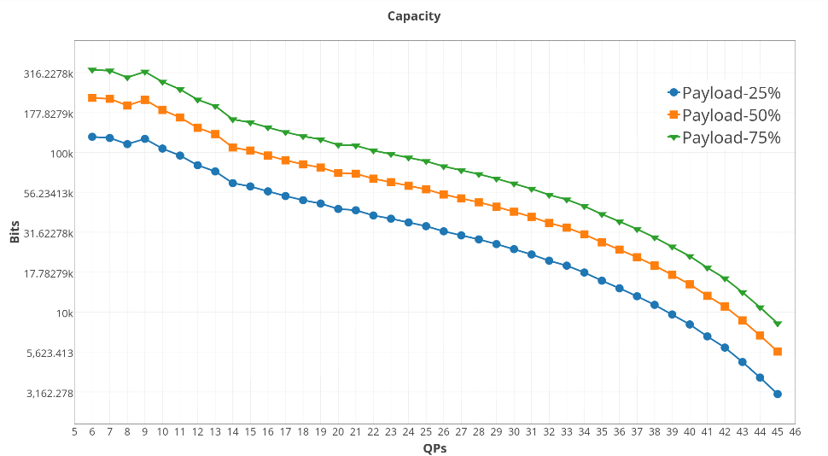
Fig. 7. Capacity of the proposed algorithm with different QPs
Notice that the vertical coordinate is logarithmic. The highest capacity is achieved by the smallest QP. Combining this result with perceptibility results, the best performance of the proposed method is achieved by use the smaller QP. Thus, for real application, there is a tradeoff between data hiding performance and coding efficiency. For most commonly used QP20 to QP30, we can achieve capacity above 100k bits.

Analysis on comparison results
Comparison results with other HEVC algorithms is showed in Table 3. Capacity of proposed method in Table 3 is the capacity using payload 0.75.
Table 3. Capacity comparison with other HEVC algorithms
Experiment set | QP | Resolution | embedded frame number | Capacity(bits)
Proposed method | 12 | 1080P | 10 | 214054
Proposed method | 24 | 1080P | 10 | 92754
Proposed method | 36 | 1080P | 10 | 36920
Method in [8] | 12 | 1080P | Not mentioned | 2496968
Method in [8] | 24 | 1080P | Not mentioned | 574840
Method in [8] | 36 | 1080P | Not mentioned | 180398
Method in [9] | Not mentioned | Not mentioned | 6 | 10069

In Table 2, the method in [8] use one 1080P sequence named Tennis to test the performance which is unavailable to us. In their paper, only QP is mentioned. Method of Sheng Q et al [9] also embed message into HEVC intra direction, the capacity result showed in their paper is around 10k bits with unknown QP.
From these results, we can see that our method can achieve better performance using small QPs. The proposed PU based algorithm changes the intra direction of PUs in I frames, which will not affect the video quality significantly. The requirement of good perceptibility and high capacity will be satisfied in our algorithm.
- Conclusions
In this paper, we propose a novel PU based data hiding algorithm for HEVC intra coded frames where the intra prediction mode of each candidate PU is taken as cover. In this work, we utilized STC algorithm to overcome the shortage of reduction in coding efficiency, which is a common issue for intra prediction mode based algorithm. Moreover, statistical characteristics of intra PUs are further analyzed to reduce the suspicious degree of generated videos. The Experiments are conducted on a large dataset consisting of 1080p sequences. From the results, the best performance can be achieved by selecting small QPs, and reduction on coding efficiency is low. It has been proven that our algorithm can achieve good video quality while maintaining a high capacity. Future work will be investigated to adopt this method to an adaptive method.

References
- M. Wu, B. Liu: Data hiding in image and video. I. Fundamental issues and solutions, IEEE Transactions on Image Processing, 12(6), 2003, pp. 685-695.
- Mamta Juneja, Parvinder Singh Sandhu, “ Information Hiding using Improved LSB Steganography and Feature Detection Technique” International Journal of Engineering and Advanced Technology (IJEAT) ISSN: 2249 – 8958, Volume-2, Issue-4, April 2013.
- Hu Y, Zhang C, Su Y. Information Hiding Based on Intra Prediction Modes for H.264/AVC[C]// IEEE International Conference on Multimedia and Expo. IEEE Xplore, 2007:1231-1234.
- Yang, G., Li, J., He, Y.: An information hiding algorithm based on intra-prediction modes and matrix coding for H.264/AVC Video stream. International Journal of Electronics and Communications 65(4), 331-337 (2011)
- Bouchama S, Hamami L, Aliane H. H.264/AVC Data Hiding Based on Intra Prediction Modes for Real-time Applications[J]. Lecture Notes in Engineering & Computer Science, 2012, 2200(1).
- Zhang L, Zhao X. An Adaptive Video Steganography Based on Intra-prediction Mode and Cost Assignment[J]. 2016.
- Chang P C, Chung K L, Chen J J, et al. A DCT/DST-based error propagation-free data hiding algorithm for HEVC intra-coded frames ☆[J]. Journal of Visual Communication & Image Representation, 2014, 25(2):239-253.
- Tew Y, Wong K S. Information hiding in HEVC standard using adaptive coding block size decision[C]// IEEE International Conference on Image Processing. IEEE, 2015:5502-5506.
- Sheng Q, Wang R, Pei A, B Wang. An Information Hiding Algorithm for HEVC Based on Differences of Intra Prediction Modes[J]. Guangdianzi Jiguang/journal of Optoelectronics Laser, 2016, 25(8):1578-1585.
- Filler T, Judas J, Fridrich J. Minimizing Additive Distortion in Steganography Using Syndrome-Trellis Codes[M]. IEEE Press, 2011.

