Coding Efficiency Preserving Steganography based on HEVC Steganographic Channel Model
Yi Dong¹, Xinghao Jiang^{1,2*} ,Tanfeng Sun^{1,2} and Dawen Xu³
¹ School of Electronic Information and Electrical Engineering
Shanghai Jiao Tong University
² National Engineering Lab on Information Content Analysis Techniques, GT036001
Shanghai, China
³School of Electronics and Information Engineering, Ningbo University of Technology, Ningbo, P.R.China
{aa44,xhjiang,tfsun}@sjtu.edu.cn, xdw@nbut.edu.cn
Abstract. Steganographic Channel Model (SCM) is hard to build for different steganography algorithms in different embedding domains. Thus, theoretical analysis for some important factors in steganography, such as capacity, distortion, is hard to obtain. In this paper, to avoid introducing significant distortion into HEVC video file, a novel HEVC SCM is presented and analyzed. It is firstly proposed that the distortion optimization method in this SCM should be applied on coding efficiency instead of visual quality. According to this conclusion, a novel coding efficiency preserving steganography algorithm based on Prediction Units (PUs) is proposed for HEVC videos. The intra prediction modes of candidate PUs are taken as cover. This algorithm was tested on the dataset consisting of 17,136 HD sequences. The Experimental results prove the correctness of the previous conclusion and the practicability of the proposed channel model, and show that our algorithm outperforms the existing HEVC steganography algorithm in capacity and perceptibility.
Keywords: Steganography Channel Model, Coding Efficiency, HEVC, Prediction Units.
- Introduction
The internet is one of the most important ways for people to access all kinds of information. Government and companies have the need for secret transmission of a variety of complex data and multimedia objects. Securing the sensitive content of through open networks while ensuring the privacy of information has become essential but increasingly challenging. Encrypting a secret message transforms it to a noise-like data which is observable but meaningless. Modern steganography techniques are new research areas for these problems [1]. Compared with other kinds of steganography, video steganography has the advantage of higher capacity and lower distortion.
In general, there are two commonly used steganographic domains for videos: compression domain and pixel domain. In pixel domain, LSB is the most commonly used method [2] with high capacity, but it is fragile and easy to detect compared with compression domain methods [3-9]. In compression domain, steganography techniques are well researched for H.264/AVC. Hu et al. [3] have proposed a steganography algorithm based on intra prediction mode in H.264/AVC. Yang et al. [4] have improved Hu’s method by matrix coding. Bouchama et al. [5] divided the intra prediction modes in H.264/AVC into four groups according to their prediction direction, the result shows a better video quality while ensuring high capacity. Zhang el al. [6] analyzes the texture of the video, and propose a high security adaptive embedding algorithm using STC.
Many works have been done in H.264/AVC, but only a few were researched in HEVC. Chang et al. [7] proposed an error propagation free method based on DST/DCT modulation. Tew et al. [8] presented an approach manipulating the CB (coding block) size decision on every coding tree unit to embed information based on the predefined mapping rules. Wang et al. [9] proposed intra prediction mode based method for HEVC, a mapping between angle difference and secret message was established to embed the data. Generally speaking, there are some limitations in steganography. First, SCM is hard to build for different steganography algorithms in different embedding domains. Thus, theoretical analysis for some important factors of steganography, such as capacity, distortion in different channels, are hard to obtain. Second, there is a tradeoff between capacity and perceptibility for many steganography algorithms. Third, because of lacking high quality evaluation indicator, the performance of steganography is hard to measure. In summary, practical steganography still needs a lot of researches.
In this paper, according to intra coding process of HEVC and distortion introduced by modifying PUs, a HEVC SCM is built. It is firstly proposed that the distortion optimization method in this SCM should be applied on coding efficiency instead of visual quality and the degradation of visual quality is mainly caused by the increment of QP, not increment of embedded bits. According to this SCM, a novel coding efficiency preserving steganography algorithm is proposed for HEVC videos. It outperforms the existing algorithm, and can provide high capacity while maintaining excellent perceptibility.
The rest of paper is organized as follows. In Section 2, the proposed HEVC SCM is introduced. Based on this model, Section 3 describes the HEVC steganography algorithm. In Section 4, experiments and analysis are presented. Finally, conclusion is drawn in Section 5.
- SCM in HEVC
In this section, a novel HEVC SCM is built. In steganography, different covers have different properties. For example, coding process of DCT coefficients is different from motion vectors (MV). Steganography based on these two covers has many different characteristics, for instance, error propagation free method should be considered in DCT-based steganography, but it is not essential in MV-based steganography. Modifying DCT coefficients and modifying motion vectors will cause different distortion, and lead to different capacity. SCM can represent features for steganography in the same embedding domain. Thus, specific SCM should be studied for HEVC.
  - The Process and Characteristics of HEVC Intra Coding
Analyzing the process and characteristics of HEVC intra coding is necessary for the modeling process. Table 1 shows the main features of HEVC intra coding process.
Table 1. Main features of intra coding in HEVC
Functionality | HEVC
Prediction block size | 4×4,8×8,16×16 and 32×32
Intra prediction mode | 35
Most probable mode | 3
Block partition | Recursive quadtree partition
HEVC is a block based video coding standard. It gives up the concept of macro block, and introduces three new structures: coding unit (CU), PU and transform unit (TU). In intra coding process, HEVC will first split the intra frames into non-overlapping coding tree units (CTU), each of which is further split into smaller CUs with a recursive quadtree decomposition. For one N×N intra CU with $N∈\{32,16,8\}$, two PU partition mode is available: N×N and N/2×N/2. For intra CU with the size of 64×64, only the latter is available. Thus, the size of one intra PU is range from 4×4 to 32×32. The HEVC encoder generates 35 prediction directions from corresponding neighboring pixels and intra prediction modes. Rate distortion optimization (RDO) technique is used to achieve the best prediction direction:
$J=D+λR$ (1)
Where $J$ denotes the RD cost, $λ$ denotes the Lagrangian multiplier which depends on quantization parameter QP, D and R represent the distortion and the estimated bitrate of the current PU respectively. The intra prediction mode that yields the minimum RD cost is selected as the optimal one to predict and encode the current PU.
The intro coding process will cause a regular statistical character in the histogram of PU prediction modes. The regular statistical character is showed in Fig. 1.
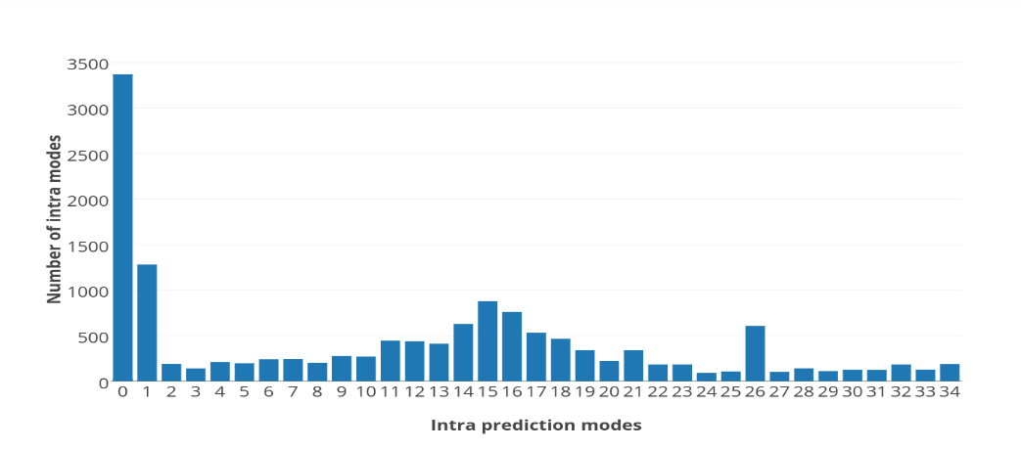
Fig. 1. Histogram of prediction modes in an I frame from an original video
From Fig. 1, it shows that the histogram has these patterns: the bar 0 and bar 1 have the higher frequency than others, and adjacent bars have a similar frequency. This phenomenon is mainly caused by the most probable modes (MPM) selection rule in HEVC. In the process of recursive mode decision, only three MPMs and several candidate modes are calculated. According to the selection rule, the first two MPMs are selected from upper and left neighboring PUs’ prediction modes. If either of them is not available, prediction mode 1 was selected as the MPM, and prediction mode 0 (Planar) is the most commonly used mode for the third MPM. During the embedding process, these patterns shouldn’t be broken.
  - Analysis of Dominant Distortion
In this section, dominant distortion caused by HEVC steganography will be analyzed to help building the SCM. When the prediction mode m₁ of one PU is modified to m₂. The original residual of this PU, denoted as RS_{o}, can be expressed as:
${RS}_{o}=P_{o}-{Pre}_{o}$ (2)
Where P_{o} denotes the original pixel value, and Pre_{o} denotes the prediction value calculated by original mode m₁.After obtaining the RS_{o}, the bits B_{O} used to encode this PU can be expressed as follows:
$B_{o}=Ent(RT(\frac{DCT\left({RS}_{o}\right)}{Q×QS}))$ (3)
Where DCT(.) denotes the integer discrete cosine transform, RT(.) denotes the rounding and truncating operations, Ent(.) denotes entropy coding, Q denotes the fixed quantization matrix, QS denotes the quantiser scale. At the decoding process, the reconstruction residual ${RS}_{o}^{r}$ can be calculated as:
${RS}_{o}^{r}=IDCT(IEnt(B_{o})×Q×QS)$ (4)
Where IDCT(.) denotes the inverse integer discrete cosine transform, IEnt(.) denotes the inverse entropy coding, and decoded pixel value $P_{o}^{r}$can be expressed as:
$P_{o}^{r}=FTR({RS}_{o}^{r}+{Pre}_{o})≈P_{o}$ (5)
Where FTR(.) denotes deblocking filter and Sample Adaptive Offset (SAO) operations. The prediction value in decoding process is same as it in encoding process, so the same symbol is used. After modifying the prediction modes to m₂, the modified residual RS_{md} of this PU can be expressed as:
${RS}_{md}=P_{o}-{Pre}_{md}$ (6)
Where Pre_{md} denotes the prediction value calculated by modified mode m₂. It shows that sum of modified prediction value and its residual is still equal to the true pixel value. So, after processing the modified residual value with same parameters as the original, following equation can be obtained:
$P_{md}^{r}=FTR({RS}_{md}^{r}+{Pre}_{md})≈P_{o}$ (7)
Where $P_{md}^{r}$ denotes the modified reconstruction value and ${RS}_{md}^{r}$ denotes the modified reconstruction residual. Thus, the conclusion can be drawn from equation (5) and (7) :
${{P_{md}^{r}≈P}_{o}≈P}_{o}^{r}$ (8)
From equation (8), it shows that visual quality of videos generated by this kind of steganography algorithms will not be affected significantly. From equation (3) and (4), conclusion can be drawn that difference among values in equation (8) is mainly caused by the choice of Q and QS. Thus, the degradation of visual quality will be mainly caused by the increment of QP, not increment of embedded bits.
However, according to the analysis in the above section, if the best mode is replaced with suboptimal one, coding efficiency will be reduced. From equation (1) and (3), if the corresponding RD cost of current PU is increased, which means RS_{md} is larger than RS_{o}, the length of B_{O} will be increased. Thus, the total coding efficiency will be reduced.
In summary, modifying the HEVC intra coding process will cause the problem of low coding efficiency, but the visual quality of generated video file won’t be affected significantly. The degradation of visual quality is mainly caused by the increment of QP, not increment of embedded bits. Thus, it is proposed that the distortion optimization method should be applied on coding efficiency instead of visual quality. These conclusions will be proven in the experiment section.
  - Definition of the Proposed SCM
A SCM can represent features for steganography in the same embedding domain. Different from Secret Channel Model and Cover Channel Model, SCM focuses on features and distortion caused by the generation process of the cover, and its influence on the performance of steganography. Based on different SCMs, capacity, security and perceptibility of different steganography algorithms can be analyzed. Through analysis results, SCM can also be utilized to further improve the performance of steganography and show the advantages and disadvantages of various steganography algorithms.
Based on the above analysis, a triple is defined to denote the proposed SCM:
$SCM=\{M_{PU}，H_{PU}，D_{c}\}$ (9)
Where $M_{PU}$ is the set of prediction modes of PU, which presents the cover in this model. $H_{PU}$ is the histogram of $M_{PU}$ and D_{c} is the distortion introduced by modifying $M_{PU}$. A mapping is built between the $M_{PU}$ and the secret data during the embedding process, and abnormality occurs in the $H_{PU}$, resulting in various degrees of D_{c} in video file.
According to the above modeling process, the dominant distortion in $D_{c}$ is coding efficiency reduction in the coding process. Steganography based on this SCM should design their algorithm based on the following equation:
$M_{PU}^{'}=\underset{M_{PU}}{argmin}{\{F_{sm}(H_{PU},H_{PU}^{'}),D_{c}\}}$ (10)
Where $M_{PU}^{'}$ denotes the modified cover, and the output of the function $F_{sm}$ should be inversely proportional to the similarity of the original histogram $H_{PU}$ and modified histogram $H_{PU}^{'}$.
- The Proposed HEVC Steganography
In this section, based on the above SCM, there are two problems need to be solved: one is how to reduce the distortion $D_{c}$ on coding efficiency; another is how to keep the histogram $H_{PU}$ similar to the original during the process of embedding secret message. In our algorithm, the first one is solved by proper cost assignment of STC. The second one is solved by specific PU extraction and selection rule. The framework of the proposed algorithm is showed in Fig. 2.
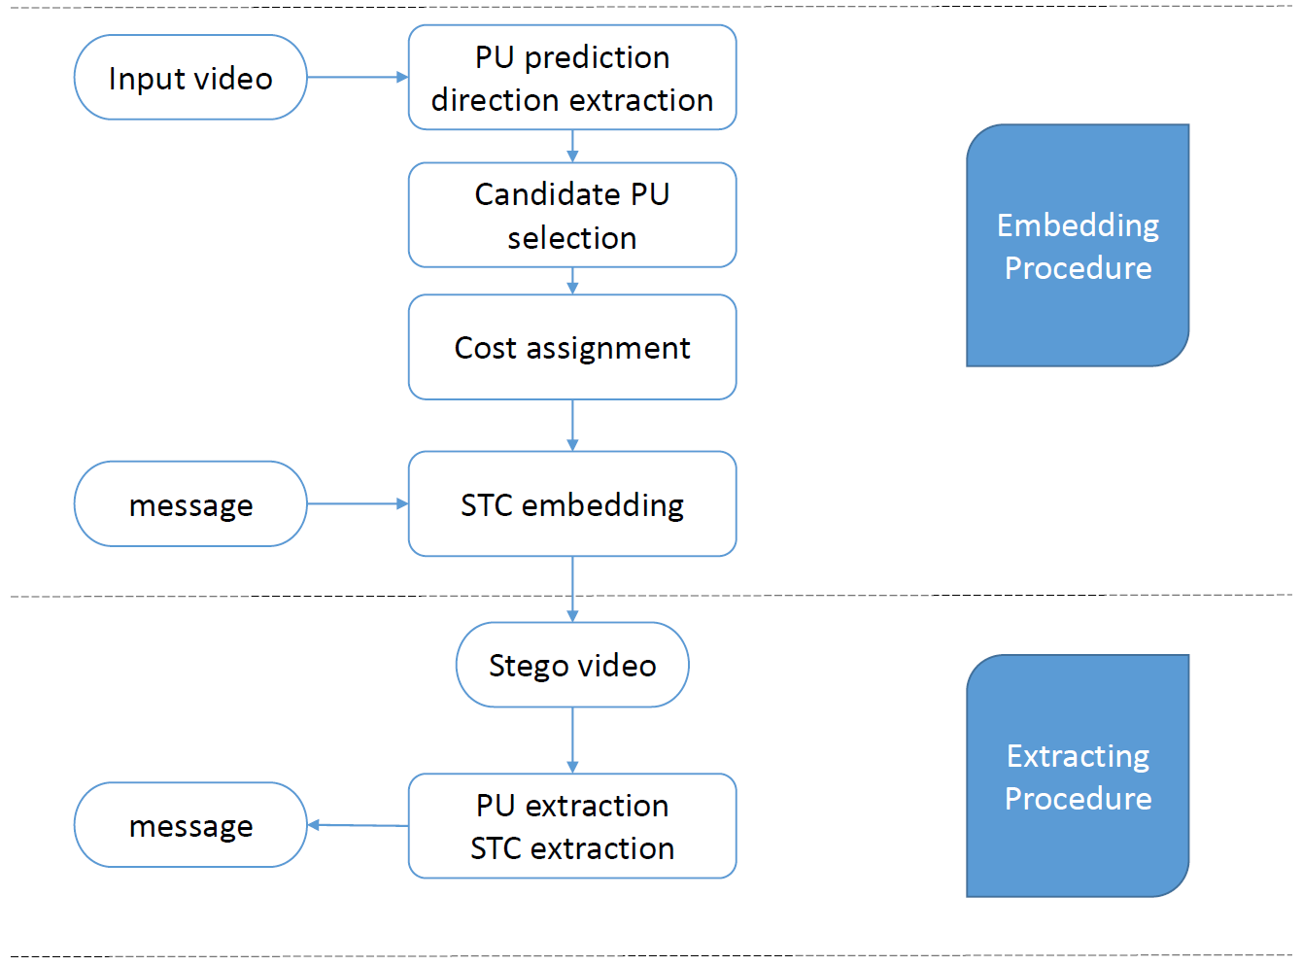
Fig. 2. Framework of the embedding algorithm and the extraction algorithm
  - PU Extraction and Selection Rule
According to the recursive procedure of block partition decision, large block partition tends to be applied to plain area, and small block partition tends to be applied to texture rich area. Moreover, when QP increases, the number of small blocks decreases. Texture rich areas are more suitable for steganography. For this reason, PUs with size of 4×4 are selected as cover in our algorithm.
Observing the 35 intra prediction directions used in HEVC, it can be noticed that unlike the prediction directions in AVC, modes of HEVC have a regular pattern. In HEVC, two number-adjacent directions have similar prediction direction. The common way to modify the intra prediction mode is to replace it with a mode that is similar in prediction direction. In this case, these modes are grouped as follows:
$\left\{\left(M_{i},M_{j}\right)\right| 2 \left| M_{i}=2 \right|{ M}_{j}, i,j∈(0,34)\}$ (11)
Where the $|$symbol means exact division,$M_{i}$ mean the current PU prediction mode has the i^{th} prediction direction. One element in the group denotes the bit 0, another denotes the bit 1. According to equation (11), the final grouping is {(0, 1), (2, 3)…}. However, this grouping method will change the histogram $H_{PU}$ significantly. The number of mode 1 will be close to mode 0 after embedding, which will indicate the existence of secret message. Thus, the first group (0, 1) is removed to keep the shape of histogram $H_{PU}$. Finally, all the qualified prediction modes of PUs in I frames with size of 4×4 are extracted, and taken as cover sequence.
  - STC and Cost Assignment Method
In order to reduce the influence on coding efficiency of the proposed algorithm. The STC method is utilized to embed the secret message into cover:
$Hx^{T}=m$ (12)
Where H denotes the parity check matrix generated by STC algorithm, m is the secret message and x is the modified cover sequence. Detail description and implement of STC can be found in [10].According to the PU selection rule, one prediction mode has one candidate mode that can replace it. Thus, this is a binary STC problem. After grouping these prediction modes, the following equation is used to map them into binary sequence:
${c_{i}= m}_{i} mod 2$ (13)
Where $c_{i}$ denotes the binary cover and $m_{i}$ denotes the original cover.
As mentioned in Section 2, the main distortion caused for this steganography is the reduction in coding efficiency. From equation (1), each RD cost is calculated through estimated bitrate and distortion of each PU. Thus, difference in RD cost can represent the coding efficiency reduction caused by changing the prediction mode of the current PU. The cost of changing one PU is defined as:
$φ_{i}=\left|J_{i}-J_{j}\right| , i,j is from the same group$ (14)
Where $φ_{i}$ is the cost of changing the i^{th} PU and$J_{i}$ is the RD cost of the prediction mode with the i^{th} prediction direction. The difference of RD cost between two prediction modes is used in the same group as the cost for changing one to another. The total distortion $D_{c}$is present as:
$D_{c}=\sum_{k=1}^{n}{φ_{k}}$ (15)
Where n presents the total number of all qualified PUs in the video file. Finally, the secret data can be embedded into a video with little distortion.
- Experiments and Analysis
  - Experiment Environment
The proposed steganography algorithm has been implemented in an open source software X265. HEVC is the state-of-art video codec standard, it is specially designed for high definition videos for higher coding efficiency. For this reason, twenty two YUV sequences (aspen, blue sky, controlled burn, crowd run, ducks take off, factory, in to tree, life, old town cross, park joy, pedestrian area, red kayak ,riverbed, rush field cuts, rush hour, snow mint, speed bag, station, sunflower, touchdown pass, tractor, west wind easy) with 1080P resolution are selected in this paper. However, not all of these sequences have the same frame numbers, which will lead to difficulty in analyzing the capacity and the perceptibility. Thus, all these sequences are further divided into small sequences with 100 frames each, and 112 subsequences are generated. In these experiments, pseudo random binary sequences are generated as secret data, and all QPs are tested using different payload rates α∈{0.25,0.5,0.75} to produce the stego sets. Finally, a total number of 17136 modified videos are generated. The detail of experiment environment in listed in Table 2.
Table 2. Environment of experiments.
Environment | Values
Encoder | X265 (ver 2.3)
Decoder | HM16
YUV sequences number | 112
Resolution of sequences | 1920×1080
Frames to be encoded | 100
GOP size | 10
GOP structure | IPPP…
QP range | {1,2,…,51}
Payload | {0.25,0.5,0.75}
Total sequences number | 112×51×3=17136
  - Comparison Experiment
In this section, the proposed steganography algorithm will be compared with another algorithm on a common dataset to illustrate the advantage of ours. As far as we know, Wang et al [9] have present several steganography algorithms based on intra prediction mode. Their latest work [9] is compared with our algorithm to illustrate our advantage in this section. The experiment set and the dataset is same as it in their work [9]. The frame number is 96, and intra period is set to 16. Comparison results in capacity, BIR and difference in PSNR is showed in Table 3.
In Table 3, the Bit Increase Ratio (BIR) is defined as:
$BIR=\frac{TB_{steg}-TB_{ori}}{TB_{ori}}×100\%$ (16)
Where TB_{steg} is the total bits of original video and TB_{ori} is the total bits of modified video. BIR is normalized with 1 Kbits to show the coding efficiency reduction, named as NCKR.
$NCKR=BIR/Capacity$ (17)
Table 3. Comparison results with other HEVC algorithm
Sequences | Algorithms | QP | Resolution | ΔPSNR(dB) | Capacity(bits) | BIR (%) | NCKR  (‰)
BQ Mall | Proposed | 22 | 832×480 | -0.02 | 30096 | 0.86 | 0.29
BQ Mall | [9] | 22 | 832×480 | -0.06 | 16182 | 1.58 | 0.98
Basketball Drill | Proposed | 22 | 832×480 | -0.02 | 37243 | 1.83 | 0.49
Basketball Drill | [9] | 22 | 832×480 | -0.06 | 11070 | 1.90 | 1.7
Video1 | Proposed | 22 | 1280×720 | -0.03 | 22171 | 1.67 | 0.75
Video1 | [9] | 22 | 1280×720 | -0.04 | 9534 | 0.76 | 0.80
Video3 | Proposed | 22 | 1280×720 | -0.01 | 23096 | 1.30 | 0.56
Video3 | [9] | 22 | 1280×720 | -0.01 | 8058 | 0.45 | 0.56
Video4 | Proposed | 22 | 1280×720 | -0.01 | 21698 | 0.98 | 0.45
Video4 | [9] | 22 | 1280×720 | -0.03 | 5502 | 0.46 | 0.84
From Table 3, it shows our algorithm outperforms the algorithm [9] in capacity, difference in PSNR and BIR. By setting the RD cost of candidate PUs to negative, the partition mode of CTU is flexible but the number of PUs with a certain size is preserved. The effectiveness of applying STC and the cost assignment method is well proven by BIR and difference in PSNR. Algorithm [9] designs a mapping rule between difference of intra directions and secret message. However, they do not consider the distortion and statistic character in the SCM of HEVC. With proper distortion prevention method, our algorithm can achieve higher capacity with lower bit increase ratio and difference in PSNR. PSNR is compared here because it is originally used in [9] to illustrate the perceptibility.
In Table 3, the NCKR is showed in percentage per 1 Kbits, presenting average BIR caused by embedding 1 Kbits. This index means the reduction degree of coding efficiency with certain embedding bits. Lower NCKR stands for better preserving coding efficiency. For video1, video3 and video4, named in [9], even if BIRs of algorithm [9] are lower, our algorithm has better NCKRs, which are 0.75, 0.56, and 0.45.
It can be observed that BIR 0.86%, 1.83%, 1.67%, 1.30% and 0.98% in Table 3 is higher than average BIR 0.43% using our 1080P dataset with QP22, which is present in Fig. 5. The reason is that the resolution of the dataset used in [9] is 832×480, which is smaller than that in our dataset. In Fig.5, QP22 is in the increasing area, meaning the decrement in file size is the main factor affecting BIR value. That’s the reason of higher BIR for 832×480 videos than 1920×1080 videos. Combining results in Tables 3 and Fig. 5, the conclusion is drawn that for QPs in range (1, 33), more bits can be embedded with lower BIR by using high resolution videos. If the QPs in range (34，51) are used, a lower resolution video is preferred in order to lower the suspicious rate.
  - Performance Experiments and Analysis
In this section, the conclusion that the dominant distortion in the proposed SCM is coding efficiency reduction will be proven. Experiments on PSNR, SSIM, BIR and capacity are designed to validate the SCM described in Section 2. Validation is done by analyzing the performance of our steganography algorithm.

Analysis on Perceptibility
In this section, video quality and perceptibility of the proposed algorithm are tested. As explained in Section 2, video quality of this kind of steganography algorithm will not be affected significantly. To prove this, SSIM between original video and modified video to demonstrate the perceptibility and visual quality of the proposed HEVC algorithm. PSNR is not used here because SSIM can present visual quality better. The results are showed in Fig. 3 and Fig. 4. For each point in Fig. 3, it is the average number of SSIM from 112 videos with same QP.
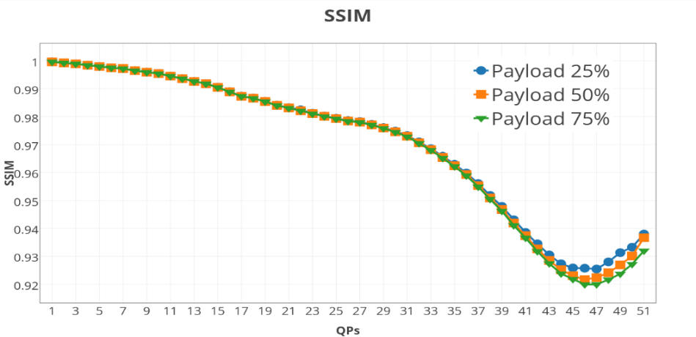
Fig. 3. SSIM of the proposed algorithm with different QPs
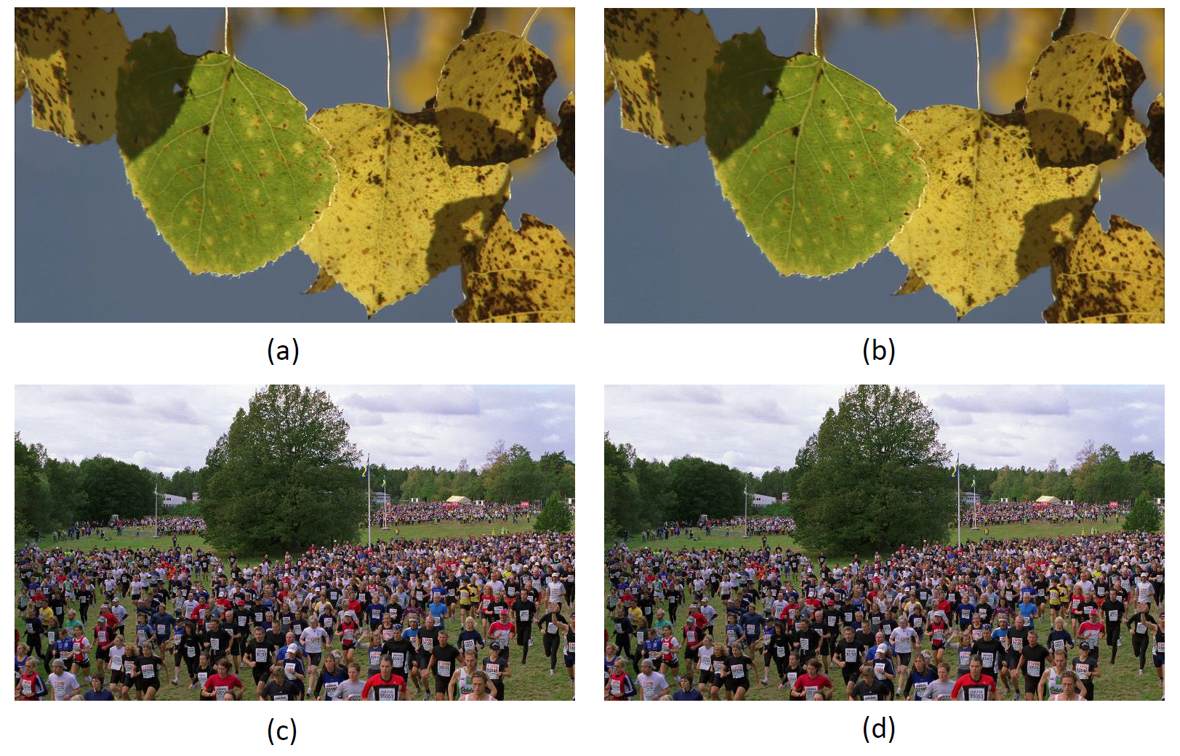
Fig. 4. Comparison between original I frames and modified I frames (a) the original I frame in aspen, QP=7 (b) the modified I frame in aspen, QP=7, payload=0.5(c) the original I frame in crowd_run, QP=7(d) the modified I frame in crowd_run, QP=7, payload=0.5
For many other steganography algorithms in other embedding channel, allocating higher embedding capacity often causes lower SSIMs. However, experiment shows that SSIMs of different embedding capacity are similar, the decreasing trend of SSIM is mainly caused by the incensement of QPs, not incensement of embedding bits. In addition, from Fig. 4, the distortion in visual quality cannot be distinguished by the human eye. These phenomena verify that the existence of secret bit will not affect the perceptibility significantly, and proves the analysis conclusion of distortion D_{c} in Section 2.
From these results, the overall SSIM value range from 0.919 to 1 and decreases with the increase of QP. QP20 to QP30 are the most commonly used coding parameters in a real application. SSIM values of these QPs are higher than 0.974, which indicates the excellent perceptibility of the proposed algorithm. There is an increasing trend in QP (46, 51) in SSIM. Combining the results in Fig. 5, the capacity decreases logarithmic with QPs. The reason for the increment of SSIM in (46, 51) is that fewer bits are embedded into videos, so the visual quality improves.

Analysis on Coding Efficiency
According to the proposed SCM, the main distortion is reduction in coding efficiency. In order to demonstrate the influence on coding efficiency of proposed algorithm and prove effective of applying STC method, BIR is calculated on the dataset. Fig. 5 shows the BIR of the proposed algorithm calculated on the dataset.
Unlike the results in Fig. 3, Fig. 5 shows that with the increment of BIR, higher payload leads to higher BIR. The conclusion can be drawn that more embedded bits lead to higher distortion in video file size, which prove the correctness of the analysis conclusions in Section 2, and the main distortion in this HEVC steganography channel is the reduction in coding efficiency.
The highest BIR achieve by our algorithm is 1.498% achieved by QP38. For the most commonly used QP20 to QP30, BIR is between 0.340% and 1.162%, which will barely cause suspicion in the real world. The optimal BIR value is achieved by smaller QP and there is a decreasing trend after QP larger than 38. The reason is that decreasing speed of capacity exceeds the decreasing speed of file size in large QPs.
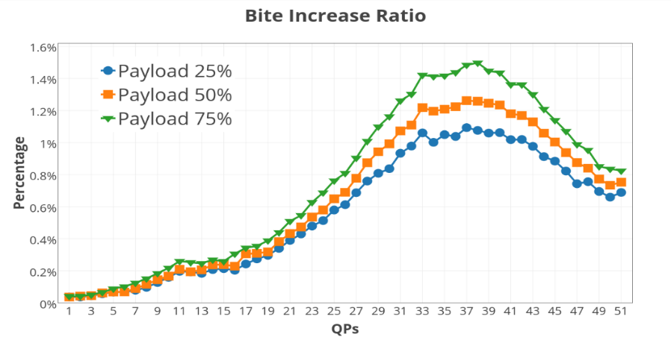
Fig. 5. BIR of the proposed algorithm with different QPs

Analysis on Capacity of the Proposed Algorithm
In this section, capacity of the proposed algorithm is analyzed. The upper bound of embedding capacity depends on the numbers of 4×4 PUs in I frames, which is two times of the capacity using payload 0.5. The results are show in Fig. 6 and Table 4.

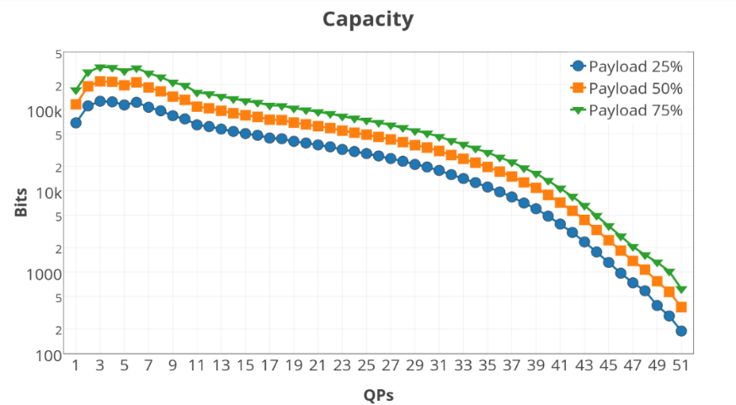
Fig. 6. Capacity of the proposed algorithm with different QPs
The vertical coordinate is logarithmic, which means the number of this kind of PU decrease logarithmically with increment of QPs. During the recursive mode decision process, RD cost is calculated by visual distortion and length of bit stream using equation (2). When QP increases, more reconstruction pixels will be calculated from same quantized value, which leads to a smaller RD cost for large partition mode. The sizes of PUs are exponential {4, 8, 16, 32}, meaning the larger size PUs exponentially merge the smaller size PUs during this process. This may be the reason for logarithmically decrement in capacity.
From Fig. 6 and Table 4, the higher capacity is achieved by the smaller QP, and the highest is 330k bits achieved by QP6, the lowest is 188 bits achieved by QP51. In QP range (1, 4), capacity is increasing. This is caused by PU selection rule because prediction directions 0 and 1 are not selected in this algorithm. For the most commonly used QP20, capacity is 102758 bits. Meanwhile, proposed algorithm provides good visual quality with 0.984 SSIM and 0.439% BIR.
Table 4. Capacity (bits) of the proposed algorithm with different QPs
QP | 1 | 2 | 3 | 4 | 5 | 6 | 7 | 8 | 9 | 10 | 11
25% | 68004 | 109830 | 125330 | 123222 | 112796 | 121649 | 105733 | 95587 | 83138 | 76070 | 64213
50% | 114869 | 191008 | 219795 | 216816 | 196813 | 213579 | 184621 | 165638 | 142703 | 130322 | 107408
75% | 172303 | 286513 | 329692 | 325223 | 295220 | 320369 | 276932 | 248457 | 214055 | 195483 | 161112
QP | 12 | 13 | 14 | 15 | 16 | 17 | 18 | 19 | 20 | 21 | 22
25% | 61230 | 57069 | 53339 | 50235 | 47839 | 44270 | 43432 | 40309 | 38465 | 36437 | 34521
50% | 102776 | 95610 | 89308 | 84228 | 80475 | 74368 | 73577 | 68505 | 65137 | 61836 | 58746
75% | 154164 | 143414 | 133962 | 126342 | 120712 | 111553 | 110365 | 102758 | 97706 | 92755 | 88119
QP | 23 | 24 | 25 | 26 | 27 | 28 | 29 | 30 | 31 | 32 | 33
25% | 32056 | 30236 | 28530 | 26665 | 24787 | 22952 | 20974 | 19534 | 17694 | 15726 | 14093
50% | 54527 | 51534 | 48733 | 45679 | 42532 | 39467 | 36138 | 33804 | 30702 | 27358 | 24613
75% | 81791 | 77301 | 73100 | 68518 | 63799 | 59200 | 54207 | 50706 | 46053 | 41037 | 36920
QP | 34 | 35 | 36 | 37 | 38 | 39 | 40 | 41 | 42 | 43 | 44
25% | 12566 | 11093 | 9663 | 8366 | 7042 | 5989 | 4866 | 3887 | 3063 | 2347 | 1767
50% | 22051 | 19560 | 17128 | 14930 | 12643 | 10832 | 8864 | 7133 | 5659 | 4374 | 3295
75% | 33076 | 29340 | 25693 | 22395 | 18964 | 16248 | 13297 | 10700 | 8489 | 6560 | 4942
QP | 45 | 46 | 47 | 48 | 49 | 50 | 51
25% | 1311 | 968 | 737 | 584 | 376 | 233 | 159
50% | 2466 | 1837 | 1370 | 1072 | 664 | 423 | 315
75% | 3699 | 2756 | 2056 | 1622 | 1140 | 611 | 437
In summary, our algorithm outperforms the existing HEVC intra prediction mode algorithm with higher capacity and better perceptibility. Results prove that the main distortion in the proposed channel model is the reduction in coding efficiency, not visual quality. Thus, the distortion prevention algorithm in this channel should be mainly designed to avoid the coding efficiency reduction. STC and cost assignment method are effective in preventing coding efficient reduction. High capacity can be achieved using small QPs. Some interesting phenomenon in the experiment results is discussed, which may be helpful to improving the performance of steganography algorithm and SCM of HEVC in the future.
- Conclusions
In this paper, a novel HEVC SCM is built. It is firstly proposed that the distortion optimization method in this SCM should be applied on coding efficiency instead of visual quality. According to this conclusion, a novel coding efficiency preserving steganography algorithm is proposed for HEVC videos. From the experiment results, the main distortion in the proposed channel model is proven to be the reduction in coding efficiency, not visual quality, and our algorithm outperforms the existing HEVC intra prediction mode algorithm with higher capacity and better perceptibility. Future work will be further investigated to the proposed channel model and adopt the algorithm to an adaptive algorithm or error propagation free algorithm.
Acknowledgement. This work was supported by the National Natural Science Foundation of China (No. 61572320, 61572321), and also supported by Zhejiang Provincial Natural Science Foundation of China (LY17F020013). Corresponding author is Xinghao Jiang, any comments should be addressed to xhjiang@sjtu.edu.cn.

References
- Aparna R, Ajish S. A Review on Data Hiding Techniques in Compressed Video[J]. International Journal of Computer Applications, 2016, 134(13): 1-4.
- Juneja M, Sandhu P S. Information hiding using improved lsb steganography and feature detection technique [J]. International Journal of Engineering and Advanced Technology (IJEAT) ISSN, 2013, 2(4): 2249-8958.
- Hu Y, Zhang C, Su Y. Information hiding based on intra prediction modes for H. 264/AVC[C]//Multimedia and Expo, 2007 IEEE International Conference on IEEE, 2007: 1231-1234.
- Yang, G., Li, J., He, Y.: An information hiding algorithm based on intra-prediction modes and matrix coding for H.264/AVC Video stream. International Journal of Electronics and Communications 65(4), 331-337 (2011)
- Bouchama S, Hamami L, Aliane H. H. 264/AVC data hiding based on intra prediction modes for real-time applications[C]//Proceedings of the World Congress on Engineering and Computer Science. 2012, 2200(1): 655-658.
- Zhang L, Zhao X. An Adaptive Video Steganography Based on Intra-prediction Mode and Cost Assignment[C]//International Workshop on Digital Watermarking. Springer, Cham, 2016: 518-532.
- Chang P C, Chung K L, Chen J J, et al. A DCT/DST-based error propagation-free data hiding algorithm for HEVC intra-coded frames[J]. Journal of Visual Communication and Image Representation, 2014, 25(2): 239-253.
- Tew Y, Wong K S. Information hiding in HEVC standard using adaptive coding block size decision[C]// IEEE International Conference on Image Processing. IEEE, 2015:5502-5506.
- Sheng Q, Wang R, Pei A, B Wang. An Information Hiding Algorithm for HEVC Based on Differences of Intra Prediction Modes[J]. Guangdianzi Jiguang/journal of Optoelectronics Laser, 2016, 25(8):1578-1585.
- Filler T, Judas J, Fridrich J. Minimizing additive distortion in steganography using syndrome-trellis codes[J]. IEEE Transactions on Information Forensics and Security, 2011, 6(3): 920-935.

