External Gravity Cosmology (EGC)

Tom Young

Contents
- Abstract 2
- Significant Observational Anomalies in current theories 3
  - The Big Bang Theory: Observational Challenges . . . . . . . . . . . . . 3
  - The Cosmological Principle: Evidence Against Large-Scale Isotropy . . . 4
  - Redshift and Hubble’s Law: Discrete Redshifts and Association Anomalies 5
  - The Hubble Constant: The “Hubble Tension” . . . . . . . . . . . . . . . 6
  - Cosmic Microwave Background Radiation (CMBR): Large-Scale Anomalies 7
  - Limitations of Standard Cosmological Constructs: Dark Energy and Cos-
mic Inflation . . . . . . . . . . . . . . . . . . . . . . . . . . . . . . . . . . 8
- External Gravity Cosmology (EGC) 9
  - Reframing the Cosmic Landscape 10
  - Gravitational Wells and Asymmetric Expansion 11
  - A Universe Without Dark Energy 12
  - Reinterpreting Redshift and the CMB 13
- Conclusion and Discussion 14

- ∗tom@young01.xyz

Abstract
This article proposes a revised cosmological model, “External Gravity Cosmology” (EGC), rooted in gravitational dynamics within an, effectively, for our purpose, infinite universe, one that replaces the need for dark energy, inflation, Big Bang singularity, addresses Cosmic Microwave Background (CMB), Redshift, homogeneous and isotropic discrepancies. In this model, our observable universe (OU) is a finite, dynamic patch embedded within an unbounded and irregular gravitational landscape, which we shall call, “The Universe” (TU). Rather than arising from a primordial explosion, the expansion and structure of OU are understood as responses to external gravitational forces exerted by mass and unseen structures beyond Our Universal Event Horizon (OUEH) like gravitational wells. The model draws critical support from recent observational anomalies that challenge the standard framework of Lambda Cold Dark Matter (ΛCDM) model. This includes early galaxy formation and oversized black holes revealed by the James Webb Space Telescope (JWST), as well as statistically significant anisotropies in quasar distributions inconsistent with isotropy [1]. Such findings suggest that the Cosmological Principle, long assumed to undergird cosmological model is violated at scales larger than our observable horizon. Central to this new interpretation is the concept of gravitational well, or mass concentrations distributed unevenly across TU, as well as the general pull of the Effectively Infinite Universe (EIU). OU is visualized as a distorted “lump” seated on the slope or rim of a, or several, gravitational wells. These wells, analogous to topographical depressions on a cosmic map, generate a net outward pull on matter in OU, inducing differential redshift and anisotropic expansion. Unlike the uniform radial expansion predicted by Hubble’s Law, this model anticipates an uneven, oblong, directionally biased expansion, a signature that can be detected and mapped using variations in both redshift and the CMB.
In this framework, the CMB is not a relic of a Big Bang but rather a composite
field of ancient, redshifted radiation from countless sources across the infinite cosmos. The observed smoothness of the CMB becomes analogous to looking into a dense forest where every line of sight yields a uniform wall of tree trunks. However, subtle variations in this “radiative forest” contain signatures of the deeper gravitational terrain beyond OUEH. By correlating these with redshift fluctuations, the external structure of TU can be inferred, effectively allowing us to map the gravitational contours beyond our horizon. This gravity-driven model emphasizes the role of well-established physics, namely, general relativity and gravitational clumping, over speculative entities like dark energy. It allows for cosmic structures to emerge through gravitational self-organization over indefinite time spans, without requiring a primordial “bang” or a finely tuned inflationary phase. Possibly Hawking radiation and black hole evaporation are also incorporated, offering pathways for light element production and entropy cycling across cosmic epochs. In sum, this alternative paradigm positions gravity as the sole architect of cosmic expansion and structure, situates our life supporting universe within a local gravity well, and explains large-scale anisotropies as observational signatures of deeper, unseen mass distributions. It invites a re-evaluation of our cosmological assumptions and offers a testable roadmap through gravitational and radiative mapping beyond the visible cosmos.

Significant Observational Anomalies in Current Theories
The exploration of our universe has always been of great interest in the history of mankind, and traces can be found from thousands of years ago. We invite the reader to momentarily set aside established cosmological doctrines, such as the Big Bang, cosmic inflation, dark energy, the cosmological principle, the prescribed source of CMB, the Hubble constant, and Red shift data, and approach the universe with a fresh perspective. Throughout history, human understanding of gravity has evolved through paradigm shifts: from Aristotle’s notion of natural motion to Newton’s law of universal gravitation, and later to Einstein’s general relativity. Each transition marked a profound departure from accepted truth. It is in this spirit of open inquiry that we reconsider gravity’s role in shaping a boundless, dynamic cosmos. This section is devoted to briefly reviewing significant observational anomalies in current theories.

The Big Bang Theory: Observational Challenges
Recent observations from the JWST have significantly challenged prevailing assumptions about the early universe’s structure formation and timeline. For instance, galaxies such as CEERS-93316, observed just 300 million years after the Big Bang, exhibit properties, such as high stellar mass, compact morphology, and elevated star formation rates, that more closely resemble mature systems than the primitive structures predicted by the ΛCDM model [2]. According to this framework, early galaxy formation is expected to proceed hierarchically, beginning with small halos that merge over time to form larger structures. Adding further tension are the detections of supermassive black holes (SMBHs) in quasars
at redshifts z > 6, with inferred masses on the order of 10⁹M⊙ (solar mass). Their existence so soon after the Big Bang requires growth rates that exceed standard Eddington-limited accretion models, unless one invokes exotic seeding mechanisms or finely tuned initial conditions [3]. These findings have reignited interest in alternatives, such as direct- collapse black holes, modified dark matter models, or even revisions to the early expansion history of the universe. Together, these anomalies suggest that the ΛCDM paradigm may not fully capture the complexity or pace of early cosmic evolution. As JWST continues to uncover unexpectedly evolved systems at high redshift, the pressure to revise our theoretical frameworks will likely intensify.

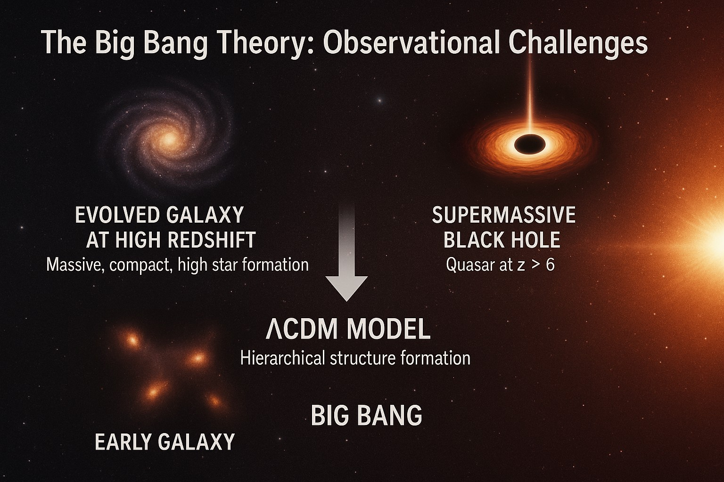
Figure 1: Observational challenges to the standard ΛCDM cosmology. The model predicts hierarchical and gradual structure formation beginning after the Big Bang. JWST has observed both evolved, massive galaxies and SMBH suggesting complex structures appeared much earlier than expected. These findings challenge key assumptions of early- universe evolution in the standard models.

The Cosmological Principle: Evidence Against Large-Scale Isotropy
The cosmological principle, which posits homogeneity and isotropy on large scales, is a foundational assumption in standard cosmology. However, several high-precision observations now call this assumption into question. A notable study by Secrest et al. [1], analyzing over 1.3 million quasars from the CatWISE2020 catalog, revealed a dipole anisotropy in their sky distribution that exceeded the expected amplitude from our motion relative to the CMB by more than a factor of two. The reported p-value of 5 × 10⁻⁷ strongly suggest this anisotropy is not due to random fluctuation or local motion alone. Supporting evidence comes from large-scale anomalies in the CMB. The so-called “Axis of Evil,” a statistically improbable alignment of the quadrupole and octopole moments in the CMB temperature map, was first identified by Wilkinson Microwave Anisotropy Probe (WMAP) and later confirmed by Planck [4]. Moreover, the Planck Collaboration reported a hemispherical power asymmetry, where one half of the sky exhibits systematically stronger temperature fluctuations than the other [5]. These features persist across various frequency bands and data-cleaning methods, ruling out instrumental or foreground contamination as likely causes. These persistent anisotropies suggest that the observable universe may lie within a region influenced by large-scale external gravitational mass. If confirmed, they would compel a revision of standard cosmological assumptions

and potentially validate models that allow for large-scale anisotropy beyond our horizon.
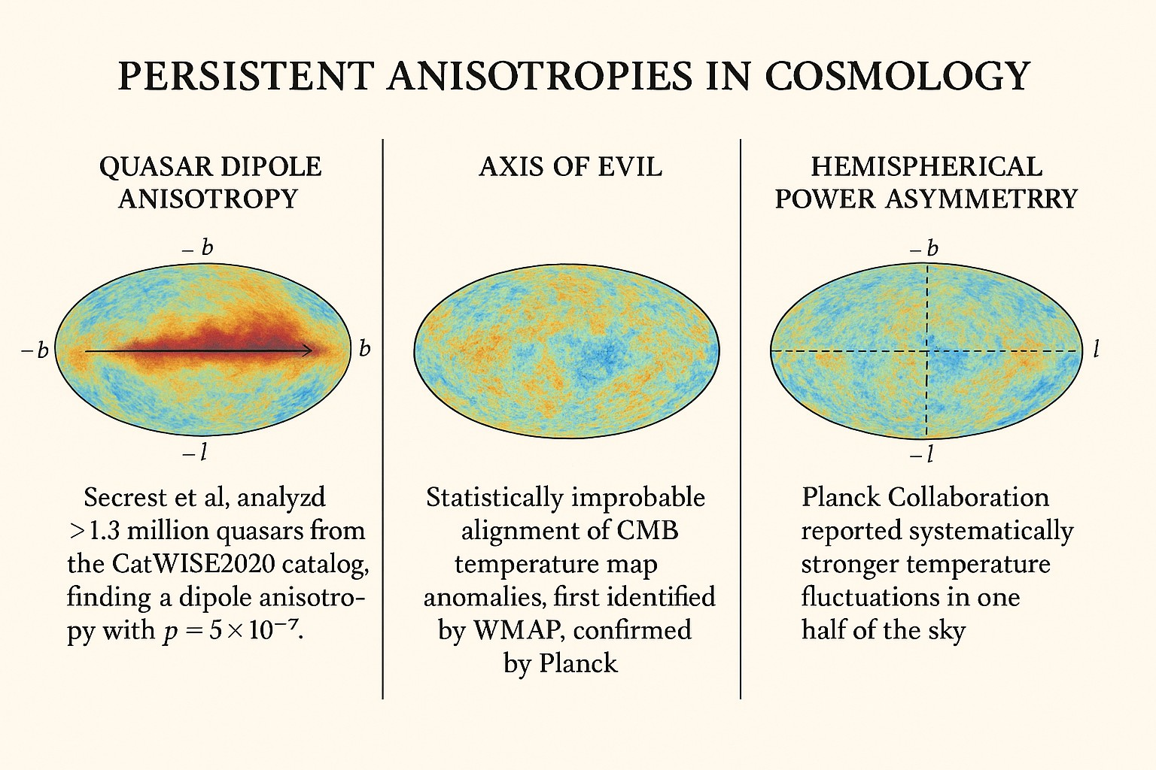
Figure 2: Three major persistent large-scale anisotropies in observational cosmology are features that appear to break the cosmological principle, which assumes the universe is statistically homogeneous and isotropic at large scales. Each panel highlights a different anomaly, suggesting possible cracks in the standard models.

Redshift and Hubble’s Law: Discrete Redshifts and Association Anomalies

The cosmological redshift, interpreted as a measure of the universe’s expansion, is a cornerstone of modern cosmology. However, recent observations have revealed anomalies that challenge this interpretation. Studies have reported instances where high-redshift quasars appear in close proximity to low-redshift galaxies, suggesting potential physical associations that contradict the expected cosmological distances inferred from redshift measurements [6]. The analysis of quasar redshift distributions has identified patterns indicative of redshift quantization. These findings imply that redshifts may occur in discrete intervals rather than a continuous spectrum, challenging the traditional view of a uniformly expanding universe [6]. Such quantization could point to intrinsic properties of quasars or alternative mechanisms influencing redshift. The investigations into galaxy rotation have uncovered a redshift bias correlated with the rotational direction relative to the Milky Way. Galaxies rotating in the same direction as the Milky Way exhibit higher mean redshifts compared to those rotating oppositely, with the disparity increasing at higher redshifts. This observation suggests that factors beyond cosmic expansion, such as local dynamics or intrinsic properties, may influence redshift measurements [7]. These

anomalies highlight the need for a re-evaluation of redshift interpretations and suggest that the standard cosmological model may require modifications to accommodate these findings.
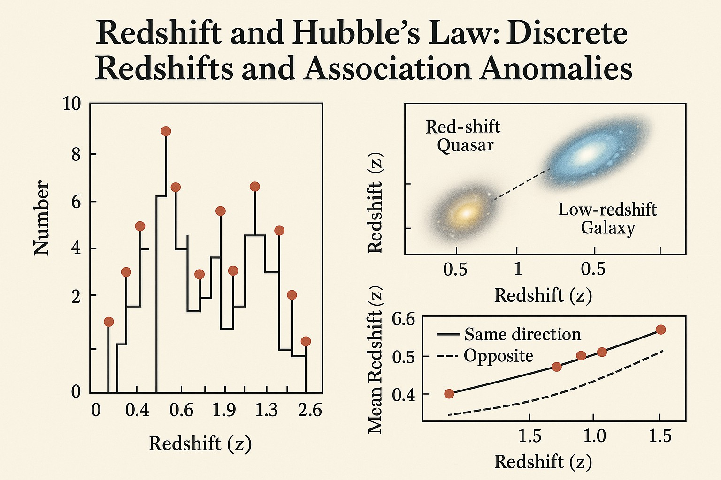
Figure 3: Anomalies in redshift observations that challenge standard cosmology. The left panel shows discrete redshift peaks, suggesting redshifts may not be continuous. The top-right panel depicts quasars and low-redshift galaxies appearing physically associated, despite differing redshifts. The bottom-right panel shows a directional dependence in redshift, hinting at possible cosmic anisotropy. Together, these patterns question the assumption that redshift solely reflects universal expansion.

The Hubble Constant: The “Hubble Tension”

The “Hubble tension”, a growing discrepancy between early and late universe measurements of the Hubble constant (H₀) has become one of the most persistent challenges in modern cosmology. While previous missions like Planck established a precise value of H₀ from the CMB, recent high-resolution observations by JWST have reinforced the higher local estimates, deepening the conflict. The lensed supernova SN H0pe provided an independent constraint on H₀, yielding a value of 75.4 km/s/Mpc [8]. This technique, based on time delays between multiple gravitationally lensed images, avoids some of the calibration issues. Complementary JWST studies have confirmed that local crowding or blending does not account for previous overestimations of Cepheid luminosities, rejecting such systematics at > 8σ significance [9]. The persistence of this tension across methods and instruments has prompted exploration of new physics. Proposed solutions include early dark energy models, evolving gravitational constants, or novel interactions

in the neutrino sector. As more lensed supernovae are discovered and JWST continues to probe the high-redshift universe, it may help illuminate whether this tension reflects observational bias or a fundamental flaw in the standard cosmological model.
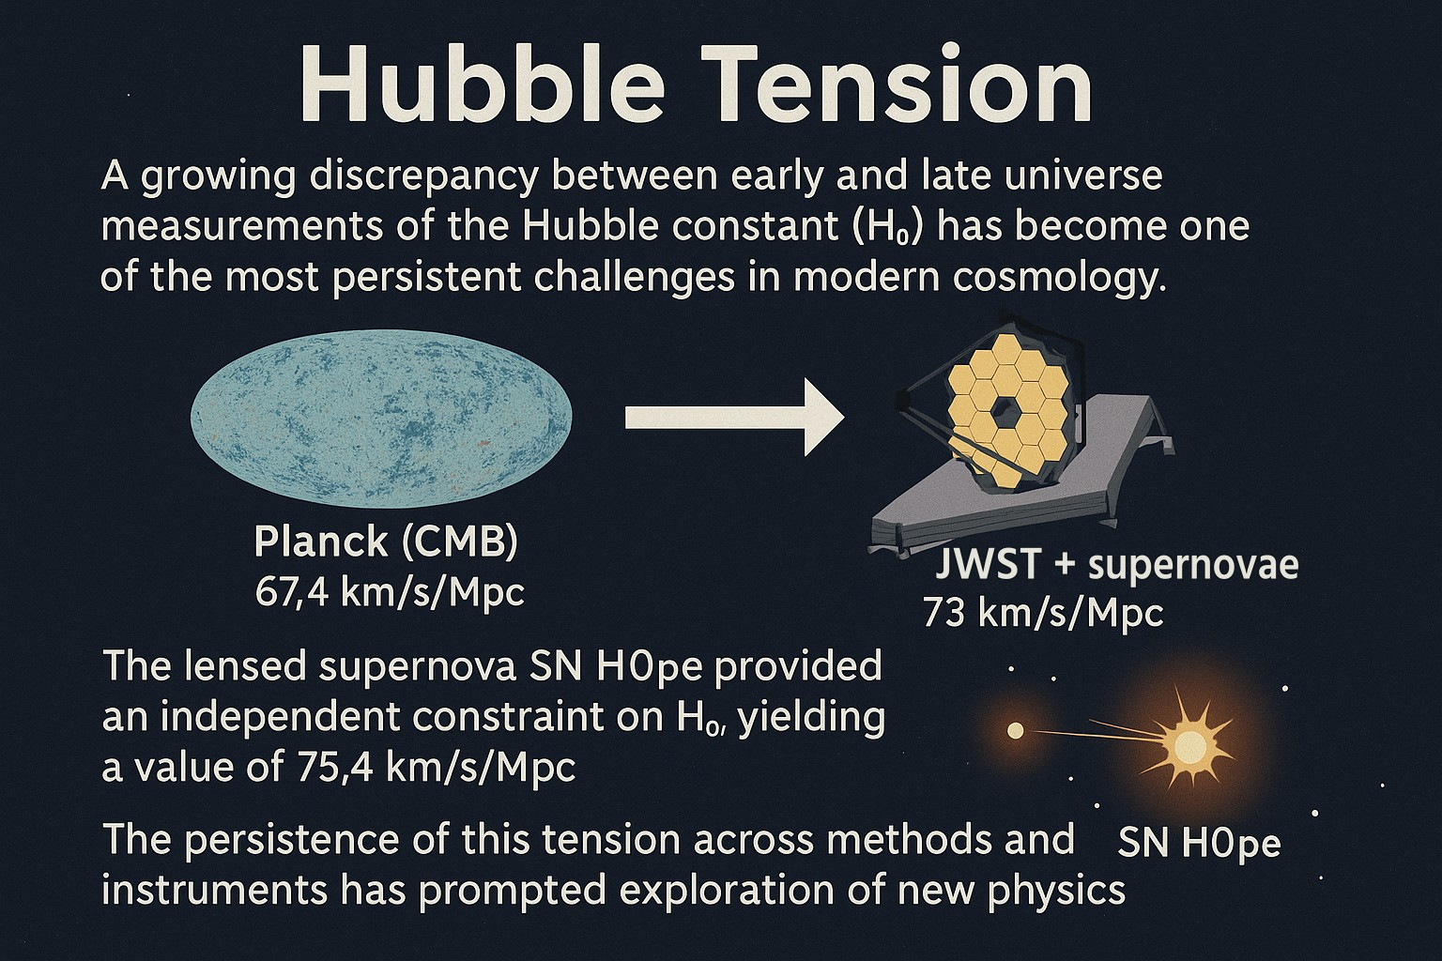
Figure 4: The Hubble tension refers to the growing discrepancy between early and late universe measurements of the Hubble constant (H₀). Planck’s observations of the CMB yield H₀ = 67.4 km/s/Mpc, while late time measurements using JWST and other local distance ladder methods suggest H₀ ≈ 73 km/s/Mpc. The lensed supernova SN H0pe provides an independent value of H₀ = 75.4 km/s/Mpc. The consistency of this tension across instruments and methodologies has led to growing interest in potential extensions or modifications to the standard ΛCDM cosmological model.

Cosmic Microwave Background Radiation (CMBR): Large- Scale Anomalies

Beyond supporting expansion models, the CMBR also encodes subtle features that challenge the assumption of statistical isotropy. Among these, the “Axis of Evil”, a large- scale alignment of low multipole moments and the hemispherical power asymmetry has remained persistent across WMAP and Planck data. Recent analyses using Planck’s PR4 release have reaffirmed the statistical robustness of these anomalies, ruling out foreground contamination and local structure effects such as the Sunyaev-Zeldovich (SZ) contribution from the Virgo cluster [10]. These anomalies now appear intrinsic to the CMB signal itself, undermining the assumption of randomness on large angular scales. Efforts to explain these observations include models with primordial anisotropies, non-trivial cosmic topology, and alternatives to inflation that allow for directional dependence in the initial conditions. Ongoing studies are investigating whether correlations between CMB anomalies and the large-scale distribution of galaxies or cosmic voids might reveal deeper structures beyond the observable horizon. As precision cosmology enters a new era, the combined challenge of the Hubble tension and CMB anomalies may signal a paradigm shift—where gravity, early-universe physics, or even the geometric structure of spacetime requires re-examination.
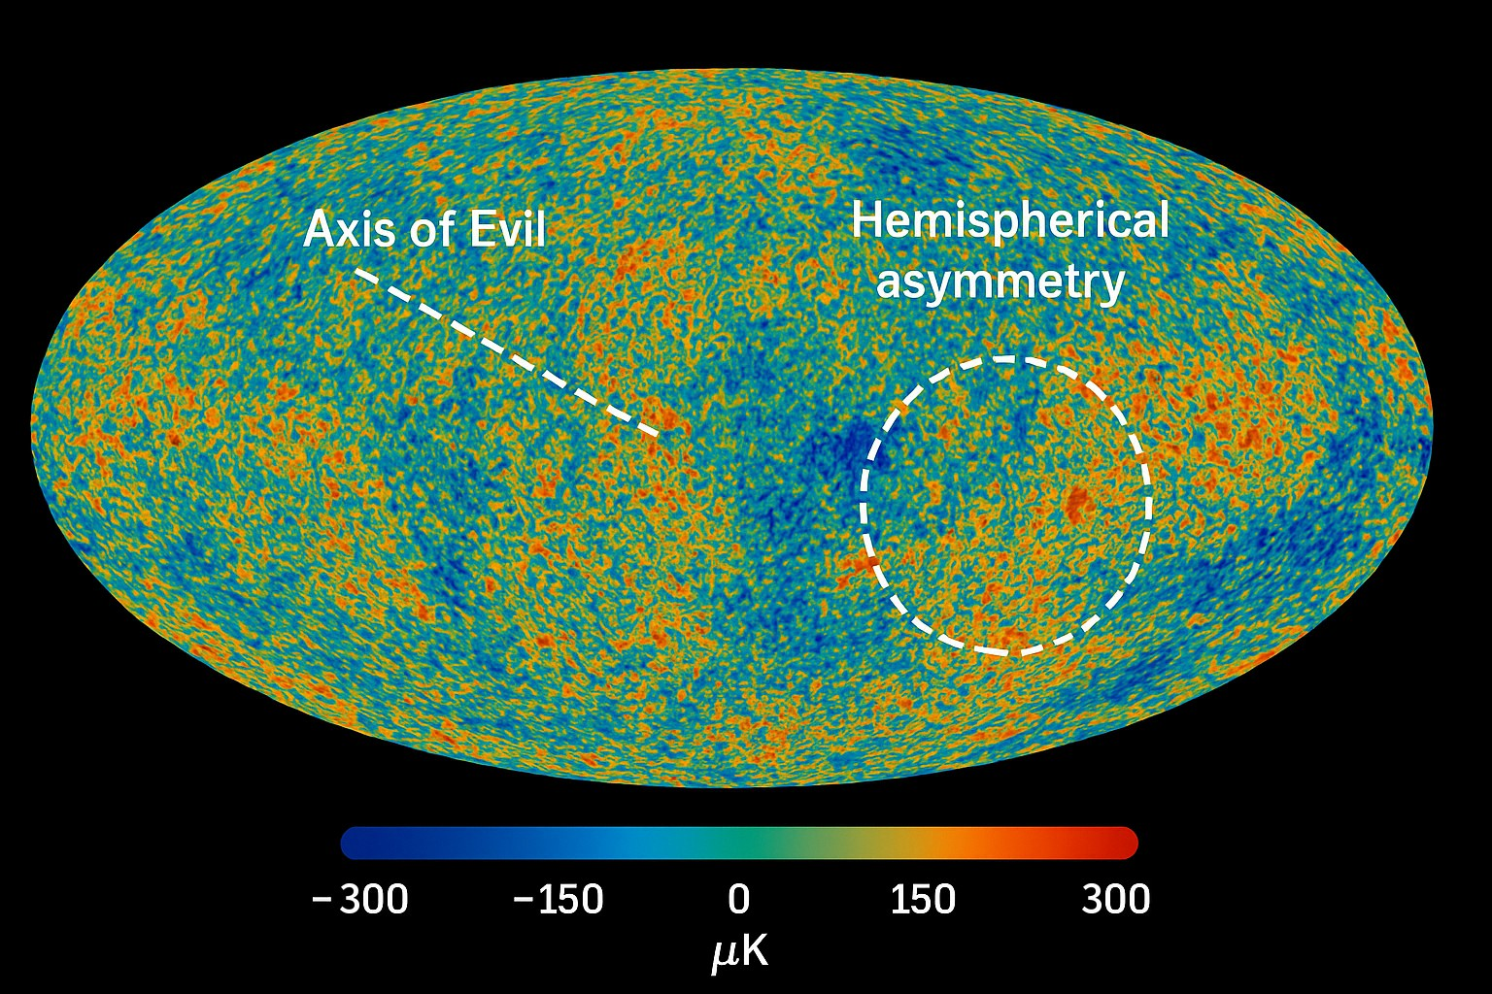
Figure 5: This figure shows a full-sky map of the CMB temperature fluctuations, high- lighting two prominent large-scale anomalies that challenge the assumptions of isotropy in standard cosmology.

Limitations of Standard Cosmological Constructs: Dark Energy and Cosmic Inflation

The standard ΛCDM model explains the universe’s structure and evolution by invoking two key constructs: cosmic inflation and dark energy. While these concepts have been instrumental in reconciling certain observations, they remain theoretical placeholders lacking direct empirical evidence. Recent data and theoretical scrutiny have intensified challenges to their foundational validity.

Dark Energy: Conceptual and Observational Challenges
Dark energy, introduced to explain the observed acceleration of cosmic expansion, is commonly modeled as a cosmological constant (Λ). However, the physical origin, energy scale, and nature of this component remain unknown. More critically, results from the Dark Energy Survey (DES) and the Dark Energy Spectroscopic Instrument

(DESI) hint that dark energy may not be constant over cosmic time, showing signs of evolution inconsistent with Λ [11]. This has led to increasing interest in dynamic dark energy models and modified gravity theories. In parallel, some cosmologists argue that the observed acceleration might be an apparent effect arising from cosmic inhomogeneities. The “timescape cosmology” proposed by Wiltshire [12] suggests that gravitational energy differences between voids and galaxy clusters could cause a misinterpretation of time flow, negating the need for dark energy altogether. Moreover, the fine-tuning problem, why the cosmological constant is 120 orders of magnitude smaller than predicted by quantum field theory remains one of the most serious unresolved issues in theoretical physics, often cited as a “crisis” in cosmology.

Cosmic Inflation: Fine-Tuning, Empirical Limits, and Alternatives
Inflation was introduced to resolve several initial condition problems in Big Bang cosmology, including the flatness, horizon, and monopole problems. However, the theory is not without its conceptual drawbacks. It relies on an unverified scalar field, the inflation with finely tuned potential parameters to produce the correct inflationary dynamics and exit mechanism. While inflation explains the near scale invariance of primordial density fluctuations, it is increasingly viewed as an overly flexible paradigm, capable of fitting almost any observational outcome without clear predictive power. Recent analyses by Ijjas, Steinhardt, and Loeb [13, 14] argue that inflation is not just conceptually ad-hoc but also fails to meet its original explanatory goals, leading to a multiverse scenario where anything can happen and thus nothing is falsifiable. Alternative approaches are gaining attention. These include bouncing cosmologies, emergent models with pre-inflationary quantum gravity phases, and non-local gravity theories. Some quantum gravity scenarios also eliminate the need for inflation entirely by embedding cosmic isotropy in the initial quantum state.

Toward a Revised Cosmological Framework
The reliance on poorly understood placeholders like dark energy and inflation indicates that the ΛCDM model may be a phenomenological approximation rather than a fundamental theory. As observational tools improve particularly with data from JWST, DESI, and CMB-S4, a growing body of evidence may soon favor models grounded in gravitational anisotropy, spatial inhomogeneities, or new physical laws. These developments justify a serious re-examination of standard cosmology and strengthen the case for alternative frameworks, such as the possibly infinite, gravity-driven universe proposed in this work.

External Gravity Cosmology (EGC)
The standard ΛCDM model explained that the universe is homogeneous and isotropic on large scales and that it originated from a singularity, a primordial state of infinite density and temperature commonly referred to as the Big Bang. While this model has demonstrated considerable success in describing the broad strokes of cosmic evolution, such as nucleosynthesis, large-scale structure formation, and CMB, a number of persistent anomalies increasingly challenge its sufficiency. There are apparent directional asymmetries observed in the CMB, a statistically significant dipole in the distribution of distant quasars, unresolved tension in measurements of the Hubble constant (H₀), and the discovery of massive, evolved galaxies within a few hundred million years of the supposed beginning of time.
EGC is proposed as a conceptually simpler and observationally motivated alternative that eliminates the need for inflation, dark energy, and an initial singularity. Instead of assuming that the expansion and structure within OU are internally driven or seeded by quantum fluctuations during an inflationary epoch, EGC posits that these are the result of gravitational influences exerted by mass and structures beyond OUEH. These masses and structures reside in a much larger and gravitationally active cosmos, called TU, which is not bounded in size nor homogeneous or isotropic.
In this framework, OU is interpreted as a dynamically evolving region, shaped by the gravitational topology of TU. The anisotropies observed in redshift data and the CMB are reinterpreted not as relics of a uniform early phase, but as signatures of directional gravitational gradients imposed by external mass distributions. Thus, the EGC model reframes cosmic acceleration, temperature fluctuations, and structural alignment as emergent phenomena caused by real-time gravitational interactions across event horizon boundaries.
This section introduces the foundational concepts of EGC, traces its motivation through recent astronomical data, and presents its capacity to address long-standing anomalies using classical gravitational physics without resorting to unverifiable or ad-hoc cosmological components.

Reframing the Cosmic Landscape
EGC reconceptualizes the role of gravitation in shaping cosmic structure by situating OU within a broader and physically active environment. Rather than assuming cosmic uniformity and internal causality. EGC suggests that the evolution of OU is deeply influenced by external gravitational fields originating from masses beyond OUEH.
In this framework, expansion is not viewed as a passive continuation of primordial conditions, but as an active, directional response to gravitational gradients exerted across horizon boundaries. These gradients arise from the mass-energy distribution in TU, which clearly neither isotropic nor homogeneous. OU, therefore, is not a uniquely privileged region, but one of a vast collage of dynamically evolving patches shaped by its position within this larger gravitational topology.
By grounding cosmic evolution in known gravitational principles rather than hypothetical inflationary epochs or dark energy fields, EGC offers a continuous, interaction-based model. The anisotropies observed in redshift distributions and the CMB are understood not as relic imprints, but as real-time manifestations of external masses. This perspective opens the door to directional cosmology, where expansion, temperature variation, and structural alignment can be traced to specific spatial influences beyond our observational reach.
EGC thus reframes the universe as an open gravitational system, where information is encoded not only in matter and light within OU, but also in the shape and pull of space itself. This approach provides a coherent physical basis for observed anomalies, while setting stage for a deeper empirical exploration of what lies beyond OUEH.

Gravitational Wells and Asymmetric Expansion
A foundational claim of EGC is that the expansion dynamics and structural evolution of OU are not solely determined by internal properties or primordial conditions, but are actively shaped by gravitational influences from beyond OUEH. These influences arise from masses and unobservable structures embedded within the larger, anisotropic fabric of TU. The resulting gravitational wells distort the local curvature of spacetime within OU, inducing direction-dependent expansion patterns.
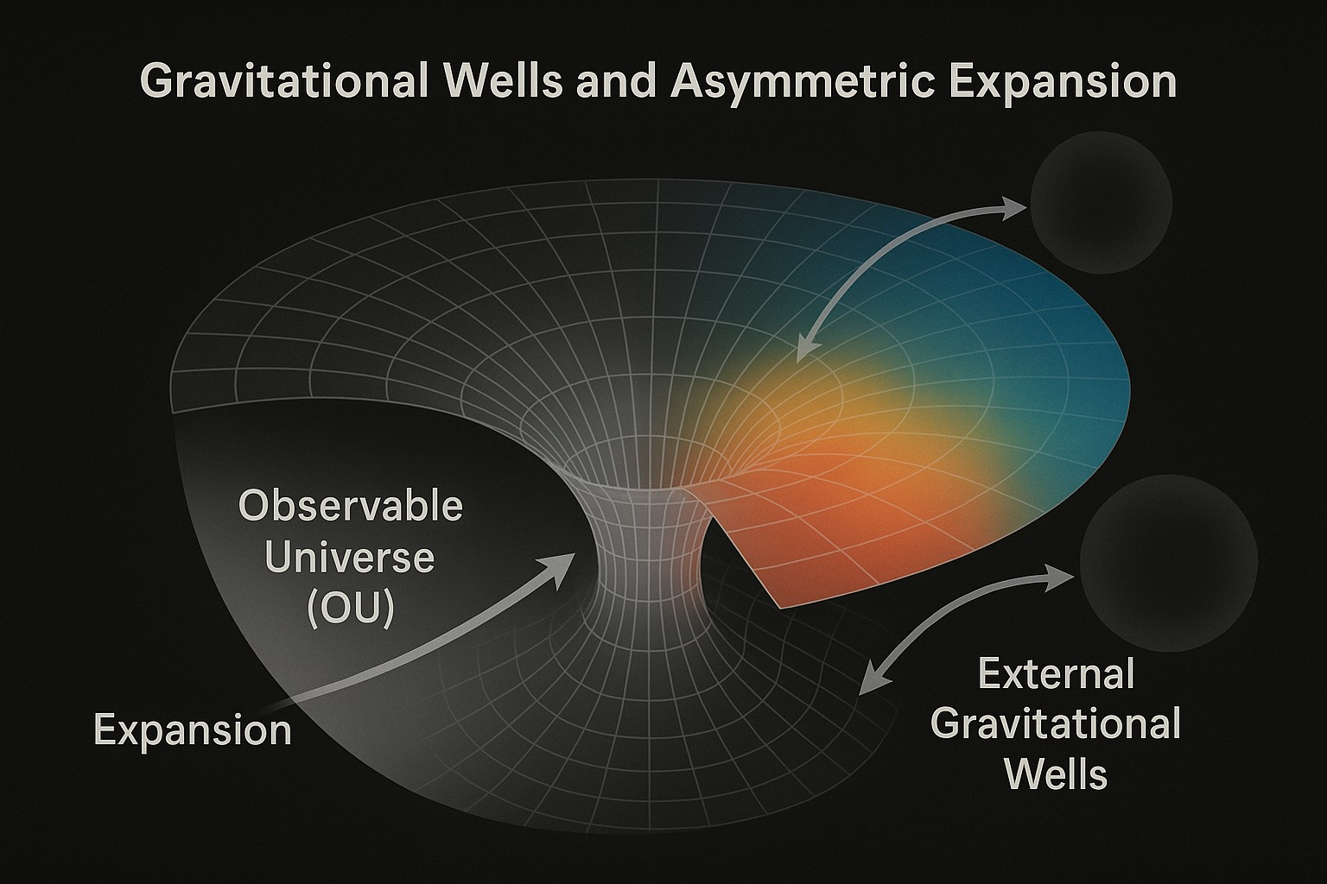
Figure 6: This figure visualizes how external, unobservable mass distributions could generate anisotropic curvature, potentially explaining observed asymmetries in cosmic expansion. It’s a theoretical framework meant to extend the standard model of cosmology by incorporating gravitational influence from beyond the observable universe.

Whereas the ΛCDM model assumes statistically isotropic expansion, driven by uniform initial conditions and dark energy, EGC predicts measurable deviations from isotropy at cosmic scales. External gravitational gradients, generated by mass asymmetries in TU, create anisotropic forces that manifest observationally as directional redshift patterns, galaxy distribution imbalances, and temperature anomalies in the CMB. These are interpreted not as residual traces of inflation but as real-time curvature effects arising from beyond OUEH.
Empirical evidence for such anisotropic expansion is growing. Secrest et al. [1] analyzed the angular distribution of over a million mid-infrared-selected quasars and detected a statistically significant dipole anisotropy exceeding the expected signal from our motion relative to the CMB by more than a factor of two. Their results suggest that an external gravitational origin may be responsible for this large-scale directional signal. Similarly, von Hausegger and Sarkar [19] reported consistent anisotropic alignments in various cosmological datasets, indicating a potential large-scale lopsidedness in the structure of the universe. Mapping local universe’s gravitational basins of attraction, researchers showed how large-scale mass concentrations affect galactic motion, even within limited observational bounds. These insights imply that similar, yet more distant masses beyond OUEH could exert significant gravitational pull on OU, warping its expansion field in ways observable through redshift gradients and CMB dipoles [20].
In the EGC framework, these directional features are not anomalies but anticipated outcomes. They represent gravitational imprints from the deeper geometry of TU, offering a coherent, testable mechanism for many cosmological asymmetries that remain unresolved within isotropic models.

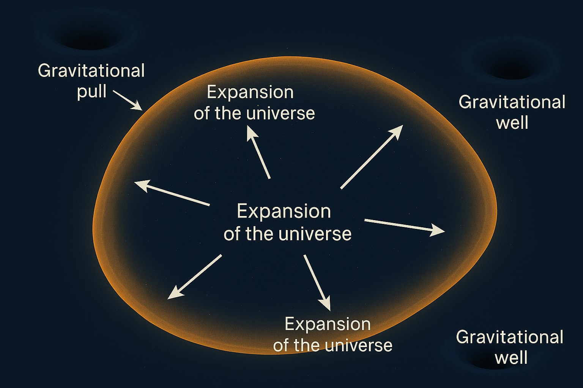
Figure 7: Conceptual illustration of the potential influence of external gravitational wells on the observable universe. The central region represents the expanding universe, where arrows indicate the isotropic expansion predicted by standard cosmology. The boundary is shown as asymmetrically shaped, suggesting that gravitational wells outside the observable horizon may exert anisotropic forces. These external masses, though directly unobservable by us from here, could distort the geometry of space and influence cosmic expansion rates.

A Universe Without Dark Energy
EGC challenges the foundational assumptions of the standard cosmological model by proposing a universe that is EIU inhomogeneous and anisotropic. In this framework, the observed acceleration of cosmic expansion traditionally attributed to a cosmological constant or dark energy is instead a manifestation of gravitational influences from mass beyond our OUEH. This perspective eliminates the need for both an initial singularity and exotic energy components, offering a purely gravitational interpretation of cosmic evolution.
Recent observational data lend credence to this approach. The DESI collaboration has released findings suggesting that dark energy may not be a constant force. By analyzing data from over 15 million galaxies and quasars, DESI researchers observed that the influence of dark energy appears to have evolved over time, potentially weakening in the last 4 to 5 billion years. This challenges the long held assumption of a constant cosmological constant and opens the door to alternative explanations for cosmic acceleration [21].
Complementing this, David Wiltshire’s timescape cosmology offers a model where apparent cosmic acceleration arises from the differential aging of regions in an inhomogeneous universe. In this model, voids and denser regions expand at different rates, leading to variations in the passage of time. Observers in gravitationally bound systems perceive an apparent acceleration due to these time differentials, negating the need for dark energy. Wiltshire’s model has been tested against supernova data and found to be consistent with observations [22].
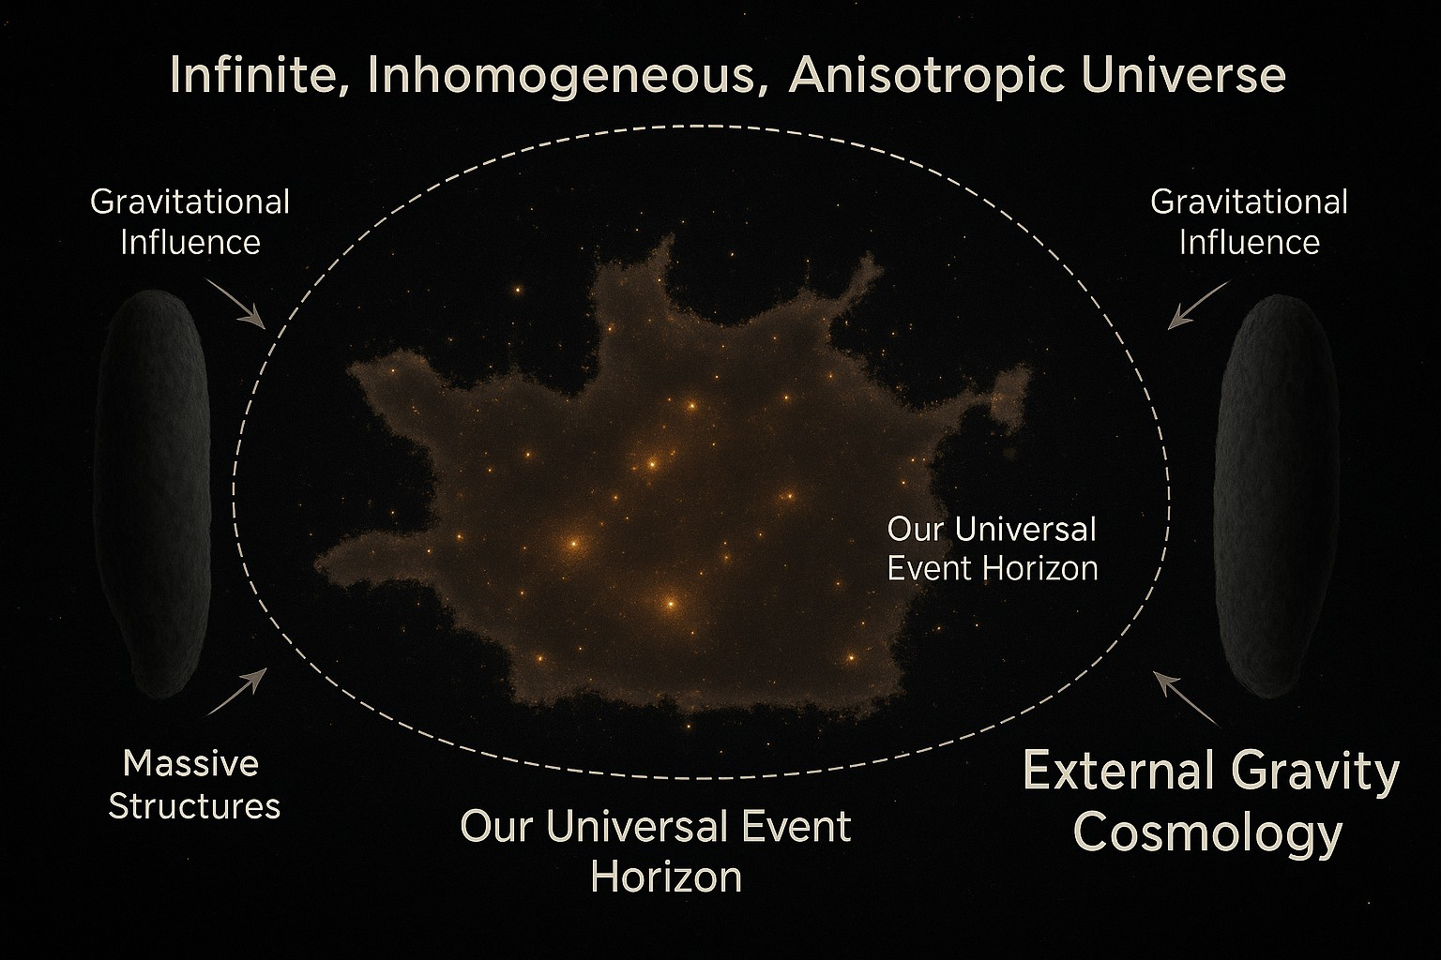
Figure 8: This figure is a conceptual illustration of the EGC framework, a model that challenges the assumption that our universe evolves in isolation. It proposes that masses beyond OUEH can exert a gravitational influence on our OU.

In summary, EGC, supported by recent observational and theoretical developments, provides a compelling framework for understanding cosmic acceleration and the large- scale structure of the universe without invoking dark energy or an initial singularity.

Reinterpreting Redshift and the CMB
Traditionally, redshift is interpreted as a consequence of metric expansion, and the CMB is considered a relic radiation from the early universe. In contrast, EGC suggests that redshift is influenced not only by metric expansion but also by gravitational differentials created by masses and external structures beyond OUEH. These differentials imprint on the CMB, which, in this framework, is not a relic of the Big Bang but a superposition of redshifted radiation from deep within TU. This perspective is supported by the phenomenon of gravitational redshift, where light escaping a gravitational well is redshifted due to the energy required to overcome the gravitational potential. This effect has been confirmed through various experiments and observations, such as the Pound-Rebka experiment and observations of white dwarf stars [23]. The ”forest analogy” aids in visualizing this concept: just as in a dense forest where all lines of sight end at tree trunks, every direction in the sky terminates at the limit of our observability, revealing a dense radiative wall. This analogy suggests that the CMB represents the integrated radiation from numerous sources beyond OUEH, redshifted by intervening gravitational potentials.
Anomalies in the CMB further support this reinterpretation. Notably, the ”Axis of
Evil” refers to the unexpected alignment of the CMB’s quadrupole and octopole moments with the plane of the Solar System, a feature that challenges the isotropy assumption of the standard cosmological model [24]. Additionally, studies have reported a lack of large- angle correlations in the CMB, which are difficult to reconcile with the predictions of the ΛCDM model [25]. These observations suggest that the CMB may be influenced by

structures and dynamics beyond OUEH, aligning with the EGC framework. By considering the gravitational effects of external structures, EGC offers a coherent explanation for these anomalies, providing a fresh perspective on the nature of cosmic redshift and the origin of the CMB.

Conclusion and Discussion
EGC offers a conceptually parsimonious and observationally motivated alternative to the standard ΛCDM framework. By attributing the large-scale expansion and structure of OU to gravitational influences from masses and unobservable structures in TU beyond OUEH, EGC dispenses with the need for inflation, dark energy, and an initial singularity. Instead, it posits that gravitational potentials external to OU actively shape cosmological dynamics through curvature, redshift modulation, and anisotropic expansion. The theoretical strength of EGC lies in its ability to provide a unified explanation for a wide range of persistent observational anomalies. These include the dipolar alignment of quasar distributions, the statistical excess in low CMB multipole alignments (e.g., the ”Axis of Evil”), the early appearance of massive galaxies, and the tension in H₀ measurements across local and early-universe scales. Within the EGC framework, such anomalies are not artifacts or outliers but the natural consequence of an open, anisotropic gravitational environment extending beyond observational limits. Importantly, EGC introduces several distinctive advantages over existing cosmological paradigms:
- OU is an embedded, finite region within a gravitationally irregular and infinite cosmological backdrop.
- The apparent cosmic acceleration, anisotropies in the CMB, and deviations in red- shift behavior are not relics of early-universe inflation but real-time gravitational effects arising from beyond OUEH.
This reorientation of cosmological perspective allows EGC to address a broad spectrum of observational anomalies that currently challenge the coherence of the ΛCDM model. The key theoretical Contributions of EGC are
- Replaces inflation and dark energy with real-time gravity: Rather than attributing expansion to an early scalar field or a cosmological constant, EGC ex- plains anisotropic expansion and large-scale structure through classical gravitational gradients.
- Avoids singularities and speculative early epochs: EGC does not rely on a Big Bang singularity, initial conditions from quantum gravity, or finely tuned inflationary scenarios. It instead builds on continuous gravitational self-organization over extended time scales.
- CMB as a gravitationally filtered field: The CMB is reinterpreted not as a snapshot from a recombination surface, but as a superposition of redshifted radiation from distant regions across TU, filtered through intervening gravitational wells.

- Redshift as gravitationally modulated: Redshift is not purely a metric expansion effect. In EGC, gravitational red shifting across large-scale potential wells modulates the redshift-distance relation, explaining apparent discreteness and directional biases in redshift datasets.
EGC provides a unified and testable explanation for multiple long-standing and recently discovered cosmological anomalies, including:
- CMB anomalies: The “Axis of Evil” and hemispherical power asymmetries, con- firmed by Planck and WMAP, are explained as emergent directional signals from gravitational differentials in TU, not statistical flukes or instrumental artifacts.
- Quasar dipole anisotropies: Secrest et al. [1] findings of a significant dipole in quasar distributions align naturally with EGC’s prediction of directional gravitational wells distorting large-scale structure alignment.
- Early galaxy formation and massive SMBHs: EGC circumvents the timeline problem for galaxy and black hole formation by removing the inflationary “clock.” Without a fixed age for the universe, early structures do not violate physical growth constraints.
- Hubble tension: Conflicting values of H₀ derived from local and early-universe measurements are interpreted as arising from gravitational lensing and anisotropic expansion gradients affecting time and redshift differently in different directions.
EGC also has many philosophical and methodological advantages like
- Restoration of causality and locality: By reattributing observed effects to classical gravitational influence rather than inflationary “initial conditions,” EGC reinforces physical causality and aligns cosmology with empirical field theory.
- Minimization of theoretical assumptions: EGC significantly reduces dependence on speculative constructs such as inflation, dark energy, and fine-tuned vacuum energy.
A critical strength of EGC lies in its falsifiability. Unlike some multiverse-based or non- local cosmologies, EGC provides direct, testable predictions. Future observations can be used to verify or refute its claims.

Predicted observational correlations:
  - Angular correlations between CMB anisotropies and redshift gradients.
  - Alignment between large-scale quasar dipoles and cold/hot spots in the CMB.
  - Directional dependence in galactic redshift-magnitude relations.

Instruments and missions relevant to testing EGC:
  - JWST and successors: to probe the temporal depth of galaxy formation.
  - DESI and Euclid: to chart gravitational lensing and dark-matter distributions.

  - CMB-S4 and LiteBIRD: to refine maps of CMB anisotropy and polarization.
  - LISA and next-generation gravitational wave detectors: to potentially detect directional curvature gradients in spacetime.
EGC invites a rethinking of the cosmological principle, which assumes large-scale isotropy and homogeneity. Rather than being universal truths, these properties may instead be emergent, local conditions of OU within TU. If anisotropies in redshift, temperature, and structure can be consistently mapped to directions or distributions in extragalactic gravitational potential, it would support the EGC thesis that:
- Our universe is not statistically typical but gravitationally conditioned.
- Observational cosmology can access information beyond its apparent horizon via gravitational tomography.
This would represent a significant epistemological shift: from seeing the horizon as a hard boundary, to regarding it as a gravitational lens through which TU can be indirectly probed. To summarize, EGC presents a physically coherent, mathematically tractable, and observationally responsive alternative to ΛCDM. It achieves this by:
- Grounding cosmological dynamics in gravitational interaction rather than speculative fields.
- Explaining large-scale anomalies as emergent, real-time effects rather than relics of an unobservable past.
- Providing a framework for directional, horizon-transcending cosmology consistent with general relativity.
- Offering a falsifiable, testable theory aligned with current and next-generation observational capacities.
As data from new instruments continue to accumulate, the possibility of empirically reconstructing the gravitational landscape beyond OUEH draws nearer. EGC stands as a compelling candidate framework to guide that interpretive endeavor, positioning gravity not just as a background actor but as the principal architect of cosmological structure.

References
- Secrest, N. J., von Hausegger, S., Rameez, M., Mohayaee, R., Sarkar, S., & Colin, J. (2021). A test of the cosmological principle with quasars. The Astrophysical Journal Letters, 908 (2), L51. https://doi.org/10.3847/2041-8213/abdd40
- Gardner, J. P., et al. (2023). Early release observations from the James Webb Space Telescope. Nature Astronomy, 7 (1), 1–7.
https://doi.org/10.1038/s41550-023-01941-9
- Inayoshi, K., Visbal, E., & Haiman, Z. (2020). The assembly of the first massive black holes. Annual Review of Astronomy and Astrophysics, 58, 27–97. https://doi.org/10.1146/annurev-astro-120419-014455

- Land, K., & Magueijo, J. (2005). Examination of evidence for a preferred axis in the cosmic radiation anisotropy. Physical Review Letters, 95 (7), 071301. https://doi.org/10.1103/PhysRevLett.95.071301
- Planck Collaboration. (2016). Planck 2015 results. XVI. Isotropy and statistics of the CMB. Astronomy & Astrophysics, 594, A16.
https://doi.org/10.1051/0004-6361/201526681
- Mal, A., et al. (2024). Quantized redshift and its significance for recent observations.
Research in Astronomy and Astrophysics, 24 (9).
https://www.raa-journal.org/issues/all/2024/v24n9/202409/t20240918 243702. html
- Author(s). (2024). An empirical consistent redshift bias: A possible direct observa- tion of the kinematic dipole. MDPI Galaxies, 7 (3), 41. https://www.mdpi.com/2571-712X/7/3/41
- Pascale, M., Frye, B., Pierel, J. D. R., Chen, W., & Kelly, P. L. (2025). SN H0pe: The first measurement of H₀ from a multiply imaged type Ia supernova, discovered by JWST. The Astrophysical Journal, 962 (1), L17.
https://doi.org/10.3847/2041-8213/ad1ddd
- Riess, A. G., et al. (2024). JWST observations reject unrecognized crowding of Cepheid photometry as an explanation for the Hubble tension at 8σ confidence. The Astrophysical Journal Letters, 962 (1), L17.
https://doi.org/10.3847/2041-8213/ad1ddd
- Jung, G., Aghanim, N., Sorce, J. G., Seidel, B., Dolag, K., & Douspis, M. (2024). Revisiting the large-scale CMB anomalies: The impact of the SZ signal from the Local Universe. Astronomy & Astrophysics, 692, A180. https://doi.org/10.1051/0004-6361/202347512
- DESI Collaboration. (2025). New DESI results strengthen hints that dark energy may evolve. Retrieved from
https://newscenter.lbl.gov/2025/03/19/new-desi-results-strengthen-hints-that-dark-energy-may-e
- Wiltshire, D. L. (2024). Dark energy ‘doesn’t exist’ so can’t be pushing ‘lumpy’ universe apart. Phys.org News. Retrieved from
https://phys.org/news/2024-12-dark-energy-doesnt-lumpy-universe.html
- Ijjas, A., Steinhardt, P. J., & Loeb, A. (2013). Inflationary paradigm in trouble after Planck2013. Physics Letters B, 723 (4–5), 261–266. https://arxiv.org/abs/1304.2785
- Ijjas, A., & Steinhardt, P. J. (2017). Bouncing cosmology made simple. Classical and Quantum Gravity, 35 (13), 135004.
https://arxiv.org/abs/1803.01961
- University of Oxford. (2021). Lopsided universe could mean revision of standard cosmological model. Retrieved from
https://www.physics.ox.ac.uk/news/lopsided-universe-could-mean-revision-standard-cosmological

- Wiltshire, D. L. (2024). Dark energy ‘doesn’t exist’ so can’t be pushing ‘lumpy’ universe apart. Phys.org. Retrieved from
https://phys.org/news/2024-12-dark-energy-doesnt-lumpy-universe.html
- Copi, C. J., Huterer, D., Schwarz, D. J., & Starkman, G. D. (2010). Large-angle anomalies in the CMB. Advances in Astronomy, 2010, 847541. https://arxiv.org/abs/1004.5602
- Abghari, A., Bunn, E. F., Hergt, L. T., Li, B., Scott, D., Sullivan, R. M., & Wei, D. (2024). Reassessment of the dipole in the distribution of quasars on the sky. Journal of Cosmology and Astroparticle Physics, 2024 (11), 067. https://doi.org/10.1088/1475-7516/2024/11/067:contentReference[oaicite: 4]{index=4}
- von Hausegger, S., & Sarkar, S. (2019). Evidence for anisotropy of cosmic accelera- tion. Astronomy & Astrophysics, 627, L7.
https://doi.org/10.1051/0004-6361/201936373
- Phys.org. (2024, September). Advanced data shed light on gravitational basins of attraction that shape the movement of galaxies.
https://phys.org/news/2024-09-advanced-gravitational-basins-movement-galaxies. html
- Reuters. (2025, March 19). Evidence mounts that universe’s dark energy is changing over time. Reuters. Retrieved from
https://www.reuters.com/science/evidence-mounts-that-universes-dark-energy-is-changing-over-t
- Wiltshire, D. L. (2011). Supernova tests of the timescape cosmology. Monthly Notices of the Royal Astronomical Society, 413 (1), 367–385. https://academic.oup.com/mnras/article/413/1/367/1062339
- Swinburne University of Technology. (n.d.). Gravitational redshift. COSMOS. Re- trieved from
https://astronomy.swin.edu.au/cosmos/G/Gravitational+Redshift
- Wikipedia contributors. (n.d.). Axis of evil (cosmology). Wikipedia. Retrieved from https://en.wikipedia.org/wiki/Axis of evil (cosmology)
- Copi, C. J., Huterer, D., Schwarz, D. J., & Starkman, G. D. (2015). Large-angle anomalies in the CMB. Advances in Astronomy, 2010, 847541. https://doi.org/10.1155/2010/847541

