# *Shape Description automatically generatedPhilosophy of Knowledge*

Contents

Project Topic: Game of words && Math 3

Team Members: 3

**Emma Georgieva 9B** 3

**Svilen Todorov 9A** 3

**Alexander Sivkov 9B** 3

**Kristian Kostadinov 9G** 3

**Scrum Trainer** 3

**QA Engineer** 3

**Backend Developer** 3

**Backend Developer** 3

Technologies used 4

Summary: 6

# Project Topic: Game of words && Math

The theme of the project was to create a C++ game related to math, numbers, or words in some way.

Our game idea is hangman – but instead of guessing letters, you guess the word.

# Team Members:

|  |  |  |  |
| --- | --- | --- | --- |
| [**Emma Georgieva 9B**](https://github.com/EGGeorgieva21) | [**Svilen Todorov 9A**](https://github.com/SDTodorov21) | [**Alexander Sivkov 9B**](https://github.com/ATSivkov21) | [**Kristian Kostadinov 9G**](https://github.com/KNKostadinov21) |
| **Scrum Trainer** | **QA Engineer** | **Backend Developer** | **Backend Developer** |

# Technologies used

* C++ (language used to make the game)
* GitHub (version control)
* Word (documentation)
* Teams (used to get the team together)
* PowerPoint (presentation)
* VS Code (used to make the game)
* Visual Studio (used to make the game)

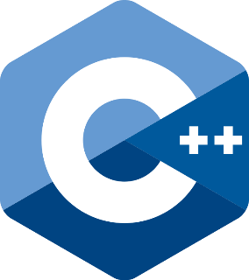



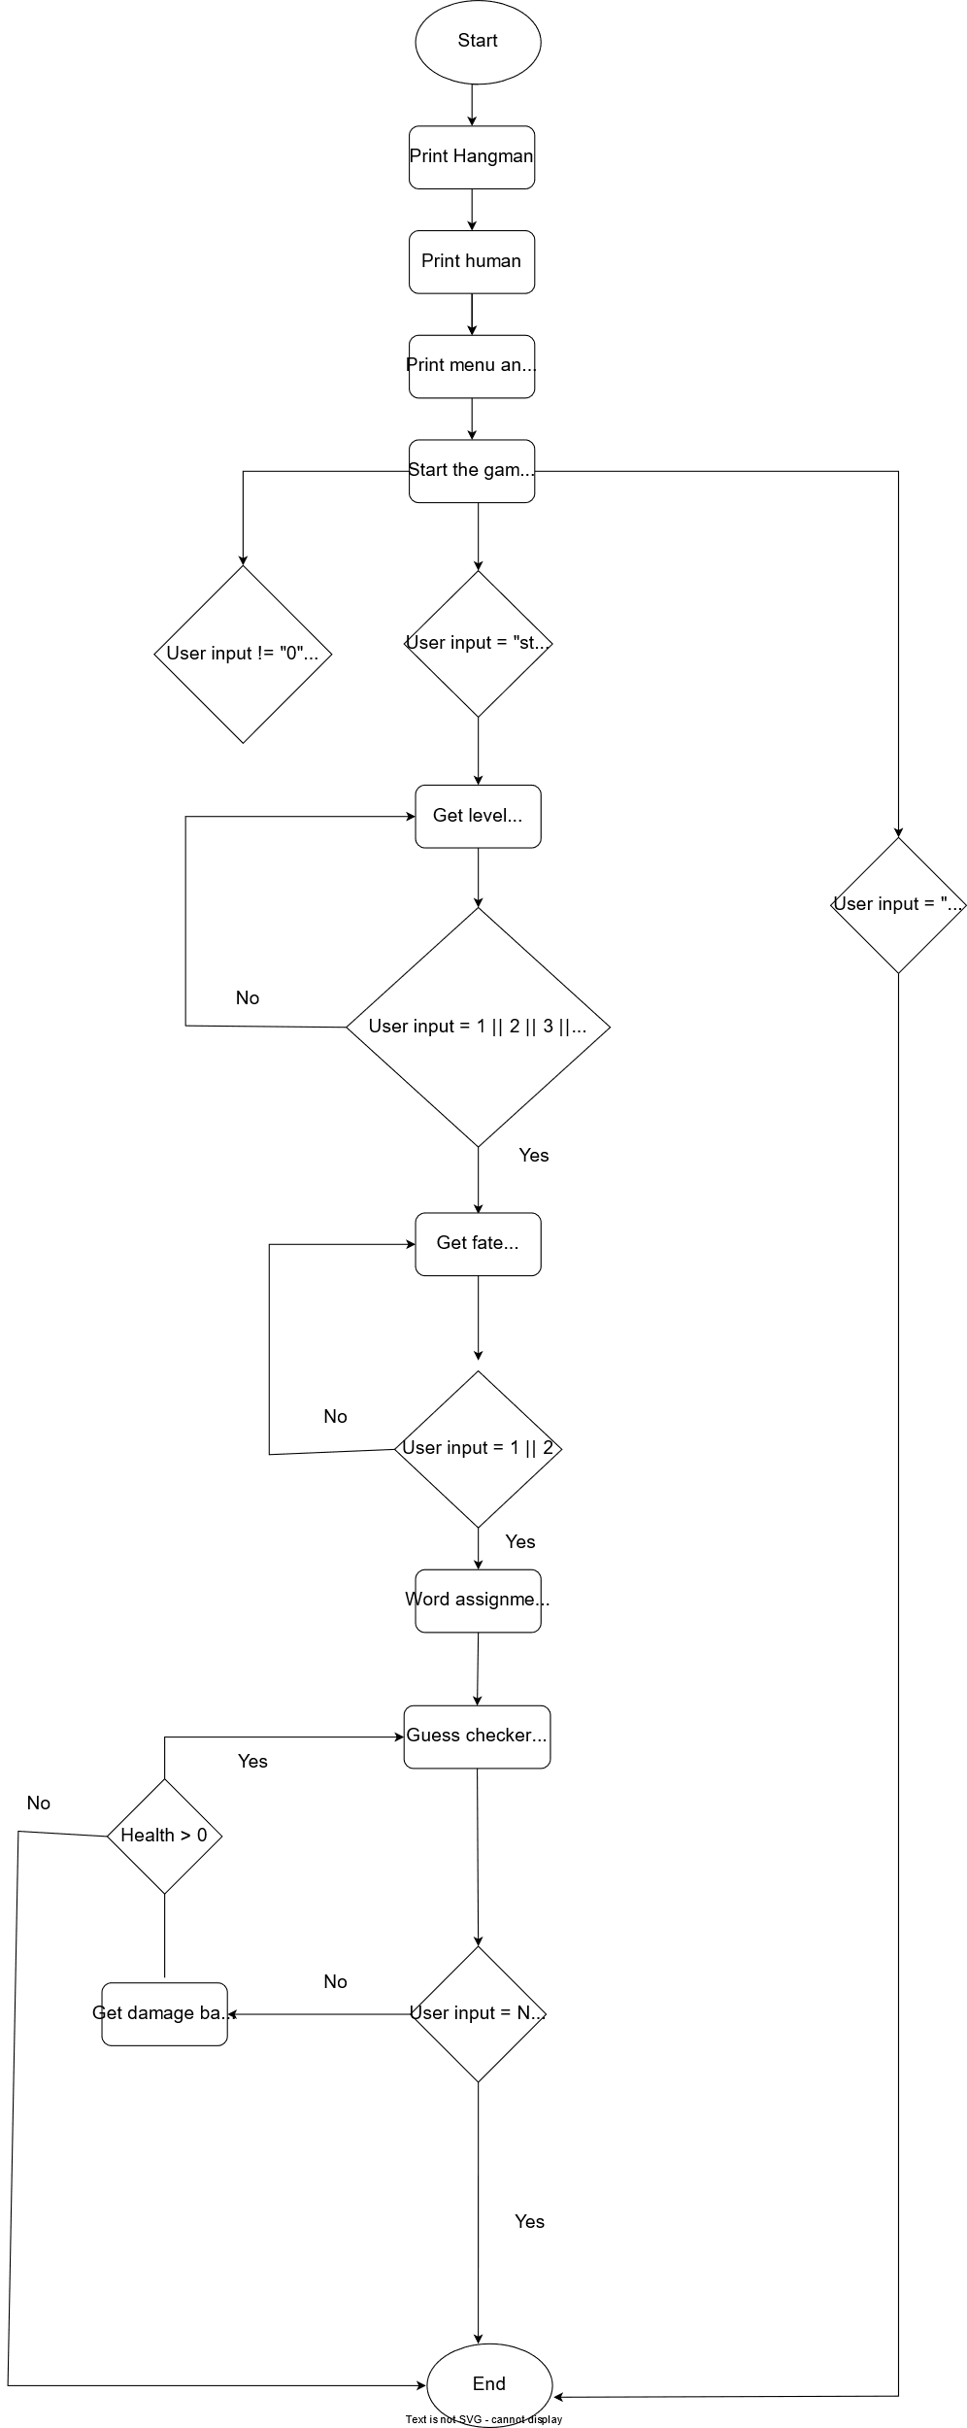

# Summary:

1. Our aims

* Our aims are to make sure that the code runs properly and that its functions have the expected output.

1. Main Stages of the project

* Creation of repository
* Creation of the game
* Documentation
* Release the first version on GitHub